**The Meet & Greet**

By Soul-Controller

Upon finishing his latest round of *Overwatch 2*, Noah Stevens found himself unleashing a deep yawn as he looked over towards his boyfriend. As he witnessed Jacob sitting at his desk with his headphones on and his head slightly bobbing side to side, the 25-year-old nerd couldn’t help but smile at catching his boyfriend in the midst of a small jam session. But despite how adorable the sight was, the man’s eyes pulled away for a moment to stare at the taskbar of his desktop computer. With his sights suddenly set on the bottom right corner, Noah was able to watch as the clock switched from 2:59 to 3:00 AM.

As he lifted his arms up and did a slight stretch, another yawn escaped from his lips to further confirm that bedtime was fast approaching. Upon rolling out of his desk chair and making his way over to Jacob, Noah leaned down to give a soft kiss to the top of the still-vibing man’s head before he finally passed by and made his way out of the bedroom.

Upon entering the bathroom to begin his bedtime routine of using the facilities and brushing his teeth, the man sat down on the toilet and pulled his phone out of his pocket to pass the time. In the midst of making his way over to Twitter to just mindlessly scroll through memes and posts from his online friends though, a notification suddenly appeared at the top of his screen from Reddit. Upon only seeing the words “...has replied to your comment”, the man’s fingers moved with haste as they tapped on the notification and forced open the app

Watching as the app immediately transferred him to the subreddit of his favorite musician, The Weeknd, the man found himself back in the thread he had been leaving multiple comments in the past few months – the Buy / Sell / Trade Ticket Megathread. As the app moved on its own accord to bring him to his most recent comment, Noah’s heart skipped a beat as he saw what the response said – “I’ve got a ticket for tomorrow’s Chicago show. Lemme know if you’re still looking”. As a slight gasp escaped from his lips, the man moved with incredible speed as he clicked on the account’s name and began to send a DM.

After finishing typing out a message that not only confirmed his unfulfilled search for a ticket while also inquiring about the price and location of said ticket, Noah wasted no time pressing send and just hoping that he’d receive a response before he went to bed. As he finished up on the toilet and washed his hands, the man couldn’t help but think back about how badly he wanted to see the newest tour from The Weeknd.

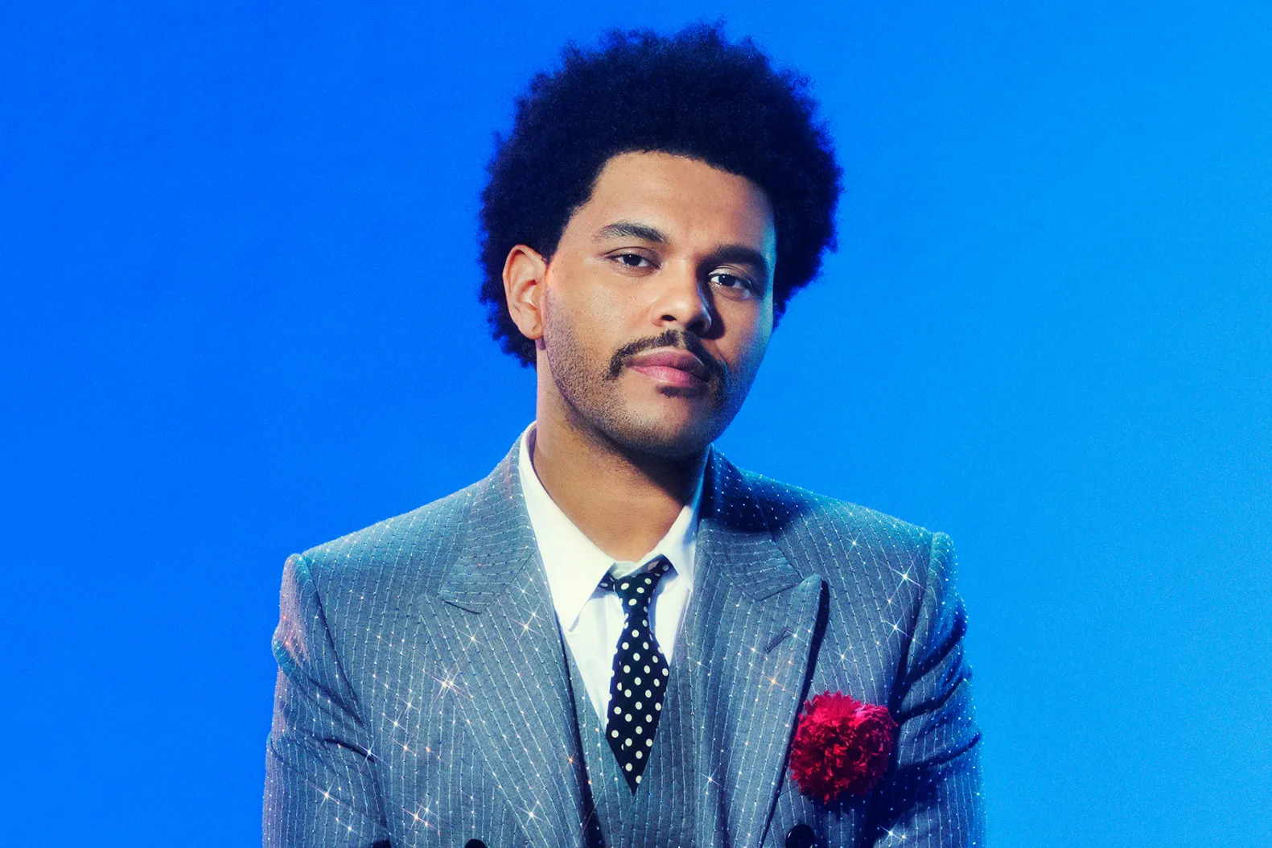

Ever since The Weeknd, whose real name was Abel Tesfaye, had become a breakout star in 2015, Noah had been an avid supporter and fan. On paper, the concept of a prudish gay man stanning a Canadian rapper who sang about straight sex and drugs seemed hilarious (especially given his affinity towards female pop stars), but there was something about The Weeknd and his thought-out eras and visuals that was just naturally appealing. Of course it certainly didn’t hurt that the young man also found that the singer was incredibly hot…

Yet despite nearly a decade of being a dedicated fan who bought every album and piece of merchandise, Noah had never been able to actually see the man live in concert before. Back in 2015 during Abel’s major label debut, the then seventeen-year-old had been prevented from attending by his parents as they worried about the concept of the nerdy and lanky kid being stuck in the middle of a general admission pit. Two years later, the young man was now a college student and had a little more meat on his bones to handle the pushing and shoving common with a floor ticket, so he had been able to finally secure a ticket to the singer’s tour for the Starboy album. But to his disbelief and anger, his manager at his on-campus job refused to give him the day off for the show and thus he was forced to sell his ticket.

With the release of not one but two albums during the course of the pandemic, Noah’s deep appreciation and enjoyment of these two newest bodies of work meant that there was no way that he would allow himself to miss another tour by his favorite musician. But unfortunately for the superfan, it seemed as though the pandemic only caused Abel’s success to grow exponentially as he leveled up from playing arenas to selling out stadiums in mere minutes. Despite having presale access, the man was left ticketless as a result and thus forced to spend the following months scouring ticket resale sites in hopes of finding something that was a) a good seat and b) not extremely price gouged by money-hungry ticket scalpers.

So as he finished brushing his teeth and began to make his way back to his bedroom, the young man couldn’t help but pray that this random account was able to fit his ideal criteria for a ticket. There was nothing he wanted more than to go to this concert, so much so that he was willing to drop everything and drive the 2.5 hour trip the very next day to Chicago if it meant getting to see his favorite artist live!

By the time Noah returned to his bedroom, he discovered that he wasn’t the only one sleepy as Jacob had already gotten off of his computer and was now just laying in bed with his phone in hand. Walking in and sitting down at the edge of the bed, the man had an undisguisable smile that was so prominent that it somehow instantly caught his boyfriend’s peripheral attention.

“What’s going on, dork?” Jacob asked, a soft chuckle escaping from his lips as he set his phone down on his chest and instead focused all of his attention on Noah. “You’re looking like the Joker over there, what’s up?”

In response, Noah crawled up closer on the bed and offered up his phone to the man. “It’s about the concert, a guy just told me he had a ticket available! I’m waiting to hear back on the price and everything, but I really have a good feeling about this,” he responded, his last sentence punctuated with a frantic light scream of excitement. “Ugh, could you imagine if I *actually* got a ticket? I’ve been dreaming of this for **years**!”

Rather than joining his boyfriend in excitement, Jacob’s face seemed incredibly stoic as he grabbed the phone and looked at the messages between the duo. “Are you sure about this? It’s a bit last minute,” he began, exiting out of the DM to instead scroll through the original thread. “I mean, what if the guy wants to charge a shit-ton of money for it? Also, going to Chicago is quite a trek and the whole last-minute situation worries me about you driving there and back…”

Not willing to hear valid points, Noah just instantly shook his head as he extended out his hand and took his phone back. “Oh you worry too much, I’ll be fine! Before we met I did countless solo trips to Chicago and back,” he continued, his words suddenly taking a backseat as he recollected the countless shows he went to back in his college-days. “As for the price, I guess we’ll just have to see. I mean, I’m not going to drop $1000 on a ticket but if it’s anywhere from $100-200 more than the original prices I’d absolutely consider it…”

Just as he finished his statement, a loud ding rang from his phone and Noah’s attention was instantly devoted to the device. As he opened up the app and returned to his conversation with the seller, the man’s eyes widened and he gasped in shock at the details of the newest message. “Ho– Holy shit,” he exclaimed, his hands trembling as he instantly typed out his response. “Not only is it a floor seat, but it’s front row!”

In response, Jacob’s eyes widened. “Wait really? How much does he want and where is it specifically?”

“He wants $350 and he’s letting me know right now where…” he began, another loud notification suddenly interrupting him. As he looked down at the device once more, a squeal automatically left his lips. “What the hell, it’s front row at the end of the runway!”

As he turned to face his boyfriend, Noah noticed as his boyfriend’s stoic face suddenly began to shift into a slight frown. Instantly, a twinge of regret coursed through his body as he realized that Jacob couldn’t join him. Despite knowing he was going to go no matter what, the caring boyfriend couldn’t help but crawl further up the bed until he was face-to-face with his partner.

“Are you ok? I could try to find a ticket for you if you wanted, it wouldn’t be the same spot as mine but still I feel bad you wouldn’t be able to go,” Noah said, a genuine frown emerging onto his face as he stared at his boyfriend.

“Oh uh, yeah I’m fine,” Jacob replied, forcing a slight smile upon his lips as he looked fully into his partner’s eyes. “I appreciate the offer but I have to work. Hell, even if I could go, I don’t have the money for that!”

“Are you absolutely sure? I don’t want to upset you,” Noah inquired.

“Of course, it will be fine. You’re the bigger fan,” Jacob said, his eyebrow raising as he decided to mess with his boyfriend. “Plus, I wouldn’t want to interrupt your little meet-cute anyway!”

In response, the superfan’s cheeks began to turn pink at the sly statement about his crush on the singer. “Oh shut up, it’s not like he’d ever be interested in a guy like me. Might I remind you, he sings constantly about seducing women and fucking models…”

Still eager to continue with his joking tone, Jacob refused to let the conversation die there. “Well, models is a gender-neutral term. He could be bisexual for all you know,” he exclaimed, which unintentionally caused his boyfriend’s dick to throb at the potential notion. Leaning forward, the man then grabbed onto his boyfriend’s hand and gave his best puppy dog eyes. “There’s one thing I ask, ok? Just *promise* not to forget about me once y’all are honeymooning in Canada!”

Immediately, Noah rolled his eyes as he grabbed onto one of his pillows and jokingly hit Jacob in the face with it. “Oh shut up,” he cackled, leaning forward to softly press his lips against his partner’s. “There’s no one else I want besides you!”

For a moment, the entire concert ticket situation fell to the wayside as the duo embraced each other. In fact, everything in the world came to a crash halt to them as each man spent the next several minutes giving each other sweet and sensual kisses to each other. As their lips eventually pulled away from each other, each man couldn’t help but blush as they stared into each others’ eyes. Upon each of them saying “I love you”, the duo finally returned to reality and went about their business.

So now with confirmation that Jacob wasn’t interested in attending, Noah’s hands trembled in excitement as he returned to his phone and went back to the DM. After copying the man’s Venmo, he made his way over to that app where he quickly input the name and sent the $350 to the user. Now stuck waiting to figure out whether he had been scammed or actually purchased genuine floor seats, the man then simply sat there as his boyfriend finally turned onto his side and fell fast asleep. With only his dimmed phone as a source of light in the bedroom, Noah was like a moth to a flame the way his eyes remained glued to the screen waiting for the tickets to arrive. After what felt like an eternity, he finally received a DM from the seller who confirmed that he received the money and sent the ticket transfer link to the email that Noah provided.

Upon exiting out of the app, he quickly headed over to his email app and waited for it to refresh. As it did and five new emails suddenly emerged, it was the most recent one that caught his eye. After clicking on it and hitting the button to initiate the ticket transfer, the man’s ticketing app pulled open and he watched in absolute joy as it automatically refreshed and a ticket to The Weeknd’s Chicago show was now in his digital wallet.

Despite how excited he was to finally secure tickets, the thought of the impending drive once he woke up caused him to try and calm down to the best of his ability. So once he sent an email thanking the user for the tickets he set his alarms and plugged his phone in before laying down. As he was slowly drifting into a state of unconsciousness, he couldn’t help but start dreaming about finally seeing his favorite singer live for the first time.

* * * * *

With the electronic synths of “Blinding Lights” suddenly ringing out from his phone, Noah was seamlessly pulled out of his dream and back into the real world. The last thing he recalled before waking up was loudly singing along and dancing to the same song as The Weeknd moved around the stage and sang directly in front of the superfan. So as he sat up and realized that today was the day where that dream would finally come true, a wide smile emerged on the young man’s face.

Despite the show not starting until 7 PM and the current time being 1:30 PM, Noah wasted no time heading into the shower and preparing to get ready for the drive towards the venue. Given how long the universe had delayed him from attending his first The Weeknd concert, the young man was desperate to get there as early as possible… not only due to wanting to avoid any potential bad luck that could delay him such as a flat tire or traffic but to also arrive at the stadium and just spend hours savoring the experience that had once long eluded him.

Most of the time, it would have taken Noah hours to decide on an outfit regardless of how simple or extravagant it was due to his overly anxious and indecisive brain. But with his excitement consistently growing with each minute that passed, the young man forced himself to be more decisive for the sake of saving time. In hopes of striking a solid balance between comfort and paying homage to Abel’s artistry, Noah had ultimately decided upon a stark red t-shirt that was a part of the artist’s *After Hours* merchandise and a pair of black joggers.

As he stepped in front of his bathroom mirror to take one final look at himself before heading out, the man felt as though he was a bundle of energy the way he was so jittery and excited. But in addition to these feelings, there was a sudden sense of nervousness emerging within him as he judged his visage and found himself fiddling with his hair and making sure he looked as great as possible. It wasn’t as if he was even going to meet the guy, so he couldn’t comprehend why his mind was being so picky about his appearance. In many ways, the tightness in the pit of his stomach made him be reminded of the anxiety he always felt before he took part in an exam back in his college days. But as he compared both events that elicited this feeling, he couldn’t help but wonder if it was crazy that he was more nervous about a concert than his college finals!

As he glanced at his clock and watched as the clock was a mere fifteen minutes away from 3 PM, Noah broke out of his self-induced stun-lock and headed into his bedroom once more. He tucked his phone and wallet into his pockets before slinging his lanyard of keys (both car and apartment) around his neck. As he took one final glance at his apartment before exiting, the man had no way of knowing that it would be the last time he was ever inside it…

* * * * *

Much to Noah’s relief, the route to the stadium was fairly clear of traffic despite the concert being in a major city. So with his excitement about finally getting to see his favorite artist live, it was no surprise that Noah developed a bit of a lead foot as his car sped with haste towards the venue. With the assistance of cruise control and no crashes or construction to slow him down, the man’s driving was able to shave off such a significant amount of time that he arrived 45 minutes earlier than anticipated! Given his already early departure

Upon getting a prime parking spot due to his early arrival, the man – clad in his *After Hours* styled attire of a red shirt and black dress pants – rushed towards the gates of the stadium. Despite how shaky and excited he was to the point where he could have surely collapsed in pure panic, Noah made it to the gate in one piece and flashed a pearly white smile as he held out his phone for the ticket taker to scan. Despite the flash of a green light from the scanner proving that he had approved to enter, the ticket taker refused to move. Instead, she simply stood there in front of the entryway, looking down at the device in a severe and somewhat alarming unblinking daze reminiscent of a person under hypnosis.

Both concerned for her safety and eager to get inside, the superfan reached out and softly placed a hand on the woman’s forearm. “Ma’am? Are you ok?”

The combination of physical touch and a concerned vocal tone seemed to do the trick, as the woman suddenly returned to life and pulled her eyes away from the scanner to instead meet Noah’s. “Oh um, yeah. I’m sorry about that, I must have gotten sidetracked for a moment,” she began, which revealed that even her voice had a dazed-like quality to it still. “But uh, anyways, your ticket is actually VIP so you’ll need to head to the other gate to gain entry.”

Immediately, Noah’s eyes widened at the notion of having a VIP ticket. Despite knowing the ins and outs of the tour in terms of its costumes and setlist, the man’s status as a broke college student had caused him to not even ponder the notion of acquiring a VIP package. “So I- I have a VIP package?” he inquired, which caused the woman to confirm with a subtle nod of her head. In search of more answers in regards to this surprising revelation, Noah forced himself to keep his composure as he went ahead to ask one more question. “This ticket was a gift, so can you tell me what package it even is for?”

In response, the woman’s lips pulled back into a wide grin. “Oh, it’s a meet and greet package. I think the event is about to start though, so you might want to hurry over there before they stop letting people in!”

The concept of missing out on a meet and greet caused Noah to instantly thank the woman before breaking into a sprint towards the VIP gate. There was no way he was going to miss getting to meet his favorite singer even if his brain was still struggling to comprehend the shocking news. It would hardly be his first celebrity meet and greet (he had a habit of splurging on meet and greets with his favorite female pop stars), but he’d never thought he’d have the chance to actually meet with and exchange words with the man whose voice made him swoon every time without fail. As a result, there was no doubt in Noah’s mind that this meet and greet would be different from all his previous encounters.

Upon heading to the gate, Noah allowed his ticket to be scanned once more before being led into the venue by an employee. While this was going on, the man was frantically typing out messages to his boyfriend and friends to explain the gift that the universe had opted to bless him with. By the time he had been led deep into the backstage area of the stadium until he was in line with the rest of the VIP attendees, Noah’s phone was full of enthusiastic responses both congratulating him while also expressing some slight jealousy. The biggest culprit of this dual attitude was Noah’s boyfriend Jacob, who expressed how jealous he was due to his mutual attraction to the man while also saying how happy he was for the superfan to get this opportunity.

As a result of his openly discussed attraction to the singer, Noah could then understand why his boyfriend’s messages were a clear mix of a celebratory tone to one of jealousy and frustration. But of course, there was no way that the unabashedly straight man he had often found himself dreaming about would ever be romantic with a guy like him. Having an average face and a body that had become slightly flabby from the perks of an unlimited meal plan at his university’s dining halls, Noah knew that there was absolutely no way that the singer would ever “slum” it and be with a guy like him.

As the line began to finally begin moving as the front of the line began their meet and greet experience, Noah took a moment to look around and observe the lucky crowd of individuals who he would be sharing this once-in-a-lifetime experience with. As he observed the various faces and outfits he saw that paid homage to The Weeknd’s multiple eras, Noah was surprised to discover a fairly even split of male and female fans that were visibly giddy with excitement.

Despite the discovery of his meet and greet ticket being incredibly last minute, the continued arrival of a few more fans behind Noah implied that the traffic outside the venue had finally arrived and thus delayed several individuals from making it on time. Amongst the newest set of VIP guests, the man picked up on two individuals. The first was a college-aged African American woman who had ended up arriving a good five minutes after Noah. With the few people between them just silently fiddling on their phones, the duo’s occasional meeting of eye contact caused them to ultimately exchange pleasantries and make small talk in hopes of avoiding the awkward silence that lingered in the short corridor. While the man had no clear interest in women due to his status as a gay man, Noah couldn’t help but instantly realize just how naturally beautiful she was. In addition to her impeccable style, the woman’s hair and makeup work was truly top notch as she looked as if she had just stepped off the cover of *Vogue*.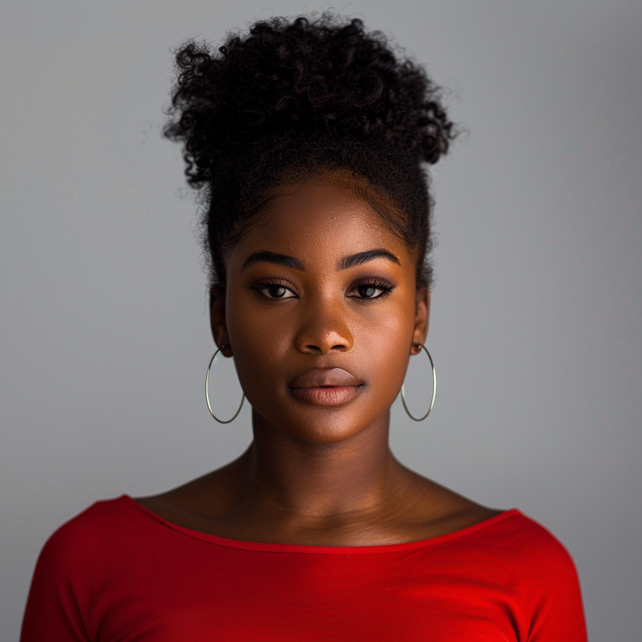

While in the midst of explaining his journey to the stadium to the young woman, who introduced herself as Destiny, Noah’s eyes ultimately met the second person of interest in the meet and greet line. Although his place in line was all the way in the back in comparison to the middle where Noah and Destiny currently resided, the superfan could still note just how attractive the young man was. Decked out in a black tour tee, the Latino man looked stunning as the shirt meshed well with his styled jet black hair and the mustache and chin strap combo he was currently sporting. In addition, Noah couldn’t help but swoon as he noticed the man’s large and inviting brown eyes that contained an innate sense of both sadness and intensity. Despite having no desire to ever cheat on his partner, the man couldn’t help but sneak occasional peeks at the young man as the line continued to shrink and Noah found himself closer to the front of the line.

With his occasional people-watching in tandem with his own excitement, time seemed to pass at a breakneck speed around him. So before he knew it, there was nowhere left for him to go but inside the dressing room to finally meet his idol. As he clenched his fists and took a deep breath, Noah gave himself a nod of encouragement before finally making his way into the dressing room.

As he gingerly stepped into the area, the man was instantly recognizing how lavishly it was decorated. Rather than the bare bones dressing rooms that he had seen in television and film, the room felt as though it was a mini-bachelor pad for the singer. In addition to two leather sofas that stretched along several areas of the room and several end tables, thick black drapes hung off from the walls as a 55-inch flatscreen played music videos and allowed the artist’s music to softly echo throughout the entire room.

However, as Noah’s eyes wandered around the room, all of that decor fell to the wayside when he caught sight of the impressive singer that was now sitting in the same room as him. Upon seeing the man’s handsome face and noticing the attire he was sporting, it was safe to say that the breath had been instantly snatched right out of him. Without a doubt, it was clear that the man was everything he had anticipated and more; how was it possible that somebody could be even more beautiful in person than they were on a screen?

The thirty-four year old Toronto-based singer slowly rose from one of the leather couches as the anxious fan moved further into the room, which caused the vision in Noah’s eyes to interpret the simple move as something truly holy in his mind. Looking at the man he had idolized for years, Noah immediately noted that the superstar looked as if he was photoshoot-ready. His eyes were instantly drawn to the sleek and sexy leather jacket that looked surprisingly incredible resting on his broad shoulders. Beneath the thick leather jacket was a black designer dress shirt, which was, to Noah’s absolute delight, sheer enough that it allowed the superfan to get a lovely peek at the man’s defined physique. As he noted the faint yet noticeable rectangles of abdominals in addition to the more prominent pectorals that pushed out against the shirt, it was no surprise that the fan was firming up at a rapid pace. Upon taking in the entire package presented to him, it was undeniable to Noah that not only was the singer the hottest man ever to him, but he looked even sexier all dressed up!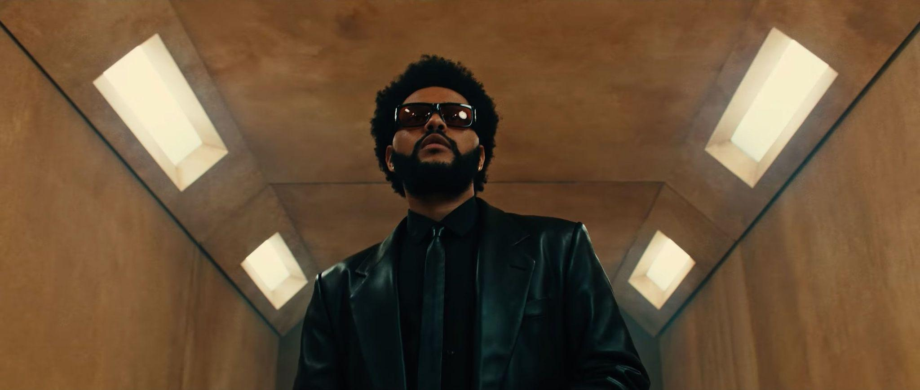

Although Noah could have been content with just getting to view his favorite singer and celebrity crush like this, the concept of a meet and greet meant that he was destined for more. As a result, the man watched as The Weeknd stood up and began to make his way over towards him. With each step that the man took towards him, Noah’s senses were going haywire. In addition to the faint scent of cologne getting stronger, the man couldn’t help but stare at The Weeknd’s leather pants and how perfectly tailored they were to each of his meaty thighs. In addition, the man’s ears were seemingly being prepared for the impending one-on-one interaction by the sound of a slight squeak. Upon looking down, Noah stared in amazement at the expensive-looking black leather loafers that were wrapped around The Weeknd’s feet and expertly completed the all-leather outfit.

However, as a polite smile began to spread further across The Weeknd’s (or more appropriately Abel Tesfaye’s) handsome face with each step, the clothing he was wearing was only a hindrance for Noah’s horny mind. A primal lust began to emerge in the deep recesses of Noah’s brain, which had begun desperately screaming for Noah to tear those clothes off of the singer and admire his body. But as he tried to brush away those thoughts and remain calm, Noah began to look around at other aspects of the singer who was now nearly face-to-face with him. Although his fandom meant that Noah had been anticipating it, he was still a little surprised to discover that the singer was actually a few inches shorter than him – a modest 5’8” compared to Noah’s 5’11” stature. While he may not have been the tallest person he ever met, Noah noted that the natural charisma that radiated from Tesfaye made him feel much larger in person.

“Hey man, thank you for coming to the show,” the singer greeted, taking a step closer and outstretching a hand. Looking down at the hand, Noah was relieved to see that the singer was not accessorizing his look with a pair of black leather gloves. The concept of skin-to-skin contact with Abel was extremely erotic to Noah, so much so that he already knew that this experience would be enough to fuel his late-night jerk-off sessions for months!

Noah did his best to control his thundering heart as he stepped forward and accepted the offer of a handshake. “I-it’s amazing to meet you,” the younger man stammered, immediately and instinctively slipping into his anxious fanboy mode (which although slightly embarrassing was obviously a better alternative than the sex-crazed fanboy mentality that was fully controlling his inner monologue currently). The other man’s grip was firm, and as expected, the skin-to-skin contact was enough to leave Noah weak at the knees. “I’ve always wanted to be you-- to meet you.” It was an innocent slip of the tongue (although not completely untrue, of course) but Noah’s cheeks flushed pink in embarrassment nonetheless.

To his credit, Tesfaye’s chuckle seemed good-natured rather than mocking as he moved right past the fan’s slip-up. “Is this your first time at one of my shows?” he asked, gesturing for Noah to take a seat on the opposite leather sofa. With much relief, Noah grew excited to know that this wouldn’t be like most of his previous meet-and-greets. Usually, the interactions were nothing more than a quick greeting and photo, so the fact that Abel’s meet and greets were so much more intimate made the superfan just fall in love more. *God, why did he have to be* ***so*** *perfect?!*

Unsurprisingly, Noah was absolutely buzzing then as he realized that he would actually get a couple minutes undisturbed with his musical hero. But just as quickly as he grew excited about this concept, the superfan quickly realized that having a significant amount of undisturbed time with his biggest musical hero and crush was both exciting and extremely nerve-wracking. Noah was unwilling to allow those anxieties to take him over at this time though, so he began to fight back against his naturally worrisome conscience.

“Uh, yeah. First of many, I hope,” the fan replied, doing his best to relax into a natural smile despite the slight cracks in his voice. “I’ve been a fan for a long time though.” Noah felt like he was going to get lost in the singer’s eyes. How could anybody’s gaze be so soulful yet sexy at the same time?

“That’s appreciated, man. I hope it’s the first of many for you too. Are there any--” The singer’s voice momentarily peaked, sounding quite unlike himself. Himself surprised by the sudden and apparent change, Abel broke off his sentence and attempted to clear his throat. “Woah, sorry about that. Hope it doesn’t happen during the show tonight, eh?”

“Yeah, that would probably be bad,” Noah chuckled, happy to find that he was suddenly feeling a little calmer with every passing moment. With this newfound calmness spreading throughout his body, Noah dared himself to be more personable and at-ease with the singer. Trying his best to continue the conversation and give himself the opportunity to compliment the man, Noah quickly followed up his previous statement. “Although I’m sure you’d still sound great” he continued, his face widening further from a less anxious-looking smile into one that naturally displayed happiness and approachability.

The singer smiled and shrugged his shoulders. “That’s nice of you to say, man.” Once again though, he didn’t quite sound like himself. With the show just an hour or so away, The Weeknd grew more visibly concerned at the sudden throat dilemma he was experiencing. “Damn, let me get some water”, he said, which caused Noah’s ears to perk up. It was strange to watch it happen to the silky-voiced man, but the fan couldn’t deny that there was something oddly familiar about Abel’s varying voice...

As the singer moved across the room to collect a bottle of water from a desk, Noah’s eyes followed him across the room. However, as his eyes caught sight of one of the end tables next to the leather couch he was sitting on, Noah noticed that the older man had left his watch on the table. Suddenly possessed by an out of character bold streak, Noah reached forward and grabbed it, quickly slipping it over his wrist and clicking it into place. ***What the hell are you doing?*** He had no answers for his own question; rational thought had seemingly abandoned him at this point. Distracted by his own boldness, Noah failed to see that the pale skin around the stolen watch was beginning to darken into a caramel brown.

“Are there any songs you’re excited to perfor-- to hear?” the Weeknd asked as he returned to the sofa, holding the water bottle with both hands. Mercifully his gaze never once turned towards Noah’s hands or the table to identify that his expensive watch was suddenly being worn by his fan.

“Oh, all the usuals. Anything that gets the crowd going,” Noah replied without hesitation, impressed by how well he was handling the conversation. “There’s nothing quite like knowing everybody’s enjoying themselves, right? Getting the whole place coming alive…” It was strange, Noah was usually quite an introverted person, but the concept of hyping up a giant crowd of people no longer made him queasy with nerves. Instead he felt excited by it; he craved it, even.

By this point, Noah’s changing skin tone had crept further along to the point where the man’s arms were now sporting a deeper complexion. So as the two exchanged a few more words, the racial change progressed in secret underneath the man’s clothing until everything from the neck down was now the body of an African American man. Those weren’t the only changes he was experiencing either: it was subtle, but the lines on the palms of his hands had warped and the thin digits thickened. Given his evolving ethnicity, the thin light brown body hair that Noah had possessed was no longer fitting. As a result, the follicles shifted not only in pigment but also quality as it darkened to a jet black shade and shifted to a more curled and wiry consistency.

In addition, the man’s physique had also undergone some more notable and significant changes as a result of his ongoing transformation. His shoulders had broadened, as if being stretched out by a pair of invisible hands, while the former flabbiness of his chest had been disrupted by melting away and being replaced with the slight rising of firm pectoral muscles. These changes progressed down his body as his slight paunch was pulled into his torso to give way for a firmer core to manifest. Noah had never been the fondest of getting into a gym and working out (it caused him too much anxiety), but it now appeared as if he made it there at least three times a week to keep in trim shape.

However, it wasn’t just Noah who was experiencing radical changes to his appearance though, as the inverse of all of his changes was happening to the man sitting across from him. The singer’s skin from the neck down had paled into a whiter shade as his frame had shrunken down slightly due to the deflation of his muscles. His modest pecs were quickly sapped away as adipose tissue quickly began to fill up the chest to replace it with a new type of heftiness. Most significant were the sudden plumping of the man’s mid-torso, as a soft and flabby belly emerged that proudly declared the man to be overweight.

Despite these incredible changes, the two men found themselves so absorbed in their conversations that they completely failed to notice the exchanging of their features. While their features were unnoticeably shifting, the two men were however able to find themselves noticing the slight alterations occurring to their personalities. The Weeknd found himself growing frustrated and embarrassed as his cool demeanor melted away and left him stumbling over his words with a voice that was consistently shifting despite his near-constant sips of water. For Noah, he also noticed the singer not sounding like his usual Canadian self, but the fan quickly found himself more worried about the sudden confidence emerging from his mouth. Hell, Noah had never noticed how cool his voice could sound without all of the constant stuttering and second-guessing! As a result of this shift, it wasn’t a stretch to find Noah suddenly finding himself sympathizing with Abel's sudden foray into anxiety and awkward social interactions.

A knock on the door signaled that their time together was up, which surprisingly created an intense irritation that flared through Noah. Still, he supposed there were more fans to see, and he couldn’t be too selfish. The two men rose from the leather sofas and once again shook hands, but as their thumbs interlocked, they grew stunned by an electrical current triggered at the point of contact. It kept them completely frozen in place, their hands latched together, while their changes accelerated in a manner that was impossible for them to ignore.

Noah watched in wonder as the musician suddenly rose several inches taller, matching and then surpassing him until he stood just shy of six feet. With their hands still locked, Noah himself noticed that he had sunken down to a more compact height of five-foot-eight. With their new heights now locked in, both men’s physiques began to alter themselves slightly by redistributing some of their muscle and flab. With Tesfaye’s body, it grew increasingly flabby in all of the previously focused points in addition to places such as his upper arms, neck, and thighs. Inversely, Noah’s body was gifted with a little more bulk and muscle to give him a sturdy frame that was athletic despite its trim nature.

This was made immediately apparent to Noah as he looked down and saw his t-shirt now hanging loosely off of his body while the black leather jacket of The Weeknd began to constrict around him as the buttons of his black dress shirt also were a few seconds away from popping. Lower down on the singer’s body, both men were unaware as the round cheeks that had made an impact in the back of Abel’s pants flattened down despite the otherwise full body growth while Noah’s own pants became much tighter as a result of an enhanced derriere.

By far though, the most evident changes were in their faces as the shifting of their skin tones finally began. Now fully aware of what was happening to them, Noah could watch in both shock and innate curiosity as the color seeped out of the singer’s face to the point where it initially looked as though he had grown incredibly ill. Although he couldn’t see his changes for himself, the superfan could see by the way the singer’s eyes suddenly bulged out while staring at him that he had gained the rich dark color that the singer had just lost.

But as their skin tone exchange finished up, there were also several more things left to change between the duo – most notably their features. Growing up, no amount of skincare had been able to keep Noah’s younger face perfect, but in an instant the faint blemishes and marks from teenage acne damage faded away into oblivion and were replaced by a much smoother complexion. His face began to buzz and tingle as the changes progressed, changing his brow and jawline to become much stronger along with the rising of his cheekbones. As the man breathed, a slight tingle in his lips caused him to reach a hand up to touch the area. Upon doing so, he was able to feel the sensation of his lips plumping up to highly kissable levels. To finalize the facial changes, his nose altered in composition, growing a more strong and angular look in addition to his nostrils widening slightly, until he had the complete visage of one Abel Tesfaye.

In the midst of smiling (with his brand new set of pearly white perfectly-aligned teeth) as his free hand felt up his new visage, this action was suddenly interrupted as the man felt a momentary throb of pain emerge from his ears. Although he was initially concerned about what was going on, answers were quickly provided as the pain dissipated and the man could feel a sudden weight manifesting on his ears. He had gained the singer’s infamous diamond stud earrings! This fact was only further proven as he looked directly in front of himself and watched the shiny jewels fade away from The Weeknd’s ears. It was slightly alarming to him as he watched the holes close up within seconds and turn into the fan’s smaller lobes.

At this point, there was only one piece of evidence remaining that made it clear that the African American man standing in Noah’s place had once been Caucasian – the thick and straight light brown hair that adorned not only his scalp but the trimmed stubble along his cheeks and chin. The magic that was seemingly affecting their bodies was a perfectionist, so it worked with haste to remedy this. As a result, the shaggy hair that Noah had been growing out as of late and his trimmed stubble took on a brand new life, undergoing the same fate that befell his other body hair. As it darkened to black and the consistency shifted to become incredibly thin and wiry, the man’s cheeks began to suddenly grow more hair until he had a mid-stage beard in the making. From there, both his mane and facial hair began to suddenly move on its own accord as if he was being worked on by a stylist. Strand-by-strand, his hair was being cinched into tight curls, with each finished curl then being temporarily controlled by being magically pressed tightly against his scalp and cheeks. This process continued for several moments until every strand of hair had found a home amongst a condensed curl, where a sudden force allowed the curls to suddenly push outwards. From there, a short and perfectly maintained afro and a thick and bushy beard emerged – officially finalizing the fan-turned-superstar’s new look.

Across from him, the singer’s original facial features disappeared behind a transformation into the more average features of the fan who he had been conversing with for the past five minutes. His tight curls were magically straightened as his hair lightened a few shades to a rich brown. With the tight curls now straight, he was left with a similar shaggier cut as the superfan that now hung loosely around his ears. From there, the transformation from a dark skinned Canadian crooner to a white American young man had been almost instantaneous and the differences couldn’t be more stark.

The two men retained their original clothing, but the garments were ill-fitting upon their new bodies. Thankfully this was not the case for longer, as Noah’s black joggers were replaced by a pair of tailored black leather pants as the magic also traded his official merchandise red t-shirt for the matching black dress shirt and leather tie. In addition, the heavy black leather jacket instantaneously disappeared from The Weeknd’s body only to appear upon Noah’s. Even the beat-up sneakers Noah wore weren’t immune from the transformation, warping to become a pair of leather loafers while the material of his socks deviated from simple cotton to sleek and more expensive modal fibers.

The exchanging of bodies had been incredibly thorough and within moments Noah had become a perfect physical replacement for The Weeknd, while the real Abel Tesfaye had adopted the appearance of one of his biggest fans. While it wasn’t clear on the surface, the changes ran deep under the surface too: Noah now found himself cool and confident even in the face of a literally life-changing situation, while Abel was overwhelmed with sudden and crippling anxiety. Then again, such a dramatic fall from a global superstar to a complete nobody was likely to have that effect on even the hardest of men...

A second rapping upon the door snapped both men back into their new realities, and allowed them to break the physical contact. Noah’s heart continued to beat like a drum at a rock concert, but he remained perfectly calm on the surface as he made a game plan to just act as if everything was perfectly fine. “Well, it was nice to meet you, man. Did you want a selfie before you go?” he asked as he crossed his arms, amused as he heard the new deeper and velvety voice that he could now call his own. The man’s amusement only grew as rather than freaking out and asking what had happened to them, the former singer simply nodded meekly and pulled out his phone to snap a quick picture. At first, it seemed as though the man was operating on autopilot, but as the brand new Abel Tesfaye looked into the camera, he could see the clear confusion and fear displayed in the former singer’s eyes.

It was shocking to see the former superstar not make a scene after this swap, but Noah quickly realized that this was for the best. Given how hard he had both lusted for the man and listened to his music, there was no way that he would be willing to give it up now that he had just been gifted this new life! As a result, not needing to worry about the hassle of having to deal with a “crazy fan” spouting out insane stories of having their bodies swapped was a dream come true. Along with this, the newly created Abel wasn’t entirely keen on invoking the security guards that he had passed on the way into the room. Despite finding the situation incredibly erotic (as evident by his thicker and more prominent bulge) and loving the idea of taunting the singer now forced to live his life, Noah thought having Abel dragged out of his own meet and greet area was a bit too much.

Able to recognize how he felt so calm and collected even during this crazed situation, the intelligent young man was able to realize that surely it wasn’t just their bodies that had been swapped. Clearly, their personalities had been altered in the interim and that only caused the man to feel slight empathy for the man who must have never felt the soul-crushing weight of extreme social anxiety and depression. However, thinking about the security guards outside the room caused him to feel a slight bit of relief. Given the fact that he had no idea what was going through the other man’s mind right now, there was a slight worry that the situation could turn sour at any point. But even if the man decided to act brashly, it was comforting to know that Noah at least had some options to get rid of the “insane” super fan.

But to his surprise, the new Noah said nothing and instead allowed his stature to shift to that of an incredibly anxious young man as he silently made an exit from the room. “Hope you enjoy the show Noah! I’ll be sure to keep an eye out for you in the front row!” the new singer said, watching as the new fan simply grabbed his front row VIP badge from the VIP attendant and disappeared into the labyrinth of hallways inside the stadium.



After escorting his former body and life out of the room, Noah couldn’t help but shake his head in disbelief at his current situation. Not only had he been surprised with an unexpected meet and greet with his favorite singer, but he had also somehow traded places with him as well! Despite having no control over what happened, the man’s new plump lips pulled back into a relieved smirk thinking about how the swap had occurred with no fight or resistance from the former singer. For years he had been tormented with overwhelming anxiety and devastatingly dire self-confidence issues, yet in the aftermath of the swap, he felt none of that. Instead, it was as if he was a brand new person, starting fresh in the body and life of his dreams while no longer shackled by intense insecurities. Although he felt bad for the former singer for gifting him those issues, the young man refused to beat himself up too bad about it. Abel had the privilege of having 34 years of intense happiness and success while Noah had spent his 25 years silently suffering, it was only fair that the superstar got to understand what it was like to be a normal man like him!

Content with his new situation, the man merrily returned to the couch and took a seat as he realized that there were still more adoring fans to see him. “Ok, send the next one in,” Noah loudly said, smiling as he leaned back into the cushions and awaited the arrival of his first-ever adoring fan…