HIP HIPS MOLAY
COMMISSION STORY
BY CHALDEACHANGE
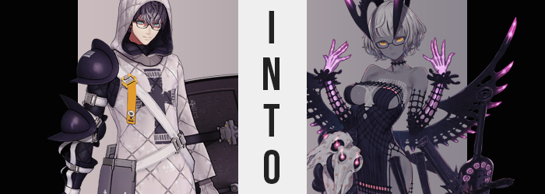

There were few that knew nothing of Jacques de Molay, particularly within the hotbed of historical figures that was the Chaldea Security Organization. He had been summoned during an affair within Camelot and had remained a steadfast Servant and ally of the organization’s Master ever since.

Serious yet shy, he was known by the other Servants and faculty as a polite young man who always appeared to have the best interests of others in mind even if he didn’t always speak up. He was an invaluable ally and a good person, even if some of his legends painted him in a worse light. There were naturally things that he regretted about his life though.

For example: how it had all ended.

But history was not something that could be changed. Not now, not ever. You just had to learn to live with what had transpired for better or for worse. There was no point in letting pain and suffering hang over your head – for who knew what path one might walk if they allowed such things to guide them? Molay had made peace with the betrayal he suffered at the hands of the French aristocracy in life, and because of that he could be the noble Servant that he was today.

At least that was what he had believed until that morning, when he found himself waking in a strange world. No… Was it truly strange? Based on the designs of the walls he was still clearly in Chaldea, but the energy was different. He wasn’t sure how he knew for sure, but Molay could tell that this wasn’t the world he was familiar with.

OF COURSE YOU KNOW. YOU ARE ANOTHER POSSIBILITY, AFTER ALL.

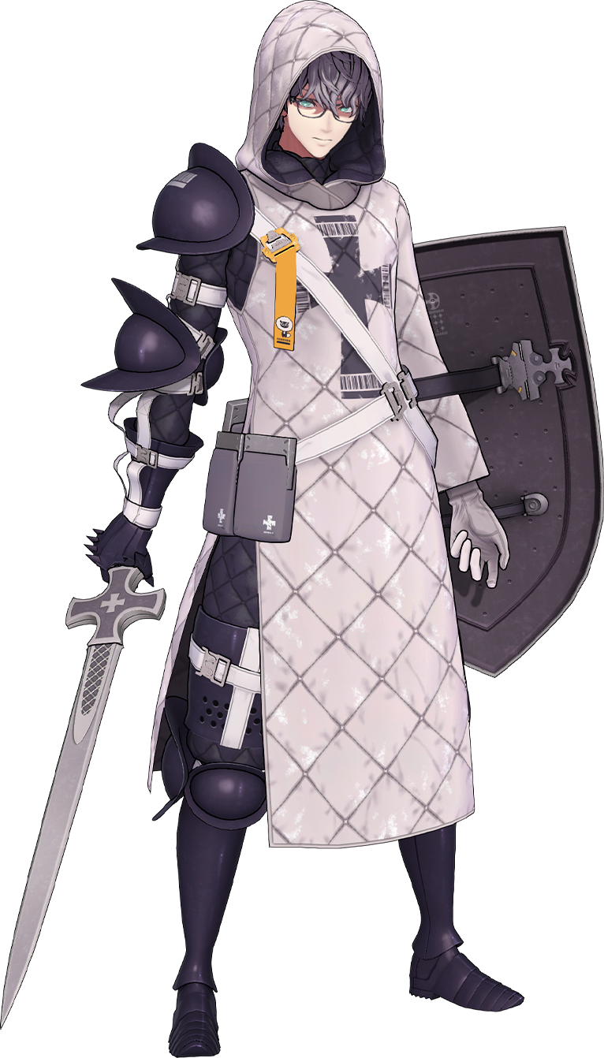
“What? Who’s there?” After casting off his bedsheets and manifesting his usual combat attire, the Saber was surprised to hear a voice. No, was he really hearing it? It was more like whatever it was, it was speaking directly into his mind. The room was dimly lit so he couldn’t even make out his surroundings to tell if anyone else was present, at least until…

A light shone. A pale purple from what looked to be an animal skull upon a black dresser. If this was his room, evidently someone had a much grimmer design sense than he did. Because there were all manners of bones laid out around the skull in the center – the source of light coming from its empty eye sockets. The energy it was exuding was menacing, and yet Molay couldn’t help but wonder if he had felt it somewhere before.

THE ENTITY THAT BROUGHT YOU HERE, OF COURSE. SHALL WE BECOME REAQUAINTED? NOT IN THAT FORM, MIND YOU.

It had taken Molay a moment to realize, but while he could understand what the disembodied voice was saying? It was not speaking in a human tongue. Rather, the words were sloshy and slurred, more akin to monstrous sounds than anything resembling a proper language. “Who are…? No, that aside. What do you mean by ‘in that form?’, exactly?” He’d managed to maintain his cool thus far. Panicking in an unusual situation was enough to guarantee a misstep, which in turn could have very fatal consequences.

There was no answer on the voice’s part; at least, not a verbal one. If it could be considered a response, the light of the skull’s eyes grew even brighter. For a brief moment the man was finally able to make sense of its shape. It looked like the skull of a goat? But that was before he was wholly consumed by its glow, and he found himself standing in a void of pale purple, all alone.

“Uck…” There was something wholly eerie about this place. About its overwhelming emptiness. Could he even call it a void when it possessed color? The very same color that the goat skull was emanating, in fact. There was no small part of Molay that desired to write this all off as some sort of deranged dream, but Servants hardly dreamed in the first place as is. How much alcohol would one Heroic Spirit need to consume to dream, much less have a dream this bizarre?

He hardly knew the half of it at this juncture, however. The aura of this space was strange, and he felt like it was pressing down against his very being. Almost like he was a cookie being baked within an oven, or something to that effect. Being a Saber, he was counting on his Magic Resistance to pull through – and it really would have worked if not for one very key detail. The fact that the energy forming this pressure was not magic in the first place.

“I don’t know what you are, but release me! I have things to attend to elsewhere.” He would have debated summoning his weapon if he had any idea where the culprit was hiding. Was this a Reality Marble? Could it be broken from the inside? The moment he deemed his captor uninterested in conversing with him, he prepared to summon his blade.

Except the sword that was conjured within his hands? It wasn’t the blade of silver steel that he was used to. Pitch black with barbed edged and a purple glow from several circles running down the blade’s flat sides, it certainly wasn’t a weapon you would expect a holy man to wield in any capacity. “What is this!?”

A symbol of our hatred.

The man’s right eye slammed shut and the blade was dropped into the void below. It ultimately disappeared into particles, returned into the man’s inventory – but this indicated that he wasn’t standing on anything. His feet were planted by the will of this realm alone. What had forced him to drop the sword in the first place, getting back on top, was a voice that resonated within his very mind. Its words were painful. Not emotionally. It caused him literal pain to hear.

“Hatred? Toward the king? The pope?” Molay had cast aside his hatred towards them long ago, but what was this burning feeling deep down at the very thought of them? And for what reason had the voice used the wording ‘our hatred’? The truth that he had yet to stumble upon was that his body and soul had both been compromised. A terrifying power had sought him as their personal pawn, and now that they had possession of her mind and flesh, they would reshape him into an existence befitting of their presence.

The influence of this monster had already begun to paint an intriguing picture of what was to come, for the man was ever so suddenly stripped of his outfit, from cloth to steel. It took him but a moment to notice what with how much it had all weighed. “My clothes!? What on earth!?” His glasses had been spared at the very least.

We cannot stay dressed like that, now can we?

There was the voice again, and just like the first time it was accompanied by enough pain to make Molay wince. On this occasion though, something was different about his eyes once they reopened again. They were glowing a menacing gold, their birth color stolen away completely in favor of this phenomenon.

“Of course. How else could I show off my ski— Ngh!?” What was he on the verge of saying? Something far too scandalous for a man of his renown, that much was to be certain! Why would he desire to show off his skin? “Urk!?” Almost as if on some sort of deranged cue, he lurched forward thanks to a highly disturbing feeling that rippled through his body. It was a crunching that preyed upon his bones – vaguely painful, but not as much as he might have anticipated considering what he could see with his own eyes.

After all, the crunching came from the compression of his very figure. It was as if he was been crushed by supergravity, limbs shortening and his torso narrowing not only horizontally, but vertically as well. Every crackling bone forced a wince, and with all of the strain he was incapable of moving in any possible way that he desired, much less utter a word. Even if he could speak, what good would it do? There was no one here to help him.

The collapse wasn’t insignificant, either. In terms of height, five whole inches had been eroded through the compressive phenomenon. He would have looked like a much shorter man if not for the fact that, well, his resemblance to a human of that particular chromosome combination had dwindled just as significantly as his height had.

Molay’s shoulders were much narrower now, and when looking at his shorter arms it was clear that something was being robbed other than bone alone. Their mass dwindled – as it dwindled across his body’s entire form – for his muscles were becoming undone. It didn’t take long for his skin to seem utterly and entirely fair without a single bulge of strength to be seen, and this only added to the overall femininity of his shifting appeal.

“Agh!?” With a louder crunch than the rest, Saber’s waistline collapsed inwards in a manner that ultimate left his hips to appear far more pronounced. And what was with his voice just then? It was pained, yet it sounded much more akin to a feminine moan than anything.

Of course, while his body much more clearly resembled a woman’s, the key aspect of his masculinity had remained. And yet the voice within his head was louder, speaking much more frequently. It wouldn’t be much longer now before, he feared, their wills would overlap altogether.

Yes, that’s right! Give us a body that any man would desire! Make us naughty!

No… No… Why would we want… such a thing…? But…?

Whether Molay truly desired this or not, it became clear that he didn’t really have much of a choice in the matter. His dick soon showed signs of regression, which was honestly a shame since he was so hung. But it didn’t take very much work for his cock and balls to slide up and inside his pelvis with a hiss, all while the walls and lips of a pussy were constructed and her inner organs were rearranged. Unlike everything else, it wasn’t even a painful phenomenon. It had been so pleasurable that the new woman had gasped sensually instead.

“No… I don’t… Do I? Mm…” Try as she might, she couldn’t stop herself from touching her own flesh. First she probed her pussy, fingers getting sticky in the process, but before long she found herself tweaking her nipples. At first it had been hard to do, but it gradually became easier with those nipples inflating unnaturally. A once muscular chest, now vacant, gained new volume in the aftermath thanks to fat pushing skin forward. Before long, Molay could grope the beginnings of a bosom that ultimately swelled to D-cup delights that appeared even bigger with her height in consideration.

Her hands were not actively touching down there, but similar changed could be seen in her lower half. Her thighs swelled until her skin was pulled so taut around them that they shone, with her ass bubbling out behind her so that it was peach-shaped and perky. A single hand wouldn’t be able to cup one of those cheeks in any capacity, that much was certain.

We can only feel this way because of our hatred. Without it, we would not have been found…

“You’re right. That hatred of mine burns… For the King! For the Pope! I hate all of them!” Having finally accepted something she had so wished to keep buried, her facial features ultimately melted away so that it was as feminine as could be – cute, and yet likewise just as sexy. In the meantime her hair grew out ever so slightly, just to the nape of her neck while also seeming much fluffier.

The woman eventually stopped playing with herself and extended slender fingertips outward to stretch. “Hmm~? Now what’s this?” Molay’s serious and shy nature must have been utterly obliterated if she was talking in such a carefree and nonchalant manner now. She was staring at his fingertips as she’d spoken. They were purple? Not only that, but they were translucent. She could see the bones of her hand all of the way up to her elbows where the phenomenon ceased.

When it came to the rest of her body, her skin tone darkened. Not to any natural color mind you, but it still darkened, nonetheless. It was an ashen gray only several shades off from being black, and yet between her breasts and across her chest there was a lighter showing in the shape of her cross. Fallen as she was, a woman should never forget her roots, right?

“Oh… Oh…. GAAAAAAAAH!” The Servant had felt it building. A pressure in need of release both upon the back of her head and the bottom of her back. When that pressure finally found release, however, the mix of pain and pleasure she felt were so overwhelming that she couldn’t even imagine stifling her own scream. From the back of her head two big, black horns erupted – edges jagged with curved, purple points that reached up after curving over her head. While from the back a pair of ‘wings’ with a similar aesthetic protruded. Considering how sharp it all was, there was nothing surprising about the amount of pain that was felt as a result.

The void that she was standing in ultimately collapsed with the completion of her transformation, and she once again found herself standing in her room. Now complete with a showy, black dress that did not even cover her shoulders, much less her inner cleavage and thighs. Everything about her ensemble exuded some degree of corruption and malcontent, and her glowing, golden eyes did not help deter her apparent menace.

But even though she appeared evil, she was wearing the most innocent of smiles – perhaps even unsettling in its own right because it was so innocent. Molay had once been a shy and unexpressive fellow, but she was even humming to herself with glee now as she skipped over to her dresser. The goat skull that had corrupted her was gone, but in its place was a tiny, black goat. Almost as cute as a stuffed animal if not for its overwhelming power.

“Coucou~ I suppose I have you to thank for this, do I?” Jacques didn’t touch the goat, she didn’t dare. But she leaned in as close as she possibly could with a twisted expression upon her face. As much as she had loathed the process, the way her body felt now? They way she looked? She loved it! Under no circumstance should she have, but that was merely the long and short of it now. Feeling sexy and powerful was the best! “A Foreigner~? Weeeell, I suppose its not all bad! But what am I to do with this aching in my loins, hm? Surely a goat wouldn’t suffice!”

The Foreigner understood it all now. This was Chaldea, but from an alternate timeline. The goat had brought her here from her own timeline and had twisted her into the fallen saint that she now was. But, hey! The specifics didn’t really matter anymore! Not from her point of view, at least. Being under the surveillance of that Outer God was a bummer, but look at everything she got out of it!

Molay pulled away and rubbed at one of her tits through the front of her dress. “Riiiight. So if I want to scratch this itch, I need to fuck someone, right? Could I enthrall someone? What about my dear Master?” As her new memories entailed though, the Master of Chaldea in this timeline was a woman.

“Mon dieu! Even better!”

Evidently that wouldn’t be much of a problem.

