A HEXT ON YOU
COMMISSION STORY
BY CHALDEACHANGE
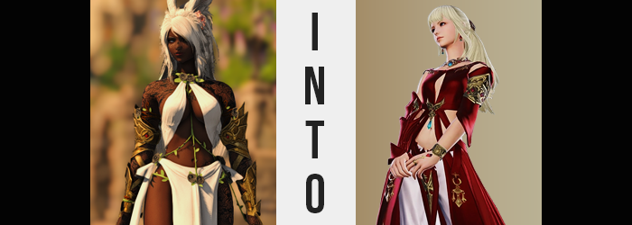

“There far too much to do for one woman…”

Lyse Hext had been the one charged with managing the Ala Mhigan resistance. Even though their oppressors had been dealt with and the Empire was no more, there was still much work that needed to be done across Ala Mhigo. The Resistance was still needed, but not for the same reasons it existed before. There was no enemy to fight, well aside from the odd mission that required clearing out some unruly monsters – and the stray Empire battalion that popped up midst the sands of their homeland once in a while.

But it would take some time for things to return to how they had been before the invasion. It had been decades after all, and many of Ala Mhigo’s people had been born during that time. Lyse was happy that she had been able to liberate the people, and she looked forward to showing those that had been born under the Empire’s rule. Even so, it was hard at times not to collapse under the weight of all her responsibilities.

She was no longer a Scion of the Seventh Dawn, a label under which she had some freedom to speak of. She was no longer masquerading as Yda. As Lyse Hext she could not escape what she had to do. There were things to organize, troops to deploy, things to be cleaned, repairs to be made, settlements to visit… and the list went on, and on, and on. “If only there was some way for me to be in two places. I wish, but haha! As if!” Draped over her desk, she vocalized such a silly desire to herself. Lyse had seen enough to realize that such wishes weren’t easily granted.

But that didn’t mean they couldn’t be granted at all.

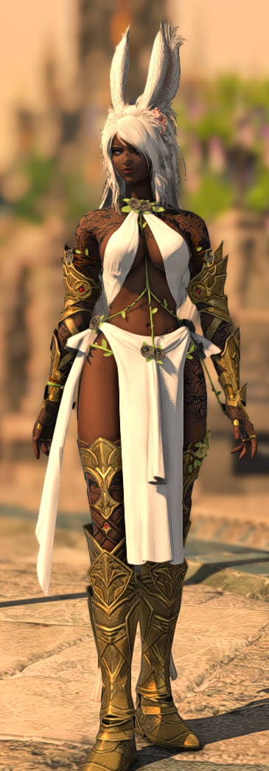
Nearby the tent that Lyse was using, a certain Warrior of Light had been taking care of some tasks of her own. L’luna Winterblume was the polar opposite of Lyse in many ways. While the Resistance leader often looked for ways to shirk off some of her responsibility, Luna was always hard at work without complaint. Being a Dancer of great renown on top of being the Warrior of Light, it meant that she was more often than not absolutely swamped by the expectations that were always thrust onto her shoulders.

Largely hidden away from the hustle and bustle of Rhalgr’s Reach, she had her own personal tent that was up near the base’s peak. It was easier to keep current on the going’s on from that point, even if she was just visiting after deterring the Final Days. The next leg of her journey was most certainly on the horizon, but that didn’t mean that she didn’t have a plethora of other things to take care of before she could allow herself to put that first leg out.

“So if I perform in Ul’Dah next week, and help with the restoration the following one… This schedule is still too tight.” Standing in front of her desk, the dark-skinned, light-haired Viera was shuffling frantically through all of the requests she had recently received. Trying to schedule everything so that she could free up time by the end of the month looked to be nigh impossible. “I almost feel like I could use a break.” Yet she more or less said this sarcastically. She didn’t really care about breaks.

Little did Luna nor Lyse know that as they expressed their own frustrations, a cart carrying new artifacts had passed by their two tents. And receptive to both Lyse’s wish and Luna’s off-handed comment, a chalice within had begun to glow… Not that the Resistance leader had much to worry about in this area.

The Viera, on the other hand?

Well, she hadn’t really made a wish. Her comment just made her an easy target to become the receptor of that wish. Unknowingly, of course. She knew naught of the comment Lyse had made, nor of the enchanted chalice that yearned to grant wishes. Besides, carted away? No one would be seeing it for a while. That didn’t mean that it wouldn’t cause any other issues in the future though.

“Maybe I need to at least lay down for a bit?” This comment had been prompted on L’luna’s part by a wave of dizziness that had struck her as if out of nowhere. It was explained easily enough from her perspective, since it wasn’t the first time overworking had made her fatigued – and it most certainly wouldn’t be the last. But rather than using common sense and retiring to the cot in the back of her tent, she simply stabilized herself with a hand against her desk. Taking a break seemed unthinkable when she just had so much to do.

With her posture done up in that way, though, and with the dizziness that left her a little unstable to begin with, she had created an environment where it was all but impossible for it to immediately click that something had begun to happen to her body. Her height, which as a Viera was already over six feet, had begun to fade. Her point of view dropped closer and closer to the table that she was viewing papers on even now. In the end, she dropped all the way down to 5’6”, which was a very dramatic loss of height.

And, of course, this meant that her scanty Dancer outfit was left looking just a little off with so much of her build gone. The golden armor that framed her arms and legs in particular was no longer a match for the lengths of her limbs, but the pieces just condensed together uncomfortably. On the other hand, the white fabric of her loincloth ultimately fell as far as her ankles, and the matching cloth that covered her breasts appeared looser, albeit still fit well enough to hide what needed to be hidden.

L'luna, eventually, groaned – but not for the reasons she should have. She was finding it incredibly difficult to concentrate for some reason. As much as she flipped through the pages of requests, she just couldn’t piece two and two together. She wasn’t distracted either, so what was it that kept pulling her away from it? “Note to self: don’t push yourself while dizzy!” It was easy enough to just explain it that way, at any rate.

But why had she sounded so uncharacteristically enthusiastic?

That became a trend, in fact. Her frustration was becoming much more subdued and her mood a little more energetic. That could be seen on her face, where a thin smile began to form. But that wasn’t the only thing happening relative to her face, either. For example? Her flatter, Viera nose appeared to swell at its tip, becoming rounder while the shape of the nose in question just became more angular. Additionally, her lips thinned and her cheeks lowered, presenting her with a face that looked far less like that of a Viera… and much more like that of a Hyur.

This wasn’t helped any by her eyes, which grew wider. Her lashes actually became shorter, but as if it were a trade, her irises lit up with a blue. Seemingly not to be undone, at least in any capacity of changing color, the well-kept, white locks of L’luna’s hair soon followed suit – fortunately not turning blue, if that could be seen as a silver lining. But was it really? That was more up to interpretation if anything.

It could be said that the change of hair color wasn’t really all that exciting. It certainly wasn’t dramatic as the change of color in her eyes. Nonetheless, a naturally bleached blonde began to surface where only a snow white had been before. The phenomenon was both quick and effective, the change sweeping through the Viera’s entire mane at once – but that hair also shortened to the center of her back and thinned dramatically so that it wasn’t all that voluminous.

If it wasn’t enough that both her hair and eye colors had changed, though, what became of her skin proved that changes in this area were not complete. It began with the tattoos that covered her arms and right leg. In all three areas, the colors of these markings lightened until they were a creamy pale that stood against her regular, dark skin tone with absolutely zero deniability. Only for the surrounding skin, all of the remaining skin on her body, to lighten shade after shade to match. So at that point? It could be said that she possessed no tattoos whatsoever.

L'luna had seen enough of her paperwork! “Why am I wasting my time with all this? These aren’t the jobs I’m supposed to be working on!” And with a voice that was lighter and bubblier than ever before, she announced something that didn’t make much sense. Those were the jobs that L’luna was supposed to be doing. The issue must have then been in how she saw herself. She was no longer identifying as L’luna, but as the person she was becoming.

And that person did not have bunny ears, sad as it was to say. The white fur on her ears hadn’t turned blonde along with the rest of her hair because they weren’t going to be a permanent feature on her figure, and that was driven home the moment they began to shrink. Shorter and shorter they became, eventually drawing down to little nubs that stuck out of her head until, finally, they disappeared entirely. But L’luna did not lose her ability to hear for even a second, as a pair of rounded Hyur ears had emerged on the sides of her head beneath her new hair. And the lobes had piercing holes pre-installed.

Now, for the most part, she was already the spitting image of one miss Lyse Hext. And L’luna herself was not so dumb that she headn’t realized. “Wait, did I become Lyse? That’s strange!” Her words practically oozed with energy, and she didn’t seem to be all that bothered by it. That said, her transformation hadn’t quite finished yet, either. Her body had retained its muscles, but her figure had been compromised a little bit. Hyurs didn’t typically have the same exceptional figures that Viera women did, and so not only did her hips narrow, but her thighs and ass became a little leaner to boot. If anything it highlighted just how muscular she was.

But her chest? That was another story altogether. Already larger than the chest of the real Lyse Hext, rather than shrinking to meet that expectation, they soon surged with additional weight. These breasts quickly filled the cups of her top, peaking at F-cups that appeared far bouncier than her otherwise lean body suggested. And why had they grown? Because the chalice has used Lyse’s wants to make her duplicate.

That said, they came with a cost. It wasn’t one that L’luna herself even noticed, for the memories of her old life had begun to dwindle. But something else faded as well. Intellect. That wasn’t to say that she didn’t know anything that the real Lyse didn’t need to know, but it left her much more airheaded and scatterbrained. ‘Bouncier’, one could say. Much like her big tits.

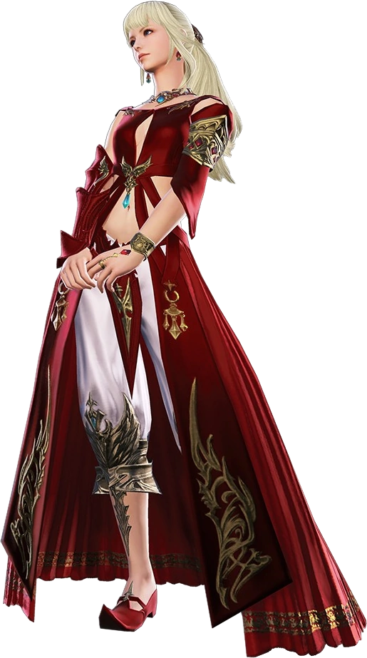
All that really remained was her attire, which didn’t fit all that well now that she was both shorter and bustier. The woman didn’t need to fret about it for long, however, for the white material she was already adorned with crawled and stretched, while the golden armor compressed and mended into new accessories. In the end her outfit was a perfect match for that of Lyse’s when it came to design, puffy pants and all. The color, on the other hand, left something to be desired in terms of authenticity.

“Hm! I suppose I should get to work, shouldn’t I!?” There was no shortage of enthusiasm radiating from the newly created Lyse Hext copy. Well, you could most certainly say she was a copy, and she was, but there was no denying that she wasn’t exactly the same either. While her dress matched that of the real Lyse’s, it kept the white of the outfit she had worn as a Viera as opposed to the bright crimson that was supposed to be readily apparent.

Of course, the different color of her outfit wasn’t as striking of a difference as the outlandishly different change to her figure. Perhaps it was for the best so that they could easily be differentiated between, but this new Lyse? Her breasts were much heftier than the original. Lyse had a healthy, average bust size. But her copy? Her tits were more than double the size they should have been, with the cut of her dress between them appearing even deeper as a result. But in her mind they had always been that big, and even with her toned physique they didn’t really get in the way while fighting.

“But I really want to get something to eat first. Food’s important too, right!?” On the other hand, not all of the differences were physical. She was just a tad less competent mentally than the original as well. Or, more plainly, she was just a little bit dumber – and in turn that made her a little more carefree. Sure there was a lot for her to do, but how could so bother with that on an empty stomach? It was thoughts like this that didn’t align with how the real Lyse acted.

And so, puffing out her chest, she made a beeline down towards the cafeteria housed within Rhalgr’s Reach. Or she had very much intended on going there, but a familiar voice had stopped her. “Hey, you! Who are you? Why do you look like m— Whoa, what’s with your chest!?” It was the real Lyse, dressed in red, glaring over at her duplicate. Well, now she was checking out her huge cans, but the sentiment was still there.

“What do you mean?” The fake tilted her head to the side, though her eyes wandered to the real Lyse’s smaller chest. “Oh, I get it! Are you jealous! It’s okay, if you drink enough milk…” Somehow the copy knew that she was a copy, and that this truth was acceptable. She also realized that she had been created according to Lyse’s idealized vision. So her big breasts were because Lyse had always wanted to be bustier.

Her dumb, insensitive comment, on the other hand, forced Lyse to blush brightly. “That’s not what I… Wait, did my wish… Did my wish actually get granted?” Could this really be true? Did she have a helper to get through all of her work? She observed the fake nodding in response, and her scowl turned up into a smirk. “Okay, got it! Then it’s okay!” Was it, though? She really had no idea where this copy had come from.

“You were going to get food, right? Let’s go! We have plenty of free time now!”

As for what to do when someone asked why there were two of them, that was something Lyse would have to think up later.

