Working His Body(Suit)
By Soul-Controller

When Martin had first applied for a job at his local S-C Fitness, he figured the concept of actually working at the gym was a total long shot. Given his incredibly average and plain appearance, he certainly didn’t seem to fit the intended clientele. Any time he walked or drove past the facility, he was always witnessing the most attractive and muscular men and women he had ever seen entering and exiting. Clearly, this was a prestigious type of gym that seemed to only draw in the most committed clientele possible, which instantly dissuaded Martin from even attempting to enter. He knew he would instantly be viewed as an outsider, which caused his delusional thinking to instantly begin envisioning himself being forcefully ejected from the facility by two burly security guards.

Although most of the appeal surely must have been due to how the company had suddenly burst onto the fitness scene by partnering with the biggest bodybuilding competitions and athletic events all across the world, hardcore gym devotees were drawn to just how state of the art each facility was. Given how expensive the monthly membership fee was, it was also another reason why normal people like Martin couldn’t afford the opportunity to enter the alluring facility.

Given its exclusivity along with how highly-lauded the place was, the aspiring fitness fanatic was willing to do anything it took to get a glimpse inside the gym. To his amusement, an opportunity soon presented itself to him in the form of a job opening. The listing was in search of a receptionist, which perfectly meshed with the man’s previous job experience. Although he had originally intended to simply apply in hopes of landing an interview and getting the opportunity to just see what was inside the building, a quick look through the benefits of the position left him actually becoming invested in the position. Not only was the base salary for the receptionist job much higher than his current office salary, but working at S-C Fitness also provided free membership to the gym. With such a perfect opportunity to not only make a higher salary and get serious about his desire to get fit, Martin wasted no time filling out the application and submitting it.

When Martin received a call a few days later from S-C Fitness, he was quite nervous to answer and immediately began to expect a flat-out rejection. To his surprise though, the man on the other line (who introduced himself as Tony) revealed that no interview was necessary - they instantly wanted to offer him the job outright. Such a reveal was a shock to Martin as he had forced his hyperactive mind to keep low expectations, so after a moment to compose himself he made up his mind and told Tony that he accepted the position. Upon doing so, the call concluded with the manager revealing that Martin was expected to show up for work the next morning and that he looked forward to meeting him.

After hanging up the phone, Martin remained slack-jawed for several minutes as his mind attempted to comprehend what had occurred to him. The whole experience had occurred so fast and now he was expected to work the very next morning! So despite how hectic his mind was as feelings of both anxiety and anticipation dueled, the young man forced himself into an early rest as he dreamt about his first day of work.

* * *
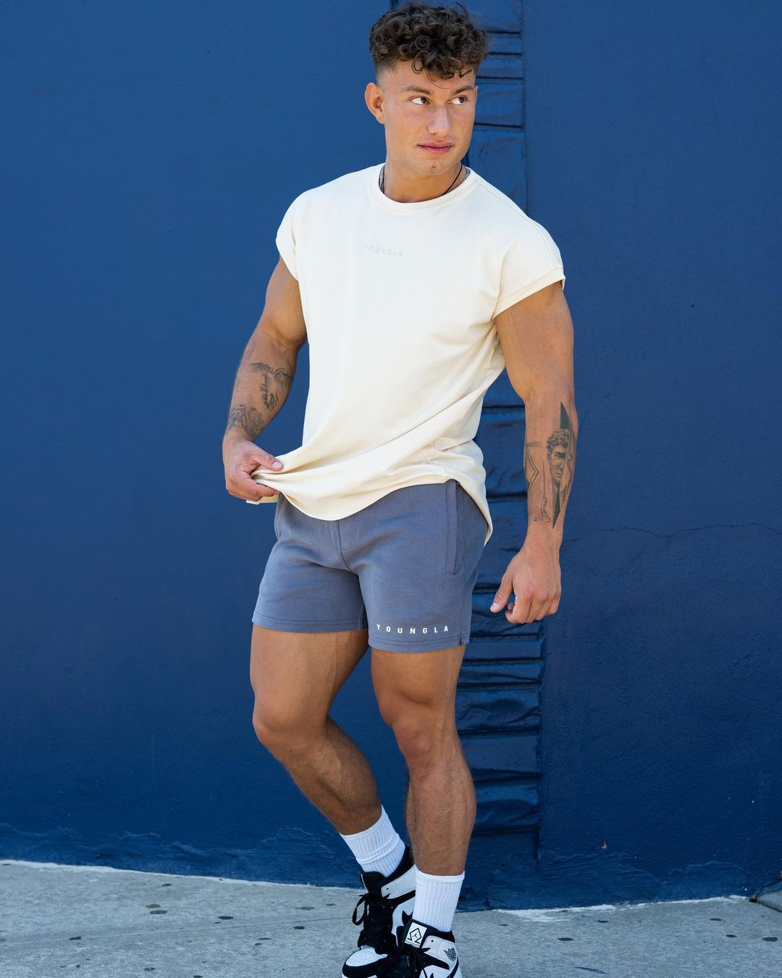
As Martin finally made his way into S-C Fitness, the man’s eyes couldn’t help but dart to the sides. While doing so, he breathed a sigh of relief as he realized that there were no humongous security guards on the verge of pouncing on him. Quickly realizing that his delusional thinking was just that, he shook his head and chuckled as he finally made his way up to the receptionist desk.

Upon reaching his destination though, Martin was instantly in awe by the hunky man standing behind the counter. Not only was he incredibly attractive with his curled hair and handsome visage, but he had a clearly well-defined physique that was only enhanced by the appearance of tattoos. As Martin’s eyes diverted away from the mystery man’s highly kissable face to avoid the reddening of his cheeks, they soon came across a name tag that revealed that the hunky man was Tony.

“Welcome to S-C Fitness,” Tony began, flashing a pearly white smile towards the meek Martin. “I haven’t seen you around here before. I’m Tony, the manager here. Are you looking to get set up with a membership?”

Despite knowing that his position at the company included a membership, the concept of being a member amongst some of the biggest men he had ever seen instinctively caused Martin to chuckle. Although he was amused by the visual in his head, it quickly dissipated when he looked up at Tony and saw that his smile had faltered and shifted to an expression of confusion.

“Oh uh, sorry about that. I was daydreaming about something,” Martin responded, returning a slight smile to try and relieve the hunky manager of his uncertainty. “My name is Martin, I’m pretty sure I talked to you on the phone last night actually. I got hired to be the new reception-”
“Of course, welcome on in Martin,” Tony exclaimed, cutting the new employee off before suddenly extending a hand out in hopes of a handshake. The 24 year old quickly reciprocated and found his hand caught into a tight grip as Tony’s innate strength vigorously shook Martin’s frail limb.

Luckily, the discomfort was only momentary as Tony let go of his hand and returned both hands to the edge of the counter. “We actually just posted the job listing yesterday so it was rad that we got an applicant so fast. Things can get pretty hectic here so I need all the help I can get!”

Before Martin could formulate a response and explain how excited he was to work here, Tony bent down underneath the counter and grabbed onto something. To Martin’s shock, he watched as his new manager pulled out a huge cardboard box that had to be at least 2 foot long on each side. Further disbelief flashed through the new employee’s mind as Tony handed it across the counter to Martin and revealed that the box contained his work uniform.

“Alright, grab your box and follow me. I’ll take you somewhere private so you can get changed,” Tony declared, his tone incredibly cheerful as he made his way out from behind the counter and began to move deeper into the gym.

Despite being confused as to why his work uniform was not only surprisingly heavy but packaged in such a huge box, Martin obeyed his new boss’ orders and followed him. While the gym novice continued to stare wide-eyed at the impressive physiques he witnessed on the gym floor (and in front of him as he couldn’t help but get distracted by the sight of his boss’ plump rear end and firm calves), Tony led the man into the back corner of the facility. After another minute of walking, the duo soon found themselves in front of a locker door that was marked as the staff locker room. Upon fishing out a hefty keychain from the pockets of his gym shorts, the hunky manager quickly found the correct key and unlocked the door for Martin.

“Go on in there and change,” he began, flashing a wide smile as he pushed open the door and allowed Martin to enter. “I’ll come back to check on you in a few minutes, I need to head back to the front desk,” Tony continued, ultimately giving a slight nod to Martin before shutting the door behind him and heading back to the front of the facility.

With his mind buzzing with anticipation about beginning his new job and his weak body desperate for relief from the strain that his arms were feeling, the new employee wasted no time setting the hefty box down on a nearby bench and peeling off the packaging tape that was running along the top. Like a child unwrapping a present, Martin was absolutely giddy as he pulled each flap back one by one to figure out what his official S-C Fitness uniform would be.

But as he looked into the box as the last flap was pulled back, intense fear suddenly coursed through his veins as he took a look at a horrific sight. Rather than a piece of clothing staring back at him, Martin’s eyes were staring directly into a deflated and eyeless face. Upon screaming in fear, the man fell back into a row of lockers with a loud crash before turning around and making a break for the locker room door.

After clutching onto the handle and attempting to turn the knob though, Martin cried out in shock as he found that he was locked in. Looking down at the knob revealed no ability to unlock the door, which left him panicked to realize that he had been locked in from the outside. Whether or not that was intentional on Tony’s part remained to be seen, but Martin’s mind instantly began to assume that the seemingly kind manager was doing some sort of hazing ritual on the new employee.

Desperate to escape from the alarming sight he witnessed, Martin began to loudly scream and beg for someone to come and let him out. He tried this a few times, but each time he tried no help came. To his annoyance, he could hear the loud grunts of gym-goers and the shrill sound of metal weights crashing down onto the floor and quickly realized that his voice was easily being drowned out.

With an escape of his own now seemingly impossible, Martin resigned himself to the fact that he was trapped in the locker room until Tony decided to come back. As a result, the man willed up the courage to make his way over to the bench that had the box on it. Although he originally planned on just avoiding the box entirely and taking a seat next to it, the man’s innate curiosity caused his eyes to glance over and stare at the realistic-looking mask. Despite how unnerving the black husks that were where the mask’s eyes were supposed to be, Martin was intrigued to see just how realistic the mask’s features were. There was a rubber-like shimmer to the skin that made it clear that the mask was fake, but this was counteracted by just how realistic the five o’clock shadow across the cheeks and chin was along with the slicked up hairstyle across the scalp.

Given how uncanny it looked, Martin grabbed onto the mask and attempted to put it off to the side to see the real contents of the box. But upon using the mask’s ears as handles to pull it up, the bewildered man watched as the head was connected to a pair of thick tattoo-covered shoulders. As he continued to lift the head up, more artificial flesh was unveiled as a pair of huge and burly arms and a wide torso made itself known. Like a magician doing a handkerchief trick, more and more of an artificial body continued to unfurl out until a full-length and deflated body found itself resting along the the top of the locker room bench.

In awe, Martin observed the husk of a body that was lifelessly resting on the bench. Despite how firm the artificial muscles of the full body appeared to be, there was still a clear huskness to each tattooed limb as they droopily hung off the side of the bench and the hands were horrifically bent against the concrete floor. Although the sight before him was understandably unbelievable to him (especially as he looked down to the body’s crotch and noticed the impressive manhood flaccidly resting along the body’s burly inner thigh), the sight of the eyeless visage remained unnerving to the young man and he opted to turn the suit over to find some relief.

Anticipating the opportunity to observe the artificial musculature that would appear along the body’s back and ass, Martin was instead stunned by the loose slit that ran down the entirety of the body’s spine. It was unnerving for the man to see, especially as the slit was wide enough to allow him to see inside the husk and notice the suit’s realistically fleshy pink hue. Although he hadn’t been the brightest kid in school, there were enough context clues for Martin to quickly put the pieces together. Taking into account the fact that the box containing the lifeless husk was said to contain his work uniform along with how the body had a large slit down its spine, Martin gasped as a lightbulb went off in his head.

“Holy shit, this is my work uniform…”

With the realization hitting him that the lifeless and deflated muscular husk that was slumped over a locker room bench was meant to be his work uniform, gym novice Martin was understandably shocked. Although he was well aware of the fact that S-C Fitness was lauded as one of the most cutting edge fitness franchises in the world, the concept of artificial skinsuits seemed like a pipe dream to the young man. But as he gingerly extended out a hand and felt along the rugged stubble-covered visage of the immensely-sized suit, it was clear as day that not only did the experimental tech exist, but his manager Tony expected him to put it on with no questions asked.

Yet while such an outlandish concept would take a while for someone’s mind to wrap around, Martin found himself wholeheartedly accepting it as a boner quickly began to form and rage against his underwear and shorts. Despite the initial shock of the lifeless husk and soulless eyes, it was clear that the suit that had been given to Martin was one that would turn him into an absolute hunk. With a bodybuilder-sized physique (which was only further aided in how attractive it appeared due to the intense tattoo sleeves that ran along its bulky arms) and an incredibly handsome and masculine face, the suit would give Martin the perfect opportunity to become someone the polar opposite of himself. Upon wearing this suit, he could become exactly who he desired to be when he dreamt of visiting S-C Fitness - an undeniable muscle beast who was the pinnacle of fitness and physical health. So while he didn’t necessarily loathe how he looked or his life, the concept of becoming someone so wildly different was alluring enough to cause a consistent stream of pre-cum to begin oozing into his underwear.

As a result, the man felt no shame but rather unbridled excitement as he haphazardly pulled off his clothes and revealed his average, slightly pudgy physique. At first Martin initially kept his underwear on due to just viewing the bodysuit as a garment to wear, but upon realizing once more what the suit would actually do, he scrapped the plan and quickly tossed aside his underwear until he was completely nude. Upon gripping onto the burly and broad shoulders of the suit and lifting it up so the flattened feet limply touched the concrete floor, the new employee was shocked to realize just how light the suit was despite how huge and realistic it looked. This was also a giant relief to Martin though as it meant he wouldn’t have to struggle putting his practically non-existent muscles to use struggling to simply hold up the suit.

With his excitement exponentially ramping up as he turned the suit backwards and stared at the large slit that ran along the length of the suit’s spine, Martin’s boner found itself prodding some unintended places as his firm five-inches found itself rubbing along the gloriously sculpted and plump muscular ass cheeks. Rather than feeling embarrassed upon realizing what had occurred, it only caused the gay man to grow more excited as he envisioned a similar sight of his new bodybuilder-self bending over another gym jock and having his way with the jock’s perky ass. Eager to make this concept a reality, Martin moved his hands away from the suit’s shoulders to instead rest along the suit’s waist. Unsure of the right process of how to put the suit on, he opted to start with the legs first as if they were a pair of pants before moving up and applying the top half as if it was a t-shirt.

With the burly shoulders falling forward as a result and causing the artificial arms to limply lay in a heap on the floor, the back slit grew larger and allowed Martin to finally begin the process of putting the suit on. Upon lifting his right leg up as far as it could go and pointing his foot, the employee plunged the limb deep into the suit as he aimed for the appropriate leg slot. As soon as his foot made contact with the inside of the bodysuit though, a palpable electric sensation coursed through his body as it seemed like both himself and the suit were excited about this potential pairing. This tingling only grew in intensity as the soft and gelatinous-like interior was filled down to the calf with the solidness of Martin’s leg. Upon feeling his toes make contact with the concrete floor, the man suddenly tilted his foot back to a 90-degree angle and allowed his foot and toes to fill the appropriate slots until the entirety of the suit’s right leg was now solid and functional.

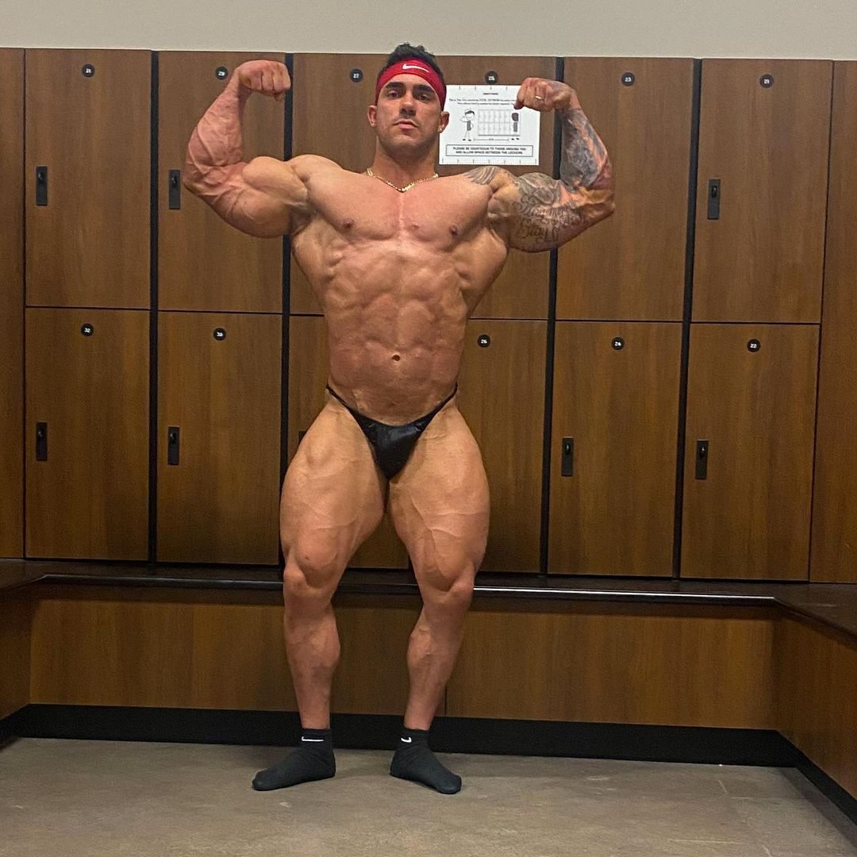
Although the realization that he was now in possession of a bodybuilder’s leg was quite the exciting one and thus made him want to take a moment to flex his insanely large thighs, the man refused to stop and marvel at it. As a result, Martin wasted no time allowing his left leg to replicate the process so he had two completely functional bodybuilder-sized limbs. But upon finishing that process, there was an additional step that would solidify his lower half’s transformation into that of a bodybuilder. The suit at this point was only functional up to 3/4ths of the bodybuilder’s upper thighs, due in part to the fact that he had neglected to pull the suit farther up to allow his average ass and modest cock to fill the deflated pouches intended for them. Eager to remedy this, Martin pulled the front of the elastic-like bodysuit out away from him and then up to allow his testicles, rock-hard cock, and ass to fill their corresponding points in the suit. For a moment, there was sudden loss of sensation as the man could no longer feel his boner, but this was quickly remedied as he felt something peculiar and thus looked down to his crotch. Instead of his normal-sized testicles and 5” cock, Martin’s eyes widened in disbelief as he saw a tube of meat that had to be at least 7 inches and much girthier (which perfectly matched with his new low-hanging and large balls).

Moving his hands behind him, the employee couldn’t resist gasping in amusement as he felt the sizable and incredibly firm asscheeks that now violently jutted forth from his tailbone. Never in his life had he possessed or felt a derriere that was that immense and sculpted. From what he saw and felt from his lower half, he truly felt like a Greek god!

Having never felt this confident before, the bodysuit was like a drug to him, encouraging him to finish the job and complete his transformation into that of an undeniable stud. Never encountering a vice as strong as this, Martin was a slave to his innate desires, an immense smirk emerging onto his face as he gripped onto the back of the suit and began to tug upwards. During this movement of the suit, the cool gelatinous interior was a great way to encounter the sweat rolling down his back as he was becoming incredibly turned on and heated by how erotic the entire experience was. Upon meeting a bit of resistance against the skintight suit in the form of Martin’s slightly pudgy gut, the elastic-like quality of the suit was further showcased as the man tugged the artificial skin out and up to allow his gut to be compressed and fully replaced by a sculpted stomach that resembled a turtle-shell.

At this point, everything from below Martin’s chest was now replaced with the physique of a professional bodybuilder. With only his chest, arms, and head left to undergo their transformations, pre-cum continued dripping from his increased manhood to form a slight puddle on the floor. The entire experience was so insanely hot to Martin, but rather than getting distracted by his carnal desires and jerking himself off, the man remained headstrong with his desire to become the total package before allowing himself to have some fun.

So as if he was pulling on a long-sleeved t-shirt, Martin shimmed side-to-side to form an opening to allow his arms to slip into the incredibly large slots of the bodysuit. As soon as he could find himself wiggling his new and thicker fingers, the man was desperate to finish the transformation in one quick swoop. As a result, he lifted his muscular arms up and reached behind his neck (which provided quite a hassle given how incredibly bulky they were) and tugged up on the highest point of the suit’s slit. To finish the motif of putting on a shirt, the man then scrunched his neck until it met his shoulders, tilted his head down, and then pulled the remaining loose elements of the suit up and over to consume the entirety of his body.
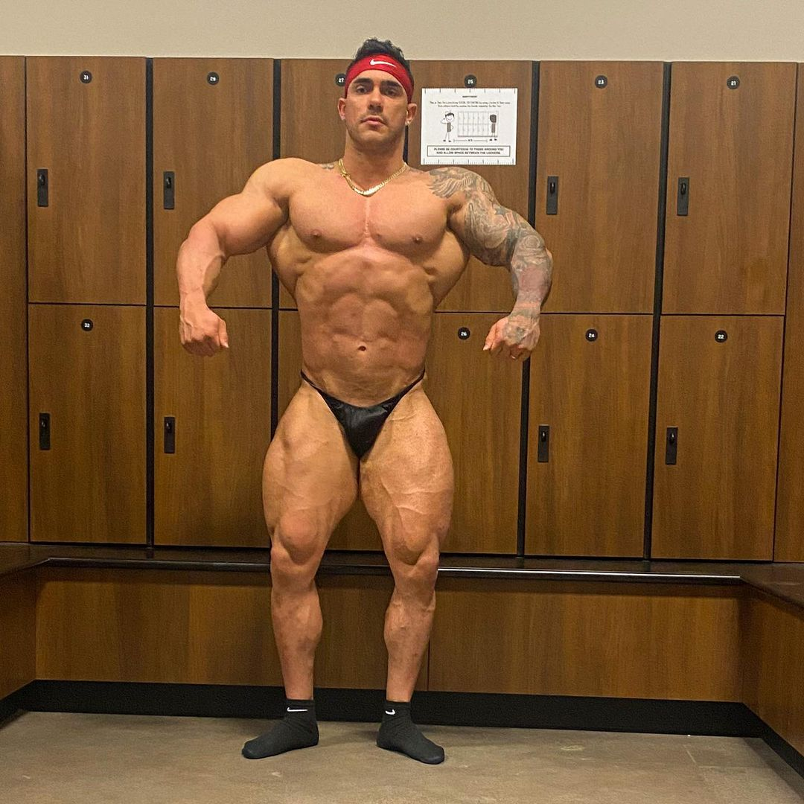
Although the way he was suddenly engulfed by complete darkness was worrisome, the cool relief of the inside layer of the suit was calming enough to prevent Martin from properly freaking out. To both his shock and amusement, he could feel the dull sensation of tugging and pinching occurring to what would soon become his new skin. Given the fact that he had no knowledge of the suit he had pulled on, he had no way of knowing that the jelly-coating of the suit was actively readjusting the suit to make sure it perfectly fit the new host to prevent any wrinkles or other issues from occurring.

The only indication that the suit was finally finishing acclimating to Martin’s body was the way his vision was beginning to reappear as if he was coming out of a pitch black tunnel. The small beam of light that he saw grew increasingly larger and more focused, until his vision was completely restored and he saw that he was still standing right in the middle of the staff’s locker room.

“Well goddamn, that wa–,” he began to say, suddenly stopping as he heard the deep and gravelly voice that was now coming out of his mouth. “Holy shit,” Martin exclaimed, giddily smirking as he reached up to his throat and felt the large Adam’s apple that was now jutting out. Hearing this new voice was an immediate turn-on, especially given how different it was from his average and much-lighter voice.

Upon pulling his hands away from his throat, the man couldn’t help but notice how weathered and well-used his palms seemed to be. Not only did they appear incredibly manly, but the multiple calluses that dotted his palms revealed that his new bodybuilder form looked as authentic as possible. Given how much he loathed intense physical labor (as evident by his countless jobs in an air-conditioned office), it was such a drastic change from Martin’s normal life that it just further pushed his mind towards kinky thoughts.
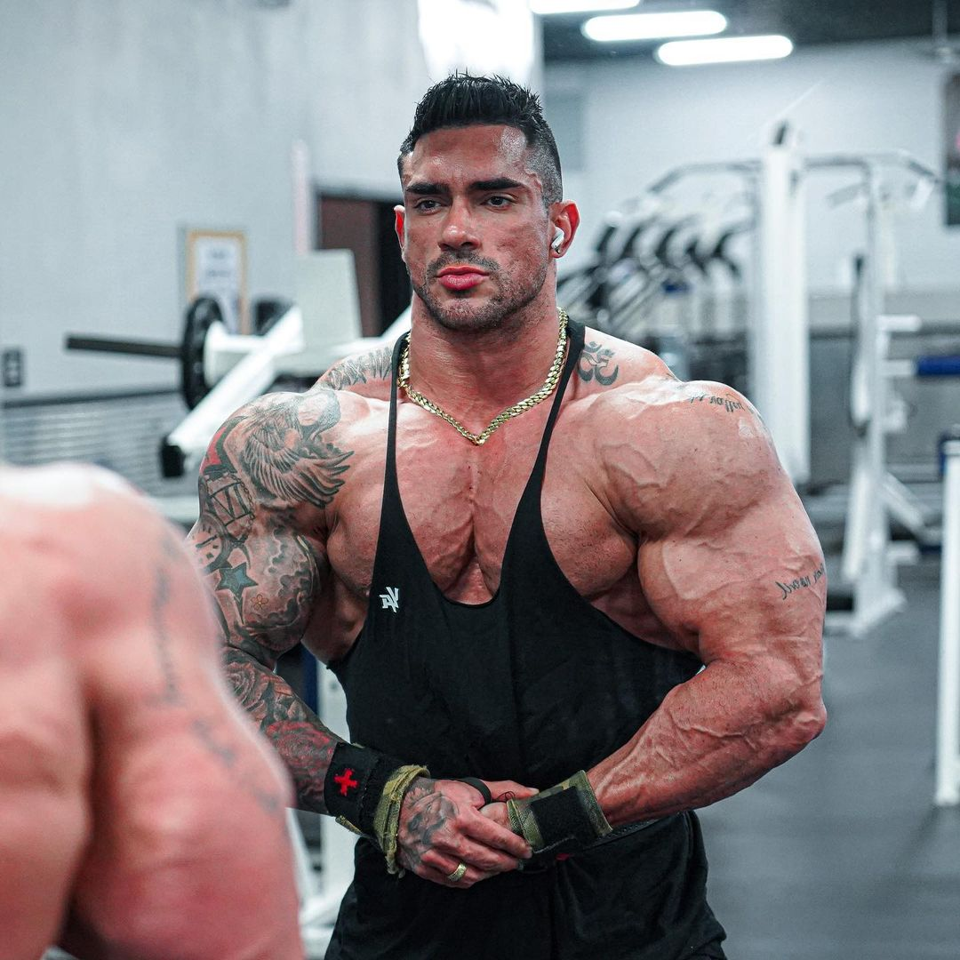
Now with his transformation complete, the man wasted no time putting those rugged hands to use by exploring his new body. His fingers grazed along his new visage to feel how handsome and rugged his visage now was. There was an intense tingle that permeated throughout his body as he felt the densely-stubbled cheeks that he now possessed along with the well-defined cheekbones beneath the surface. Although he wasn’t in front of a mirror, he already knew that he was a goddamn stud!

Upon reaching his chin, the man’s hands wasted no time continuing to traverse downwards. Rather than admiring his chest that he looked down and saw proudly jutting out from him, he opted to explore his new arms first. After feeling his intense boulder shoulders, the man used his wider palms to grip onto the tattooed flesh that composed his new biceps. “I can’t believe this is actually happening,” he grunted, baring his teeth while he lifted an arm up and turned his head in its direction. As he continued to feel the intense muscle and watch as the muscle constricted and turned into a hardened mass, a series of unintended gasps and moans escaped from his throat as he savored how great it felt to be this large and muscular.

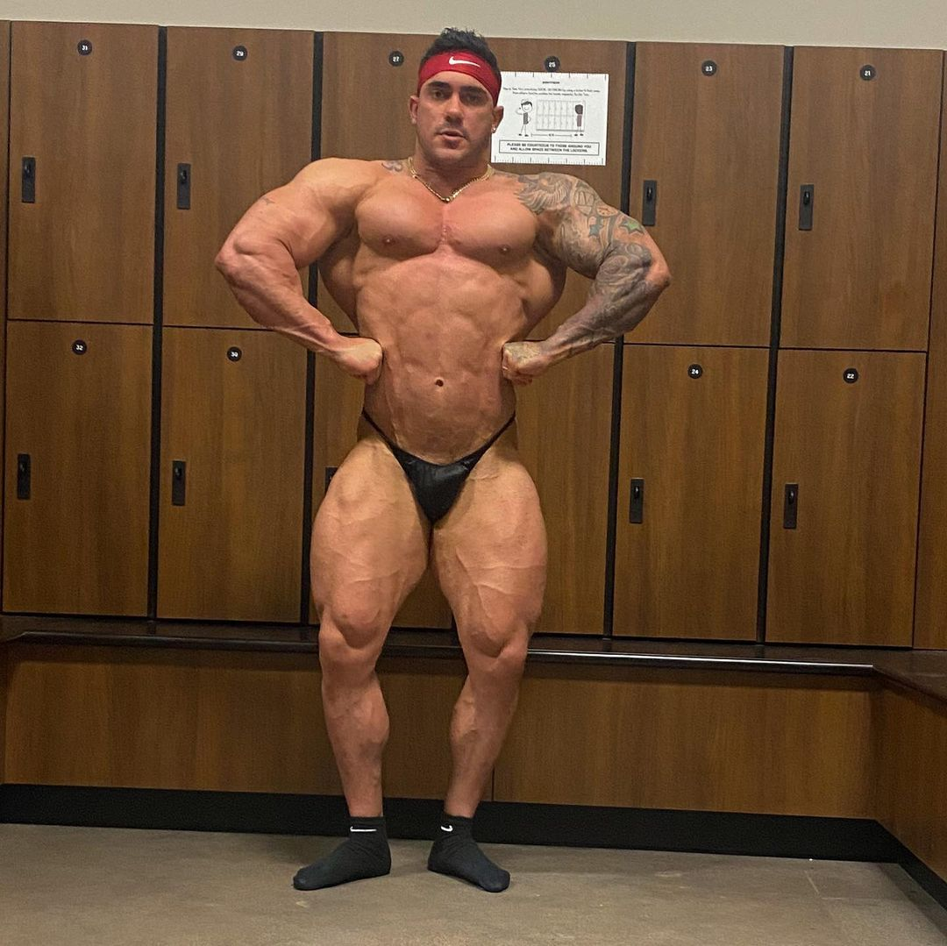
This process continued as he felt up his plump pecs and ran along the hardened grooves of his abdominal muscles. But upon reaching his waist, the man’s insatiable desire to get off was impossible to ignore as he looked down and observed his manhood. No matter how indecent he knew it was, Martin knew that he just had to get off. This experience was so erotic and he was in desperate need of a release!
Upon lifting his arm up to his lips and depositing a glob of saliva onto his palm, Martin quickly pulled the limb back down to his cock and began to jerk himself off. While tilting his head back, the man couldn’t help but grunt and smirk as he felt himself building up to an immense explosion.

As he was so enraptured by his intense lust, Martin was completely unaware of the fact that the door of the locker room had been unlocked. On top of that, he was clueless about how Tony had finally come back to check on his new employee. Tony however immediately became aware of the loud sounds of wet sloshing and extreme grunting and thus traveled towards the source of the disturbance. Just as Martin’s iron-tight grip on his cock was pushing him towards a climax, the man suddenly pulled his head back and turned in confusion as he heard the sound of someone clearing their throat. Upon doing so, the new employee let out a shriek of shock as he found himself staring face-to-face with his handsome manager. To make matters worse, it seemed like he was going to be unable to stop himself from finishing what he had started as his cock begged for release…
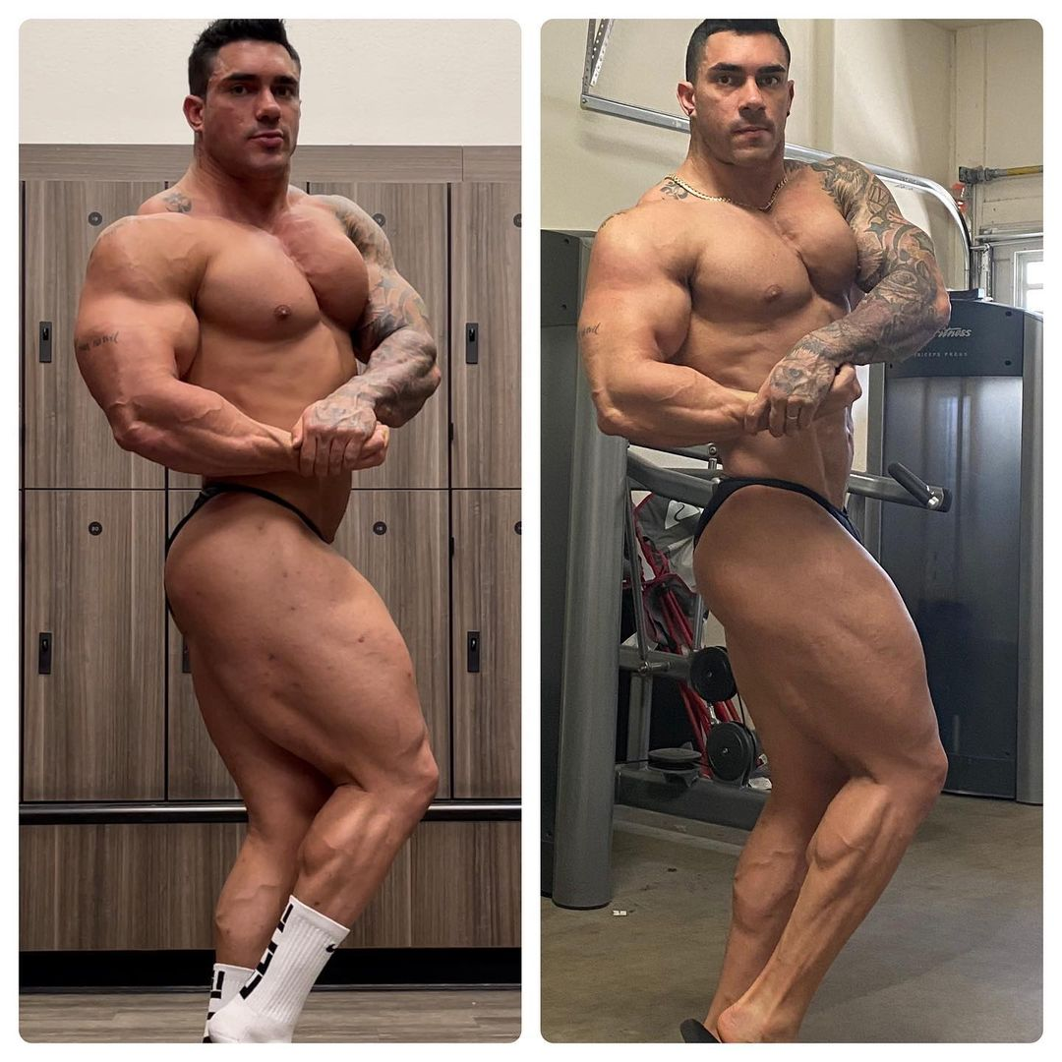
Upon realizing that he had been caught in the midst of jerking off by his new boss, Martin gasped in shock and tried to explain himself. This was the worst possible scenario, especially as the new bodybuilder’s mind couldn’t help but consider the concept of being immediately fired and being forced to take the bodysuit off and go back to his incredibly average form. “I- uh, Tony, this uh, this isn’t what it looks like I swear,” he exclaimed, stuttering over his words as he tried to pull his hand away from his cock but found that he couldn’t stop himself from continuing to slowly stroke up and down its increased length.

For a moment, the man was increasingly panicked as Tony stared at him expressionless. But after a moment, Martin felt a sigh of relief begin to form as he watched the young curly-haired man’s lips begin to curl into a slight smirk. Making his way closer to the nude bodybuilder, the manager looked Martin up and down a few times before stopping and resting against one row of lockers.

After a few moments of prolonged silence, the confusing tension was finally broken as Tony began to speak. “No, I think this is exactly what it looks like,” he began, a light chuckle escaping from his lips as he continued to look at the terrified bodybuilder. “Go on and finish what you started…”

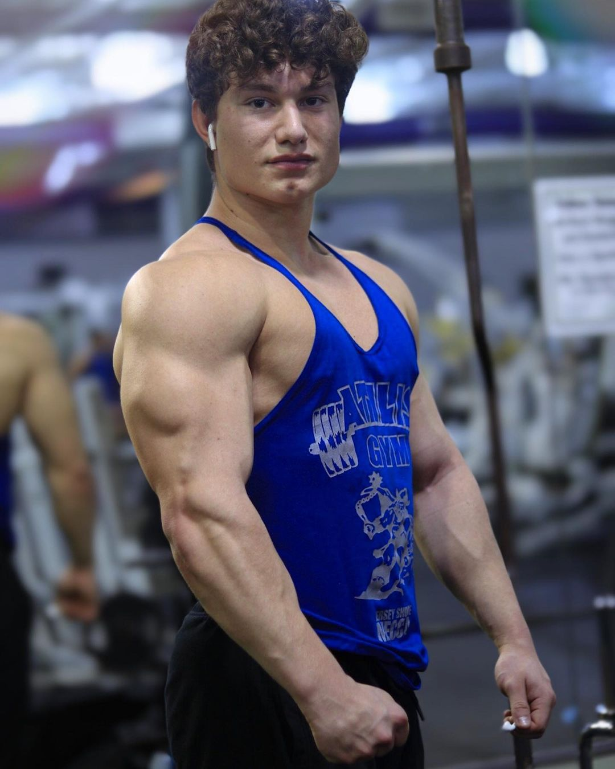
Despite how clear his smirk was, the bark-like tone in which Tony delivered the words told Martin that it wasn’t so much a simple suggestion but actually an order. Instantly, this realization caused his mind to become overcome with lust as he restarted his passionate and frantic stroking. Although he hadn’t intended for his eyes to maintain their longing stare on the attractive manager, Martin was unable to pull away as he finally reached climax and began bucking his hips as a shower of cum began to shoot out of him and hit everything in front of him from his normal street clothes to the lockers on the other side of the hallway.

Given how extreme his climax was, Martin was understandably exhausted for a moment and thus leaned back against a row of lockers and attempted to catch his breath. While he was doing so though, he watched as Tony disappeared for a moment and returned with a wad of toilet paper in hand. Although he tried to tell his boss that he would clean up his own mess, the manager seemed determined in his plan and thus refused to stop as he quickly wiped everything down and sterilized it before making his way up to Martin.

Given how heavy his breathing now was, Martin’s sight was a bit hindered as he watched Tony lean down and be completely hidden by his new plump pecs. Upon watching as the man returned to an upright position in front of him, Martin looked to see two interesting sights. Not only was his right hand holding wet toilet paper that was clearly used to clean up the puddle of cum that had spawned on the floor, but his left hand revealed that two of his fingers had been coated in the new bodybuilder’s seed. To the man’s shock, he watched as Tony gave a light smile before opening his mouth and using his tongue to lick off the remnants.

Instantly, Martin found his cock beginning to harden once more as he immediately took the action as a clear as day sign that Tony was attracted to Martin’s new form. Despite realizing the countless possibilities that this could create given how Martin himself had also been instantly attracted to Tony, he forced himself to try and maintain his composure given how jumping his manager’s bones on the first day posed a risk of losing out on this incredible new body.

To his annoyance though, this attempt was challenged as Tony ordered the new employee to sit down on the bench. Opting to obey orders first and ask questions second, Martin took his seat on the freshly-cleaned bench in the middle of the aisle and watched as Tony walked behind him. “Is uh, is something wrong,” Martin asked a minute or so later, his question spurred by the poking and prodding that Tony’s fingers were making against his immensely broad back.

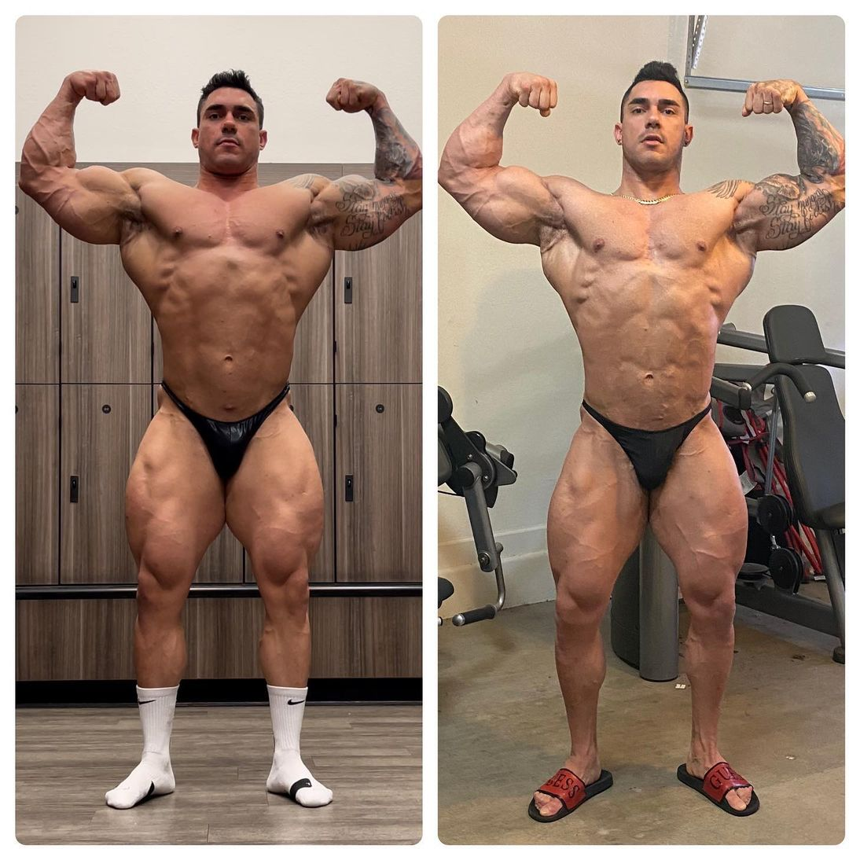
“Nah, I’m just making sure that the suit sealed itself properly,” Tony quickly responded, punctuating his sentence with a few more pokes and prods further down Martin’s spine. After this process continued for another couple minutes as the man triple-checked the entirety of Martin’s back, Tony suddenly leaned forward so he was cheek-to-cheek with his new employee. Upon flashing a smile towards the jock, he told Martin that the suit was good to go and that he could stand back up.
After doing so, Martin watched as Tony reached inside the huge box that had once contained his bodysuit and pulled out a shiny black thong. The manager then told Martin to put it on to help “cover himself up”, pointing out the still rock-hard boner that was jutting out from his crotch. Rather than feeling embarrassment about his obvious attraction to this entire scenario, the man instead felt proud of his new form and thus felt no shame as he grabbed onto the poser and began to pull it on. To his amusement though, his burly new legs and arms provided a bit of an issue of struggling to pull the skimpy piece of fabric up his body. Luckily, Martin was able to receive help via Tony, who helped complete the job and tucked the man’s cock into the tight poser and helped make sure that the fabric fit tightly into his ass crack.

Although he didn’t want to be annoying and ask all of the questions that were frantically coming to mind, Martin found himself unable to stop himself from turning to the handsome young manager and asking him the most important question. “So uh, about this whole suit thing. Are you wearing one? Or are you just, uh, naturally that buff and handsome?”

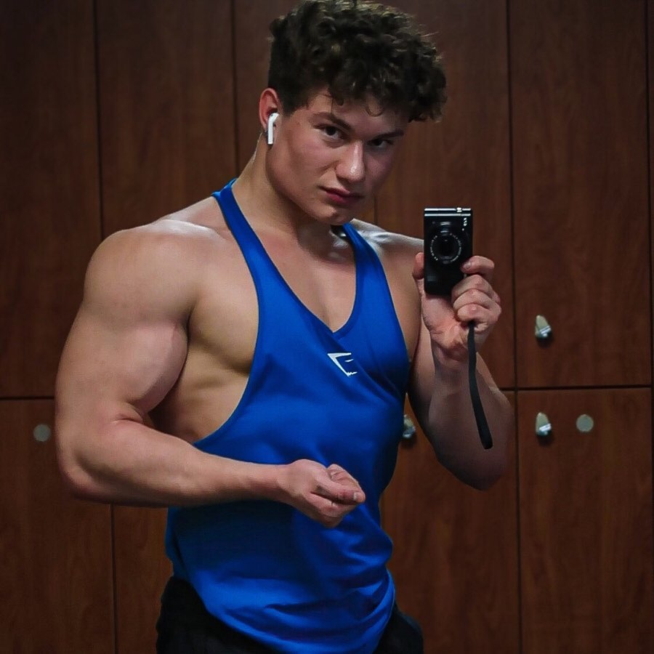
Although Martin hadn’t intended to be so direct, the question itself didn’t seem to offend the young man as the manager let out a light chuckle and flashing an inviting smile to the new employee (which only made it harder for Martin to not rush forward and plant a kiss on those plump lips). “Oh yeah, this is 100% a suit. This is about the polar opposite of what I usually look like,” he began, stopping himself as he looked down at his arms. To Martin’s relief, he watched as the jock lifted one arm up and flexed the muscle. “I definitely much prefer this body though.”

For a few moments, Tony found himself distracted by his muscles as he gave an unintended show to Martin as he flexed his biceps a few times and moved the straps of his tank top to pop his pecs and enjoy the musculature his job had gifted him. Upon finishing up with his mini flex session, the gym manager couldn’t help but smile and begin speaking once more. “Thank god it will only be a few more months until this is no longer just a suit…”

While Tony had simply stated that last sentence as a passing remark to himself, the words had instantly caused an insurmountable level of intrigue and excitement to permeate throughout Martin’s broad body. The concept of having this body permanently seemed like a dream come true, so much so that he couldn’t help but ask a few more questions. “Holy shit, there’s a way you can keep these bodies? What do you have to do?!”

For the next few minutes, Tony spent his time explaining to Martin what he meant. In hopes of boosting team morale and rewarding employees for their hard work, the company had started an initiative in which employees were able to permanently wear the suits and thus be given a new identity to live their new lives after a year at the company. Tony then revealed that although S-C Fitness doesn’t require the employees to maintain their positions at the company after receiving the bodysuit, they do aim to remain a constant influence in their workers’ lives. As a result, they require that the employees that do leave use their social media accounts to promote future S-C Fitness products and membership deals in hopes of a mutually beneficial relationship that will just foster the company’s continued growth.

Throughout the entire conversation though, Martin was confused by the fact that Tony kept referring to his form as his “new identity” rather than his “new body”. As a result, his inquisitive mind was unable to stop itself from asking more questions. “What do you mean by new identity though? Like they just give you a new body and that’s it right? It’s not like you become somebody else entirely…”

To Martin’s horror though, Tony shook his head to deny that idea. “Nah, it’s an entirely new identity bro. New body, new name, new everything. They do some witness protection level shit to give you an entirely new identity so no one could possibly know who you used to be. Hell, I heard they even have the ability to make sure that you forget about who you used to be to make sure that the company’s secrets never become unveiled.” After reaching deeper into the box that had once contained Martin’s bodysuit, the man then pulled out a shiny new name tag. “Ah see, when you’re working here, you don’t even go by your real name anymore. Like, my name isn’t even Tony! From now on, it seems your work name is gonna be Emmanuel,” the manager revealed, grabbing onto the name tag and holding out for Martin to see.

Upon doing so, there was a bizarre sense of both panic and excitement about this reveal. Although he was quite happy with his name and family and thus didn’t want to lose that aspect of himself, the concept of turning into this hunky bodybuilder seemed like a dream come true. Hell, even his new name sounded hot to him and fit his new body much better than Martin!

“Ok, before we have you get out there and start working,” Tony began, ”we should run through some basics so you’re not completely thrown to the wolves out there.” This caused the nervous new employee to eagerly nod his head in agreement. Upon doing so, Martin listened as Tony gave tons of pointers about how to appropriately help their members do their best possible workouts like reminding him to have them lift with their legs rather than their backs.

Upon finishing up after rattling off a few more tips, Tony then ended his lesson by pulling off his shirt and revealing his ripped physique. Martin unintentionally gasped at the reveal, which caused Tony to chuckle and give a friendly wink in his direction before continuing to speak. “Alright, so we also have a bunch of bodybuilders that love to come in here and get help perfecting their poses before their shows. This is most likely going to be a popular task for you, especially given how incredibly large you are,” Tony explained, looking the man up for a moment and slyly licking his lips. Grabbing a hold of Martin’s callused hand, Tony led the duo to a large full-body mirror so they could both stare at their muscular physiques.

Out of nowhere though, Tony began to rattle off countless poses and tell Martin to do them. Although his mind had no idea what he was talking about, it seemed as though the bodysuit had some sort of muscle memory as it began to immediately move on its own accord and make Martin do the desired poses. This initially freaked out the young man, causing him to frantically ask what’s going on until Tony explained that it’s all natural. Upon asking what he was talking about, Martin learned from his manager that the suits were embedded with a breadth of fitness knowledge that would allow any employee to effortlessly assist any gym member without having to stutter and be unsure of an answer.

“While working here, Tony explained, “there’s nothing you need to worry about. Just sit back and enjoy every perk of that incredible body of yours.”

After hearing this, Martin found himself taking a deep breath and starting to savor the experience of perfectly executing the poses that Tony was continuing to bark at him to do. So for the next several minutes, this exercise allowed any fears and nerves to alleviate from Martin’s mind as he found himself really getting into the posing and enjoying the positive affirmations that Tony was offering about how “perfect” his poses were looking.

Although Martin could have continued doing this process with Tony for hours, a quick glance at his watch caused Tony to immediately end the posing session. Upon giving Martin a playful but firm slap on the ass, the manager told him to hurry up and get dressed so they can begin working. As soon as he nodded his head, the man wasted no time grabbing onto the S-C Fitness branded clothing and pulling them onto his burly frame. After giving himself a quick little glance in the mirror and seeing how immense and handsome he was, the brand new Emmanuel gave a quick smirk in the mirror before turning and following his manager out to the busy gym floor. Tony had completely calmed his nerves, causing the bodybuilder to become quite eager to get started on his job. He was going to fully commit to this new role, especially if it meant that he would one day be able to have this body permanently for himself!

Working His Body(Suit) - Part IV
By Soul-Controller
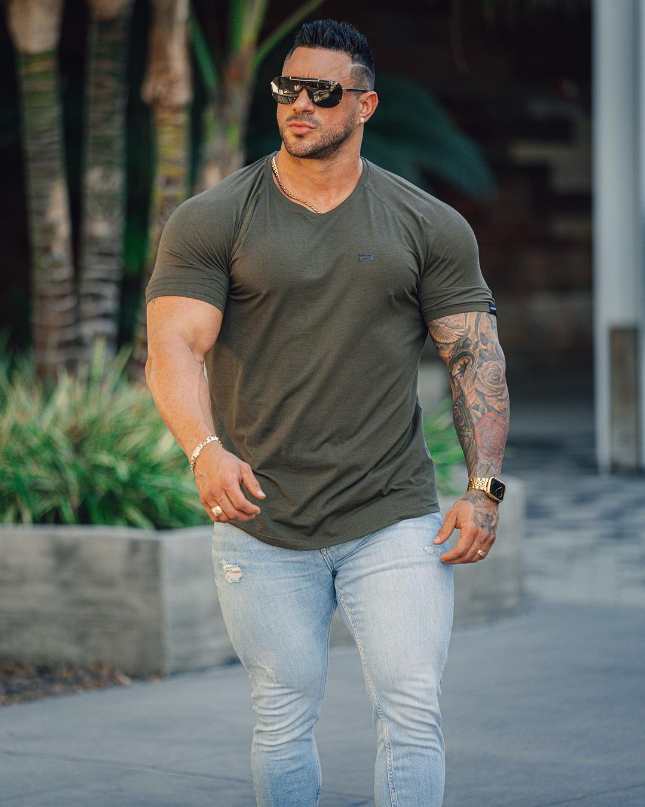
As Martin sat behind the front desk of S-C Fitness, the brand new employee couldn’t help but have the widest smile on his face. Before he knew it, the first two hours of his shift had flown by and his lingering nerves were practically nonexistent after getting his first bit of hands-on experience. For the most part, his job was much easier than expected - with him only expected to greet customers that entered the building and help them on the off-chance that their membership cards failed to grant them access.

Other than that, Martin’s only real task was helping any prospective clients sign up for a membership or answer any of their questions. Fielding questions about the gym and its process seemed like a daunting task to the immensely-sized man, but before he could even think about trying to find Tony to help answer the questions, Martin was shocked to discover the answer immediately coming out of his mouth. Although this was an immediate relief as it helped him appear more professional and knowledgeable, the new employee couldn’t help but feel slightly alarmed. Clearly the bodysuit was altering his mind to make him appear like a seasoned gym professional and employee, which was a blessing in terms of curbing his anxiety but a curse when it came time to feeling in control of his own body.

For example, the man knew that his real name was Martin, but anytime a customer introduced themselves to a new employee, the bodybuilder instantly responded in his deep and husky voice that his name was Emmanuel. Although he could understand why the suit functioned this way so everyone perfectly fit their new character, the way in which his mouth disobeyed his mind was troublesome - in fact, it sometimes made him feel like he was being puppeteered by the suit in some instances.

Despite this genuine concern, Martin forced himself to push aside those worries for the time being. Tony had said earlier that he had been an employee at S-C Fitness for a while now, so if he was still at the company after all that time and didn’t bring up any concerning news to Martin while they were in the locker room, clearly there was nothing to be worried about. As a result, the new employee found himself praying that this was all just temporary and in time both his body and mind would be acclimated to its new identity.

In an effort to focus his mind elsewhere, Martin kept himself entertained by observing everyone that walked into the building; more importantly, he watched how each client reacted to the huge bodybuilder he now was. Upon greeting them and welcoming them to S-C Fitness, the man watched as each individual had varied reactions to both his voice and body. Without a doubt though, his favorite reaction was whenever a client would immediately jump in shock and then avoid eye contact entirely. Although he had no intention of scaring them, the way they were instantly quite closed off and intimidated was a pleasant side effect. In fact, it was an immediate boost to his morale (and horniness) as he watched toned and muscular men (who were much bigger than his normal form) instantly cower at the sight of him. Whenever he would ask how their day was going and they would just begin stuttering or give a quick answer before sliding their gym card and rushing into the main gym floor, the man’s thick, girthy cock couldn’t help but throb and begin leaking pre-cum into his tight poser. Not wanting to get caught by either Tony or employees with a clear as day boner straining against his employee uniform (which was composed of a black tank top and pair of sweatpants), Martin opted to stand up and lean forward against the desk, tucking his boner underneath the counter into a cubby hole that was a perfect fit.

Although he had originally hoped that hiding his boner in the tight and compact area would help cause it to deflate and go back to its normal flaccid state, Martin’s plans were ultimately foiled when a large bodybuilder with a similar physique to the employee’s own strutted his way into the gym. Everything was calm for a second as the two gave a silent nod towards each other as if there was an instant connection of mutual respect, but upon sliding his gym membership card through the turnstile, the gym member’s calm demeanor instantly evaporated. In an instant, the bodybuilder was loudly growling in annoyance and slamming his burly arms against the metal bars in hopes of forcing his way past the gate.

Now forced to jump into actual action, Martin wasted no time yelling at the man to settle down and leaving from behind the counter to try and assist the short-tempered customer. Upon taking the man’s ID card and entering it into the computer, the new employee quickly learned why he wasn’t gaining entry to the gym - his membership had lapsed due to him not paying the latest monthly fee. After delivering this news to the man, Martin was unsurprised to see that the meathead didn’t take kindly to the insinuation that he not only was broke but unable to use the gym today. In response, the bodybuilder began barking obscenities that loudly echoed through the front office.

Although the man had initially tried to maintain his composure until someone more experienced like Tony could come up and help him, it seemed as though no such help was coming and Martin was thus left to fend for himself. So despite being a man with a normally meek personality, he attempted to confront the man and appear as imposing as possible by flaring out his impressive lat muscles and crossing his burly arms against his humongous pectorals. “Alright man, you either need to pay your bill or you can’t use the facility. There’s nothing else I can do for you besides that,” Martin stated, his tone unintentionally taking on a cocky tone as he approached the disgruntled member until they were face-to-face (although Martin’s higher stature caused him to look down at the stout yet wide bodybuilder).

Despite his short height though, the member refused to cower as he instead stuck out a callused finger and violently jabbed Martin in his chest a few times. “Oh yeah? Well what the fuck are you gonna do about it if I tell you to fuck off?”

Before the man could even finish curling his lips into a cocky smirk, Martin gasped in shock as his body instantly began to react on its own. In an instant, one of his burly arms grabbed onto the bodybuilder’s hands and pushed them behind his back while the other pressed down on his neck until he was leaning forward with his face smushed against the top of the smooth chrome turnstiles. The whole situation was quite the shock to the mild-mannered man, especially as he leaned down and began to softly whisper threats into the gym member’s ear. “Believe me bro, you don’t wanna fuck with me,” he began, allowing a deep chuckle to escape from his lips as he continued to assert his dominance. “Now I’m gonna let you go, and you’ll have the opportunity to leave without any more issues. If you want to try and go toe-to-toe with me though, I promise I won’t be as gentle with your pathetic ass,” he warned, blowing an air kiss into the man’s ear before stepping back and letting go of the man.

In an instant, the gym member’s feet fluttered back in a rapid fashion as he looked in both horror and annoyance at “Emmanuel’s” threats. After threatening to contact corporate and report him, the man could only watch as the gym employee chortled before telling him to get the fuck out of the building before he physically removed him himself. Luckily, such a threat caused the man to instantly cower in fear before quickly grabbing his gym bag and fleeing from the premises.

Despite the shock of just how aggressive and dominant his new self was being, the journey back to his seat behind the counter allowed him to realize just how hot the entire experience was. Never in his life had he been able to not only appear dominant but also have the strength and innate cockiness to back it up! Such a realization meant that his boner remained obscenely on display in his tight pair of sweatpants, although his pants would now draw more attention due to the rapidly growing dark stain around the crotch area. As soon as he was back behind the counter and his bulge was concealed, the man couldn’t resist reaching a hand down to the area and relishing in the huge puddle of pre-cum that had flooded through both layers of fabric. Fuck, being a cocky motherfucker felt great!

For the remainder of his shift, Martin found himself overcome with an intense sense of lust towards not only his new physique but also personality. In between customers, he couldn’t resist looking down and playing with his bulging pecs, either cupping them in his hands and squeezing the firm muscle or playfully popping them for his own amusement to pass the time. With such an influx of cockiness and confidence soaring through his body, it was perfect timing when he looked at the clock and realized that it was finally time to go and do some mid-shift cleaning in the facility. So upon setting out a bell for anyone with issues to ring and grabbing a spray bottle and rag to begin a wipedown of the machines, Martin tucked his thick boner underneath the elastic waistband of his pants and swaggered out onto the busy gym floor.

For a good twenty minutes, the man remained simply a casual observer as he sprayed down and wiped machines to rid it of any sort of sweat or bacteria. While doing so, Martin couldn’t help but ogle at the few undeniable hunks that were in the midst of their workouts. Bizarrely enough though, it was one of the clearly experienced hunks that kept catching his attention in the wrong way. Although it was clear that the man knew what he was doing given his muscular physique, Martin’s brain that was now full of bodybuilding and fitness information was ringing alarms by pointing out just how piss-poor the member’s form was as he did bench presses.

Knowing that he didn’t want to rock the boat too much on his first day, Martin initially opted to try and keep his knowledge to himself and instead focus on the assigned tasks he had been given by Tony. But after cleaning a few more machines and noticing how the additional time was only making the other man’s form worse, Martin found himself left with no other choice but to approach the gym-goer and offer some guidance.

Upon waiting for the man to finish his current set and loudly drop the weight onto the rack, Martin made his way up and introduced himself and asked if the man was willing to hear a helpful tip. Although the man was clearly unnerved by this huge behemoth that not only randomly approached him but towered over him as he remained laying down, the member agreed and asked what was going on.

For the next few minutes, Martin’s new knowledge allowed him to rattle off countless tips and pointers about how to fix his stance so he could remain safe while also getting as much as possible out of his workouts. Although the constructive criticism could have surely angered or offended the man, he took it all in great stride as he told the mystery hunk that he appreciated the tips and even reached out a hand to introduce himself.

Upon reaching out and allowing both of their calloused palms to be wrapped in a tight embrace, the duo wasted no time making small talk as Martin fielded questions about who he was and how long he had been an employee at S-C Fitness. In response, Martin asked his own questions and learned about how the man was an aspiring bodybuilder and hoping to take part in his first ever competition later this year. Although this was quite intriguing for Martin to hear, he was even more excited as the member began to praise him for just how “godly” his physique was. To make the new employee feel even more confident about his new self, the gym member reiterated several times about just how badly he wants to look like “Emmanuel” one day and how he’s so jealous of his bulk.

Although Martin would have usually been quite bashful and anxious via such intense compliments, his altered mind had changed it to where each compliment only made him feel more confident and sure of himself. He felt a shiver of pleasure pass through his entire body as he flared out his lats and watched the man’s eyes widen in pure admiration of his impressive build. Riding the high of so many compliments, Martin felt oddly compelled to offer an opportunity to showcase how the perfect workout form should be for a bench press. To no surprise, the gym member eagerly accepted the opportunity and sat up to instead help spot the bodybuilder and get to visually see how the employee’s tips should be implemented.

In spite of having never worked out with so much weight on a bench press before, Martin’s confidence was unwavering as he adopted the perfect position and began to lift the bar up and go through several sets. Throughout the entire experience, his cock began to violently throb due to just how easy the bench press was despite the several hundred pounds that were already loaded up onto the bar. On top of this, the oohs and ahhs offered by the gym-goer as Martin continued to rattle off tips mid-set only caused him to feel completely comfortable in his new skin.

Although this was most certainly not intentional, this was best showcased by how Martin finally finished up his last set and loudly set the bar back down and sat up from the bench. Despite only offering to do two sets, the man was so excited about this new body that he had continued to keep going until his body was now coated in a light layer of sweat. As he lifted his arms up and rolled his shoulders, Martin couldn’t help but smirk as a whiff of his ripe body odor invaded his nostrils. Who cared about his mouth not obeying his mind when everything about this new body felt like a dream come true!
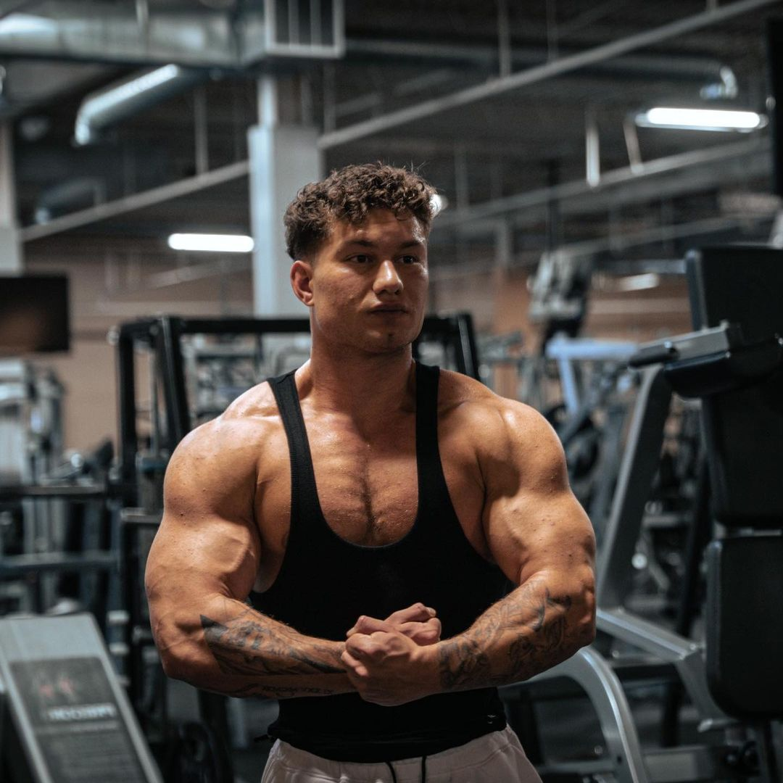
As he sat there on the bench still chatting with the member, Martin was suddenly caught off-guard when he heard someone clearing their throat. Upon turning and seeing that Tony was standing there and looking at him with an expressionless face though, the bodybuilder refused to feel too stressed about any possible judgment that his boss was showing. They had already bonded so much over the day, Martin had already viewed Tony as his best bro!

So despite the way Tony’s eyes began to angrily narrow as he asked why “Emmanuel” was working out rather than sitting at the front desk, Martin simply chuckled and shrugged his shoulders. “Ay, don’t be such a downer bro, I was just helping out my buddy here perfect his technique,” he began, standing up and waddling his way closer towards his leaner but incredibly handsome co-worker. After giving a smirk and patting Tony on the shoulder though, Martin’s eyebrows raised when he noticed how his boss’ face remained relatively stoic. “C’mon dude, what’s with the third degree? I know for a fact that you love everything about this bod, so don’t be such a little bitch about all of this. Hell, I just gave you a show for free,” he cockily said, punctuating his sentence with a rapid popping of his pecs and dopey chuckle.

Although Martin had seemingly permanently adopted a carefree and laid back personality over the course of his first shift, he was quickly knocked out of that persona as it quickly became clear that Tony wasn’t buddy-buddy with his new employee yet like that. In fact, the fear of God was quickly instilled in the new employee as Tony’s calm yet chilling voice told him that they needed to go back into the locker room immediately to have a chat. Yet despite his fear and desperation to not get in trouble due to the fear of losing the suit, he was left with no other choice but to say goodbye to the oblivious gym-goer and follow Tony back into the employee locker room.

