JOINING THE GREATS
FIRST PERSON STORY
BY CHALDEACHANGE
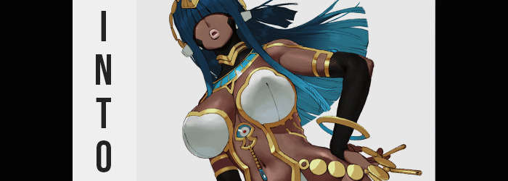

“Ugh. I’m never going to roll her. Even when I miss rate-up, the chances are way too low!”

When it came to obtaining non-limited Servants in Fate / Grand Order, particularly SSRs, at times it felt more fruitless to try than even making attempts on a limited Servant’s banner. This was because they were so seldom put on rate up, typically reserved for the rare (but increasingly more common) filler banner. In fact, the only times they were guaranteed to be available were during the Valentine’s and White Day event periods depending on the gender of the Servant you were looking for.

In this case? Nothing was really on rate up at all, I had just thrown a few tickets at the story gacha on the merit of ‘what if I got really lucky?’. Of course that didn’t work, why would it? I was never going to grab the target that I so desperately desired. Though there probably weren’t many people trying to obtain the Servant I was, and certainly not for the same reasons.

I was trying to roll Scheherazade. A Servant that, on release, received no shortage of negative remarks for her underwhelming kit and revealing design. These weren’t things I personally saw an issue with even then, but with time she had become a pretty solid Arts Servant for farming. But still, this wasn’t even the reason I wanted her. Maybe I was something of an odd duck, but I really loved the character interactions between the Servants.

Scheherazade had a few interesting ones, but among her most notable in my opinion was the relationship she had developed with Pharaoh Nitocris. I was a sucker for the trope of characters who were distant with others finding companionship in each other, and that was exactly what their friendship was. “But my Nitocris will forever be alone at this rate…” I’d had the SR Caster almost as long as the day she had been added to the gacha pool, but despite rolling for Scheherazade at a number of opportunities, including the most recent Valentine’s, I’d had absolutely zero luck.

It certainly wasn’t like Nitocris was real, but as a Servant collector and someone who just had to dote on his favorites, it had become something of a priority for me. Surely other people can relate, right? I’m totally not weird for this? …Anyways! What would soon transpire occurred because of a single line I would come to utter. Well, that and a shooting star that passing overhead. What a cliché way to go…

“I wish she at least had someone to keep her company.”

The next thing I knew I was sitting on the edge of a bed in a dimly lit room. “H-Huh!?” There had been no warning of my surroundings changing, and I certainly hadn’t moved here – wherever here even was. From what I could make out the room was very white. Actually, it was a little familiar. Didn’t it look like the standard issue dwellings for the staff and Servants of Chaldea? But that couldn’t be!

I had to re-evaluate that presumption when I looked over my shoulder and realized I wasn’t alone. Sleeping on the bed behind me was a woman barely dressed, one with dark skin, long purple hair, and growths on her head that almost looked like… the ears of a jackal? But much like my surroundings she was very flat and artsy. Like my surroundings were animated.

“N-NITOCRIS!?” There was no denying that this was who it was, and yet she didn’t stir from my shouting even as I stood up. Rather, was she even breathing? It looked more like she was frozen. Or was time frozen? “This can’t be happening. I must have just fallen asleep on my couch, right?” I raised a hand to hold my head but quickly realized. I was also animated. My body was 2D, and yet through touch it still felt 3D. “Don’t tell me there was something weird in those cookies I ate…?”

I had basically boiled this strange situation down to either: I was asleep, or I had unknowingly taken some sort of drug. Because how could this be reality? Under no circumstance could I be two dimensional, in Chaldea, and be in the same bedroom as Nitocris. And yet, so distracted by my surroundings by this juncture, I did not pay as much heed to my own appearance as I probably should have.

As a direct result of this, I immediately missed something that should have been very obvious. I was, after all, an extremely pale and Caucasian individual. I wasn’t sure how well that had translated into a 2D format, but when I’d first noticed my hands that at least appeared to be unchanged. But since I took my gaze away from them, the opposite ultimately became true.

Because the pigmentation of my skin was darkening. It wasn’t as if I had just suddenly become tanned, and it wasn’t an artificial change whatsoever. Rather? The natural level of melanin in all of my skin cells had been dialed up to a million, and the color quickly surpassed a mere tan. Reddish-brown was the color that was ultimately rendered, and this skin of mine had likewise become much better acclimated to the heat of the sun. While I would usually burn to a crisp after being outside for like twenty minutes, that was no longer the case. In fact my flesh almost welcomed the sun’s ray now. The only places where pale lingered whatsoever were on my palms and the bottoms of my feet.

But it wasn’t just a change of skin color, even though my nipples had likewise darkened. My facial structure took on a more African shape – though more specifically it was Egyptian in this case. In doing do, there was a gradual look to it that prompted the impression that, perhaps, I might be a woman? My lips were a lighter color than the rest of my face, but they looked swollen, almost bee stung. All of the excess weight that made my face round and chubby likewise diminished so that face was slender and jaw sharp.

“So what do I do here…? Here? Is something wrong with my voice?” To my own ear it sounded sultry, needy, enticing, but simultaneously intoxicatingly feminine. Words were carried by my fuller lips, and idly I brought a hand – which now sported longer and slimmer fingers with manicured nails – up to rub at an Adam’s apple-less neck without looking down.

The weight lost in my face was actually part of a broader change, too. I was by no means a thin guy, but that was gradually becoming truer. Excess meat was trimmed from my stomach, thighs, arms, chest – you name it. It didn’t take long for my body to be left perfectly trim at the expense of my outfit’s fit. My shirt had become incredibly baggy without that gut of mine to hold it, not to mention my shoulders were trimmer. My pants should have fallen down, yet…


At the very least, the feeling of these ill-fit garments was enough to finally prompt me to look down at myself. “…Huh?” Not only was I thin, but I was definitely brown-skinned – which was only an issue because it was incorrect, and yet? “Why do I… Is this how I’m supposed to look?” No? That was arguably a silly thing to think, and yet the truer it felt, the more my gaze began to change. Irises glowed golden and lashes thickened. What’s more, blue eyeshadow now highlighted my eyelids. They were very pretty, and yet? They were not displayed for long.


My dark hair was growing and quickly at that. It seemed almost impossibly straight, spilling well past my shoulders and down my slenderer back with a straight cut at the tips. But my bangs? They weren’t spared either. They grew so long that they fell past my gaze, hiding my eyes and the top half of my face in general. Yet despite the presence of these curtains, I could still see perfectly through them because of a magic my golden eyes were passively channeling.

There was a great imbalance that plagued me by this juncture. I felt unsteady on my feet, as if my center of balance had completely been changed. My height was unaffected though, and throughout I retained a height of nearly six feet. “What is…? Who am I?” My memories were a mess, so much so that I could not recall my own name. But memories of things that shouldn’t have been possible flashed by. Of giving birth to a child, of being a mother…

Naturally this things were impossible because I was not a woman. Or at least I hadn’t been when my transformation had begun. Yet my cock and balls soon folded inward after the dick in question showed signs of diminishing in length. It all folded into a new pussy, inherently and irreversibly altering my sex to female. With this key change having taken hold, everything else quickly came together.

“Mmn!” Pants dug uncomfortably into my hips. They hadn’t initially fallen from my figure because my hips had been left wide, and yet they were swinging wider still in that particular moment. A handful of inches prompted the button on the front of my jeans to pop off, while a throbbing phenomenon saw the space available inside those jeans quickly lessen.

My thighs had thinned with my weight loss, but now they were thickening again. This meat stretched my brown skin so that a natural sheen could be perceived, thick flesh making each thigh about the same width of my now extremely narrow waistline (which now looked even narrower now that my hips were so child-bearingly wide).

Tender and appealing, this thighs were adjoined to my ass, which swelled in kind. Cheek peaked in fullness rather quickly, with flesh peaking over the backs of my jeans along with their crack. But this bubbled butt had devoured the fit of my boxers, too. They were wedged fulling in between my big cheeks, and in the front they were grinding uncomfortably into my pussy. Uncomfortably, but also pleasurably?

It was good that time was frozen so that no one could hear my moans is all I’ll say.

The phenomenon traversed past a tummy that was now secretly toned beneath my shirt. That said, looking at my build and even my face? I did look about five or so years older. Like a woman that could rightfully be seen as a maternal figure. To add to this, though, I was missing two key features. But they were also all I was missing, really.

My body lurched forward, hands reaching up to grope my chest through the cloth of my t-shirt. Nipples were plucky and wide, areola triple their usual size – not that I was thinking about that. I was just twerking them without thinking, fingers occasionally sinking into the weight that was pooling beneath them. At first my chest only rose into a pair of A-cup breasts. Nothing to shake a stick at, really.

But before long they were jiggling and bouncing, lifting up my now-oversized shirt from below as they fully shaped themselves into a pair of rightful F-cups. They weren’t as perky as they perhaps could have been, but this was likely a product of the facts that I was in my thirties now mixed with the fact that my body was one that had undergone childbirth if my memories were to be believed.

As the growth ceased so too did my arousal, and I allowed my arms drop to the sides. “I… Why am I here?” Had I been somewhere else? Was something different? I wondered, caught up in my own thoughts. But as the storm that was my transformation seemed to be winding down, the issue with my clothing was suddenly subdued. My old outfit glowed gold and that light filled the room.

Once it had faded? I was dressed in a skimp ensemble that showed off basically everything except the peaks of my breasts and my loins. It was more like I was only wearing an ornate, white bra with golden trim that led into a strip of matching cloth that covered only my crotch and ass crack. Black thigh highs with golden bands wrapped my thick thighs, and matching fingerless gloves took my arms. Gold was everywhere, including around my neck and on my head. I was dressed like someone very important.

And as I now recalled, I was.

“Merneith…? My name is… Merneith?” It had been so disorienting to transform to the extent that I had, into a beautiful woman of Egyptian ethnicity, complete with a figure that was absolutely to die for. I hadn’t been sure of what to call myself, or how to parse these new memories of mind, but eventually it all settled as a name stood out in the back of my brain. It allowed my new identity to click into place, and for the first time since that transformation had begun? I felt at ease.
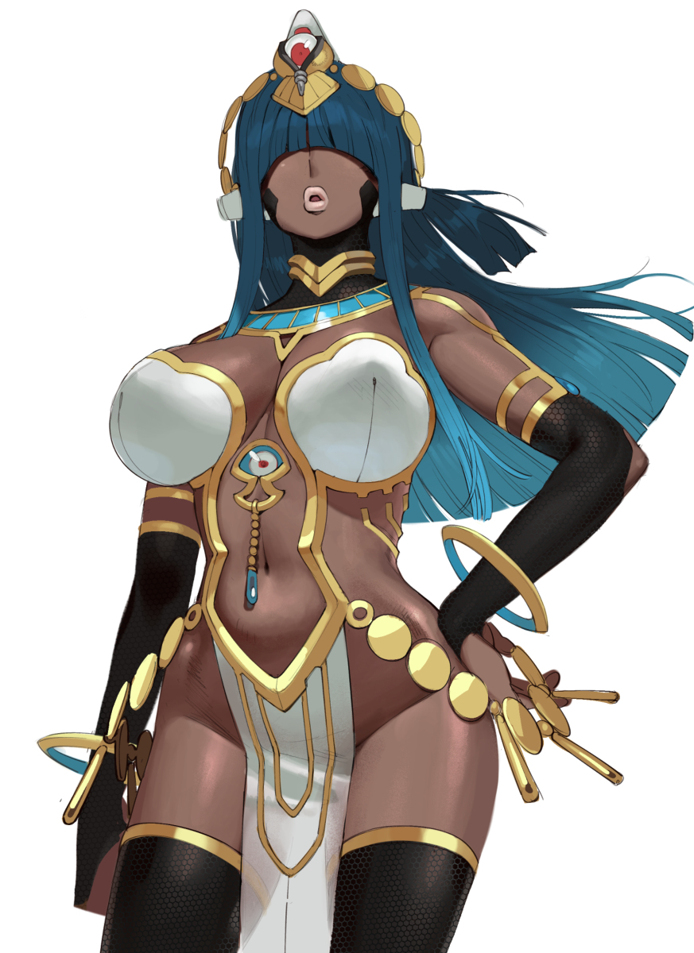
A queen consort and regent, a wife, and a mother. These revelations about myself brought clarity to those memories, along with an explanation for my presence in Chaldea. “I am Caster?” I had been reborn as a Servant, one that didn’t even exist in the game. One that may or may not have been a Pharaoh at some point according to her tomb, but in my own mind I knew that it was certainly true that I had been.

So certain, in fact, that I was no longer certain about my old memories. Could I have been a man? No, that didn’t make much sense. I would never have been able to bear a child if so, but that didn’t matter now. As a Servant I was unshackled from my past, free to do what I wished with my relationships.

“Mm… Merneith? Why are you up? I’m cold…” The sound of a familiar, half asleep voice eventually prompted me to turn back to look at the bed. Time had resumed and Nitocris’ eyes were half open, looking up at me. My full lips turned up into a smile at the mere sight of her face, affections stirring within me. I wasn’t in her room for no good reason… That’s right, I had come here to lay with her. It had been happening more and more often as of late.

Seductively my hips swayed as I returned to the bedside, and soon pressed my seductive body against the mattress before wrapping my arms around my fellow Pharaoh and holding her close. “It’s nothing, Nitocris. Let us go back to sleep… Unless you’re in the mood?” But while I was pretty horny, another thought stood out.

I would never let Nitocris feel like she was all alone again.

