Tina N’ Tyetta

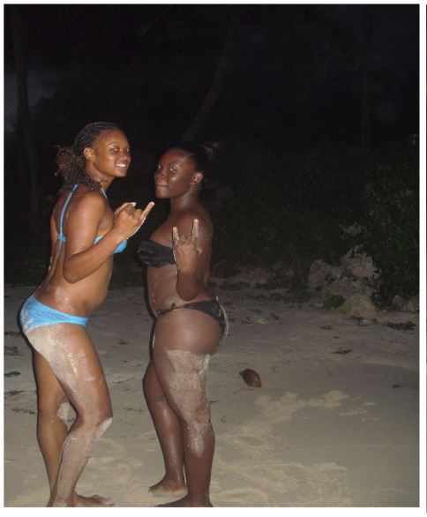

Tina was having a great time on her visit to the Caribbean. She had decided to make the trip by herself to get away from the stresses and hassle of being a busy CFO of a large corporation. She promised herself to leave her phone in her hotel room and live in the moment every day of her vacation. And it had paid off. She was enjoying herself and meeting and interacting with many new exotic people. She even had a few one night stands with either man or woman who intrigued her well enough. who lived in the area of the resort where she was staying.

The last night of her refreshing vacation, TIna saw the moon was full and the sky was so crystal clear that she decided to take an evening walk along the beach. Wearing nothing but her eggshell blue two piece swimsuit, she grabbed her hotel key and some money and left the resort. In the warm and windy night air strolled about in the sands for quite a while hoping her vacation would somehow never end. It was then she spotted a young woman sitting on otherwise sparsely populated beach who waved at her.

“Yuh nuh fi wanda round at night. It dangerous, yuh know.” The dark ebony skinned island woman said looking up at Tina. She looked about her early twenties and also only wore her black bikini out in the warm night air. Tina shrugged and sat down next to the girl in the sand.

“It’s not so bad. Everyone on this island i’ve met is so nice.” Tina Replied “...And maybe I wouldn't mind being kidnapped or something. Then maybe I’d be able to stay here a while longer.”

“Oh? suh yuh wa fi stay here duh you? “ The girl said with a smile. “ Well mi kno of a special place dat cya help yuh wid dat A secret place pon di island dat takes away all of yuh problems. Mi cya tek yuh there... fi a price.”

The girl stood up and dusted a bit of the sand off her chocolate thighs, and flicked a bit out of her bikini line before reaching her hand out ot help Tina up. Tina hesitated for a moment before taking the young woman’s hand. She figured she may as well try to milk this last opportunity for adventure as best she can before heading home the next morning.

“What’s your name? Where are we going?” Tina asked as she followed the woman, their hands and fingers locked as they trotted off into the night.

“Wi a guh Tyetta Resort, an mi name Tyetta.” The island girl said with a charming wink and a knowing smile. Tina smiled back and followed on. Just then another voice called out from the beach the were leaving.

“Pardon! yuh wudda like a picture fi a dollar?” called the voice of a young kid holding a camera.

“Of course! This is my last night on the island.” Tina said before tyetta could pose a objection. She gave the kid a dollar from her swimsuit top and the two new acquaintances quickly posed for a picture. The polaroid was slow coming out of the camera so Tina told the young photographer to hold the photo until she returned. Then she and the island girl trotted away and the kid watched then fade off into the dark shroud of night.

------------------------------------------------------------------------------------------------------

Not much more than an hour had passed since Tyetta had indulged the tourist woman she had met on the beach earlier that evening. The woman had wanted a final adventure and to stay upon the island, instead of returning home to her country. Tyetta had obliged her with wine and weed and dancing in a nearby saloon, and further obliged her, despite her protests to a more permanent lodging here on the island. Now Tyetta waddled along the beach slowly, rubbing her immensely distended belly, bulging with the form of the tourist woman as she struggled within her new slimy smelly quarters.

“Ow yuh like yuh new room at da Tyetta Resort?” The island girl teased her tourist dinner as she waddled slowly in the moonlight, “Mi hope di ...Bw-OURP... accomodations is to yuh liking.” Tyetta patted her ponderous belly where Tina’s head was protruding out beneath her belly button and shivered at the feeling of the woman thrashing fruitlessly to get out.

This was not the first, nor the last tourist Tyetta would “oblige” on this island. She has had the opportunity to experience flavours of men and women from all over the world as she gave them permanent residence on the beautiful tropical island she called home. Even if that permanent residence was as an extra layer of fat on her ass, breasts or belly. Tina had been as delicious as she expected, though not the tastiest of tourists she ever had.

“Hey big belly gyal ! wah happen to di uhman yuh did wid?” Called the photographer child Tina purchased a picture from earlier. The kid stood up beach a bit further, a large knowing grin plastered on his face. He watched Tyetta’s huge squirming belly as his sister lumbered up the beach.

“Hush yuh noise Manuel. Look at ow big mi stomach. Shi inna mi belly like a big \*BWORP \* feast.” Tyetta said as she approached the Manuel.

“Yuh such a fatty, Tyetta. Skin yuh teeth fi di camera!” He said simeotaneously bringing up the camera and snapping a picture. Tyetta gave a half smile and lumbered on toward up the beach toward their small home. Now that she had a full belly and a bra full of tourist cash, she was ready to turn in for the night and digest her delicious foreign cuisine.

