BEACH-I THE ROCK
FINAL CH: WOOF!
BY CHALDEACHANGE
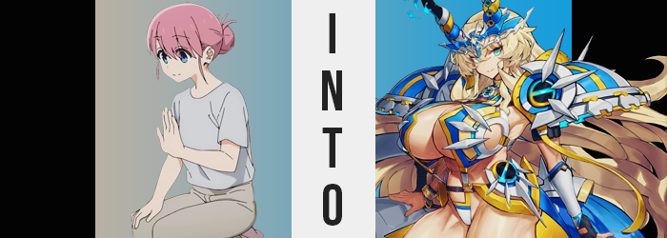

“What…? Where am I?”

Michiyo Gotoh, the mother of both Bocchi and Futari, awoke with a start. It didn’t exactly take long nor any amount of rocket science to answer her own question. She was on the couch of her own living room with the television blaring. Clearly she had fallen asleep watching the shows she had been trying to catch up on. She loved her husband dearly, but he did have a habit of being a television hog. Well she also didn’t like to make him watch things he wasn’t interested in so it was a little wrong to place all of the blame on him.

“Two in the morning? I hope they went to bed on time…” Noticing the time on the clock on the far wall, she immediately thought back to the two girls she was raising. Hitori had gone to the beach with her friends and hadn’t been home by the time she had fallen asleep, but Michiyo didn’t think there was anything wrong with that. She was a teenaged girl who was living her best life! …Something that definitely wouldn’t have been possible just over a year ago. She’d changed so much in that time and her mom was naturally proud.

On the other hand? Futari was only five. If she hadn’t been awake to make sure her bedtime was enforced, even the later summer one, then she could only imagine that her youngest had likely stayed awake until midnight at the earliest. Being the good mom that she was, once she managed to find the energy to get up and off the couch she made a start for the end of the hallway where Hitori and Futari’s rooms were.

But she had to pass by the bathroom to reach them, and something about it made her pause. The sound of the shower going inside? Was one of her girls still awake? And showering at that hour? That wasn’t like either of them unless they were sick or something else was wrong. And so out of curiosity? Michiyo stuck her head into the door in search of clues.

The Gotoh family had one of those bathrooms that was composed of two adjoined rooms. When you first walked in you’d find the toilet, sink, and shelves for leaving your belongings – while in the next door you’d find the shower and bath. It was convenient when you had even an average sized family, especially with multiple children since the bathroom could then be used by multiple people.

Michiyo wasn’t exactly going to barge into the bathing area to question her child but she was searching for clues as to which child it was. “A bikini?” She could see it on the shelf. One that had an unusually star-spangled pattern. If there was a swimsuit then was it Hitori in the shower? But the cups of the top and the lengths of the straps… No, those were for a much more endowed woman. Could Hitori have brought a guest home?

But there was something else on the shelf beside it. A pretty rainbow stone. That appeared to be… glowing?

The sound of someone moving inside of the bathing room scared the mom into retreating back into the hall. She’d seen a silhouette in the foggy glass that was much too big to be one of her daughters, and… Wait, her what? Her… daughters? Had she ever had any children to speak of? Considering her mating habits…

Mating habits?

Well she did have multiple children and still slept with her husband regularly, but never in her life had she referred to it as ‘mating’. Wasn’t that an English term in the first place? Why would she use it over simply stating ‘sex’? That said, the idea that she might use English words unnecessarily had become something that was becoming easier to believe.

The mother’s face… it gradually lost any recognizable traits that would have made her obviously Japanese. The almond shapes of her eyelids were ultimately lost and there was a fresh, notable roundness to them in the end. Structural change bled from there, sweeping downward to lengthen and thin her cheek bones. Perhaps the most excessive of these changes altered her lips of all places. They bloated to the point that she licked them with curiosity, canine teeth housed within becoming incredibly sharp. There was a youthfulness to it all. She appeared Caucasian – perhaps European? – but was she in her twenties again? Just as it seemed like Michiyo might realize something was amiss however…

Her blue eyes brightened up into a vibrant teal and those realizations were dissuaded.

“Was something wrong? Maybe I need to go back to sleep, haha…” The only person that the woman was attempting to convince was herself, and her brain had to really work overtime to do just that once curtains of golden blonde dangled between her eyes. Those ‘curtains’ were her hair, of course. The pink color that she shared with her daughters quickly lit up with gold, but more than that, well… there was more hair than that very quickly. Shoulder length locks were tied up into a bun, but that bun came undone and it spilled out in a long, fluffy, and curly mess that spilled and fanned out well down to her ankles, almost pooling on the floor.

This hair was heavy because it was so abundant. Michiyo’s head was being pulled backwards because she didn’t have the raw strength to lift it, but gradually? It became a little easier to bear. But why? Admittedly the woman affected was concerned by it but at the same time? She wasn’t thinking all that hard about things just like every other victim of the rainbow stone. They had all been manipulated mentally to go along with the flow.

Ultimately the weight of her hair had been offset by the necessary strength to support it. Her neck muscles were much more competent than they had been prior but it also wasn’t just her neck muscles. You could see it in her arms and legs, and while hidden by her shirt it was true of her chest and tummy as well. Muscles had begun to ripple, transforming her from a woman with no observable strength on her body to a woman that was notably fit.

Like fitter than she had any right to be. This power had forced her thighs to bulge as her muscles dictated, and their indentations could be seen through the cloth. This was the body of a bodybuilder, not someone who just dabbled in going to the gym. The gains Michiyo saw might as well be assumed to have come from doing steroids or something similar. That was how muscular she was.

“Hm? Were my clothes always this tight?” It was a fair question with her mental state considered. Of course she couldn’t acknowledge what was wrong with her body, but her outfit? That was a different matter entirely. Room only became more and more scarce within the confines of her simple outfit once the mother began to grow. She shot up like a weed in fact, hips and shoulders broaden to keep her proportions consistent even with her new muscles. An entire foot was added so that she was 6’3” but inevitable sacrifices had been made along the way.

Whether it was her pants or her top, her body had essentially exploded through it. Tattered cloth fell from her hulking body, arms and thighs alike now as thick as a bedside table with raw muscle. Yet her perfect, muscular form was not naked. Michiyo hadn’t exploded out of her underwear because she wasn’t even wearing them any longer. At some point they had transformed into a bikini. One that was mostly while, but had magenta, blue, and yellow stripes in a pattern across it.

She blinked. “Oh… This isn’t really what I had in mind? Why is the top so…?” Loose? The hulk of a woman wasn’t wrong. While the bikini bottom fit snugly around chiseled flesh, the top was hanging loose across breasts that were hardly distinguishable from the pecks beneath them. And the bikini top was extremely loose. There was a reason for that, but she was forced to experience discomfort first.

A notable, uncomfortable pressure had begun to accumulate just above the woman’s forehead and she both did and didn’t know what to expect – an issue manifested by changing memories. Little time was wasted before the pressure was ultimately alleviated mind you, with four black horns erupting. They almost looked like a tiara, and each horn had something akin to a gemstone in it that sparkled with orange and the same color that her eyes possessed. “My horns, they… Whoa!?”

The fact that the Servant was so strong was unhelpful against the force that pulled her forward, almost sending her face crashing into the wall. She managed to avoid that conundrum… but only because the part of her body that had caused her to fall in the first place had slapped into them instead.

Her breasts certainly weren’t lackluster any longer. Paltry, compact forms had ballooned – and that was the farthest thing from an understatement imaginable. Even after slapping against the wall her tits pushed the woman farther away from it as they continued to inflate as if to make up for how firm her body was otherwise by accumulating all of the fat she would have possessed otherwise into her tits.

They usurped her head in size. “Mmn… This is why I hate how big they are!” Michiyo’s strength was enough to lift herself upright, but considering how awkwardly she was pressed into the wall it was a difficult feat to accomplish. By the time she found the power to yank herself upright both tits made a big bounce and slapped against her firm core… either breast twice the size of her head.

How on Earth was she supposed to buy clothes?

Well, her swimsuit would just have to do.

“Hmm… I could have sworn I was concerned about something, but… Was it the fall?” The swimsuit clad Barghest paced back and force across the Gotoh hallways now that she was upright again, tits jiggling about as ass cheeks clapped against each other thunderously. She was trying to recall Michiyo’s concern for the mysterious guest that had occupied her bathroom, but there was no such concern from the Saber she had become. After all, Musashi using the shower in the middle of the night wasn’t all that strange. In fact, after a busy day at the beach, Barghest was simply waiting to use the shower herself.

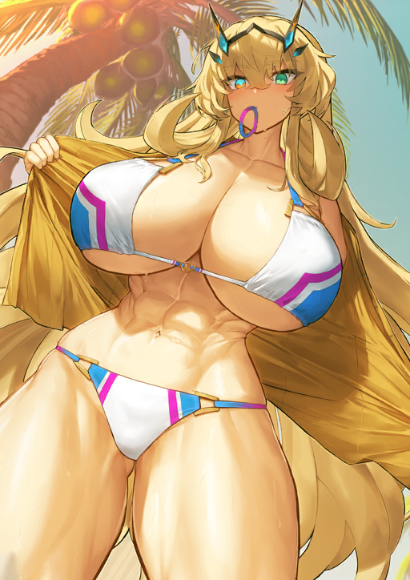
It was clear that her huge body did not translate well into a normal Japanese home. She had to keep her head a little forward to avoid bonking her skull on the ceiling, and her wide shoulders meant that there wasn’t much room to pass her in the hall. But such was her curse as a foreign Servant living abroad. It was nice of Mr. Gotoh to let her, Musashi, and Laevatein rent rooms in his home. But he was away on business, having left its care in the hands of the three women.

Laevatein was undoubtedly asleep already. She didn’t have a Servant’s constitution and was clearly tuckered out by the time they had returned home by train… Which in itself had been an ordeal because of Barghest’s size. “Well, I guess she’ll be a little longer. Maybe I’ll get something to it.” Looking to satisfy her hunger she wandered to the fridge. But there wasn’t much inside. There was only one reason for that. “Musashi…”

“Yes!?”

Barghest jumped. When had Musashi snuck up on her!? It took the canine fae a moment to regain her composure. “…Did you clean out the fridge again? It’s a little rude.” She was hungry, but that was her more chivalrous side speaking. It wasn’t fair to her or Laevatein if only one of them kept eating everything in the fridge.

“Aww, don’t be like that!”

Meanwhile, Musashi had left the rainbow stone in the bathroom accidentally. But it didn’t really matter. After all, its light had finally dimmed and all color had drained from the stone. No one else would fall victim to its charms… but that also meant there was no way to turn anyone back. Not that anyone would notice anything being wrong in the first place.

