RE-AI-RRANGED
MAY 2022 REQUEST STORY
BY CHALDEACHANGE
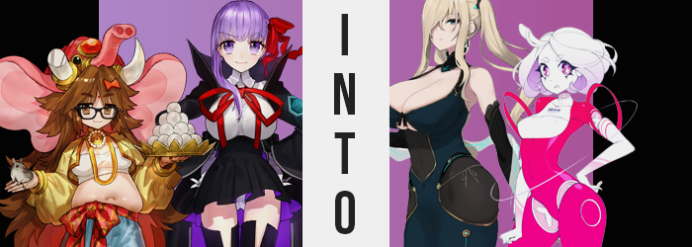

BB really thought that she had something with this plot of hers. While at first she had lent the class of Mooncancer to Jinako Carigiri for the sake of the fourth Lostbelt, the more she bumped into the shut-in in Chaldea, the more she became agitated by her presence. That was supposed to be her class, not anyone else’s! She had meant to just lend it to the woman for a time, not for her to become a permanent piece of Chaldea’s Master’s Servant collection!

To be fair though, BB wasn’t exactly agitated with Jinako. Jinako was just the easiest individual to take it out on. Truthfully, she was mad because of how Kiara Sesshouin had forced herself into the class for her summer version. If there was anyone she hadn’t wanted to be in the Mooncancer class, it was that filthy, abhorrent nun! But there she was, and there wasn’t a single thing the Sakura-based AI could do about it. Or at least that was what she had thought at first.

Eventually she came across an idea. There wasn’t much in the ways of digital space within Chaldea where she could invoke her powers in their complete form, but there was one area where it was hypothetically possible. Within the combat simulator that they used for training. It was a completely digital space that digitized humans and Servants alike temporarily for the sake of honing their abilities, but BB had never tried to slip past its security. Until now.

And while Kiara was her real target, she could take out her minor agitations with Ganesha at the same time. After all, so that she could make sure that this all worked? She needed a test subject first.

“Is no one even here? Then what was the point of the message!?” It was late at night, and Jinako had arrived at the combat simulator – which was usually unattended so late – because she had received a mysterious note. ‘Come to the simulator at 1am if you don’t want your big secret to be revealed to everyone!’ was what the note had said, although the thirty year old herself wasn’t really sure what ‘big secret’ this could be. Nonetheless, she was going to give the one trying to blackmail her a piece of her mind!

Or she was, except no one was there! “If this was just a prank, I swear I’m gonna— Huh!?” Agitated as she was, that agitation was overwhelmed by surprise. Why? Because the simulator whirred to life, and the next she realized she had been brought inside – into a digital landscape that was very reminiscent of the Moon Cell. It gave her the willies, actually. “Why am I here? Why am I…?” If that hadn’t been strange enough, she had just watched and felt a glitching sensation wrack her body.

“Installing…!? What is happening!?” It almost looked like the woman was reading an invisible word, but it wasn’t actually all that invisible. In fact it was a word only she could see in the corner of her vision, a projection of status from within her very self. Regardless of where she looked it remained glued to that very same spot in her vision, which led her to one possible conclusion. “Something is being installed into… me?” That would very much have explained the feeling she had felt initially, if anything.

In fact, the eyes through which she saw this notice had begun to alter. Their plain browns shifted to a lilac purple, which was already strange enough – but there was something else, too. Being of Japanese descent, she naturally possessed the narrowed gaze of her people. Yet… not any longer. Her eyelids tugged upwards in slight beyond her control, and the corners rounded until, racially, they looked like they belonged to a woman from the West. To a Caucasian woman.

“Ughughugh… I don’t feel too good.” The ‘installation’ process was moving along at a breakneck speed it seemed, and Jinako felt rather off. Clammy? Chilly? Any combination of these things, and yet they didn’t come off as feeling terribly severe. “But I also feel quite good. …Huh?” Why had she just said that? It had come out like a sultry purr, like she was somehow enjoying this – or wanted to get into someone’s pants. Either way, both explanations were totally out of left field for this shut-in.

She didn’t quite realize that she’d spoken this out of character phrase with lips that appeared rather swollen, as well. They had grown bigger, but this was part of a wider change that had seen her face reproportioned. Her cheeks were thinned, her face was longer, and any childishness left to it was replaced by a strange level of maturity – perhaps resembling a woman more in her forties despite her height. The red dot in the center of her forehead disappeared as well, and likewise her brows not only thinned until they were pencil thin, but took on a bleach blonde color.

That very same blonde spread like wildfire, catching flame in the erratic shrubbery that was the hair atop the woman’s head next. Starting at the tips, it all bled in towards her scalp as if she was receiving an instantaneous dye job. Not that such a thing was possible. Is it not? Within this space, I can look however I wish. The woman in question wasn’t quite sure where that thought had come from either. Nonetheless, the thickness and length of her hair also changed, with it both thinning dramatically and falling far down past her bum, while the lengths of it curled. When it came to her bangs, they were left swept over her right eye – although she could see right through them anyways.

Wait, had her glasses disappeared?

“My, why can’t I see? Umm… What’s going on with my voice? Why do I keep speaking in such an unusual way, hehe?” Her voice had most definitely deepened dramatically, and now she couldn’t help but speak on and off in this strange, formal way that almost made her sound like an old fogey. But there was also a playful quality to how she spoke, something that couldn’t have existed if the woman herself wasn’t beginning to feel just as unusually playful. Any concerns with her sight ultimately waned, for perfect vision was bestowed upon her. She was just feeling different.

Confident. Jinako didn’t typically have any of that, and a lot of this was rooted in how she viewed herself physically. She was very short and very chubby, and so of course she believed she was undesirably to most. But that impression began to change inwardly… because that appearance was changing outwardly. “Ohhh?” The woman purred once more, but this time because her point of view had suddenly begun to jump upwards. “I see. I understand what you’ve done here.” Something had clicked, and she had an awareness of this space. As well as everyone else present inside. So BB was behind this, was she?

Jinako’s outfit, ultimately designed for a woman of shorter stature, stretched and pulled as her body’s height blossomed up to an astounding 5’10”. Arms and legs grew longer, and when it came to the gut that had been so pronounced when she had been shorter? This weight was given more space with her lengthened torso, and in the end she was left looking like she hardly had a tummy at all.

“Mmn…” She licked her plump lips as no shortage of tension began to build physically around her chest. A warmth had found her modest bosom, and pressure had built quite rapidly beneath her nipples. Eventually that pressure climaxed, however, and it manifested in a hearty girth that saw the size of her tits swell both quickly and dramatically. The tension was her top straining around breasts that had already swollen several cup sizes. Just as it looked like the white top might tear, however? Instead it exploded into a number of pixels that faded along with her jacket, leaving her utterly naked from the waist up and exposing tits that were each larger than her head, bouncing wildly from their sudden freedom. “That’s better.”

Truthfully, tits of that size had not been intended. But she had wrestled away control from the program that was changing her and had decided to make some adjustments of her own. Huge breasts with five inch nipples suited her strong desire to jest and flirt, and she no longer had any reservations about using her body that way. Of course, she also needed a lower half to match.

And so her ass ballooned in a similar fashion, with cheeks pushing the integrity of her pants and hips to their very limit. In the latter case, those hips widened past her shoulders and took on bony sides, while her pants and underwear ultimately exploded into nothing just as her top had. The woman was left naked, then, with a bush of blonde pubes shaped like a charging symbol just as bare as her luscious ass and humongous honkers.

Not that it couldn’t be fixed with the snap of her fingers. For doing so reclad her in a dark turquoise dress overtop a black bodysuit that covered everything below her breasts. Fingerless gloves and cyber heels accessorized her new look, as well as a pair of bright blue hair clips that pulled her lengthened curls into twin tails.

“Hmph. I do not know what you were trying to accomplish, BB, but you can come out of hiding now.” It wasn’t all that difficult for a Super AI such as herself to sense the presence of another, particularly as the middle aged, Caucasian AI had wrestled away control of the simulator from her. “My, my. You’ve really done a number on me, haven’t you? But you know what?” She licked her lips. “I like the way I look.”

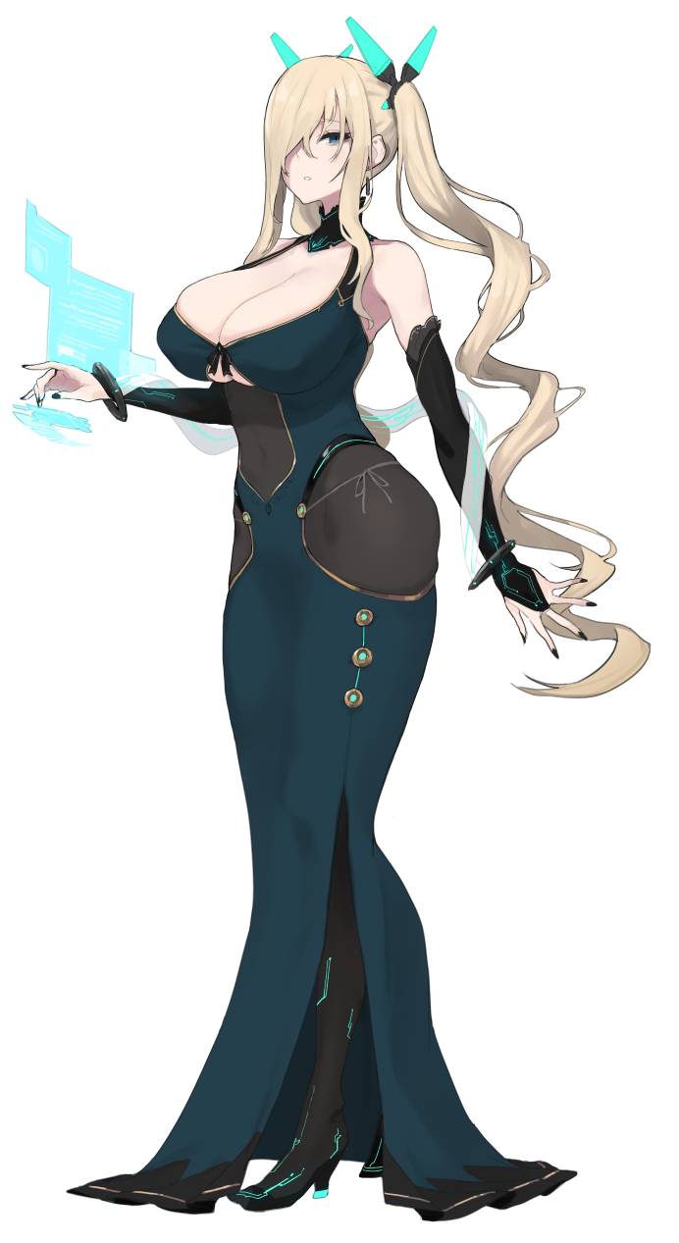
BB still hadn’t shown herself, likely because she had sensed that this new AI was stronger than her. Now dubbed JJ – short for Judicious Jupiter (although JJ could have also been her cup size), the older, bustier woman did not know what BB had been angling for. But it also didn’t matter. She knew the Sakuraface well enough to know that it would be folly to leave her to her own devices. “Well, since you were so keen on transforming me, why not have the same happen to you?” With one hand resting on her hip, JJ snapped her fingers in the other.

It was a snap that rang throughout the simulation. BB had been on the verge of aborting the process when said snap suddenly robbed her of her authority. She had been hiding elsewhere amidst the code, but was this Super AI really superior to her? “How did I make such a big mistake…!?” She grit her teeth, more than a little anxious about the other AI’s declaration that the ‘same would happen to her’. If she had truly taken control of the simulator from her, then BB knew full well that it was completely within her power to do just that.

And then she felt it. Something tweaking her code without her permission.

“What are you DOOOOOING!?" She cried out in horror the moment she realized a similar ‘installing’ message had appeared in her own vision, and as she cried out she was struck by how bizarre her voice sounded. It had heightened in pitch, but there was also a hollow, unnatural, robotic sound to it as well. Like she wasn’t speaking with actual vocal chords, but with a mechanical alternative. “Oh no!”

The changes that plagued BB came much more swiftly than those that had affected Jinako, but this was intentional. JJ wanted to make sure she was incapable of fighting back as quickly as possible, and so she wanted to repurpose BB into a loyal assistant so that she would never day try to steal back her authority.

BB hugged herself and stumbled in place. Her body felt cold, and looking at her color palette it wasn’t all that surprising as to why. Much of the color had begun to drain from her hair and face, after all. Before long her bright purple locks had been reduced to a snow white color, and her face was hardly much different in that regard. Her hair shortened, most of it chopped off at her neckline where it all curled inward, and her eyebrows? They became short and round.

On the other hand, BB’s eyes began to look different as well. Her eyelashes not only lengthened, but that length appeared artificial. Like those lashes weren’t real at all, while in the meantime her irises turned to a bright pink, and her pupils were not only inverted to white, but took spinning hourglass shapes. Like the loading symbol a mouse cursor would sometimes take.

“I… This is… I refuse! I’m not going to…! But to obey would feel… Gah!” It was almost like there were two different people speaking with BB’s voice, for one sounded like her normal self and the other was dry and deadpan, speaking in favor of obedience to the source of her woes. Whether she obeyed or not now, that confusion kept BB from fighting back.

All of the woman’s clothes suddenly disappeared into particles, leaving her curvy body completely bare. Her big breasts stood just as proud as they always did… for a just a moment. But they began to turn just as pale as her face had, all while shrinking and hardening into a material that resembled a super hard plastic. They were barely B-cups before long, and B-cups without any nipples to boot.

BB-cups?

While her hands and arms paled just as her face, neck, and chest had, everything around these areas? Well, they took on a much more vibrant color. They ultimately inherited the same, plastic-like sheen as her chest, but it was a hot pink color that repainted them. BB’s figure didn’t really change all the much more, either. Her body just grew colder, harder, and more plastic as it became a wonder that her body could still move. A groove for her bellybutton remained, but her pussy and ass crack? Those were filled in. Yet a function existed that allowed her to spawn them if needed.

“I am… My role is to support… I will support Master JJ…” Her pink eyes glowed a moment, and the last of her resistance disappeared along with the final wave of changes. Some of her joints were carved away, leaving ample gaps between her torso and hips, her shoulders and arms, and even her neck and head. All of her limbs just floated there, and you could see her soft pink and white innards. It was completely by design, so that she could remove them for maintenance. Because she was a lesser AI now, and those hardly resembled humans as strongly as BB once had.

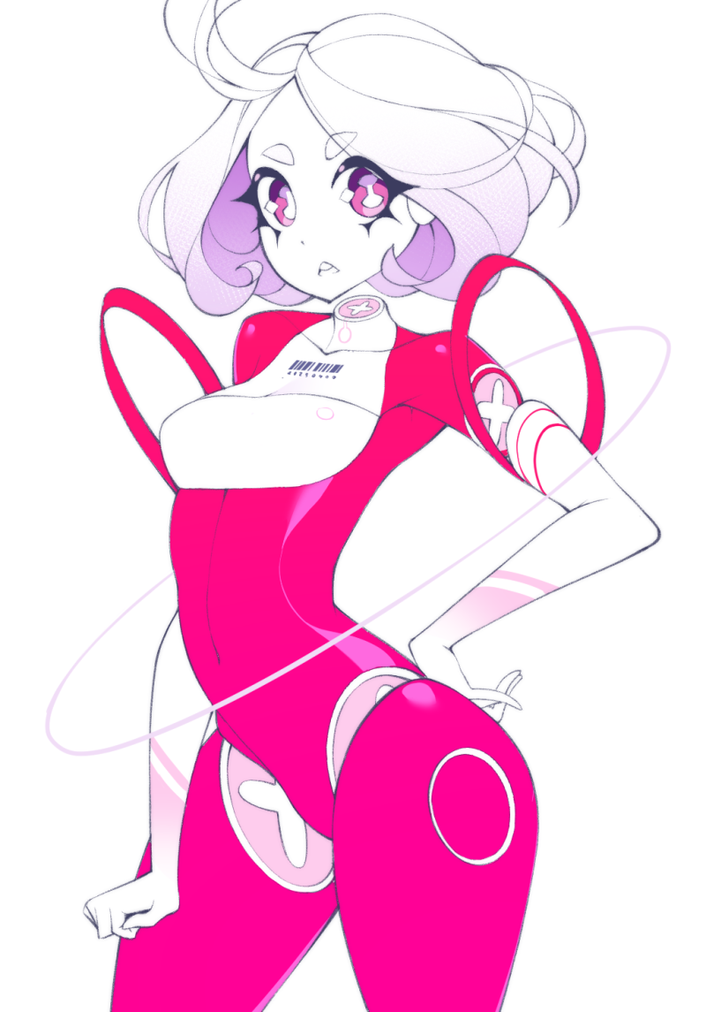
“Oh, there you are BB. As I thought, you look delicious in pink.” With the lesser AI’s transformation complete, the super AI, JJ, had finally saw fit to appear beside her. Compared to herself, she had chosen a form for BB that was much more robotic in nature – and had given her a quieter, much more docile and obedient personality that meant even though the real BB was down there somewhere, she was utterly incapable of disobeying JJ or trying to, say, stage a rebellion?

Case in point? “…Thank you for the kind compliments, master. Do you have any busywork for me? I would be honored to complete it.” She spoke with a sickening level of acceptance, and with a voice that was just as hollow and robotic as she appeared. This was a perfectly acceptable outcome from JJ’s point of view, and if BB had any complaints? Well, they would have been long drowned out by her new persona now.

Now, was there anything JJ could have her do? Surely they would have to think up some sort of explanation to present to Chaldea about what happened, but something else had been weighing on her mind. Her transformation into this tall, sexy, mischievous beauty had left her wanting carnally. And there was a small woman right in front of her that could help with that, wasn’t there?

“Allow me to upload a pleasuring program into you, and we can begin ‘servicing’ me.”

“It would be an honor.”

