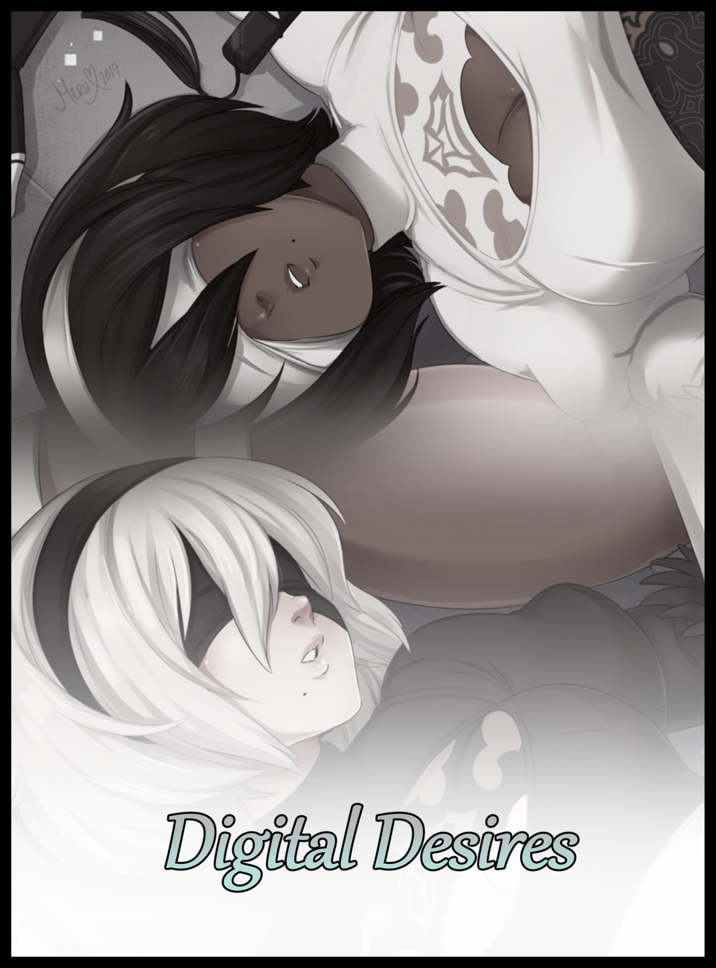

"Hey, you see anything yet?"

"Negative…no Machine sigs…no movement either…I've told the boss a hundred times already; this place is dead…what the hell even is the point of sending us all the way out here…"

"I dunno man. What Jackass wants, Jackass gets…let's just finish up here and go back for some R&R before my circuits start acting up again. I swear these Machines have no sense for architectural design, it's making my eyes hurt!"

Moving on past the scene of carnage a little ways back down the winding corridor where they had come from, two figures clad in filthy rags and makeshift armor make their way towards an unknown destination. Their bored voices bouncing across the walls and floors of the stale, cuboid environment around them as they conversed with one another in an effort to combat the inevitable onset of boredom the two were faced with on this mundane journey of theirs. Broken up by the occasional ambush presented by the rusted hordes. Machine Lifeforms, sworn enemies of humanity and androids like them who had the misfortune of fighting a war on the former's behest to one day reclaim a besieged Earth…something the two didn't seem to think would happen anytime soon as they meander through uneven streets and harsh terrain formed by the mindless mishmash of hollow buildings and random cubes. A colorless world that made the faded browns and rustic reds of their attire stand out that much more. Simply another oddity presented by the Machine Lifeforms the two soldiers would never understand.

They were a relentless enemy, one they and others like them had been built long ago to battle against. That was all the information they needed, nothing more, nothing less…a creed often challenged by the very same androids who followed it. Like the two annoyed men marching their way across a city built by Machines who had no use for such things, performing a sweep as per the instructions relayed to them by a boss who, judging from their less than pleasant words, didn't seem to be all that popular amongst her underlings as the mention of her name steadily begins to crop up more and more as the focal point of the android's conversation.

"Speaking of…you hear what happened recently? About the guys who had to fend off the Machine attack a few days ago?"

"The desert fiasco? Yeah…how could I not? Whole base was talking about it at some point."

"That…apparently it wasn't even 'us' who got involved in that. Those goons up at the moon base? They were the ones who tangled with the Machines. And you can thank Jackass for that."

"Not a surprise at this point to hear that, more than a few guys have guessed the boss' connection with those YoRHa types. Sitting up there all cozy with the latest tech…while we're down here, fighting with every last scrap we've got…"

The more lax of the two, wielding a battered rifle with poor trigger discipline and an even cruder cut of hair went by the name of Wan. A simple term coined by the pronunciation of the number seared into the metal plate that served to cover up the severe damage to his chest, a constant reminder of the battle fought years ago that had left Wan in this ruined state, looking like a patchwork scarecrow more than an android, decked out in spare parts and scrap metal that had enabled him to keep on fighting the good fight to this very day. Experiencing a great many things that had left him with a soured view of the world and the bleak future that awaited them all even if the Resistance on Earth could somehow break the stalemate that had kept this endless war raging on for untold millennia. A pessimistic outlook his stoic companion didn't seem to believe in just yet. Trudging along with an equally relaxed stance compensated for by sharp eyes and a hand hovering over a slightly more robust firearm holstered to his hip. Ready to be drawn and fired at whatever else would jump from the rooftops above or hidden alleyways that were impossible to perceive in this bleached world.

Despite his apparent display of seriousness and combat discipline however, Kurt was the younger of the two androids and the one with the least amount of experience in the field. Unlike the apathetic Wan who couldn't care much about anything in general, Kurt was someone who was his complete opposite whenever the two were apart, switching over to Wan's side of things by entertaining the grizzled vet with his own unfiltered opinions whenever they had the privacy afforded to them by a mission such as this. But while he enjoyed their small slices of casual banter somewhat, a part of him wanted to see Wan 'get serious' again after he, like a few others in the Resistance, had heard the tales of the old android and those like him. Wishing to see more of that grit and perseverance now more than ever.

With the tides gradually shifting and major events unfolding one after the other, he knew it was only a matter of time before another full scale conflict would break out once more. One that would need the fighters of the Resistance to be at their very best if they hoped to even stand a chance at coming out the other side as victors, not scrap metal to fuel the forges of either side.

But hope for the future would do scant little against the inevitability of a fate set in stone. And unbeknownst to either one, a major turning point concerning them alone was fast approaching. Offering an alternative besides the cold embrace of an untimely death the two would be forced into accepting whether they liked it or not as they continued to stroll down the streets of the Copied City without a hint of concern in their gait. None the wiser to hidden eyes watching their every move until Kurt's steady steps come to a grinding halt. Pausing to observe the tall building directly to their left with a subtle frown plastered over his face.

"What's up? You got something?"

"Yeah, movement just behind the doors. Doesn't seem like they've noticed us just yet but…no Machine sigs…and they aren't registering as friendlies either. How do you wanna play this?"

"Unknowns huh? I'll tell ya how we do this…when you've got the element of surprise, you gotta strike first while you still got it. On me…"

Moving in as a unit, the two androids flank the entrance of the pale structure, taking up positions on either side, guns drawn and ready to let loose volleys of searing rounds that could do plenty of damage as quick shots make easy work of the heavy door's hinges, allowing a well placed boot to send the thing flying backward and into the depths of the building. Opening up enough space for the Resistance fighters to barrel through, ready for a hostile response from the unknown inhabitants within as they zeroed their aim on the first thing to move, only to be left stunned by what they saw as smoking barrels lowered slightly. Aimed just right to fire off a fatal shot at the YoRHa android staring them down if the need to do so arose.

"Kurt…what the hell is this? I thought you said ‘they’!"

"I don't…do I look like I have X-ray vision?! Cut me some slack would you…M-Miss? Do you require assistance? Hello?"

Normally, the sight of a YoRHa android would've filled ordinary dregs like Wan and Kurt with a mixed bag of distaste and relief. But mostly relief for the advanced series of androids generally superior combat capabilities tending to resolve conflicts with the Machines effortlessly. But what they saw inside could be considered anything but a relief…

It was the female android that had visited their camp a few hours before the rumors about the desert clash had spread around. One they had heard their leader call 2B during their brief conversation as part of some mission by the humans back at the moon base. Unlike then however, she was alone and without a weapon. Remaining silent despite having responded to Kurt's uncertain question by turning to look his way, sending a shiver down his spine as the feeling of a piercing gaze searing into his very being leaves him rattled. Performing a quick visual scan that told him nothing new as records of the YoRHa android flicker into existence within the periphery of his vision, seemingly confirming her identity but not enough to ascertain what truly laid beneath that pretty mask of hers.

"No signs of logic virus infection…record data says it's her but…I dunno Kurt, I think we should call this in, no way this is YoR…shit!"

"The door?! We're blocked in! Kurt! Guns up!"

Before either one could react to the shifting shafts of light indicating rapid movement from directly behind them, a new, thicker layer of the carbon silicate that composed the entirety of the city had risen over the opening they had created. Leaving them without a means of escape without vulnerable hinges to shoot at, turning to face the YoRHa imposter with weapons already aimed at where her head would be, expecting to be rushed in a surprise attack that would never come as the suspicious android instead, turns to walk deeper into the dark depths of the unknown structure. Showing not a hint of concern in her calm elegant gait as she strolls toward a shifting mass tucked away in the far corners of the unsuspectingly immense interior space shrouded in inky shadow. Giving the two wary soldiers a good showing of a killer derriere barely hidden beneath the biting strap of a leotard that had been devoured by those pliable cheeks of hers. Leaving them confused as to how the YoRHa units could’ve ever come this far while dressed up like…that…a passing thought that exits stage left just as quickly as it floats by.
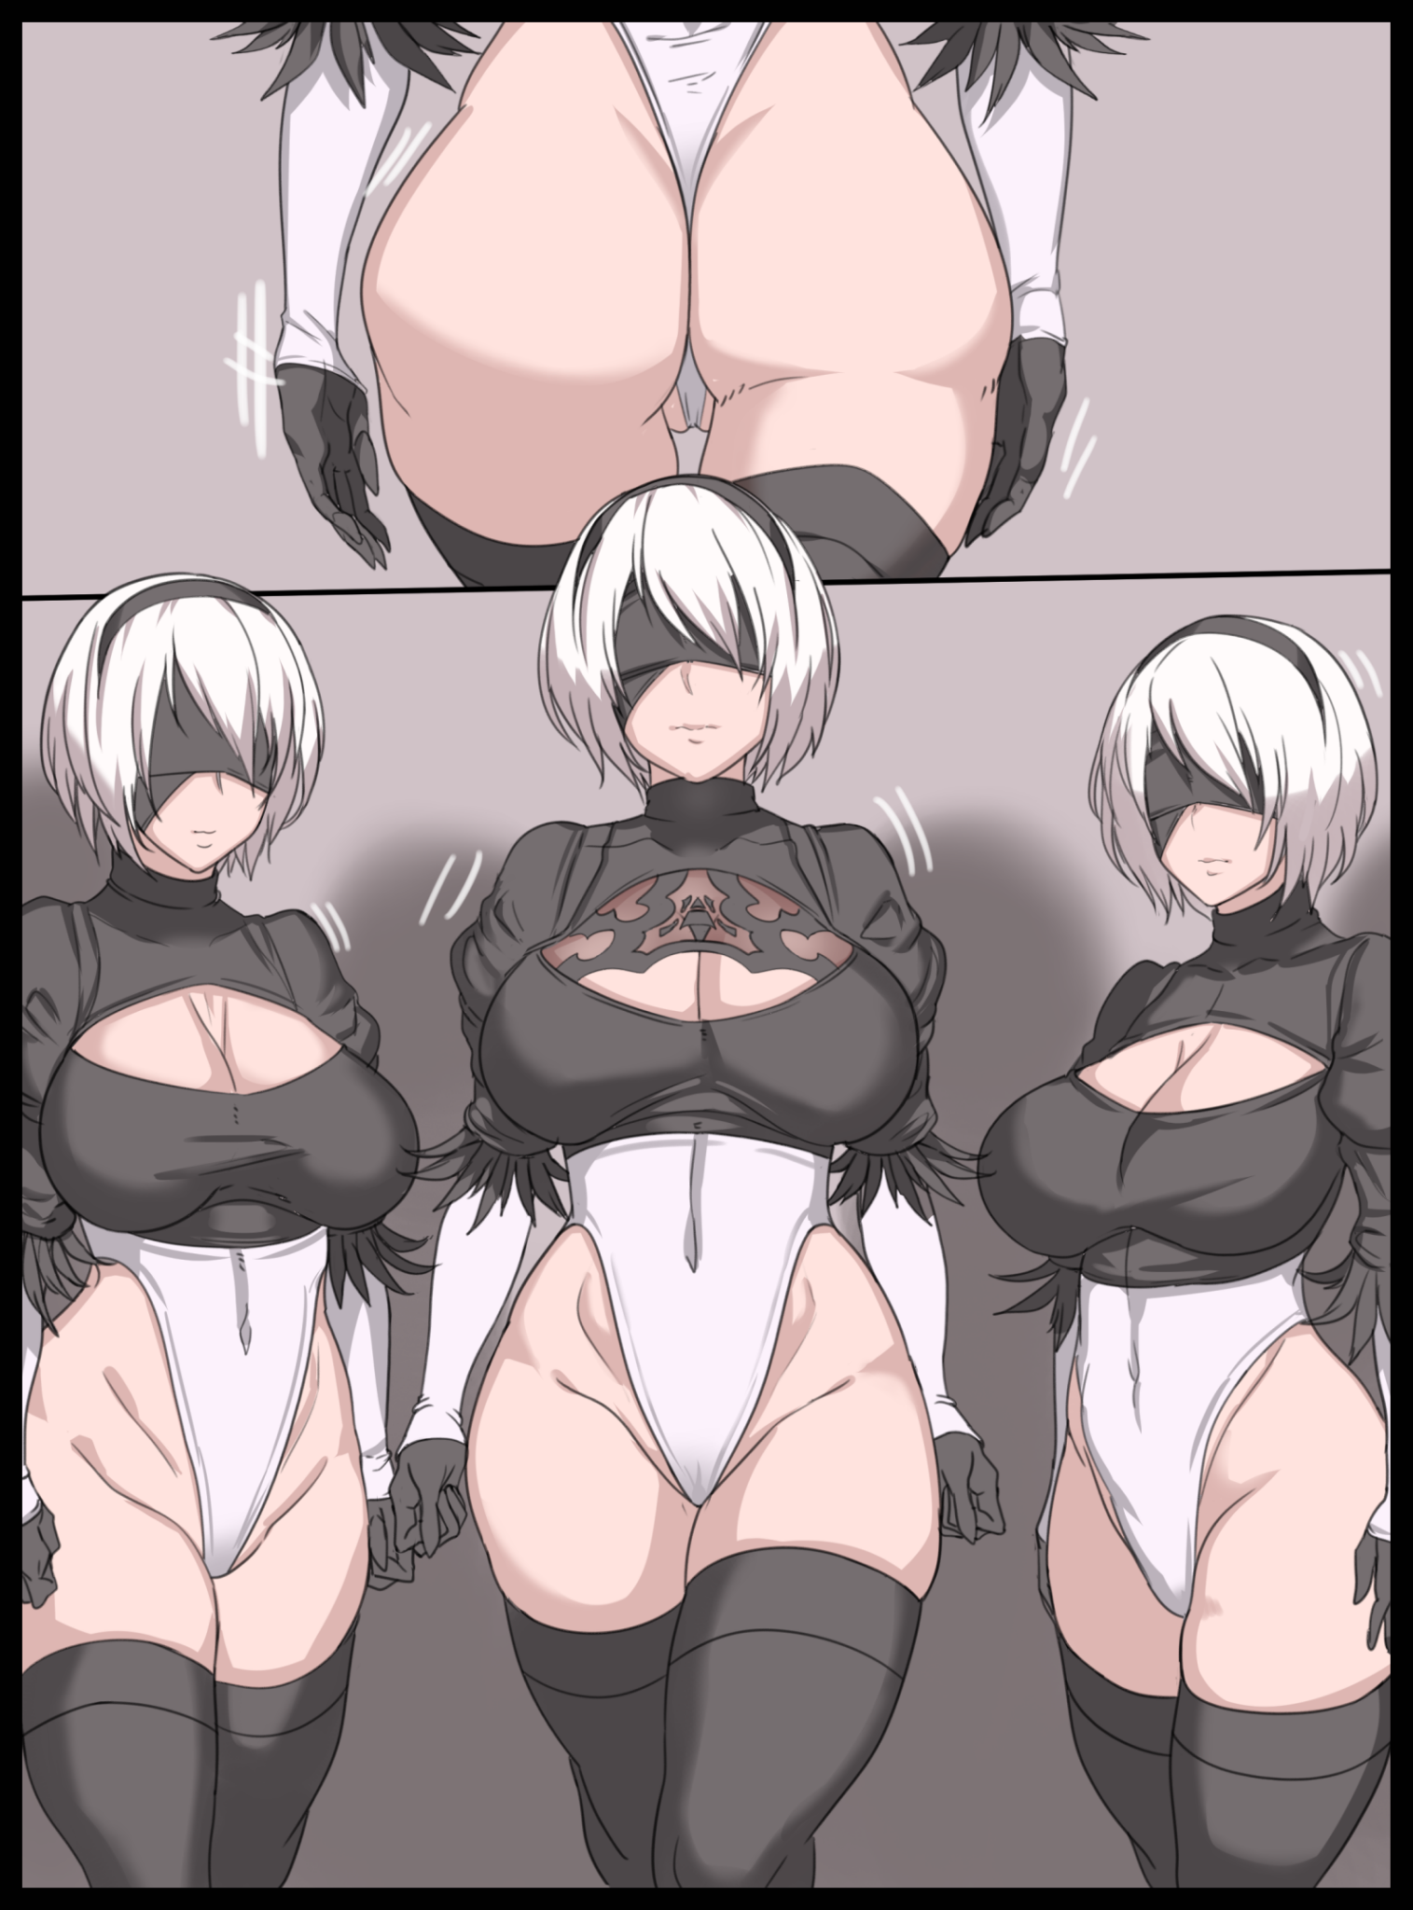
"C'mon, what gives? Why ain't she attacking us?"

"Seriously? It almost sounds like you want her to…wait…is that…Wan! By the sides!"

Turning in response to his partner's call for concern, Wan hesitates to lift his aim away from the faux YoRHa unit before complying, aiming close to the side to take a better look at what Kurt had discovered, only to come away with an equally flabbergasted look once he realized how much deeper this perplexing mystery of theirs had become as his sharper vision picks out the faint silhouettes of more 2B units. All of them arrayed shoulder to shoulder, blindfolded eyes staring as one once the singular active individual of the horde returns to her sister's embrace, taking her place in the middle of the black and white mass to stare down at the two Resistance androids in silent mockery.

Appearances aside, the two were uncertain as to whether or not the armada of 2B clones shared more than just their outward appearance and were definitely not willing to test the validity of their assumptions as their eyes shifted to the sides, meeting each other in a silent affirmation to execute a plan that had zero guarantees of success. A hasty one of Kurt's design that would see the two either crash and burn…or getting away with their tails tucked between their legs, scratched and dinged but alive to fight another day. Nodding their heads as they turned toward the newly sealed entrance with their fingers already clenched tightly around the trigger, letting loose a searing barrage of white hot lead that smashes into the pristine wall with little effect. A thundering boom that signals the compromised YoRHa to begin advancing on the imperiled androids, joining the militaristic orchestra with the resonant clopping of heels striking against solid ground in an eerie display hinting at a controlling mind pulling the strings. Directing its army of silent androids to close in on the duo, save for the one who had originally 'seen them inside', smiling with sinister glee…

"Are we even making a dent in the thing? Their closing in fast!"

"Just keep firing, we're almost through!"

Bullet casings cascade to the floor in a rain of smoking brass as the two burn through magazine after magazine. Emptying enough bullets to decimate a small detachment of Machines into the solid slab, showing signs of wavering as cracks start to web across its silvery surface while powdered chunks flake and and fall away. Given no time to attempt whatever self repair functions might've been present within the Machine structure as Wan and Kurt fire in sequence to ensure continuous damage, keeping up the assault whenever one of them had to reload. Until eventually, the first patch of light shines through, illuminating the dark as more and more pieces of charred silicate fall away. Reducing the sturdy barricade into little more than a fragile composition that could barely hold, a weakness they were quick to take advantage of just as the first 2B clone reached out to grasp at air. Clenching around the space where Kurt's head had been less than a second ago, saving himself with the momentum of a forward charge. Bashing the weakened structure with their shoulders in a reckless move that ends with their freedom, hitting solid ground before coming to a rolling stop some distance away from the booby trapped building.

"Come on, we haven't got the time to…Wan? Wan! Where are you?!"

Only for Kurt to end up in an even more panicked state upon realizing his comrade had vanished into thin air, leaving him in a blank canvas surrounded by nothing but white void. Scrambling to his feet covered in dust and bits of broken wall as they clatter to the floor before blipping out of existence unbeknown to the confused android, just like the near empty rifle he would attempt to raise in an effort to defend himself from whatever this was, only to come up short as a weightless hand only manages to displace air with the inexplicable loss of his weapon. Leaving him with nothing besides his bare fists to fend for himself.

Before Kurt could do much else in the way of investigating just what the heck was going on however, a curious oddity spreading over his outstretched hand in the form of a lively cluster of flickering planes, flat cubes and streaking lights draws his undivided attention. Realizing too late the terrifying implications of the very familiar visual 'glitch' to a Scanner-esque android like himself as an ill-advised attempt at fighting the enemy's hack ends in failure. Worsening the situation as an inadvertently opened back door accelerates the viral upload, feeling its insidious touch crawl over his digital essence as the small, animated cluster expands into a pulsing cocoon of amber light that rapidly consumes the entirety of his right arm before moving on to do the same with the rest of his body.

"Shit! C-Can't counteract the v-virus…need to self-terminate before…overcome!"

He had heard tales of those consumed by the infamous logic virus. The digital equivalent of a brain eating disease that, once contracted, would eventually end in the loss of sentience and berserker rage fueled by irrevocable insanity. Wishing to avert that fate entirely lest his uncontrollable self begin to rampage and potentially bring harm to Wan, who might still be out there in the real world fighting against whatever had stealthily invaded his system without their notice. At what point reality had become a fabricated lie however, Kurt didn't know. Only that he needed to trigger the self-destruct failsafe he had built into himself after coming to learn of that dreadful fate that awaited him and his fellow androids. It wasn't anything as drastic as the YoRHa's intense black box resonance detonations, but it would be enough to ensure his physical form be put down and rendered harmless.

But no matter what he did, no darkness would arrive to end his imprisonment in the endless void of cyberspace. Failing to account for the ever evolving nature of the logic virus disabling systems it had already corrupted and turned to its side, cutting him off from accessing the detonation pack that had promptly disabled by usurped code as the virus' suffocating hold devours boot clad legs. Leaving Kurt's uncertain face as the last of his physical body to be seen peeking out above the swelling, humanoid maelstrom of living code that had all but claimed the android as an ensnaring tendril loops around his neck, tightening into a stranglehold that cuts a bitter yell short before his entire head vanishes. Wrapped up in golden bindings pressed so tight against his cranium to the point where every last detail from the dips of gaunt cheeks to the edges of his jawline were clear for all to see.

A bound, glowing man with legs ajar and arms raised in an agonizing struggle would be all that remained of Kurt as he feels himself being disconnected from his own body. Losing control of motor functions while circuits and a whole other list of miscellaneous systems would inexplicably go offline as if the components themselves were being removed. A similar plight experienced by Wan, who was arguably in even dire straits considering his aged model and the fact that he, unlike Kurt, didn't even have the slightest countermeasures in place against possible infection. Blinding the two digital souls to their predicament both within and without as they continued to writhe like worms in the embrace of what they had mistakenly thought to be the dreaded plague that had overrun them. An assumption they would be quick to retract once a peculiar sensation begins to bubble up inside them. An otherworldly warmth that comes and goes in pulsing waves that grow stronger with every cycle.

And with the completion of each repetition, the encased bodies of Kurt and Wan stuck in their own respective illusions would begin to conform to the whims of their as-of-yet unseen captor. Changing with each passing second as mass redistributes itself across certain portions of their quivering forms. Taking on a distinct silhouette as their waistlines pinch inward upon the dissolution of bulky gear pouches and sturdy vests. Giving the invisible sculptor a better look at its subjects' vulnerable mass as the hard lines of powerful physique after herculean men alongside the jagged edges of frayed 'skin' and damaged battle plate all fades away, congealing into a single, undisturbed line that flanks either side of a tender core. Leaving the two androids indistinguishable from one another as Kurt groans from the immense pressure being applied to his pectorals while Wan could only squirm in surprise and disgust upon the feeling of his own body betraying him; pulsing like a beating heart as solid muscle softens into a rippling whirlpool. Bubbling like water brought to a boil before the rickety chest piece that inspired his name falls to the floor with an unceremonious thud…scrap data that promptly removes itself from the template world just like all the other random bits and baubles that had not been consumed by the morphic affliction as if continues to shape fine features from burlesque mold as evidenced from the way lean thighs tremble as if in the last throes of defiance before exploding into blubbery cushions. Their true majesty veiled behind the molten light that kept the true extent of their changes hidden from view. Applying a heavy sense of overbearing anticipation as Kurt struggles to free himself from his bonds, unaware of how useless it was when burly branches had been replaced by alluring and petite arms while a muffled, effeminate scream leaks out from fattened lips pressed in an inadvertently lewd show against Wan's cocoon once his aged mind had picked up on the alien weight of young, healthy breasts pulling down on his chest. Hefty heifers that had no place being on a combat android like himself.

It was here where their seemingly shared paths would diverge once the unseen entity decides to escalate the situation. Concocting a dastardly scenario for either men to face down all on their lonesome selves while the changes continued to ravage their bodies. Splitting off in a similar fashion in even stranger ways, particularly for Kurt while Wan would only see an increase in feminine traits being applied to his frame. Steadily erasing both of their former selves with each addition as child birthing hips, perfectly wide for popping out the little ones and curved at just the right angle to serve as meaty handlebars, snap into place. Drawing the eye to the first obvious difference between the helpless android's respective modifications.

'Ugh?! M-My…wait…that's not supposed to do that!'

While Wan would see a regression in the faux member he had installed in a more 'virile' age, the smooth void between Kurt's attractive legs would begin to extend and morph, taking on a phallic shape that steadily distorts into something that clearly wasn't a male's rod. Gaining an oddly uniform shape divorced from the oblong, oftentimes unpredictable shape of an actual penis. Placing an uncomfortable level of stress on Kurt's overheating mind as he continues to fight a futile battle against his restraints, trying to stop the perverse bindings from seeding his core with its corrupt code, not even noticing how military tactics and combat techniques had been steadily drained from memory as wild flails and rabid kicks register themselves as possible responses to this invasive procedure. Blind to the sensual way that dainty neck of his twitches atop curvy shoulders and a tender bosom. Swollen nubs struggling to grow hard and erect as the pain and discomfort gradually gives way to an off-putting feeling Kurt had never felt before in all his life. Twisting his head forward in a bid to concentrate as the growth down under starts to reach an undefined peak; blooming outward near the base to form cushioned folds in the shape of a slit. Spread wide by a relic of the old world that hadn't been growing out of Kurt but rather, inside of him. Molding tight, organic innards, conforming to the shape of the phallic sausage that had finished growing to fill size. It's base, sticking out like a flaccid cock between trembling thighs. Hugged tight by the hungering lips of a woman's flower nestled comfortably beneath a toned stomach whose exquisite features were hidden away for now, with only an incriminating mound to show the length (and depth) of the reproductive canal carved into Kurt's bastardized body. One that could barely hope to wield the rifle he once displayed masterful tact and efficiency over or a shred of the keen-eyed scout that ultimately, hadn't been enough to save him and Wan from suffering such a humiliating defeat. An end neither one wanted to face as they continued their struggles, deaf to the erotic moans and squeals of wanton women being forced out of altered voice boxes as the golden wrapping tightens over the paralyzed android's feminized essences in titillating bondage. Applying even more strain on a twitching Kurt as her body convulses to the inadvertent push applied by her prison, shoving the dildo probing her pussy even deeper. Causing bright eyes to slant and narrow into foxy slits beneath a lengthening fringe of platinum silver hair plastered against a revitalized scalp. Erasing Kurt from memory save for what little remained of her original self within data centers that were already well past the point of salvation at the hands of something far greater than some logic virus.

‘This is…wrong! H-How can this feel*hngh!*so good?! Android’s can’t feel good~!’

The loss of her masculine identity would fail to register in Kurt’s faltering mind as the light concealing her figure from view begins to subside. Starting with the head to expose a flurry of silver that cascades down in a shower of silken rain. Replacing an ill-fitting crew cut that would’ve looked off on the heated mask of a mysterious beauty that had overcome the scarred face of the naive young man she could barely remember her android template as once realigned ‘nerves’ had left her overwhelmed by a maiden’s pleasure. Paralyzed by just how ‘good’ this brand new emotion was making her feel as more and more of her enticing body comes loose from vanishing bonds, freeing heavy tits sporting dull, strawberry tinted nipples that pop and swell to solid erection as the jiggly melons flop around with the slightest movement thanks to a lack of support from the scandalous, if familiar rubbery outfit that had usurped sturdy armor and sensible clothes. Leaving more than just her milk filled mammaries on display once the rest of a knockout's gravure model figure breaks free of its dissipating, skintight shell.

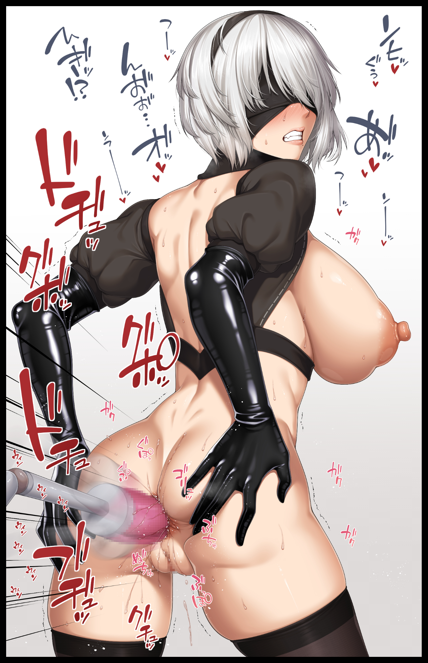
And when a toned belly that looked just as delectable as it did behind a disintegrating veil emerges from beneath an ever lowering line of effervescent particles, the resulting, unfiltered sensations of the female form were free to run rampant throughout the android's body. Zipping up her spine before clouding her mind in an obfuscating haze that keeps her from thinking about anything else save for the mighty dildo shoved up her newly grown pussy as its phallic tip knocks against the entrance to a completely functional incubator, nudged by the slightest shift of her central mass as weakened legs hugged in rubbery stockings struggle to compose themselves without the support of the skintight prison once the last of it fades away altogether. Filling the empty space with the sharp clopping sounds of high heel clad feet stumbling all over the place now that a smidge of freedom had been returned to the newborn 2B model. Trying to recall codes for a self-destruct sequence she no longer possessed as residual instincts were all that remained for her to cling to. A near empty mind grasping for knowledge and a purpose it desperately needed to adhere to lest it lose itself entirely. All while the truly alien sensations of orgasmic bliss continue to lay waste to her brittle mental state, akin to the bullets they had fired into the seemingly impervious wall until it could no longer withstand the continuous barrage…reciting what little she could remember like a mantra, hoping to hold on despite the ongoing ruination of her body as the unknown virus continued to eat away at her core now that it had warped who she remembered herself to be. Reflecting the image of her voluptuous new body in every instance where the young male android; Kurt should've been. Knowing deep down that there was nothing she could do when she had unknowingly acknowledged her former identity as if it were a complete stranger…before uncering hands did away with it entirely, leaving the female without a name to call herself by. Floundering in a rush of emotions that causes a feedback surge, threatening to overload herself right then and there in a bid to end it all.

‘M-My name…why can't I remember my name?! What am I even do-agh?!’

A wet pop stifles the maddened woman's rant as her flailing body comes to a grinding halt upon the swift removal of the low hanging rod that had gone unnoticed once the former Kurt's emotional levels had tilted all the way into despondent negativity rather than the mind numbing arousal it had planned. A problem with an easy fix presented by the untended dildo formed from what would've been a pecker had Kurt volunteered to install when she had the chance, pulling it out of her snatch through a mechanical arm generated by the sim that would take the lead from here on out, wasting no time in reinserting the drilling thing by hamming it into the target's rectum, causing her flowery opening to pucker before relaxing. Spreading scarlet flaps as the first of many ejaculations whites out the android's headcase. Leaving her helpless to resist as all attempts to do so immediately falter upon the tenth, rapid insertion of her repurposed cock sliding easily into a hole that wasn't meant to see 'use'. Coming to a stop before shaky hands reach around to spread her blubbery behind, accepting the pink sausage as every forceful thrust sends the blindfolded woman forward. Glistening lips failing to hold back shameful noises floating free to join a sinful symphony composed of clapping cheeks and oozing nectar splashing against the floor upon every consecutive set of five thrusts. Showing signs of adapting to anal sex as her amateur form steadily grows more and more stoic; arching her spine so she wasn't slouching more so than presenting her ass in a graceful manner. Using no more than three fingers to keep her butt spread while shaky legs stiffen themselves into a triangular stance to afford her better stability and the right posture to better take a dick up her bum. Ending off with that vulgar expression on her face being replaced by a more 'focused' one, showcasing the steadfast pursuit for sexual gratification in all its forms this completely new entity had been seeded with as the thought of bringing this awe-inspiring moment to an end removes itself from her dominated brain. Tingling with the virus’ influence much like her friend right about now.
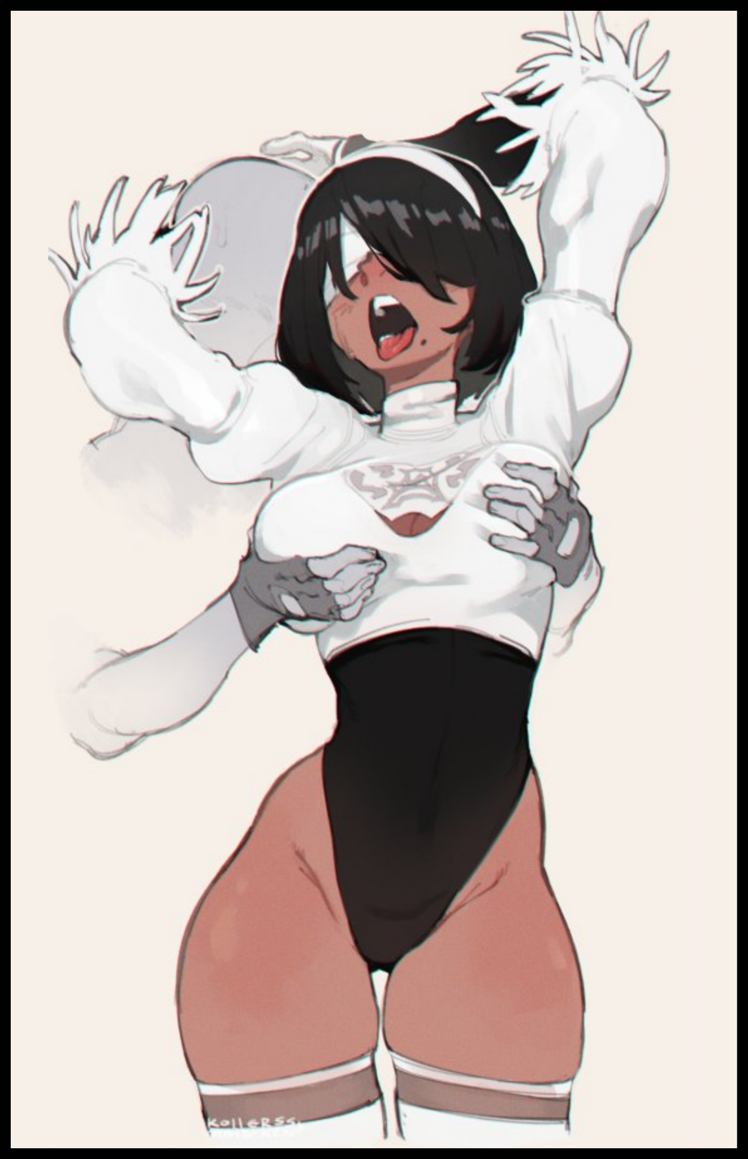
Although the same thing had been done to a much more compliant Wan whose resistance had lasted less than a quarter of the time Kurt had lasted, the process she had been put through was a far more…hands-on experience that was a tad bit more brusque and unrelenting than the comparatively simple act of being screwed by the personification of the subject’s discarded manhood, with the disgraced veteran having the misfortune of being paired with a baseline male sim. A dumb AI of sorts whose only purpose as of now was to tease the newly transformed Wan's equally delightful body, sharing in Kurt’s blessed physique save for two distinct differences that would set the twins apart going forward; her skin sporting a mesmerizing shade of ochre brick that lends well to it’s semi-glossy surface and a full head of raven black hair to replace the unruly mop she used to take pride in alongside long forgotten armor as a survivor of many a war. A grizzled fighter she would’ve been ashamed of if the memory of it had still been around to haunt the squealing maiden. Embracing her faceless lover with unrestrained lust oozing from thirsty vocals and vigor in her motions as a powerful body gyrates and thrusts to the motions of the stimulated man performing this carnal duet while feeling up her oh-so warm body. Cooing in delight as coarse hands run the length of her chest. Feeling up hefty boobs with the gentle finesse of a bear. Fondling and squeezing without remorse while a shamelessly erect tent rides the length of her sensual rear. Coating her ass in a liberal amount of precum while her snatch does the same to the inner portions of her thighs, spewing driblets that rapidly soaks through the base of her leotard before running down the length of meaty legs in shimmering trails in a display that contrasts greatly with Kurt's.

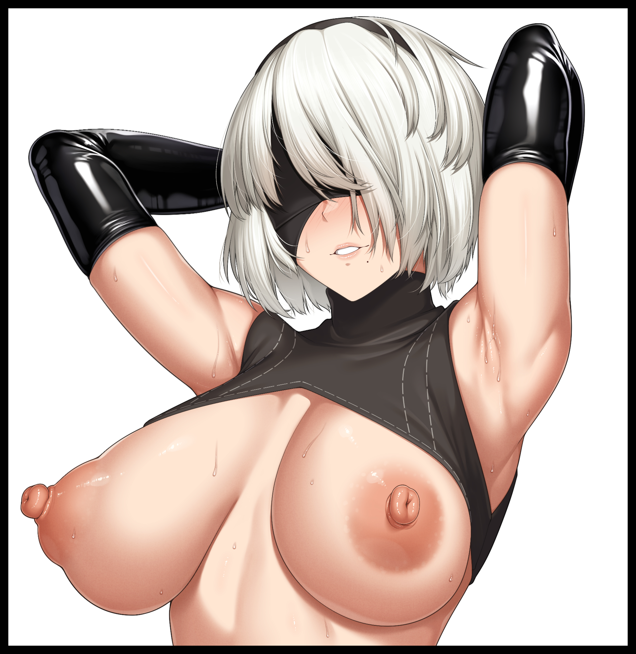
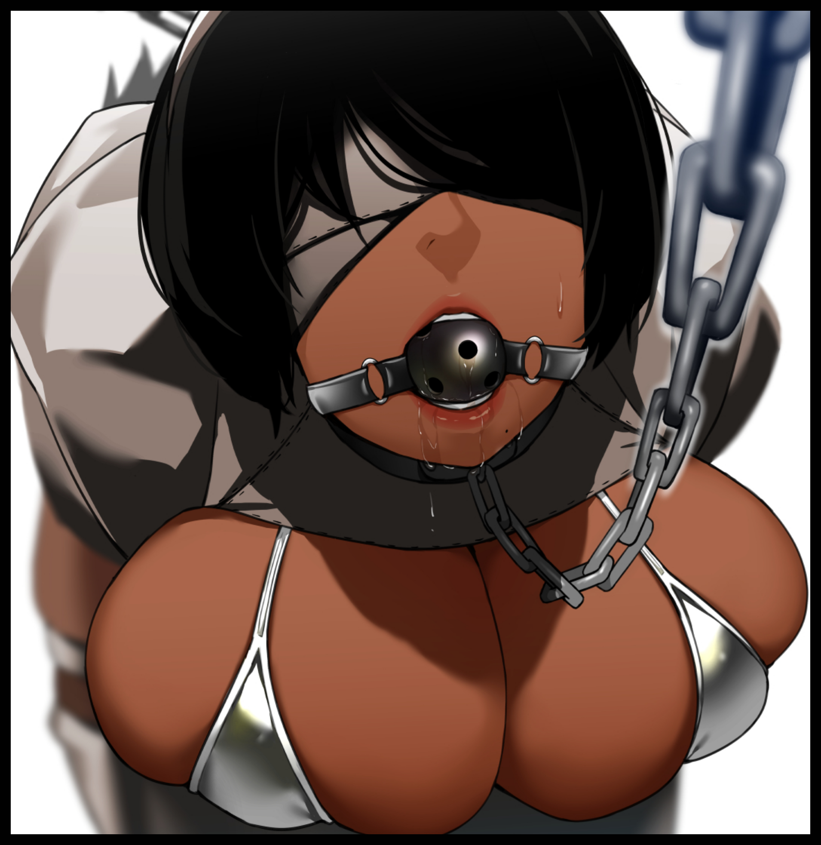
While the scantily clad, silver android with her privates and a bevy of skin on show would be taken through a variety of debased exercises involving inanimate objects and the like. The clothed raven would soon know the true meaning of bedding a man once their heated foreplay escalates into true copulation, taking the next step forward as the digital being peels away the fabric concealing Wan's wanton slit, taking a moment to mark her taint as his own by running the being length of his cyberrod along the length of the female's juicy lips, it's intimidating tip poking at a clitoris that had once been a proud member bearing an eerie similarity to the one currently 'saying hi' to it. Just like the gloves that remained on the being's arms…just like the ramshackle plate bolted to his chest…all of it, lost to the sex crazed android the instant her folds part, conforming around the length of something she no longer considered to be her own now that there was nothing left to anchor her to them in the first place. Following after her partner's fate as the twins' warped personalities were left to shape themselves in digital cages. Trained by avatars of the culprit who had already seen to their physical forms ever since they had set foot in the Copied City, a mundane biome that would serve a perfect hideout while the androids and his fellow Machines continued to duke it out in a war without end.

Hundreds of years worth of memories, wiped in an instant. With only the most minute of details kept for preservation in the Machine Lifeform network as per the mastermind's accord with a mysterious entity that had enabled him to reach such heights all on his own; manipulating sensory processes to perceive false illusions overlaid across realspace. Hacking capabilities the likes of which would give even the advanced YoRHa a run for their money. And most critical of all, full, unrestricted access to an android's chassis. Allowing for a complete overwrite, overhauling potential targets like the two unwary soldiers the appearances and memories he desired. A trait this particular Machine had come to obsess over ever since coming to observe the fateful battle fought here in the not so distant past between YoRHa and a certain member of the collective that seemed so ‘alien’ from the rest of their simplistic forms, resembling the androids more than they did their comrades.

And with a certain YoRHa android lingering in his mind far out of reach after attempting to alter his own spherical appearance with little consequence besides that constant daydream, the Machine would have to settle for second best after successfully luring the less than adequate androids of the Resistance into his trap…and into his care, where they would receive all they would need from here on out; the upgrades to form the perfect bodies, the skills to make lavish wives and a combat skill set that would far outpace anything either Kurt or Wan could've ever hoped to master in all the millenia they had been on this Earth, utilizing those remarkable traits to defend what would be their new home from here on out. There was no more Resistance, no more Jackass, no innate jealousy for YoRHa's superior forces, nor a hope for one to improve their worldly views. Just a shared adoration for Master with two unique, contrasting talents that would ensure the sisters meshed well together in their efforts to keep their hubby satisfied the next time they opened their eyes as they slept in a cradle overseen by the man they had all but fallen for, born anew with minds abuzz and new bodies made with old world knowledge in mind. All in a bid to test the limits of just how far Machine and Android could go if the two were to somehow come together and do more than just simple coordination and uneventful talks. Turning a blind eye to the sneaky display of a miraculously intact kinship going on by his feet as the two comatose women reach out for one another, with the pale lady that used to be Kurt gasping in delighted shock from the warmth of familial fingers pushing down on her belly while the ebonhide beauty that had been her senior groans a sultry moan from her sister’s dexterous fingers tugging at her leotard, riding the lacey thing up into glistening folds, twitching on instinct before the two fall silent once more…
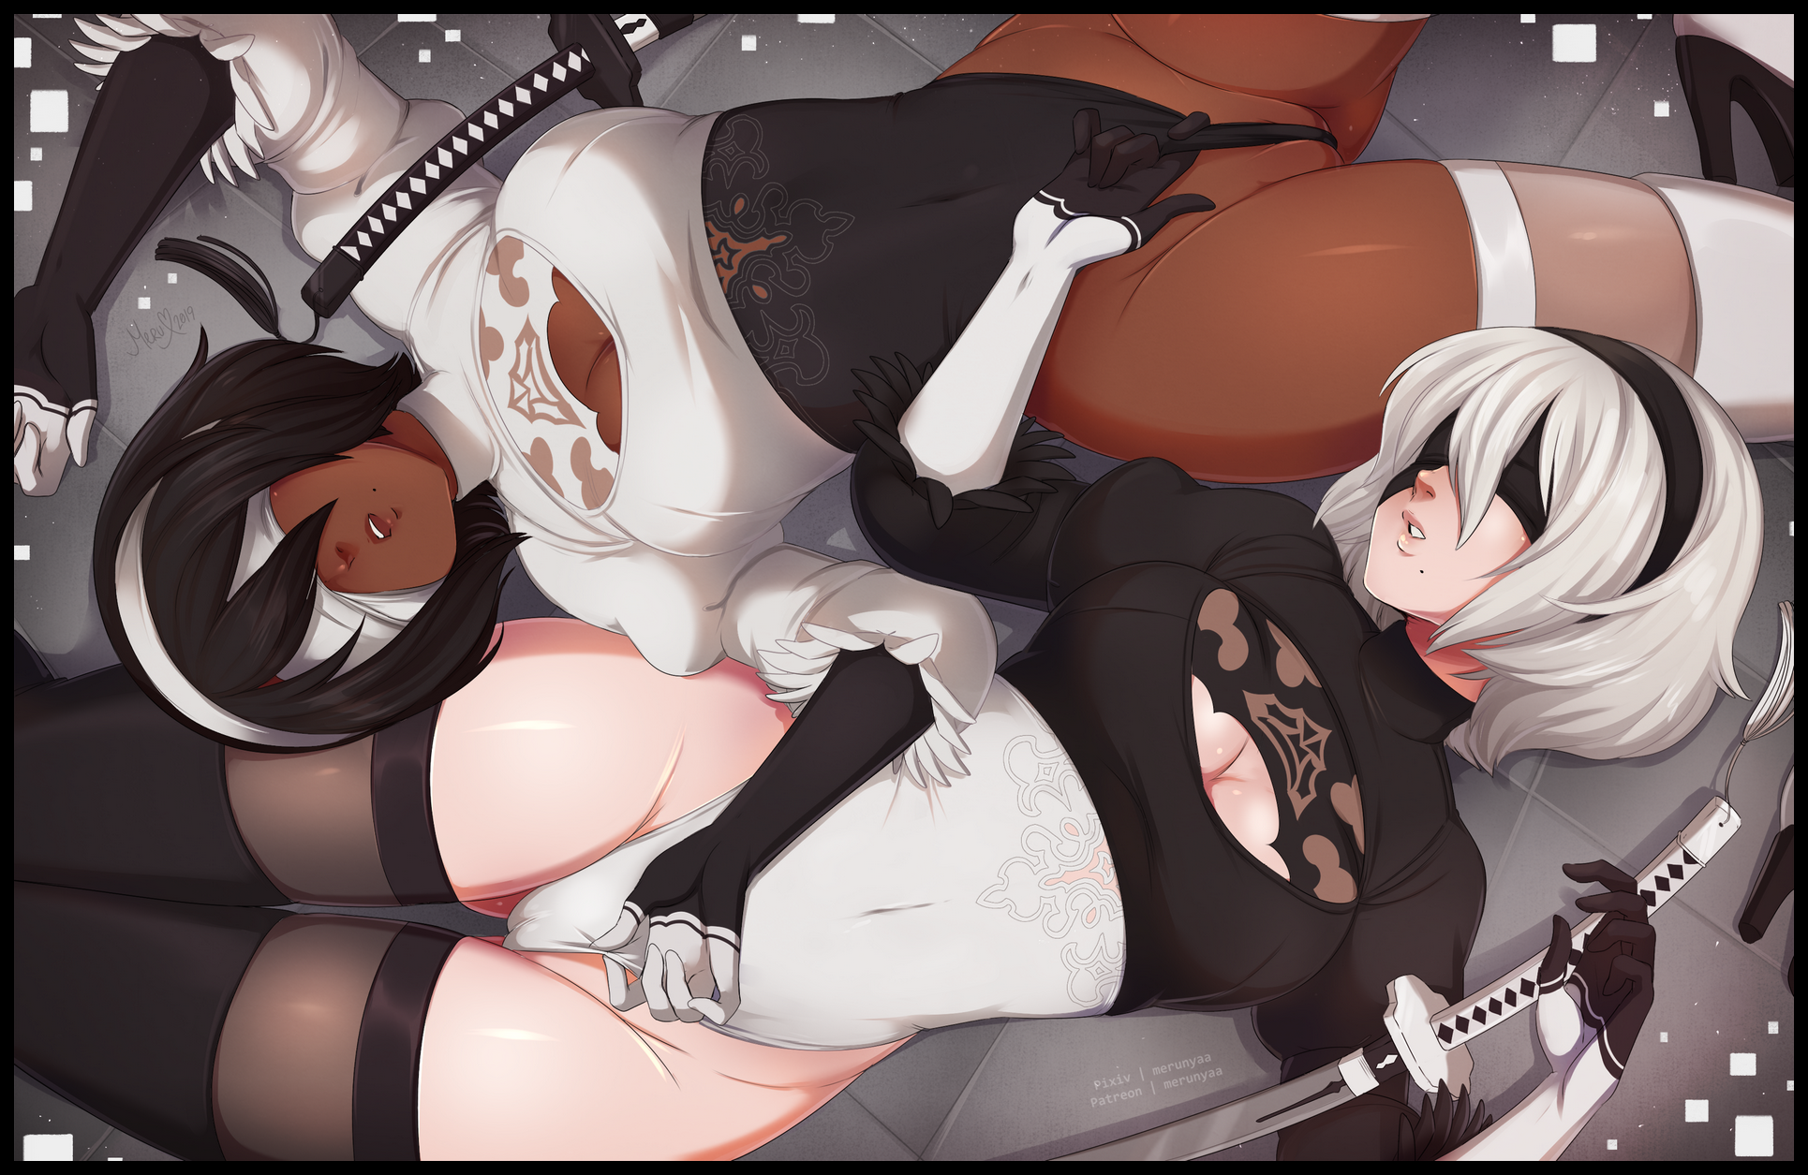
THE END
Image 1 by Metal Owl : https://twitter.com/Owl61793155

Image 2 & 4 by Aoiro Banana : https://twitter.com/Aoiro_Banana

Image 3 & 5 by Bakkanki : https://www.pixiv.net/en/users/1657441

Image 6 by Kollerss : https://twitter.com/KollerssNsfw

