KOMI CAN COMMUNICATE
COMMISSION STORY
BY CHALDEACHANGE
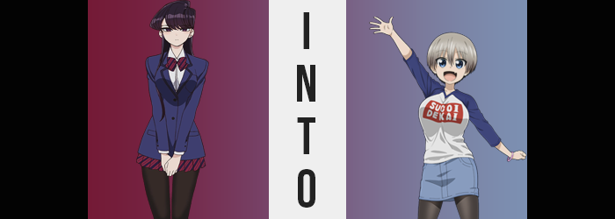

“Try it on! Try it on! It’d look great on you, I promise!”

Komi Shouko, in all of her anxiety, couldn’t help but wonder how she had ended up in this precarious situation. Well, that wasn’t exactly true. The teenager knew full well how she had ended up in these circumstances, where a vaguely gendered youth was waving clothing in her face and trying to coax her into putting them on. Realistically it was all her fault, actually. The consequences of her own actions had simply reared their ugly head. Not that these consequences were really that ugly. To anyone else this would have been an entirely normal occurrence.

But not to Komi. She was a teenaged girl who was stunningly beautiful for her age but also had one very fatal flaw. Socially inept to a fault, she had issues communicating with just about anyone thanks to her extremely potent social anxiety. But it was something that she was trying to fix! Slowly but surely, she had been making friends recently, but admittedly she had also hit what felt like a big roadblock.

It felt like she was running out of people to befriend! Much of her class had warmed up to her these days thanks to her efforts but that only meant that she now had to extend her range. Meeting new people outside of her class, no, outside of her school? That would be much harder to do and so she had to turn to previously unused means.

She had been given no choice but to turn to Najimi Osama.

To many this would have sounded like a bad idea, and Tadano had definitely insisted against it. But on the other hand? It had been Komi’s best bet to try and accomplish what she was after. After all, they were the most outgoing student in her class. When it came to socializing with others there was no one better at it. It didn’t seem to matter who they were taking to, Najimi always knew just what to say. …Well, aside from struggling to talk with Komi herself at first.

“How about this shop? If you have new clothes, then that might get someone to approach you about it!” The plan itself had been simple enough. Komi would brave a trip to the mall with Najimi and observe them. How they spoke with others, especially strangers, must have been important, right? Later on, she was even going to have them introduce her to someone from outside of the school for practice.

But she wasn’t ready for that just yet.

And so, with a hesitant nod from Komi herself, the two had begun to fish around the clothing store in the mall. It was hardly surprising that Najimi was having the time of their life rooting around in the women’s clothing section considering the uniform they wore at school. But this wasn’t really a topic that Komi herself worried much about. Najimi had every right to express themselves the way that they wanted, and they were probably all the more confident because of it. In a way? It was quite admirable.

Eventually Najimi had remembered why they had suggested the clothing shop in the first place however, and they began to look for clothes for Komi specifically. “I guess she probably doesn’t have a lot of spending money. Hmm…” And in the end the process took a lot longer than either of them would have liked, namely because Najimi was picky. But they were also something of a prankster.

Komi was hesitant about their choice. A white shirt with blue sleeves that read ‘SUGOI DEKAI’ in white amongst a red background. Based on where that text was imprinted, right across the chest of the shirt, she could only imagine what it was referring to. “It’s not what you’re thinking! That’s just a saying! I’m not saying you have to buy it, but at least try it on?” Because they wanted to take a picture with their phone and send it to Tadano. Just to see the type of reaction he gave in response.

But in the end the girl was ultimately defeated but Najimi’s puppy dog eyes and retreated into the changing room with the shirt and no more than a sigh. I’ll just get it over with and be done with it. Or so her thought process had been at the time while taking off everything except her underwear, skirt, and tights. Her bra just made her chest stand out too much, and in a shirt with that message on it she didn’t really want that to be the case. Looking in the mirror of the changing room after throwing it over her head, she just sighed again.

I don’t want to show Najimi this… Because she had the right of mind to assume that they were going to take a photo. If she had just asked Tadano to come along with her then she wouldn’t have even been in this situation in the first place, right? So, in a way it was just as much her fault as bringing Najimi with her originally. She’d just have to deal with it for now.

Komi quietly stared at her reflection in the mirror on the back of her door as she steeled herself to quickly show the friend she had attended the mall with in the first place. Even though the teen was tall it was clear that the shirt was not intended for someone of her size. It was too loose and reached her thighs. Like the kind of oversized shirt that you wore to bed because you had no other use for it. “…?”

In the end though? With her gaze fixed on her reflection it was only natural that the teen would notice if anything was awry. And it very much was. Blue. The color blue had seeped into her irises. But I’m not wearing colored contacts… She was too terrified of touching her eyes to do that, nor would she have had any reason to. But leaning in closer to the mirror she found that she couldn’t deny the color had changed.

What was she supposed to do with this information though? Should she get Najimi? But what was Najimi going to do about it? Making matters more concerning? Well, now that the colors of those eyes had been altered it seemed to be a matter of their shapes shifting too. She could feel her eyelids being pulled back a little so that more of her eyes were exposed. She was still clearly Japanese, but she almost appeared younger somehow?

Her face swelled so that it was rounder too, but the subject of her implied age was quickly muddied as the rest of its features grew. Her nostrils flared, but what really stood out were Komi’s lips. They puffed up until they were abundantly soft – that sole aspect of them making her seem older than she had been. But not by much. In the end? It was all because her age had only changed slightly. She was now nineteen.

“My face!?” Once she realized she could no longer recognize herself in her own reflection, Komi blurted out— Wait. She blurted out? She had used her voice? It took even the socially anxious girl herself a moment to realize. And while she didn’t talk all that much for most to be familiar with how her voice sounded, she could tell that it was much higher than it normally was too. This was all wrong… right? Like her hair! My hair’s not supposed to be long and black! Wait… Is it not?

It was supposed to. So long as she completely saw herself as Komi Shouko, at least. But therein was where the inconsistencies arose. On a subconscious level the girl’s understanding of her own identity was shifting. She didn’t see herself as a teenager with long, black hair. It was supposed to be short and silver, right? Almost as to react directly to this newfound ‘understanding’ of herself that hair began to move and lighten. It rapidly resembled the image she had in her head, for each individual strand lightened in color to this silvery coloration while it regressed into a bob that didn’t even slip past her nose in length.

Too much hair is a pain to take care of anyways!

“Mm… I guess nothing’s really wrong, right? But this shirt still doesn’t suit me. The size is all wrong for my height, isn’t it?” Hardly ever one to even talk to herself, it seemed the teen had become quite the yapper without even realizing it herself. Thoughts that were once reserved for herself and herself alone were being articulated aloud without a single care for who might hear them; not that anyone was within earshot to hear them. Even if they had, though? It wasn’t just Komi’s body and mind changing. It was all of reality itself.

And so, it didn’t really matter what happened. In the end it would be recognized as how things always were not just by Komi, or at least the woman she was becoming, but by everyone who had known her. So there was no reason that her height, something she had already suggested she was seeing incorrectly, becoming shorter would really elicit too much of a reaction out of her. “Eh?” But that wasn’t to say it wouldn’t elicit any reaction out of her either.

Dropping from 5’6”, a height that was well above average for a girl of Komi’s (previous) age all the way down to a meager 4’11” in just a matter of seconds wasn’t exactly something that could really go entirely unnoticed, after all. Not as limbs compressed on themselves along with her torso, the weight that existed shifting around from the crunch so that her tummy was fuller, and her breasts and thighs seemed a little more ample. But only because that old body weight wasn’t erased for some reason.

The oversized shirt she was wearing before now reached past her thighs and was clearly still much too big for her. “Huh? Why do I feel like I was just really tall? That’s weird!” Or so she giggled to herself, unknowingly showing ignorance to the truth of the matter as she had been for a short while now. Even her hands and feet had shrunk, her fingers in particular a little bit thicker than they had been prior now that they were shorter. That wasn’t so suggest that she was going to gain any extra weight… Well, she was. It just wasn’t going to be around her tummy beyond what was already there.

Elsewhere, mind you?

“Oh!?” Once again, the girl’s reaction was a little more subtle than you might have expected considering what had triggered it. Her undergarments and tights had just felt very tight all of a sudden. Because the flesh that they were wrapped around was swelling ampler. Her thighs were part of this, skin stretching beneath tights that did the same as they grew a couple of inches wider. Just as it looked like her tights might tear, though? Something happened to them. Their fit shifted to accommodate her widened gait. A similar phenomenon blessed her panties just in time, as they’d begun to wedge within cheeks that swelled to sizes a little more ample.

But in the end? This all paled in comparison to what happened to Komi’s chest just seconds later. The SUGOI DEKAI print had been crumpled and folded since the breasts that it had wrapped around were much too small to stretch the design out properly, but with a surge the girl’s weight tilted forward and her face almost collided with the mirror. “Woah!?” Fortunately, she just barely managed to catch herself before it was too late. “Eh? What wrong here?”

Even after correcting her posture, she found it tilting forward again. The straps of her brassiere also dug into her back and her breasts too. But the girl didn’t put two and two together; that the cause of these uncomfortable feelings were her breasts themselves. They were growing larger within a bra that was meant for a much more normal cup size, a sizing that they definitely weren’t retaining.

Fortunately for Komi’s comfort, her bra began to grow and loosen, and the cups expanded all so that her tits were no longer being dug into. They jumped past DD-cups with a hearty jiggle and grew larger still. It was almost like watching a pair of balloons inflate, each one lifting the base of the shirt so that her tights and underwear were eventually exposed. And until they reached the J-cups that her bra was now properly sized to contain. Even the slightest breath brought these new tits to heave and jiggle.

But to the woman they were attached to? Their weight felt like the most natural thing in the world.

“Huh! Guess the shirt fits a lot better now, doesn’t it?” The nineteen year old woman chattering to herself within the changing room now couldn’t possibly have been the same Komi that had stepped in. Not only did there not appear to be any semblance of social anxiety in her person whatsoever, but when it came to her body? She was notably shorter and significantly curvier, especially as far as her breasts were concerned.

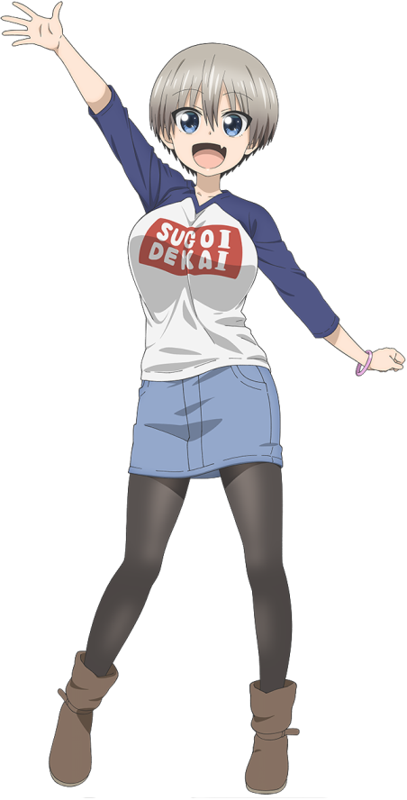
But such was the body of Hana Uzaki. It was strange though. While she regarded herself with this name? It didn’t really feel like anything had changed in the first place. Namely because more than just her body and mind had been warped. The shirt’s effects had triggered a transformation in reality itself. Komi’s entire family had been changed into the Uzaki family and their background now matched as well.

“Oi, Najimiiiiii~!” Without a care in the world, Hana called out to the youth on the other side of the changing booth door. “Do you think you could find a jean skirt that would match with this top? I think we’re onto something really special here!” Because her chest really was SUGOI DEKAI! It was perfect!

As she saw her life now? The teen had a lot of friends. How could she not with that outgoing personality of hers? Of course, Najimi was one of those friends. They were a little younger than her and she had already graduated from high school, but the truth of the matter was that they were childhood friends. They had grown up as next door neighbors and were both extremely outgoing. It was only natural that they’d hit it off, right?

“Incoming!” And that childhood friend finally came in clutch, launching the requested skirt in question over the top of the changing room door. It handed directly on Hana’s head and temporarily blinded her, though. But that didn’t really bother the young woman. She was quick to slide it up and over her tights before buttoning it around her waist. And from there? She wasted no time unlocking the door and strutting out to show it off.

“What do you think? It’s a cool shirt, right!? It suits me, right?” Uzaki seemed proud, which only prompted an awkward smile from Najimi. In this revised history it was Uzaki who had picked the shirt despite Najimi advising against it. There was no denying that she had big tits, and they didn’t know why she wanted to draw attention to them. But in the end?

Hana Uzaki was just that type of person.

