DANGANRONPA: SOCIAL EXPERIMENT CH2
CHAPTER 2: DOMMY MOMMY
BY CHALDEACHANGE
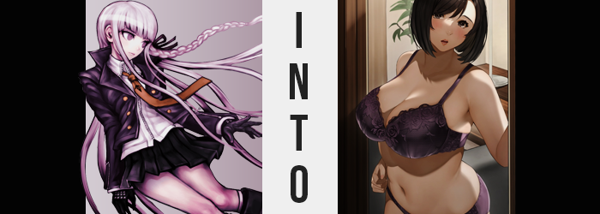

Taking it all in with a calm and measured response was the best thing she could do right now. That was what Kyoko Kirigiri told herself as she wandered the halls of the beachside resort they had found themselves in as part of the ‘Transformation Game’ they had been injected to. Naegi and herself had just only barely escaped the horrors of Hope’s Peak, and now they had been thrown into a similar situation? She could only imagine how poor their luck must have been for that to be the case.

What they needed now was information. The identity of the mastermind was of the highest priority, of course, but they weren’t really given much in the way of rules. They just had to successfully not ‘get transformed’, but that was such a vague losing condition that she couldn’t fathom what it actually meant. Like Naegi, she didn’t really believe there was a technology out there that could change someone’s body, which was the only interpretation she could really fall onto.

And then there was the matter of the other players. Junko Enoshima had been among them. The very same mastermind of the killing game they had survived. The very same mastermind she had watched end up killed gruesomely by the machinations of her own event. Unless they were playing with a ghost, there was something very wrong with all of this.

“Inn rooms? Is this where we’re supposed to be staying?” After successfully investigating several branches of the building, the young detective ultimately found herself in a wing of the resort that looked more like a hotel than anything. There weren’t a lot of rooms, but they were all clearly marked with their names. Junko, Naegi, and even her own. Although she missed the name on Naegi’s room mystically changing just moments after she walked past it.

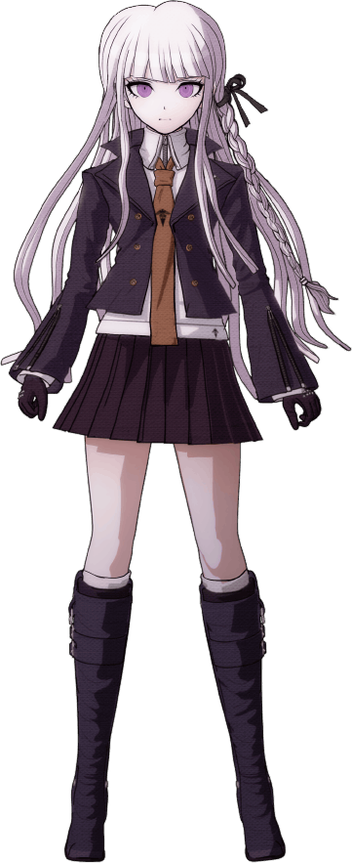
If these spaces had been set aside for them, then it was possible that there would be clues inside, no? She couldn’t think of a better place to stash important information than in a room they would have arrived at inevitably. And so Kirigiri slid inside, allowing the sliding door to close behind her.

What she found in the room’s interior was, well… “It’s definitely a hotel room.” With a big bed, a television, an adjoined bathroom, and a window overlooking the nearby ocean, it was pretty standard when it came to the type of room you would likely find in a hotel. The more she investigated the room, the more she realized there were no clues either. At least until she entered the bathroom.

“…No, this isn’t really a clue. Did a previous guest leave their laundry here?” On the back of the bathroom door she’d found a set of undergarments dangling. Colored a shiny purple, the bra alone was much bigger than her own chest – probably E or F cup, and that might have been generous. While the panties looked fit for a woman almost twice times her size. Still, considering how neat and tidy everything was, it was certainly strange, and so she reached out to grab them with her gloves.

“…Huh?”

And doing so triggered something that happened so impossibly fast that her mind couldn’t wrap around it. The underwear had gone missing before her very eyes. Or at least that had been her understanding until she realized the fit of her own underwear was wrong, with her bra protruding loosely and her underwear sliding down her legs to her ankles. Peeking down, well… “How… did I end up wearing them?” It was clear. Her own underwear had disappeared, and the oversized ones had been applied to her in their place.

Kirigiri tugged at the clothes she was wearing overtop of them, feeling the cool breeze from the room’s air conditioning tickling the exposed area beneath her skirt. “This is impossible. Did I black out for a moment?” Even if she had, the implication was that someone had changed her underwear before she had realized, which still barely made sense. The young woman felt like she was at a loss, but at least she had her detective skills to fall back on.

Or so she was supposed to, but for some reason? She was having a hard time analyzing things. Kyoko bit her lower lip as she attempted to reason something, anything, but her mind kept wandering to fantastical possibilities and… data entry knowledge, for some reason. Like the kind you might expect an office lady to know. “That’s not…” Helpful.

Nonetheless, it kept her plenty distracted as her body’s natural design began to warp and bend. In the beginning it was something seen in much more (comparatively) subtle areas, such as the darkening of the purple of her eyes and an increase in vibrancy of the tinge of her skin, stealing it from its original pale to something that was arguably pinker and healthier. Albeit her skin somehow was almost left looking a little worn, with the odd blemish and stretch mark that seemed out of place seeing as her body’s mass had not increased. Or at least not yet.

When it came to Kirigiri’s hair, the pale purple locks that she was known for began to shorten and darken simultaneously – the braid on her left ultimately coming undone and the ribbon that bound it drifting to the floor. It didn’t take long for it all to become a bob of dark black, one that’s bangs were swept to the right to expose an equally dark brow. This change in color and style applied equally to her pubes, but of course you couldn’t give a bob cut there. Instead, darkened hairs lengthened into a full bush.

The detective felt warm. Strangely so. It wasn’t as if she was a stranger to arousal in any capacity, but to find herself wearing another woman’s underwear and get turned on? Did she have some sort of strange kink she hadn’t been aware of? Though why would she get turned on from wearing her own underwear?
“What? These aren’t—”

It went without saying that the lingerie was not hers. It didn’t fit her at all, and she would never pick something so lacy. So why had her mind just accepted them as hers? And why did she feel like she owned plenty of similar sets? Kirigiri pursed her lips, unaware of how they had swollen and both become glossier and slightly drier – as her face began to show a more advanced age than it should have as a teenager.

There were actually a number of signs developing to suggest just that; that she was no longer a teenaged girl, or at least wouldn’t be for very much longer. Plump, juicy lips were just a small part of it when it came to her face, with her complexion there looking rather tired with plenty of pores open. There was also a slight bit of chub finding her cheeks, making her face appear fuller and her eyes, now decorated with longer lashes, appear smaller. Rather than a teen, it gave off the impression that she might be a woman in the middle of her life.

How could I be a teenager? After all, I have a daughter that age.

Evidently, Kirigiri had noticed her own reflection. Her new face, her new hair, and had come to the conclusion that she was no longer a teenager herself. What’s more, she felt just as accepting of it as her friend had in the dance hall when it came to his own transformation. The side effect of this transformation game was in full force, prompting the victims into simply accepting their new lives without much of a question. “Right, my child…” Even her voice sounded fuller and older now.

All that really remained was for her body to properly fit the lingerie she had been forced into wearing, and it hardly waited much longer to do just that. Her body just, rather promptly, grew fuller. Just in general at first, mind you. Her hips pushed almost impossibly wide, and her tummy broadened both directly in response and as a side effect of the soft weight that made her bellybutton seem deeper and deeper. The flesh of her gut was muffining, and as a result her skirt snapped from her hips and the buttons on her jacket began to pop off.

Thicker and thicker she became, weight born both from age and an inactive lifestyle taking her frame from that of a healthy teen to that of a chubby woman in her forties over the course of only thirty seconds or so. Before long even her top had torn, and she was practically naked sans the purple bra that still looked too loose upon her. She’d even peeled off her own gloves, revealing thicker fingers without a single scar upon them.

Without thinking, the woman licked her lips as the warmth from before built – plainly focused on her breasts and loins. The more this warmth built, the more, too, the flesh in these areas built past the chubby yet attractive frame she’d developed. For her lower half, the density of her thighs increased to make good use of her childbearing hips, and her rear end jiggled out into an attractive rear that was largely firm but still had lost a little of its luster due to her age.

On the other hand? Her breasts were quick to bubble up. “Mmn!” The adult herself couldn’t help but moan, hands gripping her tits beneath the gap in her bra as that gap narrowed more and more. Inevitably they reached around a G-cup sizing, each tit as big as her head and more sensitive than it had ever been. While her nipples? Erect as they were, these brown spots were just as large as her eyes. Kirigiri could remember how she loved having them suckled sexually these days. A beauty mark had even appeared beneath the leftmost breast, and her fingers grazed it after withdrawing them now that the bra fit perfectly.

“Mm… My, my, my. I see how it is. So I’ve become a victim, have I?” The woman, clearly around forty years of age based on the wear on her face and her girthier build, rested one of her cheeks in her hand while staring at her reflection in the mirror. As had been the case with her partner, she was aware of the fate she had suffered – but cared little to question it. She had lost and that was fine. This new life felt wholly natural to her anyways.

From Manaka Saitou’s point of view, wasn’t this a good thing? She was an older woman, one who’d had several children and worked full-time as a single mother. But now she’d been afforded a vacation at such a prestigious and wonderful resort! She’d even met someone, even though that someone was a woman much younger than herself.

Adjusting her bra over her G-cup bosom, weight both natural and from getting up there in age, another hand rubbed the bulge of her tummy and teased dipping beneath her matching panties. But she stopped herself. The whole ordeal had left her feeling incredibly horny, but at the same time she knew she’d soon have a guest. The woman she had met, who despite being a dancer appreciated Manaka’s mature charm.

“That’s right. Mikoto will be here soon…”

She just hoped that her teenaged daughter didn’t walk in on them again.

