MIKU TWO
COMMISSION STORY
BY CHALDEACHANGE


There were few people in the school that had never heard of Koharu Fujiwara.

She was the student council president, a leading light in the societal structure of the school that not only listened to and helped solved the problems of her peers, but also made decisions that impacted the student body on the daily. It was a delicate position that required delicate leadership considering the number of people that it ultimately impacted. But it also required thick skin. One wrong move and the dark haired girl would have her peers breathing down her neck.

For someone of her position, it was important to stay out of any drama. Any incidents that could create rumors of bias or favoritism could and would be used against her by detractors, and if she was too strict then she also risked backlash from her fellow students. It was lucky for Koharu that she was generally a quiet girl, then. Quiet, and yet she was strict whenever it was necessary for her. It helped keep her out of trouble… even if some strange rumors had been circulating about her for a while now.

Fujiwara-san has a thing for her teacher, doesn’t she?

It was a rumor that had been causing her problems for some time now… namely because it was true. Her teacher was Shinji Yabe, or Yabe-sensei as he was referred as by his students. The young man taught home economics and was the instructor for the Cooking Club. He was kind and gentle, but also extremely dense… and Koharu had fallen head over heels for him against her better judgment. It was something she had been trying to keep on the downlow, but…

“Then she showed up.” Reflecting on this topic, the high school girl grumbled these words under her voice after collapsing onto her bed face down. She’d only just returned home for the day after carrying out her student council duties and it was well after 6pm. She was in a specifically foul mood because she’d caught sight of an unsavory sight on her way home. The man that she was in love with had been spending time out in the open with another woman!

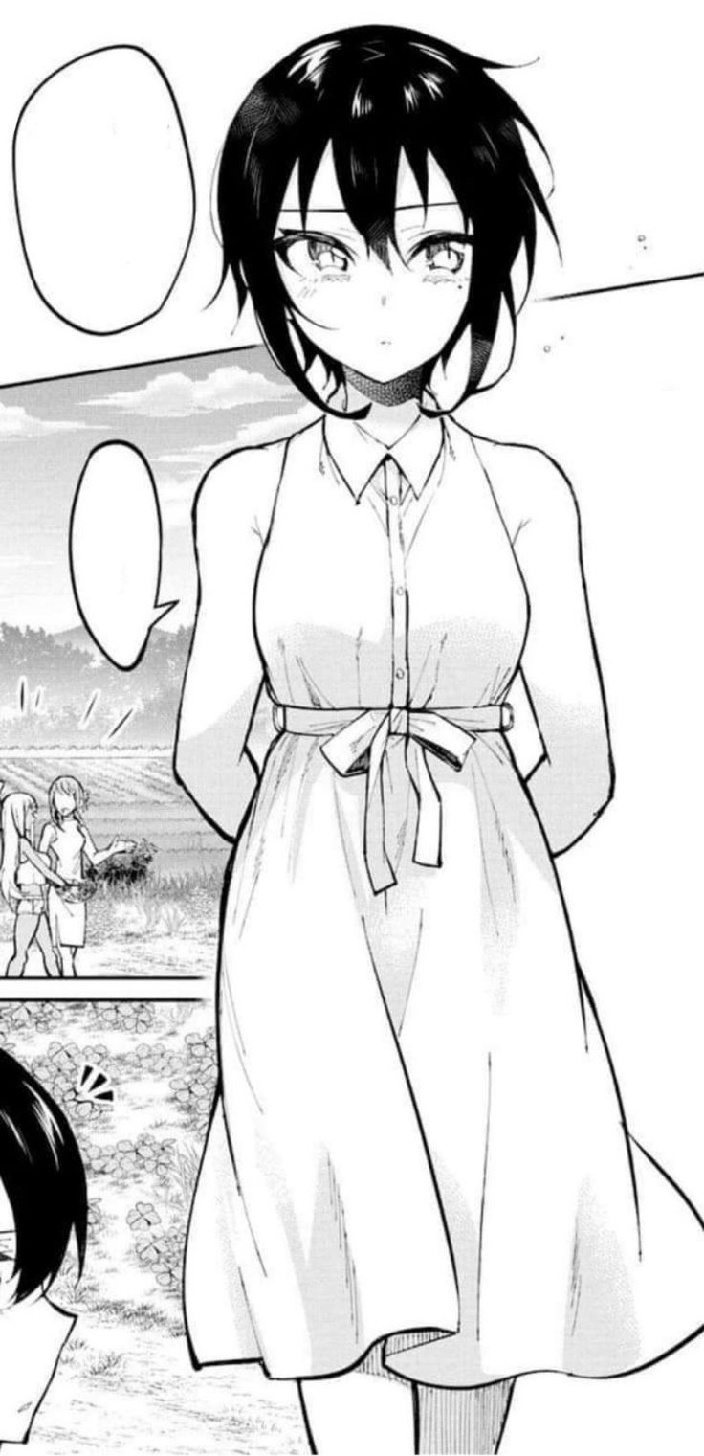
…Not that she had been especially surprised by this sight. Koharu was well aware of the fact that she had a love rival. She was a girl her age that went by the name of Miku Okazaki, and she was also Koharu’s polar opposite. She was a beautiful gyaru girl that stood out in a crowd. She was taller, bustier, and inherently sexier as a result. Miku was also extremely outgoing and bubbly. If she’d been into girls, even Koharu herself probably could have fallen for a beauty like that.

But as things were? They were rivals, and the student council president felt incredibly inferior to her in every possibly way. She had gotten close to Yabe-sensei so easily, and while the two had only seen each other in class and at the Cooking Club before, more and more sightings of the two together outside of school were being gossiped among the school’s students.

“I wish I had what she had, then I’d at least stand a chance!” Or so Koharu blurted out as she kicked her feet on her bed. It was only natural that her frustrations would reach this boiling point, but at the time it didn’t occur to her that her words had just initiated a change of fate for her. One that would strip her of the present self that she hated. And it began with a change of scent? “Hm?”

With her head buried in her pillow, the girl noticed that the fragrance had become… off. It wasn’t a bad fragrance. It was a floral perfume that smelled incredibly sweet. It just wasn’t a perfume that she would wear, which prompted her to lift her head to see a bright pink pillow… upon a bright pink bed… within a bright pink room. None of which matched the aesthetics of the bedroom she had stomped into just moments prior. “Wh-What?”

Acknowledging that the bed she was laying on was not her own, she quickly pushed herself off of the bed and stood up, looking around at her surroundings frantically. Where am I? Since she must have been in a stranger’s home somehow, she kept herself quiet at that moment to avoid alarming anyone that might have been alarmed that she was in their home.

If she was to liken the room’s design and scent, including what appeared to be an open, walk-in closet overflowing with stylish outfits that were definitely too big for her? She would liken it to the kind of bedroom Miku might live in. But that couldn’t be the case, right? Because how could she end up in Miku’s bedroom? “Did… Did I not go home after school?” She whispered to herself in hopes that she wouldn’t be heard.

She supposed that maybe it was possible she was just misremembering things. Was it possible something had happened, and she had been brought to Miku’s house? That still didn’t really make sense, because it wasn’t like she had woken up on that bed. She had been conscious the entire time! Try as she might, she couldn’t think of an explanation. But an invasive thought ended up providing her with an answer she hadn’t expected?

What? This is like, totally MY room!

“Wh-What? No, its not…” Of all of the strange things to think, this was perhaps the strangest thought that could have crossed her mind at all. It would have been impossible to mistaken something you had never seen before, much less a place, as being your own living space. The view from the window didn’t even oversee the same street that she was used to! She was in an entirely different part of the city! “I must just be too overwhelmed. I need to calm down for a moment and, like, think…”

Would it have been more fruitful to just try and leave immediately? Probably. She could get a better idea of where she was if she was outside of the house. Not to mention if she could get out without being seen, then she didn’t need to worry about alerting any of the residents. But how hard would that even be? She didn’t know how many people lived in the home, but it had to at least be three right? The room she was in looked like it belonged to a teenaged girl, so there were likely two parents that lived there too.

Hm? And my one-chan!

Koharu blinked several times when, yet another strange thought crossed her mind. But this time was a little bit different than the first time. It was vague and blurry, but the thought on this occasion seemed to rouse something akin to a childhood memory of spending time with a young girl that appeared vaguely familiar. What’s more, that memory was in the very room she was standing in, albeit the décor was more fitting for a child. Or two.

So, something was clearly wrong with the teenager mentally, but the problem was actually much broader than that. There were signs that something was amiss with her body, too. “Hm?” Koharu found herself idly tugging down on the base of her shirt with one hand, while another tugged on the base of her skirt. It was in response to that feeling you had when your clothing got caught on something and were lifted up to reveal your skin.

But that wasn’t actually what was happening. No cloth had been caught on anything. The teenager hadn’t even moved. But her clothing had been lifted nonetheless; courtesy of her own body stretching. Her height had actually shot up as she pondered any memories within this bedroom. It was only about two inches or so, but that definitely made a difference when wearing a uniform that was tailor made to fit her original size.

“E-Eh!? Something’s totally weird here!?” It wasn’t until Koharu looked down to see what was wrong with her outfit that it occurred to her. The height was one aspect that she noticed at the time, but there was something else too. Patches of her skin looked… weird. It was like she was being splotched with rather large freckles, but in reality, these splotches were areas of tanned skin that looked to have been forged in a tanning booth, or perhaps even applied with a spray can. “What’s with my skin? It looks way hot!?”

The student council president almost bit her own tongue there after blurting out what amounted to the opposite of what she had desired to say. It also sounded rather vapid and trendy, like something a… Oh no. “Like something a sexy gyaru bitch might say!?” She ended up doing it again! Talking in such a casually trashy way was not something the president ever did! She was too meek and proper for that!

But it also made sense, didn’t it? The tanned spots on her body were spreading, merging into each other everywhere that could have possibly been tanned while naked to give her complexion an even, albeit still artificial tone. It was the kind of fake tan she was accustomed to seeing on Miku’s body, so it lined up with how she was talking. “Hah!?” But, as she soon realized, it lined up with something else as well.

A strand of hair fell between her eyes, leaving them to cross briefly… simultaneously showing off their dull browns brightening to an emerald green instead. But this was a color change she hadn’t noticed. In actuality, it was a different color change that had prompted her gaze to shift towards in the first place. That strand of hair was a bright blonde. “Even my hair!?” But it was far more than just a single stand.

The girl brought both hands up to run her fingers through her mane. She didn’t look at those hands as they passed her gaze, but the moment they touched her locks she could tell that something was just as wrong with her tanned fingers as it was the hair they were touching. There was too much resistance around her nails. Surely because they were longer and had been accessorized with hot pink stick-on extensions to increase their gaudiness levels, the fingers already longer from her prior growth spurt.

Koharu found the body of her hair to be more distracting anyways. It had all been dyed a golden blonde – the same gold that was present in Miku’s hair – and as she touched it, she could feel it lengthen and vaguely curl into a wavier style. It must have reached her hips before the growth ended, and a heavy floral fragrance wafted off of it from a changed shampoo.

“Even… Even what? Something’s totes wrong, right? But… was it important or something?” It was seemingly becoming difficult for the girl to even grasp what was happening. What had seemed wrong a second ago didn’t feel so strange any longer, and that was an energy that was maintained as she rubbed her inflating lips together. A pink gloss was spread across them beneath a nose that had become sharper, while her green eyes widened and were painted with thick mascara. Even her brows had become pencil thin! …Strongly resembling a certain gyaru that she knew.

Her fake fingernails tugged at the neck of her uniform top. “Feels kinda stuffy all of a sudden…” She purred and giggled, not even looking down at the source of that stuffiness any longer. But it was plain to see for anyone paying attention. The base of her uniform top was beginning to lift up further, courtesy of a growth focused on her B-cup bosom. Or at least they had been B-cups once upon a time.

The top four buttons of her top popped off to make way for the swelling of tanned flesh within. Her breasts were ballooning, snapping the back of her bra clean apart as her mounds sensually surpassed D and even E-cups. “Mm?” With a voice that was deeper and pointedly sensual, she let out a groan that sounded somewhat erotic as one hand began playing with one of these tits. They’d grown to a mighty H-cup sizing and were bigger than her head. Her old uniform top was pulled up right beneath them, leaving a now toned tummy exposed.

But in terms of clothing malfunction, this was only one half of the story. Koharu had reached a brief moment in her transformation when she was having difficulty thinking about much at all. This was because her personality and memories were being properly rewritten, and so she didn’t really react much to her swelling tits nor… the immense wedgie that was being pulled in between a pair of cheeks that had nearly quadrupled in girth. This full, heart-shaped ass set her hips on a widening journey of their own, lifting her skirt until you could see her panties cameltoing in the front. Of course, she who had a thicc ass usually had thicc, tanned thighs too. And her own legs didn’t oblige.

Until finally? She just snapped out of it, not even questioning why she was wearing a uniform that had to be roughly four times too small for her.

I really grew out of this one, huh? Maybe I should just throw it out!

“Hm… What was bothering me again? AH! I know! Onee-chan totally keeps taking my clothes and stuff!” Fake fingernails curled into a pair of balled up fists as the blonde gyaru pouted one of her cheeks up cutely. She didn’t seem at all concerned about her appearance nor how she was acting, at least not anymore. But why would she? In terms of figure and personality? She was now totally better than Miku! She had bigger boobs, a fatter ass, and she’d stop at nothing to seduce Yabe-sensei! She’d go even farther than her little sister!

Well, maybe referring to Miku as her ‘little sister’ was making a mountain out of a molehill. Keiko Okazaki may have been fuller figured than Miku, but the two were twin sisters and Keiko was only about ten minutes older than Miku. Still, it was enough for the older sibling to hold it over the younger, and Keiko wore a smirk on her thick, gloss-covered lips at the thought of it.

Did any of Koharu remain within this new gyaru, though? The only physical trait of the student council president that remained was the beauty mark under her left eye. Internally? There was a vague part of her that sort of remembered living an inferior life. But it was easy to shrug it off, seeing as things were so much better for her now! “Is she back from school yet, or… OMG! She did not sneak off with Yabe-sensei behind my back, did she!?”

They may have been twin sisters that got along perfectly most of the time, but the only area where that wasn’t true was when it came to matters of their hearts. They had both fallen for the same teacher and were constantly climbing all over each other to win his attention. “Whatevs, not my prob! Sooner or later she’s gonna realize that I’m, like, way ahead!” Keiko was cocky for good reason. The way that Yabe-sensei looked at her demonstrated to her that he was way more into her than Miku. She was the NUMBER ONE GIRL in his heart!

Which was all Koharu had wanted before her transformation, after all.

