CAW TITS
MAY 2022 REQUEST STORY
BY CHALDEACHANGE
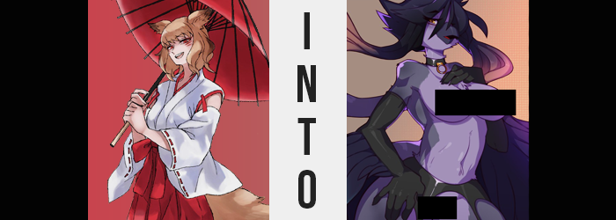

It really wasn’t Ranka’s modus operandi to involve herself in situations like these.

While she was an all-powerful kitsune that could travel the very worlds themselves, she was hardly ever one to involve herself in the affairs of mortals when it came to any of these worlds. There was never any personal attachment, and there was hardly ever any real motivation for her to stick her neck out for strangers. But in this case? She had let her guard down, and in doing so she had made it so that she had to involve herself in this world’s affairs.

Because a thief had made off with her umbrella. The very same umbrella she took with her from world to world. The very same umbrella that had been with her through thick and thin. There was sentimental value in something that otherwise could have been seen as quite mundane and easy to replace. But Ranka would likely make a show of how she simply cared for the sake of her pride. Which was still technically part of the reason as to why she cared.

This world was occupied by beings that looked more like animals than most of the worlds she visited. Whether modeled after mammals, reptiles, birds, or even insects, there was a distracting variety of them. So distracted that a thief had slipped her umbrella away from her while investigating a local bar. But the kitsune also wasn’t that easily duped.

For a woman of her power, tracing the thief back to his hideout wasn’t all that difficult. The city she was in was futuristic and vast, but naturally she had methods of finding her belongings were she to misplace them in any capacity. Any capacity such as leaving them behind, or having them stolen by rude little troglodytes. Ranka didn’t realize that she was making a mistake however, and that not only had her finding the umbrella been expected, but it had been planned for. As a new arrival in this world, she held little comprehension of its local affairs.

Such as, say, an evil organization going around and transforming potential victims to add to its ranks. This city actually once had a great deal of humans living in it, but all of them had fallen prey to this organization and transformed to match the general populace. And Ranka? Well, her fox features aside, there was plenty of opportunity for someone to mistaken her for a human.

“Ah, there it is. I’ll just be taking this and I will be on my way, then.” And so after a relatively short trip, the kitsune had found her umbrella housed in the basement of a rather seedy building. Security was abundant, but using her abilities it had been simple enough for her to sneak past most if not all of it. Propped up against the far wall of a small room, she strut up and picked up the item without even an iota of concern for potential danger.

But danger found her regardless of caution. Slits in the floor opened, and glass walls erupted around her, trapping her in the room with the umbrella at her side. “Oh, that’s cute. You intend on trapping a kitsune, do you? I’ll have you know that more competent trappers have most certainly tried.” Ranka, as always, was absolutely arrogant. She saw the idea of someone getting the better of her to be utterly inconceivable (even though it absolutely did happen on occasion) and was no stranger to gloating baselessly.

As far as she was concerned, to escape all she would have to do is snap her fingers and she would end up outside of the building. How could trap a magic wielder as powerful as her? You couldn’t! Or so she had truly, honestly believed up until she’d done the finger snap in question. “…Erm?” Not only did she not find herself outside the building, but she was still very much firmly rooted in the same spot she’d been before – trapped within the glass case.

“Surely something just went wrong…” Yet another snap of her fingers amounted to the exact same outcome. As did trying to use a different spell. “…Is this case interfering with my magic? How?” There were magic users in this world, albeit magic in this realm was more based in science than anything. Was it somehow disturbing the magic from her homeland? If so, then wasn’t this very bad?

If she hadn’t thought so initially, Ranka would have believed so the moment the glass walls, floor, and ceiling became opaque with a dark purple. Although despite no light passing through, it was still somehow illuminated inside. Through what could only be magic. “Curses! I need to get out of here before this situation gets worse!” Could she break out with physical strikes? After almost breaking one of her knuckles with a punch, it seemed like a resounding no was in order.

“…Hm? Wait a moment. Am I simply seeing things, or…?” It was difficult for her to say for certain, seeing as how she was trapped within a box of a consistent color, but was the box shrinking? It appeared that the roof was closer to her head than it had been a moment ago, which was what had prompted her to wonder this aloud. The truth of the matter, however, was that she was thinking of what might have occurred in reverse.

That is, to say, she was growing taller within the box’s confines. It was her shrine maiden-like outfit that gave this away, as the top was pulled from skirt, and the barely attached sleeves were hoisted higher up on her arms. So distracted by the fact that she had been caught, it was just one of those strange things she had dismissed while her emotions were elsewhere. That said, it was getting difficult to dismiss them as the trend continued with other aspects of her body.

Such as a disrobing that was forced not by the kitsune’s hands, but by a sudden growth of her bosom that forced the folds of her outfit to unravel – exposing breasts that had doubled in size quite quickly. That was a change that Ranka couldn’t really ignore. “What on— My mommy milkers! …Erm?” There was plenty wrong with this situation, but what had she just blurted out? No, she had practically purred it.

Something was wrong with her body, but something was most certainly wrong mentally as well. Her memories had begun to feel somewhat clouded, and from that cloud she had begun to think and blurt out strange things even if she hadn’t intended on it. Saying ‘mommy milkers’ instead of ‘chest’ was certainly a prime example of that, indicating the direction her mind was being rewired.

“And my fat ass!?” It got worse, as the same swelling feeling that had reshaped her breasts likewise came for her lower half. The back of the crimson pleats were pulled thin as her bum expanded next, the gesture ultimately forcing her hips to widen dramatically in the process. The ass was huge, but it was perky and firm as well – traits that soon found themselves shared with thighs that expunged in shape and finally tore through her lower wear. “Ungh!?” Unpleasant as it had felt, she couldn’t help but moan as her panties were wedged between her cheeks.

Her figure had gone from an average sized, average figured young woman to that of a taller, older bombshell in a matter of moment, and the whole process had left the kitsune confused and visibly winded in how heavily she was breathing. “This is impossible! To think I’ve become so damn sexy! And what is with my speech!? I’m talking as if I’m some depraved slut!”

It didn’t help that something in the back of Ranka’s mind immediately went: And what’s wrong with being a little slutty~? It most certainly did not help at all. Her body felt hot, and yet she managed to keep her hands off herself for now. Whatever was happening, it was clearly the fault of the box she was trapped in. She had to break out! She had to! But it was futile, and it was becoming even more so.

After all, so distracted by her new bombastic figure, the woman didn’t notice that the traits associated with her abilities had been dwindling away while much of everything else had grown. Namely her kitsune tails and ears. In the case of the former, Ranka always hid three of the four tails she possessed for personal reasons, but nonetheless the quartet of them all regressed back into her body nonetheless, while her ears? Their fluffiness did little to prevent them from disappearing beneath her hairline, where tiny holes appeared on the sides of her head to allow sound to pass through.

The hair that surrounded these new holes appeared to differentiate itself from how it had looked previously as well too, though. The color wasted no time in darkening to a raven black, and its length grew dramatically – restyling on top into some notable spikes, while the length in the back parted into two tails that strangely grew pinked the longer it grew.

Ranka had been about to comment on things once more when the sudden sound of her lips clacking together gave her pause. Lips were supposed to be soft and flexible, but they had clicked together like pieces of plastic. It was so distracting that she brought her hands up to touch her lips, but… “Oh myyyy~!” The way she expressed her surprise had not been the intended way, but she was surprised, nonetheless.

Fingers had met her ‘lips’ sooner than expected, fingers quickly coming into contact with a hard protrusion where those lips should have been. That protrusion had a sharp tip, and was pulling farther and farther out from her face – soon bringing the shape of her nose into its design so that she could see it by crossing her eyes together. Eyes that, in the meantime, took on a golden color. “Is that a beak!? It’s quite, mm, alluring!” She could imagine locking her beak with the lips of another, exchanging tongue… Or perhaps using it as a weapon against those that challenged her… No, was that really what she should be thinking at that very moment!?

Even the hand that had reached up to explore this toothless maw exhibited differences. The hands almost appeared swollen for a time, with nails pulled into sharp claws, but they became stranger still as a strange, downy softness began to coat them in a very dark purple color. Ranka squinted at them, confused, before memories that had begun to surface in place of her old ones answered the question for her. “My plumage? Why do I find that so strange?”

They were very fine, very soft feathers. And that had begun to appear across more than just her hands. The darker ones spread up her arms, around her torso’s sides, and down her back to cover her ample ass and muscular thighs, while a brighter purple covered her tummy, tits, and between her legs. While these feathers were fair, they gave her body a very fluffy look that was more apparent in area where they were longer – such as in the gap between her breasts. Not even her face was safe from their wrath. Well, her beak aside, of course.

“I’m… a bird? But I’m suppose to be a… a… Oh, why do I care?” There was little point in denying what she had become, and she was finding it harder to think much of her old life. It was simply becoming obscure to her, while the final aspects of her body and personality succumbed to corrupted memories that had forced themselves into her mind.

There was only one area of her body that hadn’t been feathered, and it was everything below her knees. Instead of looking softer, the skin there had darkened to black and taken on a drier texture – which was also applied to her feet. But those feet grew larger, toes spreading out and gaining hooked claws. Though she lost two toes on the front on each foot, while a new one extended from the back of her heels. They were undoubtedly the feet of a bird, but there was something strangely sexy about them too.

Well, her voluptuous legs certainly helped.

All that remained was the eruption of further plumage, this time from the backs of her forearms. These feathers were long, thick, and a mix of blues and purples. But there were also tiny bones among them, which would ultimately allow her to glide short distances with them. The perfect tool for an assassin. Or a kidnapper. The organization had plenty of roles for a talented, older woman such as herself.

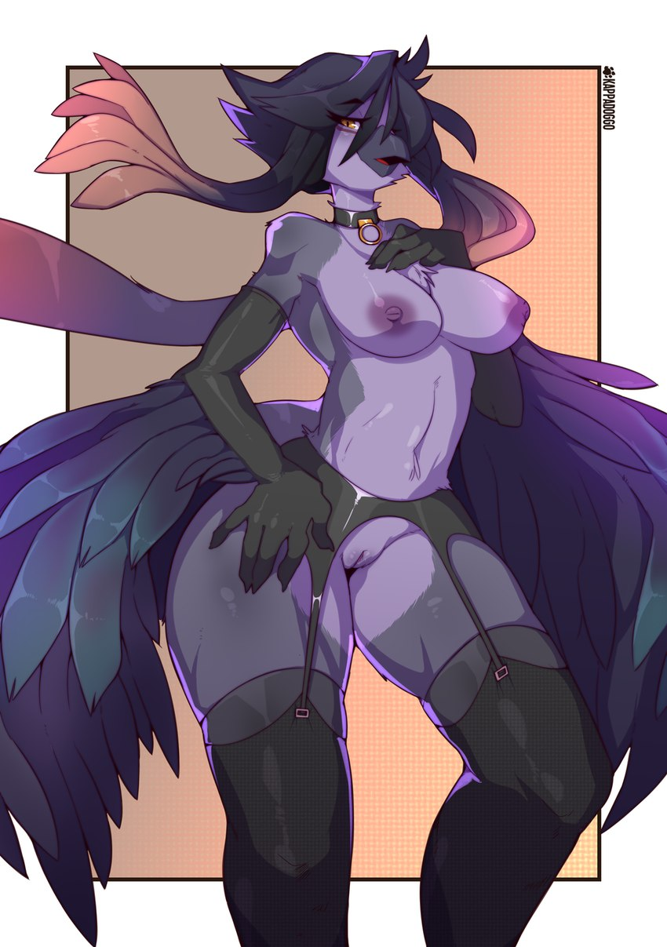
“Ara, ara~!” Her newly formed beak opening and closing as she spoke, the question as to how she could speak normally was once again highlighted once the purple walls around her fell back into the floor and she was able to strut sensually out into the room again. Noting the umbrella beside her, she picked it up and immediately broke it between her feathered hands. “I have no use for this anymore.” She threw the broken remains over her shoulder, not even batting an eyelash at the sound of them hitting the ground.

An umbrella would not serve her well as a weapon, which meant she would not be able to serve the organization she worked for well, either. And that was how she had been rewired; with an absolute loyalty towards the dark group that had trapped her and transformed her. Was the old Ranka down there somewhere? Perhaps, but her new identity as Ravenwing was dominant.

Strong, successful, alluring, experienced. Those were the adjustives that best described the bird woman. There was nothing she wouldn’t do to accomplish her missions, no one that she wouldn’t kill. She never grew close to others, but at the same time had a penchant for seducing strangers to satisfy her more carnal needs. And yet at the same time, there were plenty midst their group that saw Ravenwing as a motherly figure. She did give off that aura at times, and there was something nurturing about how she treated those younger than herself.

Those that were beneath her, however? She would sooner step on them with her sharp, clawed, bird feet. “Shouldn’t I be receiving orders soon? Oh, I suppose I should get dressed before I do that…” She’d been playing with her big tits idly this whole time, letting them bounce and enjoying the feeling. But it was true that if she went out topless she might get some unfavorable looked. But then again… “Oh, what do I care? Is anyone going to challenge me for not being fully dressed?”

Unlikely. She’d sooner get a quick fuck from someone, in all likelihood. And that was honestly fine with her. Living a life in the shadows where she could do whatever she wanted, whenever she wanted? There was no greater freedom than that. And she would revel in it.

Regardless of how much blood ended up staining her hands in the process.

