GETTING BATTY
COMMISSION STORY
BY CHALDEACHANGE


I wasn’t sure why I’d gone to all the trouble, because parties themselves weren’t usually my scene. And hell, that was true about parties in general – but this wasn’t something so conventional. No, considering the season I’d been invited to a costume party of all things. Maybe it was the fact that while wearing a costume I would be less recognizable, or perhaps it was just a bit of childlike whimsy on my part, but I had ultimately RSVP’d to the invitation I’d been sent to say I would be in attendance, before hastily ordering the stupidest costume I could think of.

Only a few days later, that costume arrived. It was a Sonic the Hedgehog costume actually, and the cheapest one I could find. Rather that make me look like Sonic, it bore more resemblance to a big, blue fur suit that just happened to have the general shape of Sonic’s head correctly. “That’ll do.” Not that I was at all complaining about it. After all, if the point was to look as little like myself as humanly possible then it was absolutely perfect. Even if it meant looking more like Sanic than Sonic.

Of course even though the costume was so big, trying it on was something that had to be done. It took me several more days to make the time to do so, but eventually before getting changed into my pajamas one night before bed, I instead decided to make time to try on my Sonic costume. I probably could have gotten away with wearing normal clothes underneath it, but something deep down told me that doing so wouldn’t be particularly comfortable, so I abstained.

It didn’t take all that long to jump into my person Sonic the Hedgehog knockoff hell, and honestly? It was pretty comfortable. “Maybe I’ll use these as pajamas after the party…”, or so I entertained the thought. Despite being a little big, it all felt rather snug at the same time. In fact, it was very, very warm. I naturally assumed that the cause of this was the fur lining of the costume, but only because what was actually transpiring was something that by all means should have been utterly impossible.

“Huh? Did the costume get tighter or am I just seeing things?” I hadn’t lifted the hood with the head spikes up over my head yet, for I’d been distracted by the fit of it all. When I had first put it on, it had certainly been very loose. But now? Pulling at the blue fur around my opposite arm, it seemed to be a lot tighter than it had been. The slack that had been there before just wasn’t there.

At the same time, there was a strange pressure beneath my shoulder blades that I really couldn’t quite place. A hand reached back to try and touch the places in question, but with their positioning it was more than a little hard to do. Was I bending too far forward? Pushing my shoulders too close together? I couldn’t really fathom what other phenomenon could logically cause a pressure like this. But little did I know, this was not a phenomenon that was beheld to even a drop of logic.

RIIIIIIIIIIIIIIIIIIIIIIP!

“EHHHHH!?” How else was I supposed to react to the combination assault of both the sound and feeling of the back of my new (twenty dollar) costume exploding out from behind me along with the sensation of the pressure that had been building erupting all at once. I almost fell back clean onto my ass, because in a sense the phenomenon felt similar to something yanking on my back in the first place. Things didn’t really improve once I’d restored my balance though, because with hands reaching back once more… they gripped onto something.

Not only could I feel those somethings with my hands, though. I could also feel my hands touching them from an opposing perspective, as if I was touching something on my own body. Naturally, my head immediately whipped behind me to catch sight of the growths – and they were certain growths. “WINGS!?”

Was there any other way to describe what I was looking at, honestly? Two black growths that had escaped around the areas of my shoulder blades, fanning out behind me in either direction in a way that didn’t resemble a bird’s. Rather, they were more akin to the wings of a bat, or at least the cartoony sort. “That’s impossible! People don’t just grow wings!” And surely no one was debating that fact, but the reality in front of me contradicted this greatly.

My fingers traced their wingspan to the best of my ability, aided clearly by the fact that I was slowly understanding how to move them. I probably would have ended up fixated on doing so if not for a loud POP that echoed from within the depths of my ears. The sound reverberated in a way that vibrated my ears to the point that they felt numb, and when my sense of hearing returned?

It was far stronger than I could have ever fathomed. “What the—Ow!? OW!” Every sound in my house felt like it had been dialed up to one-hundred, and that of course included my own voice. Every creak, every pop; it all sounded so close, and until I adjusted, even speaking hurt momentarily. It provoked me to cover my ears. The issue? Rather than finding them at the sides of my heads, hands had to climb ever higher until they met a pair of large, pointy ears that extended from behind my hairline. Like an animal’s ears. Like a bat’s ears, if my wings were anything to go by.

I ended up dropping my hands from these ears however, and not because I’d intended to. All of a sudden it was as if a feeling of weakness had overcome my arms, or like my hands had suddenly grown far heavier than I could fairly accommodate into a lifting position. Both were more or less true, at least according to the feeling of the gloves of this Sonic costume tightening around them. It was almost like my hands had swollen? But the tension of the gloves themselves eventually subsided.

Looking down, I couldn’t help but cry out in surprise at what I saw, though. My hands appeared to be almost double their original size, and the gloves that contained them had not ripped because they had stretched in kind to accommodate this size change. Not only that, but the gloves had been dyed white – and were they made of leather now? “How on Earth is any of this happening!?”

I was so fixated on my hands that the fact that my feet had undergone a similar transformation had escaped me. The length and thickness of each foot, and of course every toe on those feet, had engorged itself while my costume socks shifted to lift me off the ground, turning into a pair of white leather heels with pink hearts on the tips, as well as pink bands at their tops that my new gloves likewise sported.

Considering I’d put on a Sonic the Hedgehog costume in the first place, the pieces were beginning to fall into place. I was turning into a Sonic character? But it wasn’t Sonic himself, obviously. The changes so far suggested another character entirely, and one that was a woman at that.

“Ugh, at least I can lift my hands again, but—woah!?” Things had begun to happen faster and faster, and what appeared to be in store next was a dramatic drop in height. Regardless of how old the anthropomorphic animals of the Sonic the Hedgehog series were, the fact that they were all much shorter than a human was something that could not be denied. It was unusual though, because while it could be argued that I grew shorter with a great deal of consistency, the oversized versions of my hands and feet didn’t really make it feel that way.

“How tall am I? I can barely see over my bed!” For someone that had been well over the five-foot mark before, a collapse all of the way down to 3’5” was quite the dramatic fall. I was fortunate that my clothes and costume had shrunk along with me, as had my new wingspan. But the fact that it was looking less like a Sonic ensemble and more like something else was a discrepancy that continued with flourish.

The blue of the costume around my gut, butt, and upper legs was tightening even beyond the scope of my shrinkage, after all, and in the process of doing so it was clear that the color was becoming darker. The material was softening and stretching as well, but in the process it ended up highlighting the excess weight in my gut and legs, not to mention the fact that it was revealing the bulge of my crotch.

All of these issues were ultimately dealt with in due time. The fatty curve of my stomach merely faded away as what was clearly becoming something akin to a black bodysuit compressed against it, forcing any unneeded fat away so that my stomach looked much more trimmed down. Even so though, there was still a slight tummy bulge that looked increasingly weird when compared to my legs.

Because while the excess weight in those legs was compressed away as well, in terms of shapes they became even thinner around the thighs than most human legs were – something made clearer by how my hips pulled wide, and by the legs themselves shortening in slight. More and more, it could be best described as my figure sliding into the realm of the cartoonish. This assertion certainly went double for my ass, because it compressed tightly within the confines of the bodysuit and yet still jutted out with an overly dramatic arch, paired well with my widened hips.

It all appeared downright womanly. “Nn! No! Not there!” I couldn’t prevent myself from both wriggling my legs and allowing a subtle moan to escape my mouth in response to what I had dreaded would eventually happen. The bulge in the front of the bodysuit that represented the size of my dick dwindled until it was completely flat – because it had disappeared in favor of a woman’s counterpart. A pussy more plainly stated. My big, gloved hands reached down to feel the area from shock, and of course I could feel the indentation of a woman’s lips between them.

Very little remained of my Sonic costume now. Only the peaks of my arms and the cloth around my chest really remained, for the hood with the head had been torn off along with the appearance of my wings. But as the material unwound to reveal the fact that my upper arms and shoulders were not only impossibly thin, but had turned a dark orange color (as had my legs and torso), the chest area brought about a more revealing change.

After all, the cloth was being forced forward. “And of course…” I practically cooed my observation, what with how my voice now carried a much womanlier sound to it. But it all fell in line, considering my new biological sex and the fact that the last feature (or features) related to it were now growing in. As the blue fabric was forced away from my neck, it dwindled near the tops to reveal the bulging, orange cleavage of a full pair of tits while the cloth in the front hardened into a pink plastic shaped like a heart. Looking down, I got a full view of my mega-mammaries, and all I could do was sigh.

“My oh my, so that’s how it really is, isn’t it?” I could recognize it. The fact that I was even speaking strangely now, and yet there was an undeniable feeling of acceptance that accompanied that realization. Like deep down I knew there was no point in fighting it any longer. I did go momentarily silent, but only because pressure built around my head – and it could only be doing so for a single reason.

As things were, I had possessed a perfectly normal, human head atop the body of a Sonic character, which looked super out of place. To match, it was inevitable that my head would swell, and swell it did. Bigger and bigger, growing wider than my shoulders while the hair atop my head turned the same white as the fur that lined my bat ears. This hair shortened until it was fur of a similar color, and ultimately spread down to my nose and around my eyes, before sticking out as four or five licks in the back to resemble hair.

My eyes grew and grew to fit the shape of this grown head as well, colors of my irises altered to an icy blue while lashes flickered longer and longer. Blue eyeshadow painted my incredibly large eyelids so that they stood out even further, and a pink gloss found my lips where tiny fangs had emerged from between them. Rounding it all out, the orange of the lower half of my face was forced forward slightly, giving me a muzzle-like design that culminated in a small, black, wet nose that protruded from the tip.

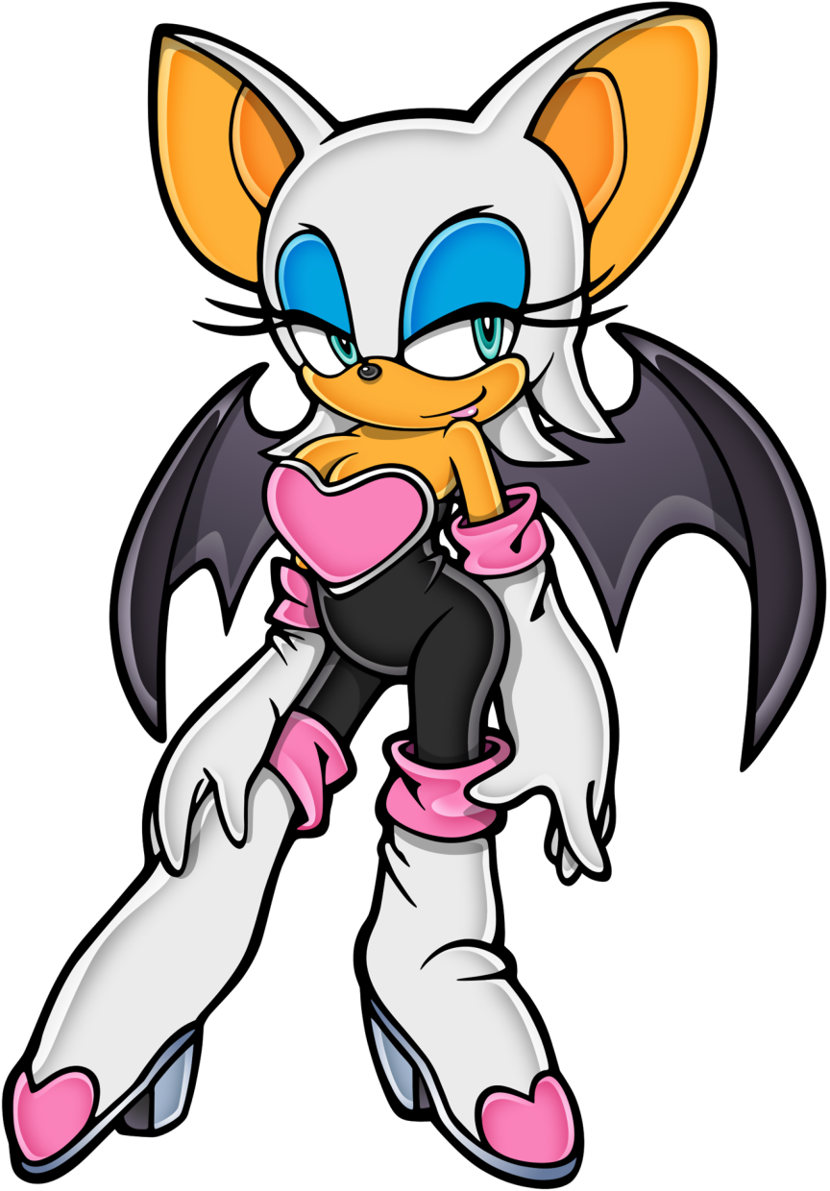
My long lashes fluttered along with the blue eyeshadow that decorated my incredibly huge eyelids. “Oh my, did that really happen? I’m Rouge the Bat now, am I?” Try as I might to dissuade it, my voice carried a sultry, wanting tone that fell in line with my plump lips that were painted in a bright pink gloss. I could recognize my situation, that I wasn’t actually Rouge the Bat – or at least I hadn’t been only minutes prior, but what I thought and how I conducted myself were different things entirely.

There was no doubt that my body, that of an attractive, anthropomorphic bat, had no business existing in the real world. But from how my breasts heaved when I breathed, to the twitching of my big ears, there was no denying that it had been made to work somehow. Even though my room was so dimly lit, it felt like I could see far more than ever before too. “Maybe this isn’t so bad, but then what do I do with myself now?”

The cause of my transformation aside, what to do next was something worth thinking about. If I walked down the street looking like a sexy bat woman, undoubtedly people would think it was just a costume at first. But eventually someone would realize, and then I’d probably be hunted? Scientists would undoubtedly want a piece of an existence like mine – assuming my transformation was permanent of course, though I felt fairly confident that this was the case.

So there was really only one option available to me now. Go into hiding. I had wings, did I not? So I could go to places I’d never dreamed of before. “I life on the run doesn’t sound all that bad, though. A tour of the world, stealing the treasures of humanity!” I waved my thick, gloved hands dramatically as I pitched the idea to an audience that consisted only of myself. It was strange… I’d never thought about theft before, but now stealing things like precious jewels was a rather appealing prospect.

A hand of four fingers rubbed itself against the skintight black material of my bodysuit, and the sensitivity of the touch seemed to trigger something in me. Something that caused a slight moan to escape my lips and a twitch of my legs to move. This was so bizarre in every sense of the word, and yet for how strange it felt, it also felt right. I almost didn’t want to change back. More and more, I felt myself embracing my new identity and the personality that came with it.

Until it finally sunk in just why touching my thigh had made me feel so strangely. “Well, I suppose I’m a woman now. So there wouldn’t really be any harm in exploring that body, right?” My bed was right there, so as soon as I got these clothes off…

“But just how the hell do I take off this outfit?”

