|  |  |
| --- | --- |
| T-Dreams  Inspired by a Captioned Image  By Maryanne Peters  I told Mom that it was bullshit, but she didn’t seem to believe me. I told her that Sis was just getting back at me for fucking up her prom night. I said that I wasn’t interested in that stuff.  “You can’t deny who you are and what you feel,” she said. “It is not good to repress your feelings like this. Open up.” |  |

This is all the new age shit we teenagers have to deal with. It’s like the trans-thing is flavor of the month. It’s like Mom actually wants a trans for a son, so that that she can say: “I am an understanding and progressive parent aware of gender issues and fully supportive of my child and his or her life choices”. What has happened to the world?

“You need to share these thoughts with your friends,” she said.

No way! That would really fuck up my life. If everybody I know thought that I was a tranny, it would kill me. There she is talking about me going public about my “gender issues”.

“Ok, Ok,” I said. “Just let me explore these thoughts in private for a while, first. If I feel confident about coming out, then maybe later.”

Of course, my sister was thrilled. She would get her revenge in watching me squirm as my mother sought to develop me as her second daughter. Squirming worse than she did in that prom dress.

All of these sites that I was supposed to be surfing suddenly became my daily internet content. All these sad guys who were deluded into thinking that they had some kind of female psyche, despite three facts staring at them in the mirror from below the belt. I started by feeling sorry for these guys.

But not all of them were so sad. There were stories of joy. It was as if there was joy on the other side if only they could break through.

Mom suggested that I wear something feminine around the house to help me “Get in touch with my feelings”. It was just a dress, made of soft material that fitted loosely around my shoulders and floated around my legs. In the warm days of spring it was probably the most comfortable thing I had ever worn. I did not mind the tightness of the forming panties and the training bra underneath. I did not realize that a garment could be as liberating as that dress.

I confess that I became curious as to what else I might be able to try.

Mom said that I had beautiful hair, naturally blond and quite full. She said that I just needed some length, and she started it off with some clip in extensions in platinum blonde. I had to color my own hair to make them look any good, but that did not seem like a big deal at the time.

But at school I got a hard time for it. Honestly I felt like crying. But I remember all the transgirls and their video blogs. It is about sucking it up and holding your head up. It will all change when you get through the hard part – when you look so good and act so completely that they have to accept that you are not really a boy – you never were one.

To think that day would never come for me was discouraging.

But it did change for me when I went to the mall with Mom. I wore some girly clothes and my extensions and a bit of makeup – maybe aa bit too much but I did it myself and I was learning. Jurgen was captain of the soccer team and he saw me admiring a pretty outfit in the window.

“It can’t be,” he said. “Are you Bob?”

“No on the weekends,” I snapped. I was sure that he was going to be mean to me.

“You’re gorgeous,” he said. He just stared at me, like he was looking at a sunset, or something. I have never been looked at like that before. It made me feel strange, but not in a bad way. “You’d look even better in that,” he said. Ponting at the window display.

“Maybe not,” I said. “I don’t have the breasts for a cut like that.”

“Not yet,” he said

I still don’t, but the bodice on the pink ball dress makes it look like my little titties are much bigger than they are.

The End

© Maryanne Peters 2020

Frank Meets Becky

Inspired by another of Jenna’s Captioned Images

By Maryanne Peters

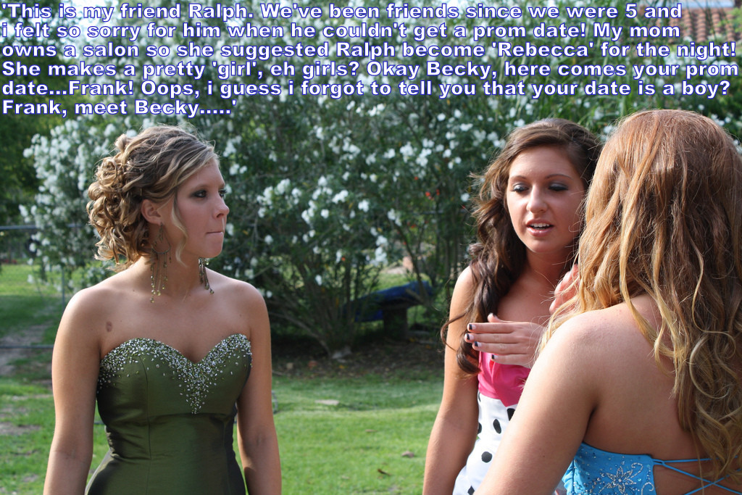

I have to say it, I was amazed. I mean, I knew Clara and I knew that her mother had a salon, because I like, had my hair for the prom done there. Just some height and a few curls down the back, nothing special. And Gabby was with us too. And a new girl, in a gorgeous green dress.

I mean, I knew who Ralph was – the little guy with the shaggy hair – right? So we are in the garden behind the hall to meet the guys and Clara (in the pink and polka dots) says: “This is Rebecca, who until a few hours ago was just plain Ralph”.

Well, I was staggered. I mean like, I could not believe it! Like, the hair was real, and how come he has breasts under that strapless dress? How is that possible? They looked real.

So Rebecca is looking across as if to say: “Did you have to?”.

“We all have to help,” says Clara. “You see I have lined Rebecca up to be with Frank as his date tonight.” Like, she means Gabby’s brother Frank. Like “The most likely to be a Billionaire before he is Thirty” Frank. Ok, maybe a little shy around girls, but a real catch.

So I look across at Gabby, and she has a look on her face like: “Whatever”. Not like she knows, but like she does not disapprove. Weird, huh? Like: “Oh yeah, Frank will be OK with that”. As if any guy would be happy to learn that the girl he is taking to the prom has a cock.

And then I see Clara and Rebecca look up and behind me and I turn, and there is my date Brett (looking super hot) and Frank, looking, well … sort of hungry.

Clara says: “Frank meet Becky …”. And before she can say Becky meet Frank, he has Rebecca’s hand and is planting a big kiss on it, and Rebecca, until that evening Ralph, is giggling and almost fainting.

Clara said that we all had to help, but Becky did not need any help. It’s true. We were all watching, to see how things would play out. If somebody was hoping Becky would let something step, a step out of place, a big deep laugh, a manly gesture, line up at the boys restroom, well, they would have been disappointed. We could all take lessons from Becky.

And Frank was all over her. He treated her like a princess, and it seemed like she was born to be treated that way. And by the time the slow dancing started they were locking lips. How would this evening end? That is what I was thinking. When Frank discovers the ugly secret lurking at the top of her tights, there will be trouble, or so I thought.

“Why don’t you treat me like that?” I said to Brett.

“Tonight, I am going to give you something very special,” he said. Somehow out of his mouth it just sounded like a talking penis.

We had sex after. It was not the first time. It was OK, I guess. I have to say that I was worried for Becky. She would have to talk her way out of it, and that would be hard considering how tight they were clinched on the dance floor.

But it turns out I had nothing to worry about. She was just what Frank wanted.

We never saw Ralph again. It was Rebecca from that night on. She’s a lucky girl. I guess he is a lucky guy.

So, where the hell is that man of mine now? Brett!

The End

© Maryanne Peters 2020

|  |  |
| --- | --- |
| A Study in Woman  Inspired by a Tiffany Captioned Image  By Maryanne Peters  When I heard it, I could not believe it. There must have been a part of me that did, because it seemed that my very insides had been ripped out – my heart anyway. Lost love: They write about it, but you cannot know the pan unless you live it. I had fallen in love with Mandy, and now I had to know if it was true – was she really a man?  How do you ask? How do you risk hurting the woman you love like that? How do you say: “Are you a man?” If she is or not, it will destroy her.  I needed to know. I needed to talk to her privately but not in private. I did not want a scene in the office, or at her place or mine, or even in a restaurant or a bar. So I decided that I would just do it as we left the building.  “I have had heard some stories about you,” I said. “I can’t believe them. It seems crazy to ask you but …” |  |

As only Mandy can, she just looks straight ahead and continues walking. She says, with a deadpan matter-of-fact voice: “Yes, it’s true. I am a man and this is a project for my women’s studies course…”.

She had cut me deep, but she hardly seemed to care. I was looking at her lovely profile and hoping that this was a bad dream.

“… I love being admired by men,” she said. She looked at me with those big eyes behind her glasses. She was talking about me. She knew that I wanted her. “I quit college yesterday and I am staying on with the firm as Mandy.”

That meant that the women’s studies course was over – the essay would never be written. But she was staying on. That meant …

“By me a drink!” It was not a request. She put her slender through mine and looked at me again. There was no mistaking that look. My heart was healed. I was not going to lose her after all.

The End

|  |  |
| --- | --- |
| Thesis Accepted  Inspired by a Captioned Image (Tiffany)  By Maryanne Peters  Kim Maunder was one of my most able students. At the age of 22 she already held a bachelor’s degree in psychology majoring in neurological theory for human behavior, and she was well down the track in postgraduate studies towards a master’s degree.  I teach courses towards a master’s degree, but for my most able students I adopt an open approach towards conferring masters degrees by thesis, inviting students to present a course of study for my approval, in a subject of their choice to be presented as a thesis within two years. Kim chose as her subject mind control. |  |

Mind or thought control, or thought reform (we no longer use the term “brainwashing”) is a contentious subject in psychology. The idea that using psychological techniques including pharmacological and even surgical intervention, can change a person’s attitudes, values and beliefs, has been largely debunked. “Brainwashing defenses” have been turned down by the Courts in many high profile cases. Hypnosis has been shown to fail to introduce unwanted thoughts.

More recently however, neurology appears to have opened up the possibility that some specific individuals might be susceptible to influence provided that their “neurological pathways” are not rigid.

I warned Kim that there was always the danger that in the controversial edges of our discipline her work might be criticized as “pseudoscience” and fail to achieve the full approval of the Board of Professors. She was still keen to proceed. She had a volunteer to help her – her own father.

I am not sure whether Mark was her natural father. He was younger than her wealthy mother and seemed largely dependent on her. But he had agreed to participate in a program to reduce what he referred to in his letter of consent as “a sex addiction” - even that has been called “a cultural myth” by some psychologists. How much of his consent was due to coercion by his long-suffering wife and his daughter (my student) did not concern me at the time. There was clear evidence that the subject was a genuine volunteer including a video recording.

I was curious as to how Kim would go about the exercise and the presentation of her work. I did suggest to her that to eliminate any suggestion that the behavior might be voluntary, her subject would need to show changed conduct completely at odds with prior recorded behavior.

She determined that the best proof would be to turn a womanizer into a woman, and a man-loving woman at that.

She was already almost a year into the project when she told me, and I have to say that I burst out laughing. As I said, nothing like this had been achieved before in countless experiments on human behavior. But she insisted that she was serious and that I would have proof soon enough.

That proof did not come in the form of a written paper or a demonstration before the Professorial Board, but rather by accident when I met Kim in a live music venue in the City. With her was a woman who appeared to be in her early thirties (just a little younger than me) with long blonde hair and wearing a tight sequined mini dress and matching high heeled stilettos. She was dazzlingly beautiful, and I may have said so.

“This is the subject of my study,” said Kim. “This was my stepfather Mike, now I suppose that she is my stepmother Mary.”

I was staggered. I had the video recordings of the consent only a year before which I was to check later to confirm it, but on the night, I thought that it was just a prank at my expense. It seemed unbelievable given to feminine grace that this woman possessed.

I have to confess that I was smitten. I could not pull myself away from her presence, and then as she increasingly allowed me, her perfect body. Kim seemed amused.

I looked at the video the following morning. There were traces in the face and the voice, even though they seemed so different, but the eyes give it away. Those china blue eyes. As impossible as it seemed they were the same person.

I asked for her to arrange Mary to come and visit me for “behaviorial assessment” but I had already accepted Kim’s thesis and decided that the master’s degree should be conferred. My real reason for wanting to get Kim into my office was to consummate what had started at that club. My thesis is that for a person to truly become a woman she needs to take a man inside her, and I am hoping that Mary will accept that.

The End

|  |  |
| --- | --- |
| Bucky’s Girl  Inspired by a Captioned Image  By Maryanne Peters  This is a nightmare – right? You break up with your beautician girlfriend and she gets her revenge by drugging you and feminizing you while you sleep. It has to be the worst thing that ever happened to a guy – right?  Well, this is me. Yes, the girl in the tight black halter-top mini-dress with the silver motif and the black high heels. The girl with the dyed blonde hair and the extensions in a high ponytail. The girl wearing the dramatic evening make up and the drop earrings in her freshly pierced ears, and clutching a bag only big enough for a lipstick, some mascara and few tissues. The girl pouting at the camera shaking in Bucky’s hands. That girl. What does the look on that girl’s face tell you? She’s not having a nightmare. |  |

Most guys in the beauty business are gay – right? So, what do you make of Bucky? Big, strong Bucky. A guy who can work wonders with scissors and a blow dryer but is also a mixed martial arts champion. A man who is built like a real man, and can make lesser men feel … well, lesser. I my case, make me feel that I am not even a man at all, or that I don’t want to be one.

She said Bucky would go wild for me, and he did. She said that he would take me home and make me his, and he did. I was terrified, but after he had introduced me to what love really could be like if you just let him do it, I was never going back to the way I used to do it. I lie back and enjoy it now. It is so much better to receive.

Maybe she thought Bucky would just use me and throw me aside. Bucky is not like that. When he falls for a girl, he falls hard. And he is not going to let a little floppy appendage get in his way. Such things are easily cut away, and should before we are married.

But for now he likes me to wear the outfit I wore that first night. It is just that now Janet fills it out completely. All but one of the traces of Jason are gone, and when that last bit is gone, I suppose we will be partners in the business.

I guess that means that little bitch, my ex-girlfriend, works for me now.

The End

© Maryanne Peters 2020