UNDER THE MOON
MAY 2022 REQUEST STORY
BY CHALDEACHANGE
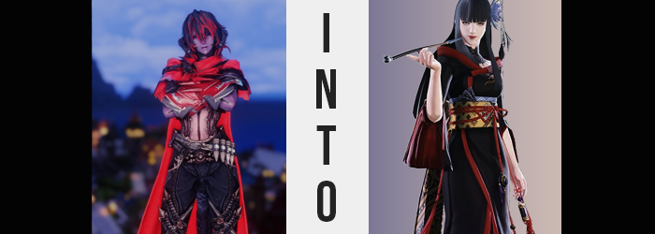

“A lunar eclipse, huh? Why the hell should I care?”

The atmosphere in Kugane that evening had certainly been festive, and for what the locals most certainly believed to be a good reason. After all, lunar eclipses only occurred every few years. In times long past it became tradition to celebrate this passing of darkness across the moon’s phases, heralding in four seasons of bountiful crops and good tidings for the people of Kugane and Doma.

This lunar eclipse in particular was very important to the locals, for it was the first one that had occurred without the presence of the Empire in the country. They had finally won their freedom, and there was no one to tell them how they should or should not celebrate. Of course, the people of Kugane itself had never been that beholden to Garlean’s meddling considering its status, but plenty of people visiting were from mainland Doma.

And so with booths going up and trinkets being sold, the background noise naught but the happy cries of children and the pleased mumbling of adults caught up in the good vibes, there stood one woman who, well, wasn’t really having any of it. She had come to Kugane at a bad time, it seemed, passing through the port town on her way back to Eorzea after an expedition in Doma.

Erdene Kal didn’t really have much of an appetite for these cute little gatherings. She was the type of Au Ra that preferred to be alone, surrounded by peace and quiet even when she was in the best of moods. But with the city being so loud and obnoxious, even as the night wore on? She wasn’t in the best of moods. Not by a long shot.

She had honestly just wanted to catch a quick nap before her ship left in the morning, but with all of the noise from outside of her inn window that was more or less impossible regardless of how many pillows she wrapped around her horns to try and muffle the audio. And so, in the end, she just retreated to the roof of the inn building. Begrudgingly, of course.
“All this for the moon getting dark for a little bit. I sure don’t fuckin’ understand the appeal of it.” With her arms crossed beneath her chest, the woman stared up at a sky that had been becoming increasingly starry as time wore on. “So much for getting some shut eye, because like hell I’ll be able to fall asleep on the ship right away.” The voyage back to Eorzea would definitely take a while, and so of course she’d eventually fall asleep at some point. But she would have rather slept off the fatigue from the trip back to Kugane from Doma in the first place.

Oh well. They’d have to deal with a super cranky Erdene. A fate, arguably, worse than death.

It seemed the eclipse hadn’t started just yet, based on how the moon was still completely full in the sky. Not that it really mattered to her. She wasn’t up there to observe, she was just up there because it was the quietest possible place. Even then, she wasn’t sure she could just lay on the tiled roof and catch a nap. Maybe if she lugged her pillow up there? Well, if she wasn’t stopped by the inn staff on the way. In fact, didn’t that sound like a good idea? The sky was clear, the breeze was good. So long as there weren’t fireworks.

BOOM! BOOM!

“Fuck.” There went that idea. Some had gone off in the distance, completely dashing that plan. “You assholes! Who’s going to see the moon through those!?” Real ‘Au Ra lady yells at clouds’ behavior, since there was no way anyone down below had heard her shouting. Erdene groaned and rolled her shoulders. She wasn’t so much of a savage that she’d whip out her scythe to ruin everyone else’s day, at least. Even she could see that this part of the world deserved moments like these after their liberation. Annoying as it might have been for her.

With nothing else to do now and all hope lost, her gaze was eventually cast back up at the moon. “…Huh? The hell?” She arched an eyebrow, utterly shocked. Not only had the lunar eclipse seemingly begun, but the light of the moon was already blotted out. Was it supposed to happen that quickly? It wasn’t, right? But if that was the case, then why was no one below panicking or at least commenting? The truth of the matter was simple. Erdene was the only one witnessing this, because she had been chosen by a force greater than herself. Chosen for what, exactly?

Nothing good.

“Is no one else seein’ this? HEY! Anyone… Huh?” She had leaned over the side of the building to yell at some passersby, but in doing so she revealed to herself the cause of the silence. So distracted by the moon, she hadn’t noticed that the chatter of the people below had quieted too. Now it all made sense, because everyone down there? They were frozen solid. Like time had stopped for everyone and everything but herself. “Am I caught up in a spell? This is impossible otherwise!”

Actually, what she was caught up in was something akin to a tempering, although it wasn’t working in the same way as when one was tempered to a Primal typically. It was having a very notable effect on her body for one, and you didn’t really need to look much farther than the woman’s skin to see that.

From the moment she had been born, Erdene’s skin had naturally been that dark violet color that wasn’t as unusual for an Au Ra as you might expect. Depending on the tribe, their colors could range from sickly pale, to dark blue, to tan, to yes, even purple. But the woman’s natural skin color was lightening under the muffled moon in the sky. It paled more and more, not quite reaching towards the realm of an absolute white, but it was a pink that flirted with the border of it.

Of course this meant that her dark scales stood out all the more plainly against this lightened skin color. At least for a time. At least as long as they existed. Because they wouldn’t linger for very much longer. “Should I get some help? Did I fall asleep? Am I sleeping?” She had been tired beyond belief, so it wasn’t outside of the realm of possibility that she’d actually fallen asleep on the roof and this was just a dream. A very, very vivid dream.

Although she hadn’t realized what was going on with her body in this ‘dream’, either. Her scales, for example? They had begun to crack and dry out at an alarming rate, with pieces flaking off across her body. Whether it was the scales on her arms, legs, neck, or even the sides of her face, they all broke away to reveal skin just as pale as the rest of it.

In the meantime though, the same cracks had appeared across her dark-colored horns. Little by little they chipped away from the tips towards the center. As her people processed sound using their horns as a medium, this flirted with the possibility that a pair of gaping holes might be found on the sides of her head once they had completely crumbled away. This, fortunately, was not the case. What was exposed was the emergence of a pair of fleshy, rounded Hyur ears.

Erdene stomped her heel, feeling her agitation grow. “If this is a dream, wake me the fuck up!” Despite her cries falling on deaf ears, it still made her feel better to yell, nonetheless. Doing so only served to loosen her tail, however, which uncomfortably popped off from her tailbone and landed on the ground behind her. “Huh? My pipe?” She had immediately spun around to express shock that one of her appendages had just fallen off, but once she knelt down to examine it? A different word had popped out to describe it. And no sooner than she had said it did that dismembered tail shrink and malform into a black, bone pipe that she scooped up nonchalantly.

“A tail? Hah! Since when did I lower myself to the likes of the Steppe’s tribesmen?” No… Wait. She loved the people of the Steppe. Erdene was an Au Ra herself, right? But… she wasn’t? Weren’t they just worms that had gotten in her way? Worms…? None of these thoughts made a lick of sense to her! It was like her mind had become a mess of uncertainty, and the woman thinking them felt even more at a loss once she realized.

It didn’t really matter how disoriented she was, mind you. Her situation simply worsened, nonetheless. Her layered hair color was promptly washed out as she stumbled about atop the roof, both colors not only darkening to a raven black, but also occupying more space for her hair began to spill down her back. Long and silken, none of the choppy wildness that Erdene loved about her hairdo persisted. Instead, with bangs cut in a straight hime-style across her forehead, it was the long and beautiful style of a princess. Or someone who believed themselves to be a princess of a sort.

For all the menace her mind was quickly flooding with, mind you, she’d hardly be suitable to be referred to as such. There was just so much hatred building within her. So much raw emotion, and yet her expression was becoming increasingly calm. Eyes shone silver and narrowed until they looked more typical of the Doman people, while her lips not only swelled plump but inherited a cherry red color. A beauty mark appeared beneath the left side of these lips, and her face was left looking longer overall. She was beautiful, elegant, and yet like a carnivorous flower, this was all to lure in her prey.

“Ahaha! I’m…!” Free? She had almost blurted that out. Hadn’t Erdene always been free? She had always believed that, but it was more like a second ego had tried to say this. New memories, new personality traits; they were both reshaping the kind of woman she had been, and the kind of woman she would be going forward. Erdene had always been confident, but there was a smugness that accompanied it while her body entered its final phase of changes.

The woman grew several inches taller, pulling her top up to reveal a pale tummy below, while the tightness of her pants was enhanced by the widening of one’s hips. She had never considered her body to be indecent, lean and typically figured as she was, and yet… Bloat set in, targeting her thighs and ass. Both areas swelled greater and greater, but her pants were already so tight that the pale flesh both had nowhere to go, and the material was so strong that they couldn’t burst out either. The best they could accomplish was the cheeks of her ass poking out from the peak of her legwear, but this wasn’t sustainable.

Her top had a similar issue to deal with, for her breasts had begun to grow all the same. With nipples fully erect, they were digging into the underside of her armored top without any respect for her own comfort. Bigger and bigger these breasts grew until they reached DD cups, but the space was so limited in her clothes that she was having difficulty breathing. It made her want to lash out. To tear her clothes right off.

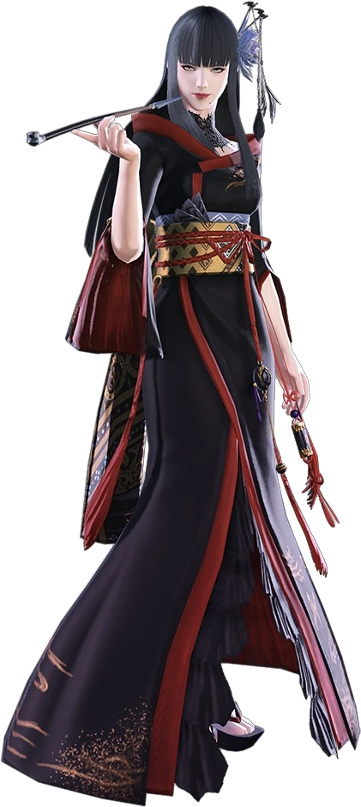
Fortunately, she didn’t need to do that. Because the light of the moon returned, and motion returned to the world below just as her outfit was reskinned as if she had accessed something from a glamor dresser. Her Reaper garb replaced with a long, elegant kimono of black with red trim, while a purple floral ornament found her hair. Walking on raised sandals, it was the visage of a woman anyone who had lived in Doma the past decade would recognize. Because of how much suffering she had brought them.

A tongue that was slightly longer that it had been minutes before ran across lips painted cherry red before the long, black pipe that had been fashioned from her once-tail was ultimately placed between them to inhale the contents. The feeling of the smoke inside of her lungs brought her some calm, which felt needed for the woman could not quite grasp why she had become so jittery in the first place.

There was no recollection in her mind of enduring a transformation, one that had twisted her body, race, mind, and soul. She simply accepted herself as she was now. And she was now a woman that was even more upset by the happiness on display on the streets below than the woman had once been. After all, she was the second coming of Yotsuyu goe Brutus, the once imperial viceroy of Doma that had oppressed its people according to the Garlean Emprie’s will.

Or, well, this was technically her third coming.

It had been her job to torment these people. A people who had abandoned her and left her to suffer as a child. It was because of this that she had never batted an eyelash when it came to torturing her own people, and because of this that she had been willing to go to the extents she had to accomplish her goals. Even now, standing high atop Kugane – a place once untouchable even by her, she was thinking how joyous it would have been to ruin this little festival of theirs.

“But I suppose I’ll need to take stock of my assets first.” She certainly spoke with much more elegance than Erdene had, even though it was concealing just how sinister she was deep down. That said, she had a point. Since she was assumed to be dead, and the empire no longer had any hold in this part of the world, it would have been foolish for her to take any action without power. She had no soldiers, no Primal abilities.

…Actually, the more she thought about it? Wasn’t this situation terrible? If anyone in this city caught sight of her, they would immediately have her thrown in jail, if not worse. “Perhaps I’ll need to give up on any aspirations here.” She bit her lower lip at the thought, but living free was preferable than spending the rest of this life in a prison cell. What options were available to her in that case? Fleeing.

“Ugh, do I need to start a new life abroad?” How would she make money? She would need to take up a new alias as well. Eorzea would be no good, seeing at the Scions were stationed there. What about Thavnair? If she could sneak herself aboard a ship, that was one option. Nonetheless, Yotsuyu wasn’t at all happy about the idea of rebuilding her life from zero. Abandoning this place and building something humbler felt like an awful idea.

But Gosetsu would be proud, if anything.

