*Welcome to The Coven*

*Siggy Commission for Kilandra*

Living in a family of eccentric magic practitioners was one of never ending excitement where every single day was never a boring one with experiments and spells going off like fireworks on the 4th of July. And if you had something of your own to bring to the table? Then you might just find yourself at the center of attention…until the next useless magical implement or spell comes along to wow them all.

But what if you were just an ordinary, red blooded human with zero aptitude with magic? An ordinary person like say the guy running by every morning on his daily run (and occasional lab rat for a wayward spell).

Then you'd be bored out of your mind since the family's idea of entertainment was inventing new spells or fooling around with magical artifacts that probably shouldn't be used as a paperweight. And if that wasn't enough, then you'd be struggling to focus on important things in your mundane life like school or work when explosions, yells and otherworldly noises were considered simple ambience for almost every day of the week.

That was the life Charlie had to live, a normal young man growing up in a household surrounded by a loving mother living a hidden life as a famous enchantress and an elder sister studying under her mother with a penchant for hexes and a mischievous streak hidden behind the facade of a ditzy fashionista.

And not to mention the father who was almost never around considering the seat of importance in the greater world of magic he occupied.

It was easy to see why poor Charlie would've felt stressed out and alone in a family where every member was either extraordinary or of ridiculously high standing.

But that didn't mean his family saw him as anything less, nor did they ridicule him for it. Sure, it might’ve been the barb in one or two fights with his sister but that was to be expected in a family after all, siblings were always going to clash sooner or later. Deep down however, they loved Charlie all the same…even if they might show their appreciation in ways that might not seem that way on the surface.

And on the day of the annual Witches Coven held at Charlie's home considering the status of his mother and father, his sister was itching to test out her latest hex that was most certainly not meant to be used on men at all in an effort to get her stray little brother to join in on the festivities for once…

Suzie’s Plan

Suzie was a simple woman, Living a cozy life with her esteemed mother and tutor; Selina, while spending every hour concocting a new hex in an attempt to make her name known in the world of magic. And with her comrades in arms providing tips and feedback through the witches equivalent of a study group, Suzie was well on her way with devising a hex to be used on faithless lovers, surprised no vindictive witch had ever thought to create something like this considering the amount of women being cheated on everyday.

With that goal in mind and the idea of another witch beating her to the punch spurring her on, Suzie had wasted no time in making her concept a reality through countless trials and repeated tweaks to the inscriptions and complex magic circles needed to ensure the final product wasn't some botched abominable reject. The hex needed to punish a faithless man after all.

And after months of hard work and tests numbering in the hundreds, Suzie had the final product held tightly in her hands. And on the day of the Witches Coven no less.

Taking a quick peek around the house and it was as usual; with her mother finishing up on house cleaning, her hardworking father absent as usual…

**"And Charlie's gone again…"**

Her brother had been born without the ability to channel the flow of mana, making him a regular human being, that had left him bitter and brooding even if he didn't show it on his face. Making it a point to avoid coming home whenever possible if it meant he didn't see another spell being flung around willy nilly. Something she was sure he wanted to do himself.

With the Witches Coven taking place tonight, it made sense to see Charlie already gone so early in the afternoon…but she wanted him to experience what it was like for the participants of the Coven, only there was just one small issue…

An issue to which she already held the solution to in the palm of her hands. *'I'll just need to tweak the formula abit, but I'm pretty sure this will work!'*

Running down the stairs with an eager smile on her face, an eager Suzie calls down for her mother with excitement lacing her every word.

**"Hey mom? I've got something I wanna ask you about for tonight's Coven~"**

Charlie

In a downtown street bustling with activity in the middle a sweltering midday sun, a portly young man probably no older than 26 years old was in the middle of lifting weights, ignoring the vibrations coming from the phone in his bag as he continues to work out, grunting with each heavy lug lifted above his head.

This was Charlie; lone son and the sole disability in a family of exceptional individuals with extraordinary talents.

He didn't use to think much at all about his inability to use magic or cast spells when he was younger, only ever feeling amazed whenever his enchantress mother would fill the room with astral projections of the cosmos or during the rare occasions his father would return home with yet another wondrous artifact. Until his sister; Suzie, had chided him about being a *'normie'*, causing a fight between them to break out that resulted in Charlie breaking a nose while his sister got away scot free…

From there it was a downward spiral of isolation and avoiding his family whenever possible, keeping to himself or hanging out with his other *'normie'* friends at school without a care for the people back home, unaware of how deeply regretful his sister was despite their still frosty relationship, unable to bring himself to talk about it and mend the broken bridge.

Until today, that bridge was still left in tatters with no hope in sight of ever seeing repairs…

Unbeknownst to the stern faced young man however, the air around him begins to simmer in the undetectable waves of magical energy from a powerful Hex cast halfway across the city. Hefting weights all while being oblivious to the ripples spreading across his body, doing away with calluses, body hair and other blemishes until only creamy smooth hide with a lovely peach hue remains.

**"Phew…worked up a sweat alright…time to move on to squats I guess…"**

Putting down the dumbells with his biceps and forearms stinging, Charlie assumes a stance with his feet spread apart and bent at an even angle, continuing with his workout while ignorant to the changes occurring beneath his softer skin with fat bubbling up and slithering like snakes all across his body, leaving behind shapely limbs lined with the firm muscle and toned flesh he had trying to build up for months.

But the flabby mass needed somewhere to go, and so they pooled around strange new places on Charlie's body; building behind his pecs and filling up his rear all while the changing man continues to squat away, with each rep leaving the formerly obese man looking more and more effeminate with a noticeable jiggle to his ass and chest, especially when a pair of bloated mammaries begins to fill in his flimsy top , lifting the sweaty singlet away to reveal a tight toned core where a flabby overweight navel once was, leading down a sleek hairless slop between his notably curvier legs where a disturbing scene was playing out unnoticed.

With how plump Charlie's thighs now were, each rep brought an uncomfortable squish go the man's trembling member as it squirms against an invisible hand pushing against it, crushed into pulp every time Charlie lowered himself to the floor with a hearty jiggle to his swappable derriere. And every time his thighs suffocated his shrinking manhood, it would grow smaller and smaller…

Until with one final rep, Charlie's thighs part to reveal a puckered cameltoe formed by her newly grown labia squeezed up tight against the elastic material with no underwear beneath to hide her virgin folds, grunting in a girly voice with a fierce blush on her now unrecognizable face as it enters the final phases of the transformation with her well kept beard long since retreating back under the same soft skin that coated the entirety of Charlie's body.

**"58…almost there…"**

Pumping up and down with her C cup breasts straining against her tightening top, Charlie continues her reps unabated by the tight clenching sensation of new muscles and organs forming beneath her aching belly, grunting and sighing in soft womanly gasps with her dark eyes softening at the edges, before coating themselves in lustrous lashes as the broad bridge of her nose cracks into a cute ridge leading down to lively lips colored a naturally exuberant shade of pink with sweat running down her flushed cheeks at the effort to power through the discomfort and weakness in her arms as a little muscle turns into toned flesh to lend more to her beauty, leaving the once chiseled shoulders small and weak.

**"Shit…69!"**

Mouthing the naughty numbers in her airy new voice, Charlie groans in exertion as her curly head of matted hair begins to twitch, before flowering outward into a luscious mane of chestnut brown hair that sticks to her sweaty brows and down over her ears, with the rest of it flowing down her back in a soft mane that tickles the nape of her neck and the exposed area of her shapely back, forcing her to thrust her chest outward as they finally stop growing into impressive Double D's that bordered on the E cup range, sloshing and jiggling with milk.

At this point, Charlie had stopped verbally counting her reps, mentally counting upward as the pain and discomfort in her body eventually begins to ebb and wane, taken over by a pleasant warmth radiating from between her legs and beneath the milky teats flopping away as she rose and fell, held aloft by her powerful new legs as they shook and trembled with the effort. But a woman like her needed new clothes to fit her body, and so began the material changes as Charlie's old singlet morphs into a proper sports bra that eases the tension on her breasts while providing some measure of support while her boxers morph into waist high leggings the only serve to accentuate the curves of her child birthing hips and hearty bubble butt with a neat little bonus for the gym bros now eyeing her up as they leered at the clenching outline of Charlie's snatch squeezing between her legs with each slow squat. Only they didn’t seem to realize that the hot piece of ass they were admiring was standing in the spot where an overweight man once was…

*'97…99…'*

And as her hair magically bundles itself up into a nice cute ponytail, Charlie's transformation into a stunning babe that looked nothing like hos former obese self is complete, leaving her drenched in her own sweat and feeling strangely tingly all over as she pushes her fringe out of her eyes with the end of te exercise.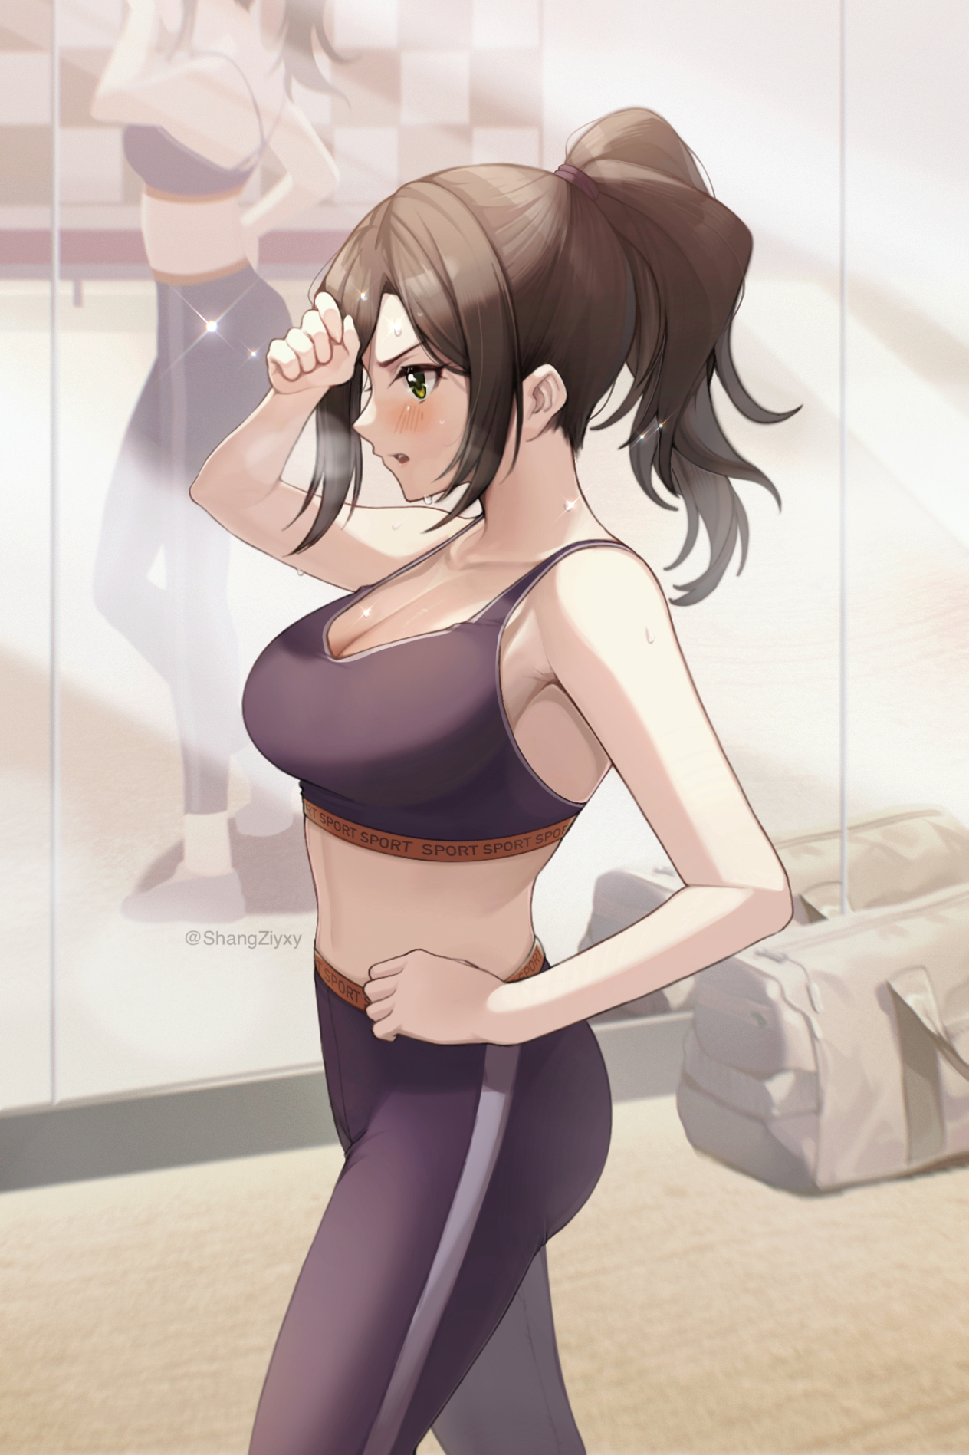

**"...and a 100! I did it! Time for cooldown…my chest feels so tight…”**

**“You sure did hun..say, wanna go and hang out after you’re done coolin’ down? I’ve got a nice lil spot I know down at a bar your sexy little ass will love~”**

Raising her brow at the creep that had suddenly appeared by her side, Charlie slaps the hand slowly winding around her cinched in waist before realizing something was obviously wrong, frozen mid-punch at the sight of the pendulous mammaries hanging off her chest with inverted nipples straining to be set free from the suffocating women’s sports bra now biting into her sexy new physique.

A quick inspection of the rest of her body followed by a look at the full body mirror on the wall to her right only confirmed the rest of her suspicions, with a stunning beautiful number standing where her taller, albeit overweight male self should’ve been, completely ignoring the buff man trying to get her attention as a vein pops in her cranium…

***“God fucking damn it Suzie!!!”***

Charlotte

All he wanted to do was to do a quick workout session at the gym before heading out to grab a bite and crashing at a friend’s place for the night, but all of that was jeopardized by her sister who had been trying to send her messages ever since the afternoon had rolled around, only now rushing to read through them all after finding herself turned into an embarrassingly hot girl made even more awkward after realizing she looked a bit like her mother, even sporting her natural wavy hair at the tips. But that wasn’t the main concern on her mind.

After taking shelter in the women’s locker room where there was thankfully no one else around, Charlie had sat down to read the warnings her sister had sent her; telling her many times to prepare for something that would *‘help her partake in the Coven without needing to worry’*, whatever that meant.

Angrily calling her up, Charlie’s brow twitches at the sound of her big sister’s cheerful voice leaking through the phone. **“Heya lil bro! Or is it lil sis now? C’mon~ Don’t leave me hanging!”**

Groaning, Charlie cups her phone between her shoulder and ears before getting up to change, gingerly stripping herself down and blushing at the sight of her exposed tits as the creamy mammaries come free, dripping with sweat that she quickly wipes down. **“Did you really have to make them this big?”**



**“Oh my gawsh! You sound absolutely amazing! And FYI? You do realize you take after mom a lot right? It’s our genes at work here! If your tadda's weren’t as big as your head, then we’ll need to go for a trip to the mystic to get your family tree checked! Oh, oh, mom wants to talk!”**

Slipping on a baggy jacket with crackles of static in her ear while cursing at how annoying her chest was, Charlie’s anger softens at the sound of her mother’s voice leaking through into her ears. **“Hello dear~ Is everything alright with you? I know it’s a bit abrupt but just know this isn’t another of your sister’s pranks…come home will you? Just for today?”**

Sighing with her chest beating with a twinge of heartbreak, Charlie leans against the locker with her jeans halfway up her legs. **“I’m fine ma…but what do you even need me back there for? I can’t use magic, remember? What good am I in a gathering for witches even if you turn me in-”**

**“-That doesn't change the fact that you’re my son! Well…daughter now I suppose…but just know that I…we…have always loved you Charlie, your big sister might be a bit of a prude at times…but I hope you realize she's been trying to reconnect with you ever since that quarrel…”**

**“...I’ll…I’ll be there ma…thanks for that.”**

**"Don't mention it darling, that's what mommy's here for! Oh I can't wait to see how you look like~"**

Exhaling as she does up the buttons on her jeans, Charlie steps away from the locker before turning to face the mirror, giving herself one last lookover with her hands uncomfortably running over her nubile figure, wincing every time her adventurous digits graze an overly sensitive spot on her foreign new body.

**"Heya! I'm back! So, I take it you'll be coming over for the Coven?"**

**"Y-Yeah…I am…but uhh sis? About what ma said…I-"**

**"No need to worry your pretty little head about it! It's already behind us so we're better off just moving on alright? Anything else you wanna ask before I go? Gotta help mom prepare for the first visitor."**

**"Nah, there's nothing else, I'll see you…actually wait…when you said I took after ma…does this mean…the me I am now…is how I would've looked if I was…y'know…"**

**"Born a girl? Totally! Speaking of, we need a new name to call you…how does Charlotte sound? Ohhhh it totally fits how hawt you sound, alright enough chatter, I'll see you later baby sis!"**

Before Charlie can protest, the phone line goes dead, slumping her shoulders in defeat before tucking the phone away in her pocket. Taking one last cursory glance at the mirror with a soft blush on her cheeks and a sideway view of her voluptuous figure before turning to leave with her rucksack slung over the shoulder.

**"Charlotte huh? Gosh this is so weird…"**

Making her way back home was easier said than done, with her mind still that of a man, the newborn Charlotte was having a hard time adjusting to all the stares sent her way. With the leering eyes of men and the envious gazes of women bearing down on her wherever she went, spurring her steps faster and making her more than aware of her new ‘feminine’ allure; blushing at the sensation of her smooth thighs rubbing together or her firm breasts bobbing with each hurried step she took with the silky strands of her ponytail tickling the nape of her neck.

For while she thought wearing men size clothes was a good way to conceal her shapely new figure, the loose baggy clothes only served to emphasize and bring attention to her herself with her breasts appearing much larger than they already were and the tantalizing contours of her body being outlined like a tease, begging for some brash knucklehead to give it one hard pull to reveal the juicy contents beneath.

By the time Charlotte had arrived at the train station, the weary woman had simply hopped into the next cab available in the stands outside, resting her head against the window after providing directions for the driver to follow.

*'How do girls even manage being looked at all the time…'*

The Coven

Finally arriving at the front lawn of her humble little home at the edge of the suburban area, Charlotte steps out of the car, relieved to be alone once more without a massive crowd eyeing her like lions would a piece of juicy meat.

But before she can even grab her keys to unlock the front door, the mahogany wood swings open with a familiar face peering out at her with an eager smile with a whole array of voices she had never heard before emanating from the many women already roaming around the house, presumably the witches here to attend the Coven.

**“Ohhh you look as beautiful as i thought you’d be gurl! Come on in!”**

Pulling her inside before she even had the chance to utter a greeting, Charlotte soon finds herself confronted with the faces of her mother’s colleagues as the conversation dies down into hushed whispers with all eyes directed her way. Leaving her embarrassed and at a loss for words…until she hears what the other witches were really talking about amongst each other.

*‘So she’s Selina’s youngest? The one who can’t use magic…I’d heard it was a boy….’*

*‘If anything she’s inherited Sel’s looks nicely~ I wonder if she’d be willing to lend a hand in my Transmogrification experiments~’*

*‘Try anything funny and Selly would have your head finely diced Jess~ And even then you’d be lucky to die right then, keheh~’*

Swallowing the ball in her throat at the very ominous intentions behind the whispered words of the 13 pairs of multicolored, otherworldly eyes directed on her, Charlotte takes a trembling step back before another familiar figure pushes her way past the crowd with a warm smile on her face upon catching sight of her.

**“Oh baby girl~ Come and let mommy have a look at you! Mmm~ Suzie was right, you do take after me…welcome come dear~”**

**“H-Hello ma…i’m back…”**

Returning her mother’s embrace in what felt like an eternity of not interacting this way with her parents, Charlotte’s tense shoulders relax as she melts in her mothers warmth with a chorus of chuckles and happy aww’s from the other witches, basking in the moment with her mother’s bosom providing some excellent warmth to lull her to sleep with her reduced stature leaving her just tall enough to crane her neck slightly to look Selina in the eyes. Parting from their hug, Selina wrinkles her nose playfully after giving her daughter a quick inspection.

**“Hmm, it won’t do for my pretty little girl to smell bad…Suzie? Be a dear and get your sister cleaned up alright?”**

**“You got it mom! Come along sis! Let’s leave the old timers to their business!”**

Moving on upstairs past the crowd of witches as they waved Charlotte and Suzie farewell, the weary younger sibling sighs in relief with one hand held aloft by her sister, dragging her along the familiar halls to her bedroom.

**“Hahah! What’s up Char? Been working out or something?”**

**“As a matter of fact…yes I was…until your little surprise hit me…Ma’s friends are…scary…”**

**“Aww you’ll get over em, most of em aren't bad once you get to know them! Like Jessica for instance, she's really got the brains even if she looks a little…y’know…not alright?”**

**“Jessica…you mean the one who said stuff about a trans-thingy?”**

**“Transmogrification! It’s her greatest invention, uses it a lot on her rivals since men would rather bed her than a warty toad, cool gal really, had a chat with her once over video call and she was super rad! Not to worry though, we’ll be upstairs for the rest of the evening so no worries if you aren’t ready to talk with em yet!”**

**“I wouldn’t call that…*’rad’*...wait, aren’t we supposed to attend the Coven? Why’re we staying cooped up inside your room?”**

**“Ohh, you’ll see why soon baby sis~”**

Stepping through to her sister’s room, the door opens to reveal yet another cast of unfamiliar characters consisting of 1 other girl and 2 boys…2 very handsome boys that were beginning to make Charlotte feel all sorts of funny as she gazed into the brunette’s azure blue eyes and chiseled features.

**“You're Suz’s little sister right? What’s your name?”**

Shifting uncomfortably for a moment, Charlotte sighs before tucking a strand of hair behind her ears, sheepishly replying while trying to draw her eyes away from the oddly stunning young man she had no idea why she suddenly seemed to have the hots for despite being a man herself not too long ago. **“Char…it’s C-Charlott-eep!”**

Before a sharp spank to her bubbly rear sends her forward into the room as Suzie enters after her with a devilish grin on her face.

**“Like what you see gurl? I don’t blame you, Max’s looks are as good as his heart is~”**

**“W-What’re you talking about? I-I don’t like boys!”**

Snapping her fingers before a wave of magic washes over Charlotte, the young woman yelps in panic as her clothes unravel into threads, leaving her in the nude for a moment until they reform into simple velvet cloth that wraps itself tightly around her breasts with a red thong biting into her plump hips and digging deep between her legs, complete with matching red wristbands before feeling herself falling to the ground and landing in a giant heart shaped cushion that had appeared below her. Leaving Charlotte scrambling to cover up her DD’s while blushing furiously much to Suzie’s chagrin, giggling madly with her friends while the two boys ran their eyes over her tight hourglass figure.

She looked like a present wrapped up for Christmas…

**“Are you really sure about that? You were totally fawning over him earlier…and your body isn’t being as truthful as you like to think it is, just look at how wet you are~”**

Shifting awkwardly in her current state, Charlotte slowly parts her hands from her breasts, letting them lay by her sides as she gazes down at herself with a hazy look, struggling to think up a comeback line but to no avail. But Suzie was right; from where she lay, she could easily see her inverted nips pressed up tight against the cloth and the slightly damp fabric between her legs struggling to hold back the leaking dam that was her tingling snatch.

She wanted to cover up her breasts, to hide her aching pussy, but something within her was telling her to bear it all for the boys to see…

**“I’m not forcing you to but…if you want, Max could be all yours for tonight Char~ If you say no it’s fine with me…that just means I get to keep him all to myself!”**

**“I dunno Suze…Charlotte’s looking like a really good choice if I had to pick…”**

**“You say that, but you can never say no to this ass now can you?”**

**“Hah…you’ve got me beat there Suze~”**

Thinking things through for a moment, Charlotte’s hazy eyes move between the girls and the boys before returning to rest over own body, lying still even with Max slowly beginning to undress as he approaches her, not even noticing the cow print bikini that had appeared over her body with a convincing cow ear headband slung over her head, complete with a tight collar now wrapped around her neck with a cowbell hanging from it. Gently pushing Max's arms away as he reaches for her aching teats.

**"May I?"**

She didn't know what the burning hole in her chest was, or why the blood seemed to rush to her head whenever she gazed at Max's face, but she couldn't deny her urges any longer. Everything; from the lick of the cool air against her slick skin to the smell of Max's manly odor was driving her insane, and she needed to get her fix now, finally acquiescing to her big sisters boyfriend as she throws her head back with a sharp moan at the sensation of the man's big hands kneading her breasts gently with a seasoned grip as something hot and hard begins to push into the steamy valley between her boobs with the other pair already well on their way to destroying the bed.

Bonding with Suzie would have to come later, for now, she had a mare to tend to as her little sister gives her boyfriend a wink before slipping outside before things got too hot and steamy for her to resist.

**“Well then, welcome to the Coven baby sis~ i'll see you soon alright?"**

Epilogue

**“So~ Don’t keep me guessing! How’s she doing?”**

**“Ohh~ Char’s taking to it nicely mom~ Here, take a look!”**

**“O-Oh my…”**

Conjuring up a misty screen from the palm of her hand, Suzie and Selina watch from Max’s point of view as he walks a very flustered Charlotte through the in’s-and-out’s of a proper titjob, giggling at the sight of the bodacious young woman struggling to heft her breasts together and needing some assistance from her man, with a look of anger, excitement and lust on her face.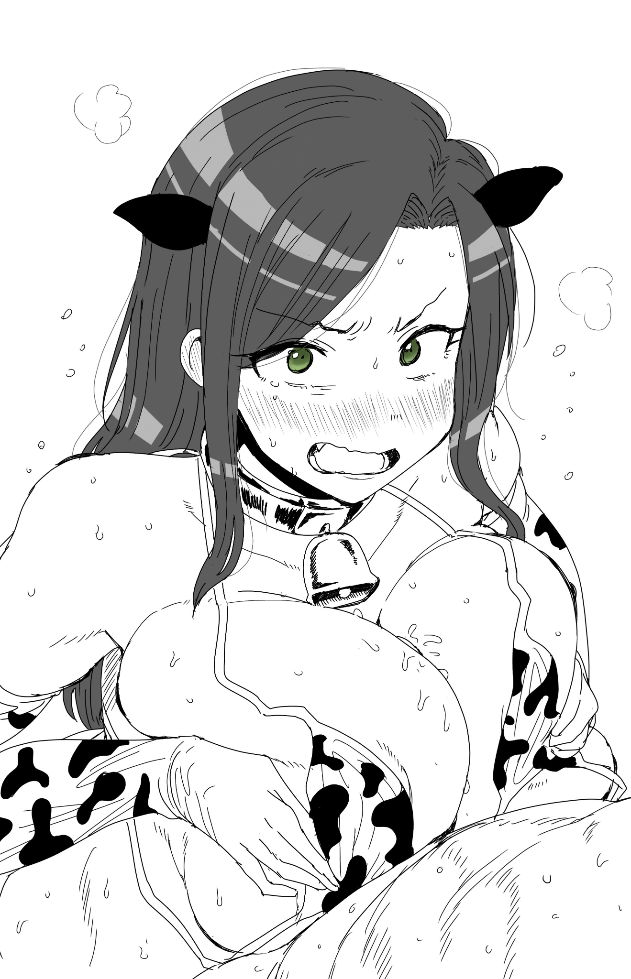

**“I haven’t seen her that happy in the house for a long, long time…do you think she’ll like being a girl? I love my boy all the same but…seeing her like this reminds me of the time I met dear Bernard for the first time!”**

**“I wonder…but that’s a choice Char’s going to have to make for themselves…to think we’d be getting back together like this…”**

Giggling to herself, the eldest daughter looks up at the ceiling with a happy smile on her face amidst the raucous conversation going on around her. After years of isolation, her angsty little brother finally returns to the fold. Shutting off the magical screen just as Max lifts a screaming Charlotte into the air before tearing off her bikini and planting her up against the wall…

**“I’d totally go for having a younger sister though, you’d definitely be a grandmother in no time with Charlotte sharing Max~”**

**“Hhhmm~ Make fun of me now dearie but age will catch up to you sooner or later~ Why don’t you go accompany Charlotte? If anything, her first time will be a painful…albeit unforgettable experience…wouldn’t you think it’d be better if you were there too?”**

**“Tee hee~ That’s real kinky of you mom…but I get what you’re poking at…good luck with the Coven! If we’re not out for dinner later, then I'll see you tomorrow alright? Later!”**

Waving goodbye to her daughter as she sprints hurriedly back upstairs to join in on the fun, Selina sighs wistfully before her thoughts drift back to her husband….glancing at the photoframe on the coffee table with a loving look on her face.

**“Ah Berny…he's going to be in for quite a surprise the next time he comes on home~”**

***THE END***