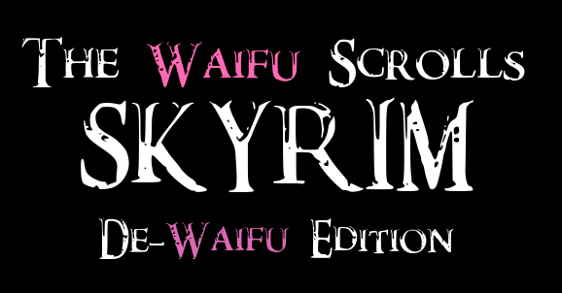

Part 8
So.
Turns out.
Roads?
A fuckton safer.
Oh, there were wolves, and ice wolves, which were just wolves but white, and bandits by the score, along with an entire fort full of necromancers that would’ve made any kind of travel impossible, which seemed like it should’ve been of… high priority as it was obviously the toll-point for the only road into Winterhold, but, right, this place wasn’t real, or, at least, didn’t work by real-world rules, so… sure, necromancers.
The most annoying part, though, was that they weren’t even being smart about it, with skeletons just standing guard, when, if you have an unquestioning and untiring slave, why aren’t you using it for industry? At that point, setting up in the middle of nowhere would make sense so no one knows that they’re (insert product here) was built by undead labor. I mean, if it was good enough for Chinese-created products back home, put together by employees of… questionable opportunity, why not do it here, where there’s even less access to information to investigate the sources of one’s goods?
But, nope, just a dozen assholes, all in black robes with skull designs on their chests, and three times that in animated skeletons.
Smack dab in the middle of the only road to Winterhold.
Like, the road went around Fort Kastav, which meant that the skeletons, set to fire and forget mode, just started shooting at us as soon as we got close, so we really didn’t have an option but to wreck their shit.
Not that I minded.
I actually got to see the normal version of the ice-storm spell that the Dragon Priest had sent my way, which was a third of the size, a third of the speed, and, likely, a third of the damage, but I dodge, reaching out a tendril of Shroud to grab Lydia and reposition her, letting the NPC continue to chop the malevolent mages to bits, though it wasn’t until the ‘kill-shot’ that they took actual damage, as you could stab these fuckers in the eye, and they’d be damaged, but just keep on fighting like you hadn’t just whisked their brain.
Honestly, with Lydia to capture enemy attention, the… ridiculousness of the ‘vitality’ of these people was only mounting. I’d thought I was getting a handle on it, sinking a few perk points into extra damage from my One-Handed skill, but while that’d helped it felt like I was backsliding again, and I didn’t know why.
At least my companion was keeping up with the others.
Ultimately, though, we eventually made it to Winterhold, and it, just like Whiterun, was…
Bigger than I remembered.
Smaller than Whiterun, but I’d vaguely recalled the ‘city’ being comically small, not even enough to count as a village, but cresting the last mountain to look down upon it, bringing my Shroudcycle to a stop, Lydia ‘standing’ in the side-car beside me, it… wasn’t bad.
I remembered there being a ‘great catastrophe’, some kind of super-earthquake, which had shaken apart the cliffside, plunging everyone at the edge into the freezing waters below, while the Mage’s College had remained standing, much to the suspicion of the townsfolk, but, given that was supposed to happen, like, a hundred years ago, it made sense that they’d rebuilt since then.
Glad to finally be here, I started driving down, following the road on my supernatural convenience, but, because it was so out of the norm for what the ‘people’ expected, the NPCs didn’t so much as blink, despite the Nord’s deep-seated cultural distaste of magic, which, unfortunately, hosting their nation’s Mage’s College did nothing to lessen.
It was just… so stupid.
Magic was ridiculous in what it could do, and, given that everyone here had at least a small magicka reserve, how learning the basic Healing spell wasn’t mandatory for anyone not functionally braindead was…
Was something I wanted to blame on this fucked up half-world, but, no, I would’ve been dealing with that even if I’d shown up where I’d wanted to. It’s just… it’s fuckin’ magic! It is literally supernatural ability! Yeah, there might be a big investment in effort to do the really flashy stuff, but Healing could patch you up from near-death, Clairvoyance was the ultimate ‘Now where did I put that?’ response, and Flames meant you never had to worry about lighting a campfire in the woods, with all of them having a tiny Magicka cost if you just utilized them in one-second bursts.
And it wasn’t that hard to learn!
Because while I did have Soul Talent, that just meant I picked up in a month what should’ve taken someone else a season or two, and these people had lived here for decades.
Then again, it had taken me until I was in my early twenties to learn how to cook, despite how stupidly useful it was, though that was due to… other reasons, and this was magic!
Then again, again, I still found snow cool, and not just literally, growing up in LA for the first few years of my life, when to the people of New England, where I’d moved to, it was just… a thing, so maybe it was overexposure?
But snow didn’t let you throw fireballs and find your car keys!
Whatever.
Reaching the gate, and slowing down, I picked my way through the snowy ‘streets’, the townsfolk moving at a sedate pace, milling about. Striking up a couple conversations, navigating dialogue trees, I learned that the city had a couple of nearby mines, did some fishing, and engaged in trade with Vvardenfell, homeland of the Dunmer, or Dark elves, though that was enough to help people survive, not thrive. Or, well, that was how the actual Winterhold functioned, this perverse mockery of it such that everyone went through vaguely life-like motions, but while the blacksmith might be banging away to create a sword, it would never actually be made, no matter how long he ‘worked’ on it.
I also got directions to the Mage’s College, along with a disgusted look that might mean something if it came from a person.
Arriving at the structure, dismissing my Shroudcycle and storing Lydia’s ‘seat’, our destination sat on its own enormous pillar of stone, portions of the walkway, now a bridge, arching over a several-hundred foot drop, the old, broken, and weathered ‘supports’ now hanging like architectural stalactites.
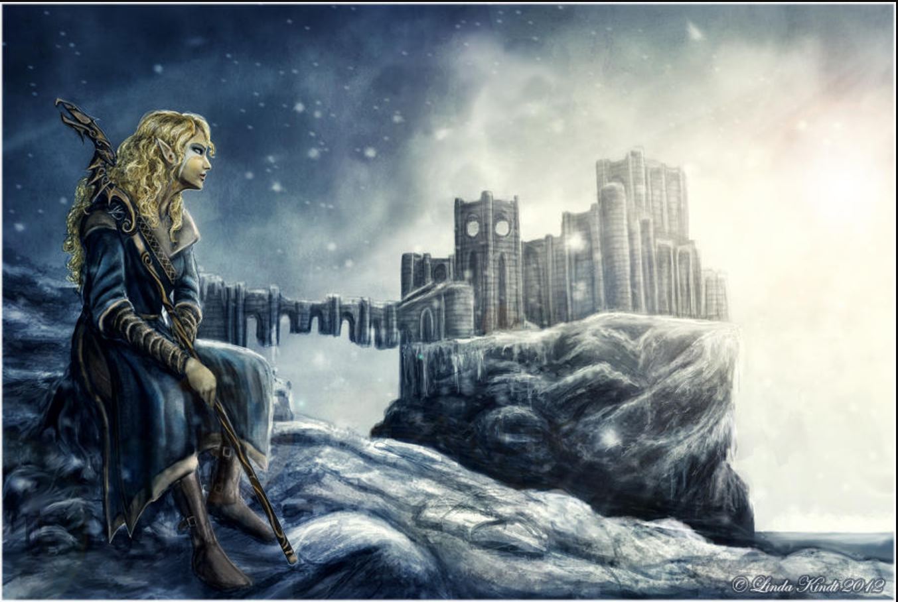
Heading up the walkway, to the first gate, a high-elf in mage robes stepped in my path, declaring, “Cross the bridge at your own peril! The way is dangerous, and the gate will not open. You shall not gain entry!”
Blinking, ignoring the vague options that appeared in the back of my mind, I asked, incredulous, “Did you just ‘You shall not pass!’ me?”
The woman’s glare evaporated into a pleasant expression, this NPC seemingly… buggy, as with friendly, if haughty, tones, she stated, “I am here to assist those seeking the wisdom of the College. And if, in the process, my presence helps to deter those who might seek to do harm, so be it. The more important question is: why are you here?"
“I don’t know, why do you think I was walking down the bridge to the Mage’s College?” I shot back, long used to replies not matching if I didn’t play the game, but, seriously?
“Perhaps. But what is it you expect to find within?” she asked in turn, going off the only option that had ‘College’ in it, which would’ve been something along the lines of ‘Can I enter the College?’, though I still couldn’t get a good sense of what I was supposed to say, only able to make out the keywords ‘Can’, ‘Enter’, and ‘College’.
Squinting, trying to make out my options, we had ‘ice’, ‘fire’, & ‘destroy’, ‘opposes’; ‘bend’, ‘will’, & ‘around’; ‘unravel’, ‘mystery’, & ‘Aetherius’; ‘knowledge’ & ‘Elder Scrolls’, and finally ‘see’ ‘looks’ & ‘inside’.
Guessing, I went with what was probably closest to what I wanted, and replied, “I wanted to unravel the mysteries of magic and find out what the fuck is going on here.”
Nodding, the woman, who my HUD named Faralda, “Ah, the immortal plane. It is said to be the source of all magic. A noble goal indeed.”
Ah, that was probably what ‘Aetherius’ was, which, since Aether, or Æther, was another name for magic, made a certain degree of sense. That said, from Basic, travelling interdimensionally, even just to others in a dimensional cluster, was no small thing, and trying it without proper preparations, even in the actual Nirn, let alone whatever the fuck this was, was something not done lightly.
Then again, if I could find a way to ‘pierce the veil’, well, I might just get the fuck out of here this century!
“It would seem that the College has what you seek. The question now is what you can offer the College. Not just anyone is allowed inside. Those wishing to enter must show some degree of skill with magic. A small test, if you will,” she continued, not giving me any mind, not that she could, really, and, looking over the options, no, my Speech, despite me doing more commerce than some merchants likely did in a decade, was still pretty low, so that left me with.
“Then a test?” I inquired.
Faralda nodded. “Excellent. A standard spell for one skilled in Destruction magic is the Firebolt. Casting one at the seal on the ground here would be sufficient.”
That… wasn’t one I could do. “I don’t know that one. Can I try a Lightning Bolt instead?”
Which was close enough to trigger to get the response of, “No? Well, if you think you're capable of it, then I'd be happy to provide it to you for a mere 30 gold. Or you can try your luck with one of the court wizards around Skyrim. They also sell spells.”
Pulling it from my inventory, I handed over the cash, but she didn’t take it. Remembering this from upgrading my Whiterun house, I added a “Here you go!” and the dialogue component prodded her into taking the money, a loading bar appearing as the book was ‘dropped’ into my inventory.
“Here you are. Now I'm anxious to see you cast it,” she stated, watching expectantly, as, after twenty-one seconds, I finally got the thing, another twenty-one for it to pop into my hands, and, opening it up…
Yep, it was chock full of magical theory, with the standard ‘If this is your first fucking magic book’ intro, though this one was written a lot nicer. However, waiting another twenty-one seconds, bringing out my Lighting Bolt Tome, which hadn’t been consumed when I’d ‘learned’ it, yeah, it was the same, word for word.
So each school got it’s own intro, despite saying, functionally, the exact same thing, the next step where you shifted the gathered mana into its specific school was different, but this first bit was just standard. So… whoever, or whatever, was perfectly fine copy and pasting instructions, then why was the first bit different?
Storing the Lighting Bolt tome, yeah, the NPC was still staring, as if expecting me to just glance at the book and cast it in seconds, but, then again, that was literally what you did in the game.
Storing the Firebolt book, I, a little awkwardly, nodded to the bridge-guard, and headed back towards town, breaking line of sight before I opened a Gate Home, pushed Lydia through, and dropped the tome on my kitchen table, not wanting to get to it just yet, and, well, I had picked up some odds and ends on my way here. While ‘Snowberries’ only gave me 0.05 points, ‘Ice Wolf Pelt’ gave me 0.5, and just tossing an entire ‘Ice Wolf’ in had gotten me another whole point outright. Unfortunately, I, sadly, couldn’t pass living things into my Scavenger program, and you could only Bind things that could think, so I was… leery’ to do so, though I’d yeeted a bandit corpse into it, though that only worked once, as it keyed itself off ‘Bandit’, not, say, ‘Female Nord Bandit’.
After tossing everything I was okay not getting back into the one-way wormhole that was my Scavanger Mission, having accrued a lot of random shit, including a Dragon Bone worth five points all on its own, I smiled, having gotten sixty-three points. Willing to splurge a little, I dropped the ten points to upgrade my apartment, then another twenty to get a Sweet Home. It was a fraction of the size the Sweet Home would’ve been before I upgraded to the newer version of the Catalog, but the number of customization options got… kinda nuts, so it was worth it.
The world shuddered, then expanded, the walls pulling back, the second half of the combo living room/kitchenette warping and retreating, quickly hidden behind growing walls, the ceiling lifting and expanding, stairs unfolding themselves into the general living space, a deep rumbling resounding, while I waited, and Lydia, well, she just stood there. Finally, the opaque windows suddenly cleared, a second doorway appearing beside the one leading back to Skyrim, and, opening it up, my home now sat on a patch of ground one hectare large, just a little smaller than the central grassy area of a running track, though, at the edges, an illusion of a valley, bordered by mountains, was maintained.
From Basic, I knew it was an impenetrable barrier, or, well, mostly impenetrable, but considering that the Blind Screaming Eternities lay on the other side, until I was a lot more powerful it better stay un-penetrated.
As I stood there, a wave of scent, almost choking, slapped me in the face, as I caught a movement out of the corner of my eye, and, turnin-
FLOWERS!
Without thinking, a razor-sharp tendril of Shroud shot out, mulching them before their deadly stinger could…
I froze, as the red blooms hit the ground, but, otherwise, nothing moved, and while I was ready to throw myself backwards… no, they were mono-species groups, the closest being bush full of crimson chrysanthemums now cut down, not the nonsensical riot of that place, nor was anything moving, be it floral, fauna, insectile, or humanoid, all of which being instantly deadly if one was stupid enough to let one’s guard down in Hell’s Paradise.
I could feel my Stress Resistance working in the back of my head, suppressing what I was pretty sure was PTSD, as, while looking out was a clear vista, on either side, just out of sight, were fields of flowers, all the way up to the edge, which were programmed for even more, and, for a moment, Fury took me, as… this had to be someone’s idea of a fucking joke.
Ringing my manager, Ms. Yinqirelliran picked up, asking, “Hello Agent Scrollcifer, has there been an issue?”
The professional tone, so different from the dismissive, malignant one she’d first taken, forced me to comment, “Well, aren’t you nicer.”
And there was the glare I remembered, as, gritting her teeth, the banshee stated, “Here at Slutlife we seek to maintain a professional demeanor at all times. Or else. Now, do you want something, or can I hang up?”
… Ah, got reamed by her boss. Possibly literally. That… helped. Armoring myself up in a Shroud Hazmat suit, a crystal bubble surrounding my head, just in case, I sent a tendril out and grabbed one of the fallen flowers, which, pulling it back, no, the impression of a human face in its coloration had just been in my head, but, holding it up, I asked, “What is this?”
Clearly biting back her first response, she typed something, and finally questioned, “A chrysanthemum?”
Looking at the floating image, carefully, no, my manager wasn’t that good at manipulation, which meant… this wasn’t her.
And, while I wouldn’t mind kicking the bitch’s ass myself, I would over what she actually did.
“Full scan?” I checked, spirit, typing something, nodding.
“Company standard for Sweet Homes. You requested it, why are you so butt- why are you so upset?” Semvelmia questioned.
Dropping the hazmat suit, as, if it was something extra, having me die to it would get investigated, though, actually, with Body Immunity I should’ve been fine anyways, I informed her, “That’s the thing. I didn’t request it. What’s standard for Sweet Home Gardens?”
This she didn’t need to look up. “Some Roses, Lavender, Marigolds, and Sunflowers, unless the Agent or their Retinue have recorded allergies. But you can ask for others. Like those. What’s the issue?”
“Look up my Final Exam’s location,” I instructed.
She did so, and I could tell the moment when she made the connection, because she froze, letting out a low, “Oh.”
“Someone in Production was likely being cute,” I stated. “Let me guess, the presets were tweaked within acceptable parameters for safety?” Mutely, my manager nodded. “Then I wish to file a complaint, as I very much Take Offense. I give my permission to do a full scan of this location to find any spy-taps or such, because I have a feeling someone got cute.”
The undead elf’s eye twitched, as I committed the cardinal sin of bureaucracy and made her do her job, but, maybe seeing something in my stance, she held her tongue, and typed. Several moments later, a deep green light swept over the area, and she frowned. “What’s… in there with you?”
“Lydia. Or,” I paused, trying to get the pronunciation correct, “LyDIa, according to my smart device. Unbound, for a… number of reasons.”
In Basic, I’d learned how to pronounce Capital Letters, as when dealing with a lot of the things out there, the difference between, say, magic, and Magic, could be vital, but putting them in the middle was odd.
Unless you were Scottish, apparently.
“You do you,” the banshee muttered under her breath, typing, and… “Found it. It’s… a Class B creation, earmarked for you before you were transferred. Of course. Fuckin’ B-itches.”
The Elf stiffened, glancing my way, as she was being rude, but, “Agreed. Contact Class E. I’m opening a complaint. Assign the ticket a two Point bounty for a case of Inter-Class Product Tampering,” I commanded, having gotten the Class E Primer on how these things were handled. Technically any malfeasance would be investigated, and bounties that sought to influence an investigation were a fairly big no-no but Points were discrete and transferrable without any sort of strings as they were essentially just Company Scrip, and would ensure the rules would be followed before they were issued.
“I, uh… done,” Ms. Yinqirelliran stated, a little unsure. “Is… is there anything else you need?”
Navigating my Shroud’s menus, I tracked down my Manager’s full Company-ID, and threw up the code on a created screen in front of me to effectively copy-paste them, causing the banshee to flinch, only to frown, as her screen pinged.
With a 0.5 point tip.
“Thank you for your prompt service,” I replied with a bland smile. “Have a nice day.”
“Uh… you too?” my manager replied, even more confused, quickly closing the call.
She’d get a bit of an Internal Investigation attention for that, but, having gone through the proper channels, it’d be easy enough for them to determine it wasn’t coerced, and let her keep it.
Because I could be nice with someone who was nice back, and such behavior should be rewarded, though a reward was never to become expected, because then it became extortion.
Reformatting the outside, the fields of flowers rippled, and disappeared, replaced with open grass, with a smattering of trees, with a small garden full of Birds of Paradise flowers, a type which had not been found in… that place.
A stiff breeze cycled the air as the changes finished, and then, letting the stress, the fear, the overwhelming rage finally go, I took a deep breath, and, now that I wasn’t being olfactorily assaulted by it, the scent was rather nice, subtly floral and with a hint of vanilla, which… holy shit, Skyrim didn’t smell.
I mean, it did… kind of, but, just like the food… wasn’t, the smell… wasn’t.
I’d been so worried about things, but, well, death had a scent, and God knows I’d dealt enough of it, but I’d just thought that I was inured to it, given, well, my final exam.
And if I never smelled another bouquet, it’d be too fucking soon.
Which is why the over-exposure from a few minutes ago had likely hit me so goddamned hard.
I could smell cooking food in my apartment, but I’d mentally set that under the banner of ‘food is weird’, not ‘everything is’, which… yeah, that was on me.
“God, there’s so much I don’t get,” I sighed, shaking my head, but, well, it was up to me to figure out, wasn’t it?
“Well, nothing for it but to get started,” I mused.
Heading inside, nodding to the still-waiting Lydia, and fucking with my Sweet Home’s settings, I turned the largest of my spare rooms into a ‘spell workshop’, entering it to find my chosen Tome on a podium, targets on one side of the room, whiteboards up and ready for me to futz about on, and diagrams of basic mana-forms, pre-copied from the book, up on the wall.
Cracking my knuckles, I looked over my reservoir of points, and picked up Science Talent, as it could help with breaking down spellforms in an intellectual way instead of the naturalistic ‘feels right’ of Soul Talent, and then, with the bit I had extra, I picked up Possession Resistance, because, while I hadn’t met anything that could fuck me over with it yet, nor did I remember anything like that even being in Skyrim…
Better not to take that chance.
Regardless, letting out a long sigh as my new acquisitions settled into the core of my being, I cracked open the Spell Tome and got to work!

<SDWE>

Priscilla N’er sighed, finally having made it to Whiterun.
Normally, if there was somewhere she really wanted to go, she’d learned to focus on it, and just go, the trip over in a flash, as she avoided everything in the way, but she could only do so for places she’d already visited, every new life blanking out her mental map, even if she could envision it perfectly in her mind’s eye.
This time around, just like the last couple times, she’d gone left instead of right, heading to Falkreath instead, this run heading up to Solitude as she picked up the needed Skills, leveling up her capabilities, and getting the needed tricks, like how to move just right to go unseen, that she needed to coast for as long as she wanted, and which she lost at the beginning of every ‘go’.
However, even in a hurry… things were… different.
She’d stopped by Redoran’s Retreat, to kill the Bandits there and pick up some supplies, only…
It’d already been cleared.
And not just cleared, but stripped down completely, long enough that the bodies had long ago disappeared, the only thing that she could take the mushrooms, but those regrew every two hundred and forty hours.
Heading south, with rapid, ground-eating strides, taking down the bandits that endlessly roamed the lands with a couple swings of her blade each, a muttered pronouncement of ~Air~ allowing her to unleash rapid strikes that took them down before they could do more than prepare to hit her, a Fury spell turning one of the group against the others to let her handle them easily, taking only from the gold and the most precious of items to sell to Adrianne, she made it to Fort Greymore that night, sneaking up upon the bandit stronghold…
Only to find it’d been cleared as well.
Again, while not quite to the bedrock, the bodies had long since all disappeared, every container empty, every weapon rack emptied, everything gone.
It reminded her of what she’d done, when she’d tried to ‘do everything’, in the foolish hope that that would be enough.
For a moment, she thought she’d gone crazy, that she’d gone and done everything that she first did, and, having finally snapped, she’d made her way to Solitude with no memory of doing so, but… but no. It wasn’t just that she thought she’d heard it, the other people had reacted to it, and the people here, their reactions were set, so, if something didn’t happen the way it was supposed to, they wouldn’t even notice, but they had, and, and, and it’d taken her almost a fortnight to get here, when the Greybeards called out to her the same day she killed that first dragon, and consumed its soul.
A soul that she didn’t have, nor did she have that deep, undeniable knowledge of ~FUS~ that came with that first Word-Wall and her first dragon kill, the two pairing together whether she wanted it to or not.
So, it hadn’t been her.
But everyone here thought it was.
Did… did she go back in time?
Was there another her running around?
It seemed impossible, but whenever she died, she did go back in time, though she never could figure out why she went back to those moments.
Sometimes it was when she’d woken, or when she got to a city, but other times it seemed to do so randomly, yet she never lost a full twenty-four hours.
But something had changed.
And, once more, she had no idea what it was.
Not wanting to waste anymore time, she abandoned the empty fortress and ran down the road to Whiterun, not stopping as day turned to night turned to day turned to night and finally a third day dawned as she arrived, the top of the Jarl’s castle glowing gold in the light of the rising sun.
“Dragonborn,” the guard greeted, which Priscilla started to nod in return to, but…
But, while she was, the only dragon she’d killed was one that’d attacked her on her way here. She’d killed the flying lizard easy enough, the beasts tough, some of the toughest in the land, but this early on in the course of events, when she had not yet come into her own power, they were always weaker, more limited things than the true terrors they’d become.
At least for everyone else.
But while she’d consumed its soul, allowing her to use the Shout she’d picked up from the Word-Wall in Shriekwind Bastion, she’d done so in private, and any she’d displayed her Shout to had died within seconds.
So… how did this guard know who she was, as, this time, she’d not displayed her status in front of a half dozen guards, and Irileth?
“Why are you expecting this to make sense, Pris?” she muttered, heading through the gates, shaking her head, and dropping by her favorite blacksmith to unload her gear, going through the motions, reflexively she questioned, “Do you need help around the forge?”
Only to receive a blank stare.
“I said, do you need help around the forge,” the Dragonborn repeated, wondering if she’d remembered wrong. “Can I do something for you? Can you show me how to work a forge? Can I have a few pointers?” she rattled off, but… nothing. “I’d like to make a sale,” Priscilla sighed.
“Take a look,” the woman replied, the awareness of what the woman had in her inventory making itself known, and allowing the Dragonborn to unload most of her loot.
She wanted to ask about the quest, which, small as it was, she’d always enjoyed doing, but… now she couldn’t.
The sudden sense of loss was as unexpected as it was painful, and she stood there for a long minute, processing it, Adrianne waiting for her to be done, stating, “Don’t forget to check inside the shop if you need anything,” when Pris, ending the conversation stepped away.
She did just that, as Adrianne hadn’t had enough gold on hand to purchase everything the Dragonborn was carrying, Ulfric taking the rest, and, with hurried steps, Priscilla made her way to Jorrvaskr, entering the Companions’ headquarters, but, talking to them, they were… waiting for her?
Heading out back, Vilkas was there, waiting for her to ‘prove her strength’, despite her never having started the process of joining the Companions. It was easy enough to do so, a few swings all that he wanted, and running a few errands to finish the Quest, which, once she started doing, appeared in her mental tracker, though the first few steps were oddly missing.
It was only when she was done, an hour later, that she paused, then groaned, having forgotten what she was here to do.
Heading back to the main plaza, the Gildergreen still withered, like it’d be before she went to the Eldergleam and got its sap, or sapling, to rejuvenate it, Heimskr preaching the worship of Talos like he always did, she turned up the stairs towards Dragonsreach, the Jarl’s castle, and, ascending them, entered it.
However, talking to them…
They knew her, or, at least, things had happened like they would’ve if she had done the normal quest-line she did to get things started.
As insane as it was, the ‘other her’ idea seemed to be making more and more sense.
But she’d never met an older ‘her’, so if she met a younger ‘her’ then would that be her or would it be another, different her, and what would happen to the her that wasn’t her if something happened to her, and vice versa, and would the her that wasn’t her be like her or would the her that wasn’t her be like everyone else and what would she do if she met another her and…
Groaning, Priscilla rubbed her forehead, having gotten used to, as hellish as it had been, this sameness, but, what was even happening here?
Talking to Proventus, according to him she’d even already bought a house, and fully furnished it, causing the Dragonborn to break off the conversation then and there, because to drop the several thousand gold on all of that meant it was almost certain that the other her was still here!
Taking off running, jumping down staircases, Priscilla knew this city intimately and knew the best way to navigate it, through the Cloud District and into the Plain District, until she finally made it to Breezehome, which had been her center of operations for much of her first life, going to the other cities but always returning to Whiterun every time.
Stopping at the door, a sudden feeling of indecision washed over her, as she didn’t know what she’d find.
But she was the Dragonborn.
She’d Eaten a God!
She could do this!
So, putting her hand on the handle, she pushed, and it swung open, revealing…
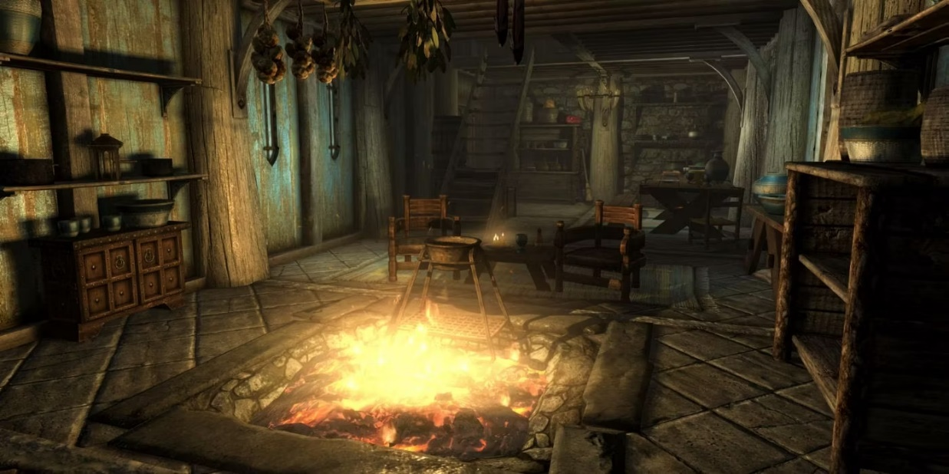
The same setup she’d known for ages.
Equipping her Paralyzing Glass Longsword with a thought, drawing the weapon out of the air, the Dragonborn wished she’d gotten her enchanting back up to nominal levels to add more than a single second of effect, but a single second could be enough to take down an unresisting opponent, gaining enough advantage to further wrestle them into submission, rope at the ready at her waist. Crouching low, steps silent, she continued deeper in, the only sound the eternal crackling of the open hearth. Carefully opening the doors at the back, the alchemy lab was as she remembered, the books stacked like they always were when she first moved in.
Heading upstairs, Priscilla carefully checked the rooms there, but… it was empty.
Furthermore, the entire house was untouched, not even looted in the slightest, and if it weren’t for the door being unlocked, she’d almost thought whoever had been here, likely some other version of herself, so similar that the people here couldn’t tell them apart, had just bought the house and left.
But, the other her had to have at least opened the door, to unlock it, but… then what?
Slowly descending the stairs, looking over the place, Priscilla tried to spot anything out of place, wishing she remembered how it looked exactly, but it’d been decades since she’d seen it last.
It was only standing there, waiting, that she realized what was missing.
Lydia!
To get the house, you needed to be Thane, and when you were made of Thane, you received the services of a housecarl!
And they called her Thane, the house was here, but that meant…
The other her had stolen Lydia!
The bitch!
Wait, no, because if it was her, probably, then Lydia was still with her, not that Lydia was real, anymore than anyone else was here, but she remembered Lydia being more real, having conversations with her she never could nowadays…
Or was that just a dream?
She had those… occasionally.
Priscilla didn’t really need to sleep anymore, and resting in a bed had her drop into blackness she awoke from seemingly moments later, but, sometimes, she drifted off, and the world seemed… different, only for her to wake later, and realize she was still here, still trapped.
There’d been a time when she’d tried to dream as much as she could, but it was just another lie, another useless diversion, and another way to torture herself with something that’d never last.
Shaking herself, Priscilla kept searching Breezehome, looking for anything, when, defeated, on her way out, she paused, as there, on the table was… a plate, and a glass cup, but both were… odd.
Approaching it, there was a bit of pastry on the plate, which she didn’t recognize, either of them. Poking it with her blade, it wasn’t metal, but some kind of pure white ceramic, and the glass cup was not just glass, the regular type, not the same as her weapon, which was actually made of refined malachite, and it was…
It was tall, almost like a miniature tankard, though, strangely, not metal, but more than that, it was flawless, not a single bubble to be seen. It was only a third full of a brown fluid, a sniff revealed it to be… tea?
And strong smelling tea at that.
The pastry, partially eaten, was a little hard, but also crumbly, almost like a sweetroll.
Staring at it, the Dragonborn finally just shrugged, as, to learn alchemy, she’d eaten a… variety of absolutely disgusting things, and, compared to vampire dust, hagraven feathers, or a giant’s toe, at least this seemed like it was meant to be eaten.
And, if it killed her, she’d just reawaken back at the entrance, having never searched Breezhome.
“So what’s the harm?” she questioned, taking a bracing breath, before sinking her teeth into the pastry-
…
And woke up on the floor.
“I… what?” Priscilla sputtered blearily, but, even as she breathed in, a… buttery, rich taste, unlike anything she’d ever remembered eating, was still thick on her tongue.
Sitting up, looking around, she’d dropped the pastry, which sat on the wooden floor.
Gingerly picking it up, hands shaking, bracing herself, she hesitantly took the smallest bite she could, and…
It was exquisite.
Words could barely describe the complexity, the explosion of flavor that rolled across her tongue, and it was almost too much for her to handle, her knees going weak, as a throaty moan ripped itself from her throat, as she almost lost consciousness at the, the, taste wasn’t a strong enough word, but she lacked the words to truly describe the sheer perfection.
Pulling a bottle of wine from her inventory to wash it down, her mouth too dry, the difference in taste was stark, and, carefully, she wrapped the odd pastry in a square of fabric, and placed it into her inventory, pausing at the description.
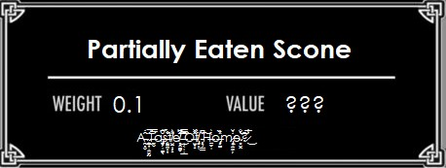

“Well, that’s… different,” Priscilla stated, unsure, turning to look at the glass full of tea, feeling, for the first time in years, maybe decades… fear.
If, if this ‘scone’ had done that to her, what would the tea do?
Getting a spoon, taking a moment to center herself, with hands well-practiced in the fine art of Alchemy, she took a sample of the drink, bringing it to her lips, pausing, then sitting down on a chair, before, with probably more force than was required, through it back like one would a shot of strong whiskey and-
…
Coming to, hours later, according to her own internal sense of time, which had never let her down, the Dragonborn found herself giggling.
Like a child.
It… she expected answers.
She expected a confrontation.
She expected deadly combat.
Instead she’d been laid low by… a sip of tea.
She had literally killed god-dragons, battling them in the afterlife, and eaten their souls.
But a bit of incredibly strong, incredibly sweet tea?
Her stomach roiled, as she laughed, unable to stop, painful tears flowing down her cheeks, before, on instinct alone, she pushed herself out of the chair and vomited, over and over, still laughing, unable to stop, crying in truth, sobbing, because…
Because she didn’t know what was going on.
And she was terrified.
Even more now.
Because, other than that one night a run she spent drinking with Sanguine, she never threw up, only, now, it came up, over and over, until she had nothing left to give, stomach spasming in a pain she’d long since forgotten, even the night of drunken debauchery with a Daedric Prince not the same as, as a sip of that stupid fucking tea!
Falling back on her ass, the smell hit her, rancid, and, if she wasn’t already running on empty, she might just have thrown up once more, as she continued to shake, and cry, just not knowing what was going on, just like she had hundreds of years ago, when she’d thought that’d been the end of things, that something in her had broken, had gone, but, but maybe it wasn’t, and some part of her hated the fact that that part of her still survived, even as the wiser part of herself knew that was a good thing, she just wished it didn’t hurt so much.
She didn’t know how long she sat there, but, eventually, she gathered herself together, taking another bottle of wine from her inventory to wash the acidic taste form her mouth, taking a change of clothes out and wiping herself clean, when she realized she needed to, the mess not having vanished on its own, as well as the pool of sick that pooled on the stone floor beside the hearth.
The act itself brought a bitter laugh to her lips, as when was the last time she’d needed to clean? Not just rearrange inventory, but actually wipe things down?
By the Gods, it was… she didn’t actually remember.
Looking at the fouled cloth, she reflexively tossed it into the fire, but… Right. Right. Things didn’t burn.
“What am I doing?” she asked, helplessly, stowing them in her inventory, to dump in the wilderness later, the description having changed to Soiled Fine Clothes, though, oddly enough, they were still worth the same amount of gold.
Looking around Breezhome, it felt… confining. Almost like the walls were closing in on her, even though she knew it wasn’t, and, and she had to leave.
She had the ‘Scone’, the wonderful, amazing bit of ambrosia, and for a moment Priscilla consider taking the ‘tea’, but, no, that was the vilest poison she had ever imbibed, and she knew that, if she picked up the glass, she would shatter it in an instant.
Stepping outside, a guard walked by, nodding to her and stating, “I hope you're finding the city in proper order, Thane.”
“I, I am,” she agreed absently, looking around, trying to see anything else that was out of place.
She’d thought it was another her, lost in time, but, but she’d tried to cook, spent years trying to recreate the flavors she’d remembered, maybe even decades, if you added all her attempts together, but she’d never made anything, good or bad, that was close to that pastry, or that indescribable filth that pretended to be tea.
Though, now that she thought of it, she… she’d never seen any tea in Skyrim. Ever.
In Cyrodil, yes, but ever since she’d gotten here, it’d been nothing but mead, wine, ale, water, and occasionally milk.
Why… why hadn’t she noticed that before?
“GAAAAH!” she shouted in frustration, dropping her head into her hands, ignored by everyone that walked past.
Priscilla wanted to run, to hide, to not have to deal with this, but… no.
Unlike everything she’d done for centuries, this, this would not wait for her to get ready.
Gritting her teeth, forcing herself to stand straight, hands gripped so tight the fingers of her gauntlets dug painfully into her palms, she mastered herself, because she was no weak milk-drinking maid!
She, she was the Dragonborn!
She killed Dragons!
And Kings!
And Gods!
She nearly single-handedly ended the entirety of Skyrim’s civil war! For Both Sides!
She was older than the fucking Empire!
She was the Arch Mage, the Dragonslayer, the Harbinger, the Listener, the Legate, the Stormblade, the Nightingale, the Dark Lady, the Vampire Huntress, the Thane of every hold, the Champion of every Daedric prince, she was Ysmir: the Dragon of the Fucking North, and she would conquer this task just like she’d conquered everything else in this Fucking PLACE!
Priscilla wasn’t going back inside Breezhome, because screw that, but she was going to find out what was going on here, because, if whoever had been here before had left that behind, there’d be other traces, other than stripped locations, and she’d find them.
Besides, the other person, whoever it was, had clearly been operating here for a while, and had to have been staying somewhere!
So, she’d explore, scour the surroundings, track down every clue, and, when THEY came back to Whiterun?
The Dragonborn would be ready!

Music
Bigger than I remembered - The True Size of Winterhold: Skyrim in UNREAL ENGINE 5!
God, there’s so much I don’t get, - Hell's Paradise: Jigokuraku OP Full「WORK」
Gaaah! - Skyrim Theme Song - Full (Dovahkiin Song)

