BLOOD BUZZ
COMMISSION STORY
BY CHALDEACHANGE
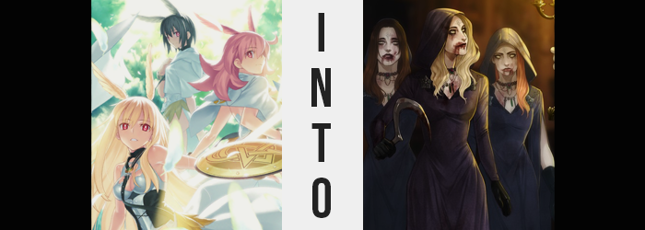

Chaldea’s game night had been going out without a hitch.

Well, okay. It was just a game night. What was the worst that could happen, really? A little bit of disorganization? Some confusion about which groups would be using which rooms? It wasn’t like there was the risk of anyone dying mysteriously unless one of the faculty members stepped on a Monopoly piece and fell down the stairs or something. That only happened once! Rest in peace, Ernie the Janitor.

The members of Walkure all felt like their night, personally, was going very well. They had lucked out and had managed to get Ritsuka to play video games with them, and considering the time of year they had elected for some spookier options than normal. It was sadly a little difficult to scare their Master, but wasn’t it completely understandable? Going through the Singularities and Lostbelts, she’d surely witnessed much more terrifying things than anything a video game could depict.

“Resident Evil… Village, right?” After they had all finished their Alan Wake session, their Master had gone off to fetch snacks and use the bathroom once they had all decided on the next game they would play. Ritsuka was already gone, and the dark-haired Ortlinde was flipping through Chaldea’s book of game discs looking for the title in question.

She eventually received affirmation the fluffy, pink-haired Hildr and managed to find the disc after a little searching. Ortlinde could tell the child Servants had been using the gaming room recently because everything was out of order, and no one had the strength to teach them how to alphabetize. Well, the Valkyrie trio were of like mind in that they didn’t want to have to teach the kids either.
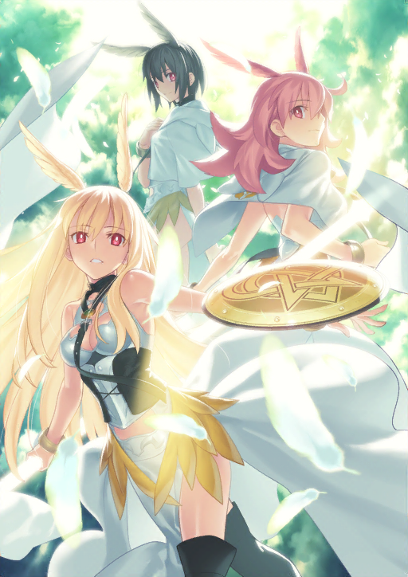
With the disc popped in, the three women huddled up on the couch as they had during the previous session – with room left for their Master, of course! The screen went black and showed some text, yet once it should have gone to the title screen? Something went wrong. The entire television screen began to glow a still, bright red, with no indication that it would change anytime soon. “Uhm… This isn’t supposed to happen, right?” The blonde-haired Thrud asked with a tilt of her head. “You didn’t break it, did you Ortlinde?”

“N-No… Of course not.” Ortlinde was the most soft-spoken of the three sisters, and so even though she was a little offended that Thrud had just insinuated she had done something wrong, it didn’t exactly come across in her tone of voice. She was the one holding the controller, but that was about the extent of it! “Maybe it’s a problem with the machine? Let me try restarting it.” The magic of modern technology was that even the most harrowing of potential issues could be solved with a soft reboot.

And yet, while the light on the gaming console clearly turned off, the television screen did not change. It continued to broadcast the crimson glow, and in fact it almost seemed to be brighter than before. Before the three of them realized what was happening, they could hardly take their eyes off of it – and the controller fell from Ortlinde’s hand and onto the floor below.

“I feel… strange…” Or so Hildr said. Her body felt all tingly, a phenomenon shared between the three of them all at once. The other two winged women agreed with the fewest words possible, and for some reason they all stood. Was it because they felt uncomfortable? Something like that, perhaps. It was a little more complicated, and the underlying cause was much more disturbing.

As the trio stood there, all three sets of eyes promptly began to appear… askew. Their borders darkened as a thick and almost hastily-seeming applied mascara painted their skin – smoky in aesthetic, yet at points it dripped down almost like teardrops. All of the eyes themselves appeared to grow narrower in scope, the perfection afforded the appearance of the Valkyries dwindling while a paranormal glow beset each of the six irises. An eerie, golden color that overwhelmed the reds of their eyes and, ultimately, dyeing their pupils to a smaller and more mundane black.

With the lights of their eyes glowing brighter, the discomfort the three women felt increased almost tenfold. It was borderline painful, and yet not a single one of them breathed a word to that feeling. Because as painful as it was, a strange instinct was pulling them away from acknowledging it. The feeling convinced them that the sensation was normal and necessary, but the feeling itself amounted to something extremely disturbing.

Like a million tiny insects were wriggling around inside of them.

“Ah…” Ortlinde muttered as if she had realized something, but in actuality it was a noise forced by the crawling phenomenon moving into her mouth and face. For a brief second it almost felt like something had crawled about in the back of her mouth only to disappear, and not long after? She choked. All three of them did, until they coughed up blood that splattered against their lips. They raised their arms to wipe any spew that hadn’t fallen to the white floor away, but all this really did was smudge the splatter and blood so that it looked like they had just sucked something dry.

The taste of life juices hung on their tongues and, deep down, even the ever passive Ortlinde felt strangely excited by them. Flavorful and desirable, it was almost as if it had awakened some sort of dependence on the fluid within the bodies, and rather than wonder what had frozen them so, the three’s thoughts soon wandered to how they might procure more. It began innocently enough at first – such as considering Chaldea’s blood bank as a potential source.

Hildr’s pink hair, soft and fluffy as it was, began to look unusual against the red light still pouring out from the television set. Its softness was waning, hair becoming stringier and stringier with each passing moment. While the locks themselves were coarser, they also became wavier and swept over the front of her shoulders – all while an average, blonde was forged from its natural pigment to do away with her once natural rose.

It may have been too similar to Thrud’s hair color, actually, had Thrud’s hair not also been changing. Unlike her sister’s lightening hair, hers was darkening slowly so that it became a medium-toned brunette. The subtle curls plagued her locks as well, albeit not as dramatically as they had Hildr’s, and they had shortened so that they reached just past her shoulders.

Did that mean that Ortlinde was spared from any shift in hair color and style? Quite the contrary. She typically kept her hair so that it was the shortest of the three. It was a nuisance to fit long hair into the hoods they typically wore, and she didn’t like the feel of it against her neck. But it was growing longer and longer, until it eventually rivaled the length of the manes of her sister… at least on one side. On the right it had grown and the bulk of it was swept to the left. The left side was a different issue altogether though. All of the hair there was shaved away, left to fall onto the ground beneath her and mix in with the blood she had coughed up previously.

“A-A-Ah!?”

“Ngh!?”

“H-Help…!?”

All three woman, despite having taken what was happening largely without making a sound thus far, all made uncomfortable noises and pleas for help as their bodies began to convulse suddenly. They feeling that something was crawling within their bodies had only grown more apparent – and more painful – and they were no longer capable of merely accepting what they were enduring as normal, even if they felt it might still be necessary.

They thrashed about unnaturally, so much so at times that it appeared that they might fall onto the floor. Despite it all, however, self-preservation kept their feet mounted squarely upon it. Which led to some rather grotesque looking poses where their bodies appeared to bend and twist at junctions where they most certainly shouldn’t have. Legs bending between their hips and knees, torso’s bending all of the way backwards.

And yet nothing cracked nor snapped. Their bones all remained intact. So this begged the question of what was really happening with the bodies of the three women? It was unbelievable to think, but pairing the crawling sensation that rippled through their bodies along with a dull buzzing noise that had begun to emanate from their flesh, it was almost as if…

They were completely composed of insects of some kind.

In the end it was more than just a theory, for Thrud’s mouth opened suddenly to eject a palm-sized fly of some sort. One that flew around her before disappearing back into her hair. It was gross and disturbing, but beyond the pain not a single one of them batted an eyelash at the phenomenon. It was weird to a spectator, and yet to them? With their minds slowly being rewired, they were gradually accepting the eccentricities of their new existence.

Their hunger for blood grew more depraved in the meantime, and the structure of each Valkyrie’s face shifted almost in tandem with these worsening thought. The canine teeth of the trio all sharpened until they were razor sharp, and the bloodstained lips that held them appeared to grow plumper and more enticing. Er… Blood aside, that is. Unless you’re into that?

Would you really be reading this if you weren’t a little into that?

The noses of the women grew rounder yet longer simultaneously, and cheek bones found themselves reconstructed in a way that gave them each similar – yet subtly unique – aesthetics. There was no doubt that they were still related, and yet their sported differing facial inconsistencies. Ortlinde’s face, for example, looked a little more youthful beneath her red hair with a more angular cheek. Hildr’s face was slightly longer, and her once panicked expression seemed a little more complacent than it usually did even when passive. And Thrud? She bore the softest cheeks of the three. Her face appeared the most mature in a sense.

All of them winced in tandem with each other, all of them screaming in vaguely different voices – for a sharp pain scraped against the skulls of their foreheads. They could not turn their heads to look at each other, but from an observer’s point of view it was clear what was happening. Markings were being etched into the skin, weaving lines that corroborated an ominous looking sigil. Despite the fact that it was cutting their skin, it did not draw blood, and before long it was almost as if these markings had been there all along.

The convulsions that the three had suffered did eventually draw to a close, but the vibrations of a buzzing from within would never cease again for as long as they lived – which would not be that long if any of them opted to step outside in any capacity. With a body forged by blowflies, a sharp drop in temperature would be enough to freeze them solid, much less kill them. This was a truth that was imprinted in all of their minds.

Minds that were slowly falling more and more into depravity. Cutting others to steal their blood soon became something acceptable. Hunting humans to drain them of their juices? A preferred activity. No one’s mind became more depraved than Thrud’s however, and the brown-haired woman’s mind kept wandering to torture and maiming. To whom? Surely she could cut apart… Erm…? Or whip… Um…? For some reason she was pretty sure that she could have named a plethora of people in this building moments ago, but now the only people she could identify in her memories were her sisters and her mother.

That was true of the memories of all of them, mind you.

With their postures at least now recomposed, it was clear that the outfits of the three women had begun to change. Just like was the case with their Valkyrie costume though, all three of their costumes changed to resemble one another – preserving the uniformity that was so key to their relationship.

Whether it was cloth or steel, it all darkened and softened until it was a gentle silk. Skirts and loincloths stretched to mend with their tops, ultimately becoming a single, long, flowing, dark-purple gown for each of them that was complete with a hood. In all of their cases, that hood was pulled up over their heads. Black, leather gloves found their hands, and heeled shoes covered their feet. All in the interest of keeping them as warm as could be… despite the low, v-neck cuts of their robes.

Strangely though, their outfits didn’t seem to fit all that comfortably. In fact in most cases their costumes were a little loose, with their gowns resting near the floor. While in terms of face and hair, Ortlinde, Hildr, and Thrud had all carried some differences, when it came to their body types they had always been identical; they sported average curves that weren’t exactly eye catching.

Which was exactly why the robes looked like they needed some adjustments. It wasn’t so much the robes that would be adjusting to fit their bodies as it was their bodies that would be changing to fit their robes, however.

All three women shot up discreetly, limbs and torsos lengthening so that they were roughly three inches or so taller. There were subtle differences though. Thrud stood in the middle, but Ortlinde as an inch shorter and Hildr an inch taller than her. This was a trend that more or less carrier over into the figures of the women.

In terms of breast, Ortlinde’s didn’t swell very much even though they did grow a single size. On the other hand, Thrud gained two cups and Hildr gained three. This was just as true of their asses, which parted hips and saw thighs flourish in a similar fashion. All three of them had full, undeniably attract figures that would readily attract the gaze of a human – but it was clear that Ortlinde had drawn the short end of the stick.

What she lacked in figure, however, she was slowly making up for with depravity. The fixation on torture that Thrud had developed wasn’t present, but her mental state became more questionably unhinged. The movement of her golden eyes was erratic, and her peaking bloodlust had her ready to throw herself at just about any warm body she could catch sight of aside from her sister. Her breathing was much heavier than the other two as well, for she was getting restless being forced to stand as still as she was. Her body just kept buzzing, buzzing, buzzing…

Not one of them could identify their surrounding any longer. They couldn’t remember how they had gotten here or why. And as if to indicate that their memories had taken a dip so drastic that their identities had been lost, the feather wings atop their heads all fell off. Don’t worry, though! Later on, they would return to snack on them. After they’d had a main course, at least.

“Hahaha! I don’t know about you, my dear sisters, but I feel absolutely amazing!” After a long silence, it was the red-haired Daniela that finally cackled manically. She had been the soft-spoken Ortlinde beforehand, but now she was the most erratic and unstable of the three; incapable of stifling her laughter as her body moved about unnaturally. Blood of an unknown origin clinging to her mouth – as it did all of their mouths – she smirked and caressed the ass of one sibling and the face of the next.

Bela, the blonde-haired eldest child that had been crafted from Hildr’s existence, was the one who’d had her ass touched. “Knock it off, Daniela! I’m not in the mood!” Compared to her old, more energetic nature, Bela was typically quiet and easy to agitate – as shown by her pushing the youngest of the three away.

Thrud had seen herself fashioned into the middle child, Cassandra. With her face touched, she could only wonder how it would feel to chop off Daniela’s hand and watch her writhe in pain; she was an absolutely depraved sadist, after all. “I feel great as well. Is this mother’s doing?” The three had begun to pace around each other, smacking their lips to and fro. They were all hungry, and yet they hardly understood their circumstances as things were.

This was not their mother’s castle, even if the world beyond the nearest window looked to be just as cold. At even the slightest chill their bodies quivered, each composed from head to toe with hundreds of special insects that could disperse if they so willed it. They were monstrosities, chimæric mutants that fed on the flesh of humans. The sisters didn’t care though. It gave them power! And it was the only lives they knew, in the end.

Before any of them could question it further though, the door opened, and a woman stepped through. Petite, with hair of orange and eyes of yellow, this Japanese girl should have been wholly unfamiliar to the trio. This ended up not being the case, and without thinking the three of them jumped Ritsuka Fujimaru with gleeful cries of “MOTHER!”.

The crimson light of the television wore on in the background even still. It coerced one of the sisters into biting the Master on the neck, and it coerced the trio into temporarily leaving. The stranger may not yet have been their mother in body and soul, but that would soon be arranged. As they waited outside of the room, their mother being reborn inside, it was Daniela that posed the question.

“Does anyone wanna like, make out? No? Just me? Suuuure! Everyone’s going to say Daniela is crazy again!”

“You’re crazy.”

“Yup.”

