GIRLS’ UNION
COMMISSION STORY
BY CHALDEACHANGE
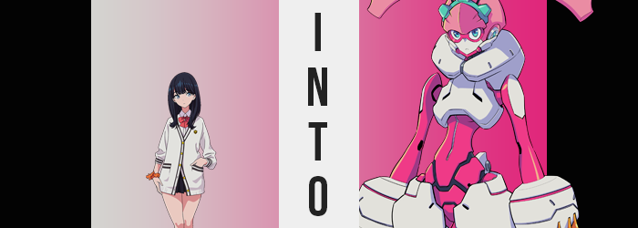

It appeared that the conflict that had plagued their city was finally coming to its conclusion. That was the thought that had crossed Rikka Takarada’s mind as the kaiju known by the name of ‘Zegga’ had finally been vanquished by the efforts of Gridman and the Gridknight. The monster’s body eventually glitched out, ultimately revealing what had existed at its core.

Akane Shinjou, the girl who was at the heart of everything.

Rikka had rushed to her side despite the chaos that ensued as Gridman turned his attention on the true mastermind behind everything, Alexis Kerib. Honestly? It had all been so much that the teen hadn’t been able to properly process everything in the end. The truth of this world, the truth about Akane… But there was one thing she did know. This world needed to be protected. Akane needed to be protected.

“But I can’t do anything like that by myself…” While tended to an unconscious Akane, Rikka had made this comment to no one in particular. In fact, it exemplified the level of agitation she felt regarding her own uselessness. Gridman and Yuta were fighting the final boss high in the skies above, and she wasn’t able to do more than she already was. Surely Yuta would say it was enough, but…

With Akane’s head rested on her thighs, she suddenly became aware of the fact that her friend’s hand had reached up to touch and squeeze her own. She’d stirred back to consciousness, and she wore a sad smile. After being wracked within the core by the feelings of all the people her kaiju had killed, it was clear that Akane had suffered plenty. “Then do you… want to do more?”

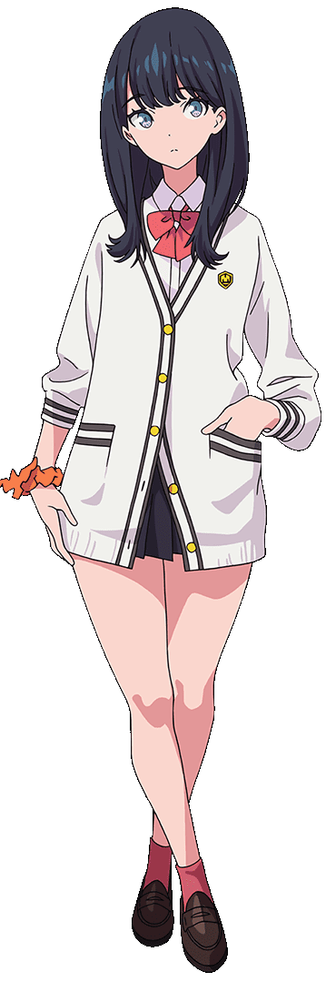
“Huh!? Akane, it’s fine. You don’t need to force yourself to… talk?” She’d been about to usher the girl into conserving her energy when she noticed what Akane was holding up with her free hand. Wasn’t that…? “That… Isn’t that what Yuta uses when he transforms into Gridman?” She was fairly certain that it was called an Accepter.

Akane smiled. “Yup… I bummed it off Alexis without him realizing. Guess he planned on using it as a backup plan at some point. It’s not going to create another Gridman, but I think… With the two of us together…” It was clear that she was in pain, but she managed to lift herself off of Rikka’s lap, nonetheless. “Thing is, I don’t know what’s going to happen if I use this. I just know it takes two people. Are you… Are you sure you want to risk it? Because I want to help stop Alexis too. After all…”

This was pretty much all her fault in the end.

Rikka understood Akane’s feelings. Probably better than anyone else. She slowly nodded, eventually standing beside some rubble at the bridge’s edge. “Yeah. Let’s try it. I don’t want to sit here twiddling my thumbs anymore. Yuta needs me. And…” It sounds like you need me too, Akane. That was something she couldn’t exactly bring herself to say, however.

Akane, getting slowly up and onto her feet, held the Accepter out with a nod herself. She didn’t know how she knew, but what she was supposed to say just came out as if she had known all along deep down. Like it had been something engraved into her very soul. “ACCESS FLASH!” Akane screamed this with all her might, and just as suddenly turned into a flash of pink light that flew into Rikka’s body.

“E-Eh!? Akane? Where did you go!? Akane!?” Rikka took a step back, utterly dumbfounded. Yet while she was asking about her friend’s whereabouts, more instinctually she assumed that the lilac-haired teen hadn’t gone anywhere. No… She could certainly feel her presence. Almost as if she was inside of her? And not in that way, you perv!

Even so, she turned herself around several times making sure that Akane, or at least the light that Akane had become, wasn’t lingering about somewhere. After a few passes it finally did strike her that something had begun to limit those movements of hers. Almost like… “What’s going on with my clothes?” Yeah, something was definitely going on with her uniform. At her elbows and shoulders it was more restrictive than normal, and she could feel the hem of her skirt on the verge of nearly suffocating her hips.

Before she could really address that though, and she’d certainly been on the path to do so, something more pressing came up. Rikka had brought a hand across her torso to tug at the opposing sleeve, only for her eyes to catch something rather uncanny about the hand she was reaching. Wordless, she froze. Her fingertips were a pure white, and not only that but her fingernails were clearly gone. It was something that had plagued both hands, and before her very eyes the teens hands were entirely engulfed by the shiny discoloration, one that appeared metallically glossy more than anything.

CLACK. CLACK. CLACK.

Her hands still worked properly, but whether it was her fingers bouncing against each other or simply balling her fingers into a fist, there was a clacking sound as if something hard and inorganic was bumping into something equally so. “H-H-Hah!?” Rikka’s lower lip quivered. What else was she supposed to say to something like this!? With the grooves of her finger joints slightly more carved out than they should have been, it almost looked as if she had the hands of a doll!

Because she’d turned her attention away from the tightness of her clothing, the sound of her garments beginning to tear took Rikka by just as much surprise as the state of her hands did. It wasn’t something that was at all isolated to one part of her outfit or another, for whether it was her toes forcing their way out of the fronts of her shoes, or the breadth of her shoulders blowing out the sides of her top so that sleeves, struggling against the thickness of her arms themselves, became detached.

Rikka wasn’t stupid. After feeling the strap of her panties snap along with the clip of her bra (for the sheer mass of her breasts had outgrown her cups in every plausible way, yet she hadn’t actually gained any cup sizes) it was plain as day what was happening. “H-How!? Why!? Is it because of the Access Flash? Wait… Am I becoming…?” Like Gridman? Her fingers aside, her body was growing incredibly large at a pace that was steadily quickening. It had yet to affect her figure, and so her proportions were still 1:1, but it was clear Rikka had already grown to nine or ten feet in height with her width swelling to match.

Tatters of her clothing had begun to peel off where torn, exposing the girl’s naked body to the entire city – not that anyone was truly around to notice considering the city’s current state. But what it ultimately revealed was a little more complicated than simply Rikka’s bare form, because signs of the solidification that had afflicted her hands could be seen elsewhere as well.

In fact, not only was the white growing more persistent against her skin, but an even more unnatural tone was finding itself bleeding into her tone as well. A hot pink that appeared to be more fixated on her lower torso and arms than anywhere else, although it became even with the white while cast against her legs. Whether it was pink or white, the fact remained that anything kissed with an inhuman coloration hardened and earned the same metallic sheen her hands had, casting doubt on her own humanity and providing her with an almost impenetrable durability.

“My body feels… cold. But it doesn’t feel bad?” It was the best way she could describe it, all things considered. It was a healthier approach mentally than continuing to be shocked as she grew bigger still, at any rate. Even as her body began to distort in ways that made her appear less and less like herself. Still humanoid, and yet… Evidently not all that human.

One are of note in that regard was the ‘skin’ around her wrists. Just as white as her hands and just as solid, it had begun to swell in a way that made it almost look like she was having the world’s strangest allergic reaction. This appeal only lingered for a moment or two though, because once it swelled a head’s size around either wrist, it continued to expand downwards so that her hands were wholly engulfed on the top.

With hot pink tips, the bulbous white growths earned pink and black grooves on their surfaces, while a strange pressure could be felt within them. Rikka could feel them? They were an extension of her body? “Oh!?” The pressure eventually culminated, taking her by surprise as a trio of yellow claws burst out of the front of either piece. They were gauntlets of a sort? A weapon that could be used to destroy evil.

Seeing them made her feel a little more confident and a little more at ease. She took it as confirmation that what she was hoping was happening actually was. She was becoming a living weapon like Gridman!

The hot pink had decorated her arms splendidly, and the shapes of them thinned out to give them something more of a skeletal appeal that widened where they met her new gauntlets. A white panel rested at the peak of either arm, but Rikka’s shoulders? While turning pink, they merely sagged inward so that there were solid, rounded stubs between her arms and torso. They were very functional and very flexible joints, so much so that she’d be able to spin them 360 degrees if necessary.

By this point in time, Rikka was likely eighty feet or so tall. Larger than the nearest building, but nowhere near as big as the skyscrapers deeper in the city. This meant that her clothes had long since fallen to the ground below in scraps, now so microscopic from her point of view that she couldn’t perceive them. Of course, because she was so big she was also heavier. Something the bridge she’d been standing on was soon to remind her of as one foot fell through the solid concrete and into the water of the river below. “AH!?”

To be fair, it wasn’t wholly the weight of her body that had been responsible. Her toes had ever so slowly being crunching in towards her heels, feet practically disappearing while a pale pink covered everything beneath her knees (which sat above a pair of white caps the suggested her lower legs could be separated if need be). While the girl’s heels didn’t disappear exactly, they lifted higher and higher as their bottoms flattened – just as flat as the fronts of her ‘feet’, now little more than a curved extension of her legs with exhaust holes in the fronts of either side.

Rikka had grown further, and much more quickly. Nearly one-hundred feet in size, her second leg collapses the bridge and both limbs went into the cold water below. It didn’t feel cold, though. Everything below her knees was submerged, and yet everything above? With its pink and white striped pattern, the metals there did retain their overall human shapes. Her knees were knobbier in the front and deeper in the back, but overall…

The most significant shift was more or less to the girth of her thighs. Once unbelievably thick, they had narrowed in slight so that they still appeared plump, but with their pink and white legging color scheme they seemed more reasonably plump rather than how they had appeared prior.

More significant was the growth of her hips, which swelled in a manner not dissimilar to how her gauntlets had formed. White steel surged, bloating in a wholly unnatural way until it was little more than a metal skirt that wrapped around her hips and rear – complete with a cute, little bunny tail-like appendage in the back. This skirt, like her gauntlets, could be felt as if it were her own flesh and blood.

Peculiarly though, it left her groin exposed. Such was only a passing issue in the end, for her pussy sealed itself away in hot pink steel that spread throughout the entirety of her lower torso. Rikka’s ass cheeks followed soon after, both cheeks becoming a single, pink bubble as the crack between them sealed beneath her white skirt, and this pink saw her tummy thin inwards while grooves of black revealed that there were several pink plates working in tandem with each other.

The area beneath her breast grew slightly taller, a single, vertical groove running down the center of her front while the sides collapsed in to make her torso appear much lither than a normal, human one would have. It was just enough to encompass the incredibly durable, machine spine that had been solidified from the bones within.

Rikka exhaled one final exhale, for she soon found that breathing wasn’t a requirement for her continued consciousness whatsoever. “I guess that makes sense, seeing as… Oh, that’s kind of cool?” At some point, the machine woman’s voice had taken on a mechanical echo. It was slightly higher than her original voice too. But she had been in the process of commenting on her lack of breathing. It made since that an artificial body wouldn’t need to breathe. She no longer had lungs, and it was only cooling fluid that flowed through her mechanical veins.

In tandem with her loosened breathing requirement her chest began to look, well, rather malformed. Nipples disappeared into white plating that wrapped around her upper torso, the gap between her tits filling in until it was all a consistent piece that jutted out dramatically from the pink of the rest of her skeleton. In many ways it looked like a highly advanced vest, sporting tunnels for exhaust to escape in the face of overheating. What’s more, it grew and extended around her neck, bloating out behind her so that it resembled a ‘hood’ for her ‘vest’.

The mass of Rikka’s body had finally peaked at two-hundred feet, and the city she knew so well now looked so tiny from where she was standing in the river. Her body felt so powerful despite its sleek design, and yet she braced herself for the final phase. After all, she could feel her neck stiffening – which meant it was only a matter of time.

Her prediction had certainly been on point. Her chin hardened along with the teeth inside her mouth, although it dried out to the point that it was clear no saliva was being produced any longer. The lower half of the girl’s face took on the same porcelain white as much of her body, but the hot pink had a presence as well. It formed a mark around her eyes, and it also framed Rikka’s chin – broaching the space between two white extensions that whipped up to her… ears?

Were they really still ears, however? They were certainly sound receptors of a sort, but silver with teal centers, they didn’t exactly look like human ears anymore. Then again, neither did the eyes that dried out and took on a dull, teal glow. They did resemble the eyes of a person, but their lights made it clear that they were merely cameras meant to do the work a normal set of eyes might.

Rikka blinked, and yet she didn’t really blink. Her cameras turned on and off. There were no eyelids to blink with. The teal of these eyes, however, was not the only place other than her sound receptors that this color popped up in. Rising from her hairline, a growth that looked like a teal, cog-like tiara took shape, spitting her bangs from the rest of her mane. Though… that was merely a passing concern. The softer pink that had decorated her lower legs painted, quite literally, all of the hair atop her head. And her bangs? They merely became a solid half-dome that rested beneath the tiara.

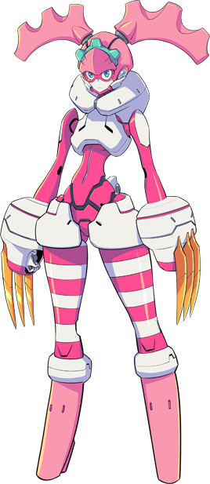
The rest of her locks? They flattened and wound themselves until the top of the woman’s hair was little more than a pink dome. Black grooves ran back from the tiara though, and within a moment’s notice a mechanical sound filled the air. Her head was opening, and through that opening a pair of long, pigtail-like antennae protruded out to the sides of her head. They certainly appeared to be detachable based on their gray bases, while was enough to ponder whether or not they were weapons.

And, so, her transformation was complete.

“I… what is? This feels amazing!” Feet of steel submerged in the river below, Rikka was left in awe by not only her sheer size, but the amount of power she felt throwing through her veins. Circuits? She wasn’t exactly sure what her body was made of now, but the pink and white were certainly harder than any metal she’d ever heard of. If anything, she could only assume she was comparatively durable to Gridman himself.

Is that what had happened? Had she become an existence akin to Gridman? A skyscraper-sized, steel lifeform capable of fighting kaiju? It all sounded so unbelievable, but as she flexed the fingers that she looked down at the metallic fingers nestled within her clawed gauntlets, she was left with little choice but to believe it.

THIS REALLY IS AMAZING, HUH? I REALLY FEEL LIKE WE’RE ONE IN THE SAME! IT’S… NICE.

“Huh!?” The machine woman cried out, startled by a voice that reverberated within her own mind. The speaker had clearly been… “Akane? Are you… Are you inside me?” That’s what it felt like, and considering how Yuta had described becoming Gridman to her in the past it was highly likely that the pair of them had experienced a similar phenomenon. Akane was the equivalent of Yuta, and she had become the equivalent of Gridman.

But now that she was aware of Akane’s presence? She could feel it to. The UNION between two bodies and souls, acting as one towards the same goal. That was what Yuta and Gridman were like.

ARGENTEA! IF GRIDMAN HAS A COOL NAME, THEN WE SHOULD HAVE ONE TOO, RIGHT? SO DON’T YOU THINK ARGENTEA HAS A NICE RING TO IT?

It did. Of course it did. Akane didn’t even need to ask, for they were feeling and experiencing the exact same things. “…Yeah! Yeah. That name… Does have a nice ring to it. But how do we, uh… How do we fight?” If Rikka’s current body possessed the ability to do so, she undoubtedly would have blushed then and there. Being so intimate with Akane… It felt nice. It felt like something she had, deep down, always wanted. And she could tell that Akane felt the exact same way.

NO IDEA! BUT WE’RE GOING TO FIGURE IT OUT! I FEEL LIKE WE CAN DO ANYTHING LIKE THIS, ARGENTEA!

Akane’s words were certainly reassuring, but would it be that easy? Gridman and Alexis were so far in the sky, and all she had were these rockets that were shooting out of her bunny-like ear appendages. Wait… “Hey! We’re flying!” More rockets sounded, this time from the bottoms of her toeless feet once they lifted out of the water. And up they shot, towards the battlefield they had been so far below.

OF COURSE WE’RE FLYING! TOGETHER WE CAN DO ANYTHING!

Regardless of how this turned out, Akane seemed to be happy. And so that made Rikka happy.

No, she felt even more strongly. Could this feeling be… love?

