HEARTS REALIGNED
COMMISSION STORY
BY CHALDEACHANGE
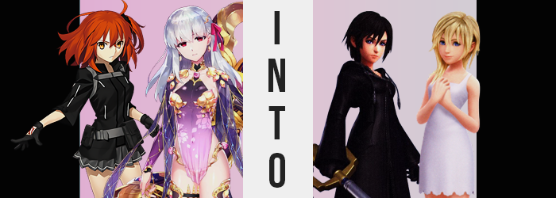

The Paper Moon incident had come and gone without much fanfare.

At least that was how it felt from the perspective of Chaldea’s Master, Ritsuka Fujimaru, even though the reason it felt that way was essentially out of her control. The first Ordeal Call that she had been made to face had transpired in a digital space and upon returning from it? Her memories were lacking to say the least. The struggles she had overcome, the people she had met, the bonds she had forged… They might as well have all just been one long dream.

It was something that bothered the Master, but it ended up being something that she had to reckon with sooner rather than later. “How... did I end up here?” The last the ginger could recall she had been getting lunch in Chaldea’s cafeteria with Kama in tow. Ever since the Paper Moon incident the Assassin had been following her around a lot more frequently.

There had been a flash of light and… it was hard for her to describe, but she supposed it felt like a pull. It was all so instantaneous ultimately, because once the flash had dimmed she wasn’t standing in the cafeteria. She was standing in a completely different location that wasn’t unfamiliar, but it wasn’t wholly familiar either. The atmosphere almost felt nostalgic.

“Wait, could this be…?” In terms of defining features there wasn’t anything that stuck out in particular. Her best guess was that it was a sizable storage room. One that was about the size of a bedroom, walls lined with shelves that showed off futuristic gizmos and gadgets. There were no windows and only one entrance. But it was the things on the shelves that had left her wondering about where she was. She felt like she’d seen them somewhere, but her memory of it was groggy. “Is this the Paper Moon?”

Asking the question aloud didn’t provoke any memories in her head. The Master supposed it couldn’t have been that easy. So what was the storage room connected to? Considering she had been deposited in the back of the room she had a little bit of a walk to the door to find out. Some of the items on the shelves looked a little like weapons or security devices, so maybe it was some sort of security company?

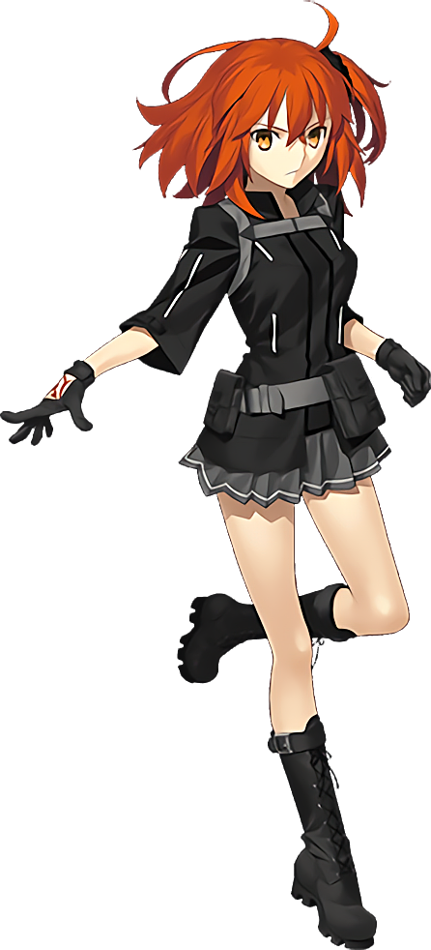
“I need to make contact with da Vinci-chan and Mashu…” Wondering where she was? Well and good. But she needed to figure out how to get back to Chaldea too. Her Command Seals were still in tact but she couldn’t sense any Servants nearby. Kama had been right behind her and other staff and Servants had been in the cafeteria at the same time. If the light was what had transported her then was it possible that others had been brought into this place as well?

There were too many things to consider. Ritsuka had to narrow her scope, so trying to get into contact with Chaldea should have been her primary focus at the time. Would she be able to do it from within the storage room? It might have been too risky to venture out without knowing where she was or what waited for her. Contacting them should have been possible, but it struck the woman suddenly.

“…How do I do that again?”

Why couldn’t she remember the process!?

It wasn’t just the process for contacting Chaldea. What was Chaldea!? That information felt extremely important and yet it had been wiped entirely from her mind. “O-Oh no!” And these were just the things she could realize she had forgotten. Was it possible she had forgotten things she hadn’t event realized? When had that started? When she’d arrived in this warehouse? Of course Ritsuka didn’t have any answers to these questions seeing as she couldn’t remember much in the first place.

In the meantime? One look at the woman’s right hand would demonstrate that things were a lot more concerning than she had even realized. The crimson Command Seals that she kept there were fading, disappearing entirely over a matter of seconds to indicate that her role as a Master had ended. But there was a reason for this as changes she couldn’t sense demonstrated.

Namely the creation of a Saint Graph within the core of her soul.

Ritsuka’s mind was reeling. She was a what? Her job was to…? She was supposed to be looking for…? Had she been looking for anything in the first place? Where had that idea even come from? It was almost like her mind was hung up like a phone waiting to be dialed. She was trying to dial in information but nothing was coming up.

“Hmm…” It served as an ample distraction from what was happening to the woman’s body though. Then again it was debatable if she would even notice these differences with her mental state in the condition it was in. Not that the very first change that occurred was one she would have been capable of noticing anyways. There were no mirrors nor reflective surfaces in the storage room she as still holed up in, and so the fact that her eyes changed from orange to bright blue in color would have been extremely difficult for her to see.

Oddly, what began with the color of her eyes soon spread into their shapes. Ritsuka was a Japanese woman and so her gaze and facial structure naturally reflected that, and yet? First that impression was sapped from the shapes of her eyelids, rendering them slightly more Western in design – but not entirely so. Perhaps her Japanese heritage had been mixed with something else, but it was difficult to say because she was becoming someone from a different world entirely.

The woman blinked, shortened lashes fluttering while pursing her lips from confusion. Those lips were a touch thinner than they had been before in terms of width, but they still appeared pronounced because her face in general was smaller, slimmer, and increasingly more youthful. Rather than a woman in her early twenties, if you looked at her now you’d get the persistent inkling that she was instead a teenager around the age of fifteen or sixteen. This was helped by rounder cheeks and a clearer complexion.

“So I need to, uh…” Did she know what she needed to do? No, absolutely not. Her memories were in disarray to the point that the girl couldn’t even remember her own name but she knew there was something she was supposed to be doing. Was it related to her clothes? “My clothes? Why would…?” She had to wonder why that thought had even crossed her mind, but there was a reason. For a brief moment there had been a flash of realization: Are my clothes too big?

It hadn’t come unprompted. In fact, her body was shrinking in every conceivable way – which made a little bit of sense considering she appeared to be more than five years older as far as her face was concerned. Her overall height was collapsing though. Not significantly mind you, it was only two or three inches, but that was still enough for her shirt to hang loosely and her skirt to flirt with the idea of sliding off. Especially since her hips were now a couple of inches narrower to boot.

Speaking of boots, as she was shorter they had risen up to her knees. Ritsuka’s feet were also smaller and didn’t quite fit inside of them, making it a little difficult for her to pace about like she had been. Her hands were smaller too of course, but they were oddly calloused too. Like the skin had worn down from swinging a weapon around.

But there were other general changes to her ‘size’ too. One area was somewhat difficult to observe because her bra was designed to fit her original bust size, but the mass of her breasts had collapsed in on itself. Her nipples were a little smaller and the fatty tissue beneath them lessened in tandem until they were B-cups at best, although her bra’s shape concealed this against her shirt a little bit.

Ritsuka’s hips had been pushed inward an inch or two in a similar vein with the intention of giving her a figure more befitting of a teenaged girl very plain in what was occurring. Such as? Like her breasts the perky cheeks of her ass condensed, their more compact sizes still pronounced but not as bubbled as they had been. Her thighs suffered a loss of thickness in kind, but whether it was her legs, her arms, or otherwise? She was notably fit.

“Wait, things are starting to come back to me now!” Whether that was true or not and the girl’s memories were returning, it seemed to take place as her orange hair, the last remaining clue as to her old identity, changed itself. Oranges darkened to black as excess was chopped away only to disappear into the aether, leaving her with a short, black bob with messy bangs. She immediately felt like that hair was far more manageable and that was the intent. After all, she was the one who styled it that way!

And when it came to style… With her new Saint Graph properly established and her body changed to match it, it was her clothing that was adjusted in the end. A black, hooded cloak with matching gloves and boots was made from her old Chaldea uniform. This wasn’t a difficult task considering the materials before were already dark in color, but the cloak now fell down to her ankles to completely conceal everything but her head.
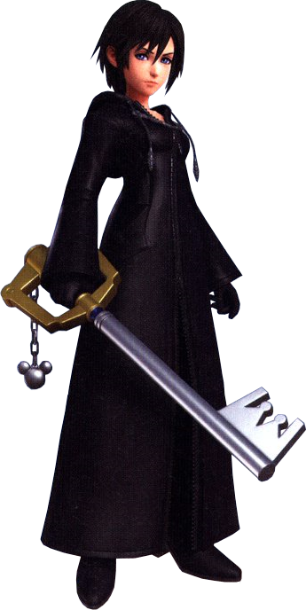
In the end there was a lot that the girl couldn’t remember. The holes in her memories were too numerous to keep track of, and the things she could remember? Well they weren’t Ritsuka’s memories. They were the memories of the girl she had become. The memories of Xion. But even then? What she could remember about herself was sparing to say the least. She was a Servant, one that had been summoned into the Saber class. This all made sense to her, but…

“My Master? Is my Master nearby?” It was strange for a Servant to be summoned without a Master, she knew that much. So if she had been summoned then the person she was bound to must have been nearby. Xion held out her hand in front of her and visualized her weapon. Sabers wielded swords, but the blade that she summoned was odd. It was shaped like a giant key. A Keyblade. She needed it to protect herself if something dangerous lurked outside of the storage room.

“Maybe things will make more sense if I find my Master…”

She really hoped they would.

“Master!? Damnit, where the hell are you?” Kama had sensed Ritsuka briefly when she had first arrived back within Paper Moon only for that sensation to disappear. Because she had never forgotten about the Ordeal Call she knew exactly where she was, but why was she there? Durga and her Master had been defeated and that incident should have come to a close.

And yet she was in one of the rooms they had been allowed to rest within during their stay. Ritsuka must have been sent back too. The fact that the Assassin had sensed her was already proof of that, but it was likely on the merit of them having been in the same room at the time as well. Obviously she wasn’t going to find Ritsuka just hanging around the room and so she resolved to leave. But she didn’t make it out the door before something drew her attention on the back of her right hand. “What!?”

A glowing, red light.

Command Seals.

“The hell? Why do I have— GAAH!?” Kama had naturally taken notice of these glowing marks (which were shaped, oddly, like a key), but a pain soon coursed through her body from within the very core of her being. The pain was brief, but from the Servant’s perspective it was as if something had just been torn out of her. And it had been. Her Saint Graph had been obliterated, which meant that she would disappear… under any normal circumstances.

But these circumstances certainly weren’t normal. “A Servant can’t be a Master! Unless…” Unless she was no longer a Servant. That assertion was an unbelievable one, but was it true? Something deep down in her ego believed it was true and the very moment she’d heard that voice, Kama’s crimson eyes adopted a bright blue not all that different from Xion’s.

Additionally? One look at the ‘Servant’s’ hair revealed that a change in color had not been reserved for her eyes alone. The silvery purple her locks sported due to her influence over her host’s body found the odd blonde strand midst them. They were sparing in number in the opening seconds, but came to infest her entire head of hair over the next twenty or so that had followed. Just as quickly as their colors changed so did the style. They shortened a little, though more obviously on the left side while the length found itself swept over her the front of her right shoulder. Kama’s bangs were also choppier and didn’t exactly frame the sides of her face in the same way.

“I’m a Master? How is that possible? But I’m not even a human, I’m a…?” Spoken with a softer voice, the memory problems that the Assassin faced didn’t quite seem to match up with Ritsuka’s. She wasn’t so much forgetting things as she was learning them. New knowledge of a new life was bleeding into her brain, existing alongside but still overwhelming the recollections of the life she’d been leading as Ritsuka’s Servant. But if she wasn’t a human… She was a god! But that wasn’t the answer she had come to either.

“I’m a Nobody?”

That term was in her head and she acknowledged it as the truth, but what a Nobody was, well, she hadn’t been given that information just yet. As she seemingly awaited for it to arrive, her body continued its changes. Already her figure was deflating just as her Master’s had. The body of her host was rather curvaceous even for a girl in her late teens, but the traits that made her curvaceous were melting away in real time.

Kama’s hips narrowed with their foundation diminishing. This referred to both of her thighs and her ass of course, with her bum becoming more compact and thighs less supple. Not to say that it all turned into naught, it was much more normal for a girl of her age. Plus as two inches were shaved off her height, making her just a single inch taller than Xion, they didn’t look as reduced as they had.

The golden petal ornaments that pressed against the girl’s breasts pushed closer to her body without the same amount of mass to keep them forward. Her bosom experienced a reduction that brought it more in line with Xion’s B-cups, although they were maybe an inch bigger overall. Her waistline beneath it had narrowed to better suit her narrower hips too, and all in all? She had a significantly more average build.

“Okay. I understand what I am. But why is this happening to me?” She was unusually calm about it all, both due to a mixture of understanding and the personality of the girl she was becoming taking control of her reactions. Little by little her face was reconstructed with thinner lips and wider eyes, a slightly more upturned nose nestled between two thin cheeks. She didn’t appear an iota like Sakura Matou in the end, and in fact might have been a couple of years younger.

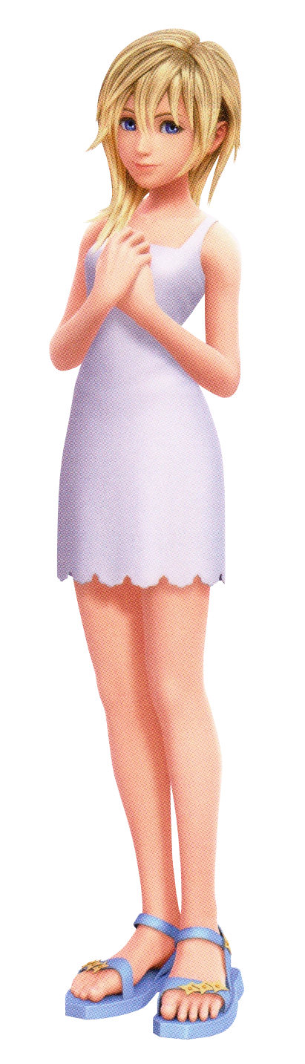
All that remained in terms of changes was her outfit. As the last of her Servanthood left her body, the clothing that was composed of her mana could no longer hold. She was left naked for a moment before the fates saw it fit to redress her. Not in anything complicated, but a pair of blue sandals and a simple white dress was afforded to her. It was comfortable and felt strangely familiar.

If anything, Namine at least had clarity now. “I see.. So I’m the Master. And my Servant is…?” The blonde’s Servant must have been Ritsuka, right? Or whoever Ritsuka had become assuming she had suffered a similar fate. It was a little disorienting for the teen. Perhaps it was because she was an existence that could control the memories of others but she could remember being Kama. Any attempt at vocalizing that, though?

It was like her brain just hit a wall. She could open her mouth to try and mention it, but no word would come out. “There were measures put in place to stop me from talking about it I suppose…” Not just that. She could control memories but there were rules. She wouldn’t be able to use her powers on her Servant nor anyone else participating in the Holy Grail War. But how did she know that? And did that mean that there would be others like her that had been transformed to participate?

“Master!”
“EEP!?”

Namine had been thinking so deeply about her circumstances that she hadn’t noticed the presence of her Servant until Xion materialized right in front of her, both girls recoiling from the reaction. “O-Oh, Xion!” The blonde smiled warmly once she recovered, recognizing two things – this Saber’s true name, and her truer name. That was Ritsuka, her previous Master. But now she was the Master and Ritsuka was the Servant? And she didn’t seem to recall anything about her past. “I see…” That must have been why that rule was in place.

So would she be the only one who remembered?

She really hoped that this wasn’t the case.

