Heel
A Short Story
By Maryanne Peters

Heel a the back of the human foot below the ankle and behind the arch
b a contemptible person - a person who is self-centered or untrustworthy

He saw her on her own and realized that she was in distress. In black tights on a deserted street she wore no shoes – she held them in her hand – silver high heels, one with the heel broken off and hanging by a thread. She was large – even a little larger than him without shoes on. She was solid too – the legs would have looked better in the heels. She was dressed well – too well to be a common whore – like she had been at a cocktail party where she was happy to show off her assets – those legs and those tits. He smirked a little, but concealed that as he pulled over.

“Can I assist you?” he said politely, having lowered the passenger side window.

“I have broken my heel,” she said. Her voice was low and husky, like the growl of a tigress, but weakened. On top of the look and sound, and perhaps by her clear dangerous circumstance, that made her all the more alluring. “And to make things worse my phone battery has gone flat. I had wondered where the music was coming from, but it was my music app draining all my power.”

She was powerless. “I left mine at home,” he lied. “Otherwise I would have called you a cab. But instead I can drop you off somewhere if you like. Get in.”

“You are not the kind of man who would exploit a girl in trouble, are you?” He was not sure if the question was genuine or playful, but he chose the latter.

“No ma’am,” he tried to sound passive. “I am just offering. I can understand your reluctance.” It was not a word he had ever used before, but it made him sound educated and trustworthy, he thought.

“I put my trust in you,” she said, opening the door and sliding in bottom first. He was further excited. It was a full posterior, curved and comfortable like Grandma’s couch

“I am going nowhere special, so you tell me where,” he said. “I just like to drive at night. The streets can be better than TV some nights.” All this was true, but only by chance.

“Is Houston Street on your way?” she asked. “Corner of Houston and Roth?”

“No problem,” he said. “But I will be taking an alternative route, by way of Advantage.”

He thought this was clever. He would take Advantage Road to get there and take advantage when he got there. He accelerated away from the scene of her troubles.

She seemed puzzled for a moment but then she realized they were in an industrial area – deserted after dark. It seemed that her rescuer might have nefarious intentions.

“I don’t suppose I could plead with you?” she said.

“I’ll take you to the corner like you ask. Think of me as an uber. I think the word is German and means “on top”. And just like the app, I need payment settled in advance.”

“I can guess what you want, but in this car, I think what you really want is going to be difficult,” she said. “Don’t think that I do this for a living, but I could give you a hand job. I have done more of those than you could imagine, so it will be good.”

“I was thinking a blow job,” he said. “Less messy”. He pulled over in a dark spot. The tip of his penis was already at the zipper and trying to break through.

“Oh my, what a frisky little thing you have there,” she said in mock excitement. It was enough to convince him that she was a whore, but that didn’t bother him. He would not be paying for this.

“Blow me then,” he demanded, sliding back his seat as much as the sports coupe could allow.

She gathered some saliva before her head dropped into his lap. Her lips went straight over it so he could feel her warm spittle and her tongue working it even as he seemed to in, to the hilt. She moved p and down and the pleasure of it drove his hands into her thick hair, as if to guide her. But she needed none of that. She had done this before. He knew it because this was not his first time either, but it was his best. He spasmed and shot.

She sat up and looked at him. A little dribble of his genetic material was in the corner of her mouth but she used a manicured and painted nail to shove that in before she made a point of swallowing deeply.

“Are you happy now?” she asked.

“I’ll take you anywhere you want to go,” he said. “And I will do the same tomorrow night, if you will give me your phone number?”

“One thing at a time, Stud,” she said. “Corner of Houston and Roth”.

He did as he was told. It was not far. He did not even wait to slide his cock back into his pants.

She opened the door to get out but before she did that she turned to him and said – “Before I go just let me kiss my new best friend.”

If he was expecting her to kiss him on the lips he was disappointed. Instead, her head dropped apparently to plant a kiss on his shrinking penis, but before he knew it she was out of his car carrying the ignition key in one hand and her shoes in the other.

“Hey, Just a minute!” he called, as if she would stop and surrender, but by the time he was out of his side of the car and following her up to the house she had disappeared into, the door was locked and he was stranded in shock, on his heels as some might say.

He knocked on the door. He called gently through the door out of regard for the neighbors he might well say – “Come on now, Sweetie. Okay, so you are pissed, but let’s talk about this. You strike me as a businesswoman.”

He was not certain if he could hear voices or not, but he waited, and sure enough, the door opened and she stood beside it, evidently inviting him in. He walked past her, and she closed the door. He was surprised to hear the sound of a dead bolt closing. He suddenly sensed that they were not alone.

Out of the shadows stepped a very large man. He looked extremely threatening, probably because he was obviously annoyed. The driver started to realize the enormity of the situation, and it was much bigger than the immediate threat. It was clear that the woman had entered the house and told this man, her protector perhaps, that she had been molested by this scrawny stranger.

“This was all a misunderstanding,” he began. “I saw a woman in distress. It was a broken heel. I just wanted to get her home. I was overtaken by …”. He stopped, because as he heard the words and saw the face staring at him, he knew this would not work. “I have done a bad thing,” he admitted.

“Isn’t it funny how history repeats,” said the man, not in anger but with an expression of resignation.

He had a feeling that things would not turn out well, but he was not expecting the needle in his neck, and barely had time to react to the cool fluid entering his carotid artery. Whatever it was it acted immediately, rendering his limbs useless. He sloughed gently to the floor as if suddenly boneless, just a blob but curiously completely conscious and aware.

“Welcome to your new reality,” said the large man. “You have plenty to learn but time to do it. Life should be a lesson. You will make mistakes but you will get better. You want to be better, don’t you? You want to be a good girl for you Daddy?”
The blob tried to speak, but that too seemed paralyzed. Even his eyes he seemed unable to close. He saw the woman approaching with something in her hand.  “Let me get you waxed and you can put on your shoes,” she said. “You will be wearing these for quite a while I think. I wore them for the best part of year before I was allowed out on my own. So much can change in a year. Your grow into a better person, just like I did. Let’s get you smooth and then I will lock these on.”  In her hand was a curious pair of shoes – black heels with brass padlocks on each.  The End | 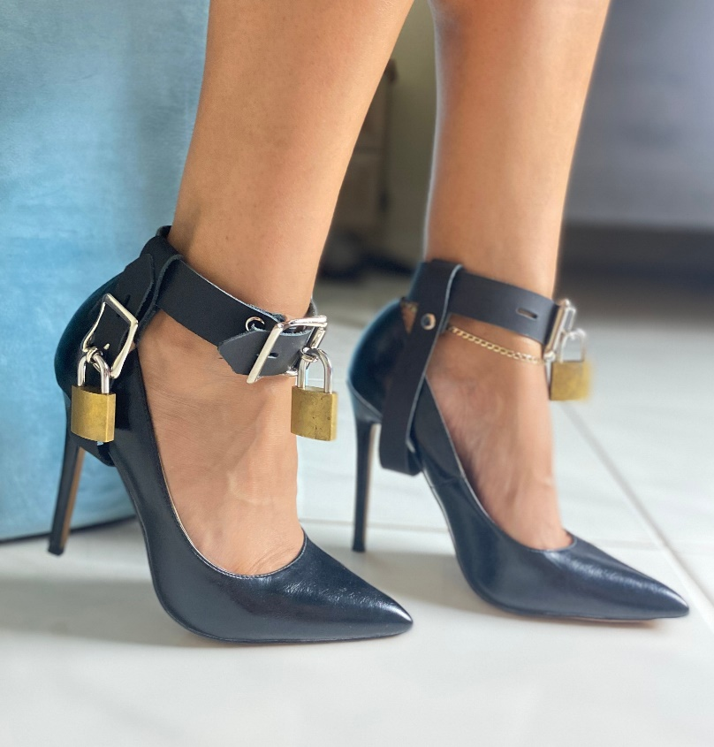

Erin’s seed: A guy who takes a woman home after she broke a heel at a party (I’m picturing her being a large woman) and she invites him up and they have a drink and start making out and she confesses that he likes to be tied up to have sex and would he do that cause she trusts him and he does and the sex is great and she says, your turn now …” I have departed from that line somewhat.

