THE THIGHWAY
BIG STORY #21
BY CHALDEACHANGE


Kazuma Sato was a pervert.

For anyone who knew him even a little bit, this was one of those ‘water is wet’ types of statements. This was a young man who had chosen to use the abilities of a thief to steal the panties of multiple women when he had been given the chance, and an individual who was constantly drawn to the sexy characteristics of women. Any woman, even if she was just a little bit pretty. Considering he was the only guy in his party it wasn’t like the others found it funny or appropriate.

The opposite, in fact. “Hey, Megumin! What about this spell here?” It had gotten so annoying lately that both Aqua and Megumin, two members of Kazuma’s party, had become taken with the idea of teaching him a lesson. That way he’d maybe knock it off. Or at least tone it down. They couldn’t handle being the laughing stock of Axel forever! Ultimately this decision had taken the two magic users to a secret, underground library that had been a two day’s trip from their base of operations.

“Oh, you’re right! This might work perfectly!”

“Ugh. Aqua and Megumin come back today, don’t they?” While most people would probably be excited to know that their friends were coming back from a trip, Kazuma didn’t have any of that enthusiasm at the time. He’d found it oddly quiet without the two noisiest party members to keep an eye on. It was just as nice to not have to carry Megumin back from her daily explosion practice! He was lounging around the mansion that the group had been given to live in.

Utterly unaware of the fact that Aqua and Megumin had not only come home overnight, but they were hiding away with some water-based illusion magic, listening to whatever he had to say. Needless to say, his comments weren’t exactly instilling them with any desire to not do what they had ultimately planned on doing to him. They were just waiting for the right moment.
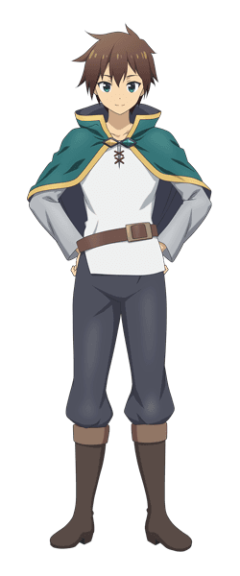
Before long that moment came. Kazuma had collapsed in his favorite chair beside the fireplace, making absolutely no effort to go out to do the chores the two of them new he had agreed to do while they were away. They remained hidden as Aqua got to work with the incantation, Megumin only lending her magical energy to the cast that was quietly activated.

Kazuma had been on the cusp of nodding off when he suddenly perked up. “Hah?” A weird feeling had caught his attention lower down – his pant legs felt tight? It must have just been the way he was sitting. Maybe his pants were riding up? If that were the case though? Then Aqua and Megumin’s spell wouldn’t have been working! …Which it was.

He sat up straight in his chair and stared straight down at his lap, raising sleepy eyes at the sight. Did his lap seem thicker than before? He was pretty sure that his thighs had never been so big that his pants were gripping them tightly from the sides. They almost looked like… RIIIIIP! “What the heck!?” Kazuma eventually shot up into a standing position, having intended on shouting an expletive at the sight of ripe thigh flesh bulging through the sides of his pants.

The skin around them had been pulled taut and spongey, glistening with all of the appeal that he would have loved to see in a woman’s thigh. Where had all the hair on those legs gone!? “Why do I have a chick’s thighs!?” If they had been attached to an actual chick then he might have wanted to touch them, but…

Well, for better or for worse he was about to get his wish granted.

His thighs were still swelling and pressed up against each other between his legs even when he was standing up straight. But this posed a more uncomfortable issue – his dick was right between those thighs and their immense mass was attacking his Kazuma Jr. from both sides. “Crud! This isn’t comfortable! Who is doing this to me!?” He had no idea that Aqua and Megumin were in the room with him laughing their asses off.

But that laughter stopped once Kazuma’s knees suddenly buckled, pointing in towards each other not because of the mass of the thighs, which were now independently thicker than his waistline, themselves. Instead it seemed as if their mass had forced his hips to dislocate and widen in gait, eventually popping back into place several additional inches away from each other. Hands reached back to try and stabilize himself, but instead Kazuma found his hands pressing into an ass that was much larger and plusher than it had been. “Do I have a chick’s bum too!?”

“MMMMN!?”

Thighs jiggled one last time (from their expansion at least), and it felt as if his dick had reached its breaking point. But the discomfort faded along with a very feminine moan that erupted from the boy’s lips. Except, well… she wasn’t a boy any longer. A panicked hand reached down to feel the front of her pants only to find that nothing was there. “I’m… I’m a girl? A-Ack! Even my voice!?” Her Adam’s apple had smoothed away the moment her sex had changed, and seemingly her vocal chords had shifted to give her voice a feminine ring as well.

Just looking at Kazuma’s face in that moment you could see that the femininity that had consumed the lower half of her body was due to emerge elsewhere. The girl’s facial features already seemed more girlish, with softer cheeks and poutier lips. The girl herself didn’t have a mirror handy to make this out, but she was progressively looking a little off? Like if she was just becoming Kazuma: but a girl, then there wasn’t a need for her face to appear this different. Such as green eyes darkening to a chestnut brown or even changing shapes so that any Japanese lineage was stolen, leaving her looking more like a young Caucasian woman.

One who was in her twenties and not her teens.

The woman was fidgeting. She was clearly upset by all this, but she couldn’t express it the way she wanted to deep down. Yelling felt too disruptive and even if she did? She couldn’t seem to bring herself to cuss. “What should I do? Maybe if I had a cauldron…?” Huh? A cauldron? What was she even saying? Alchemy? Why did she know how to do that instead of her usual skills? She could think of what she needed to do to say, brew a potion with her smaller, slenderer hands. The things she needed to gather while walking around on those now petite feet of hers… she just knew.

Her continued confusion was interrupted by two things. The first was the sight of her bangs. They were clearly longer and softer now, and the brown was a touch lighter. Her hair in general now reached down to her shoulders. But the other thing wasn’t quite so simple to dismiss. It also very strongly demonstrated that Kazuma’s personality had changed, because at the sight of his chest pushing up against the underside of his tunic? Kazuma didn’t make an inappropriate comments nor did she try to grab them. She just quietly watched as her once flat chest inflated into a pair of perky DD-cups, which lifted up the base of her shirt to show off her soft and shapely tummy.

Even she realized she wasn’t acting right. Which gave her a rather alarmed epiphany. Was she still… Kazuma?

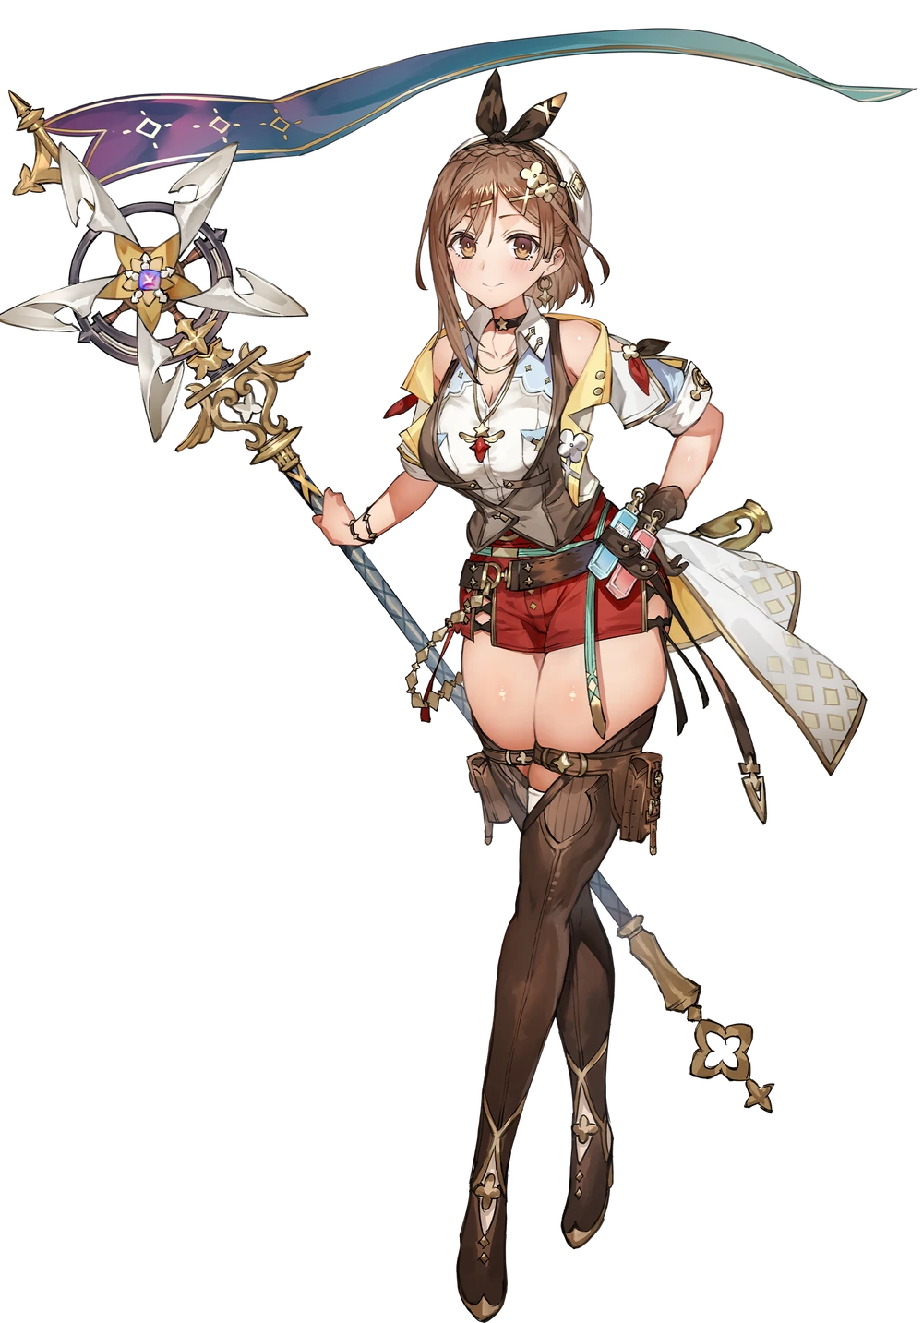
“Ryza… Ryza… Ryza! I can’t say my old name!? Oh no!” The thick-thighed, auburn-haired young woman struggled to speak a name that wasn’t ‘Ryza’. And even then? Her brain simply registered her full name a Reisalin Stout. It was clear her appearance and personality had changed along with things like her personal preferences, but in terms of memories everything from her life as Kazuma was in tact. She just couldn’t act like how she used to.

In fact, there wasn’t a perverse bone left in the eager woman’s body now. “I… what am I supposed to do about this? How did this happen!?” What was she going to wear? Her thighs were so impossibly thick that they’d torn through her pants! Fretting to herself, Ryza soon became aware of the fact that she wasn’t alone in her living room. Aqua had dismissed her illusion spell, revealing herself and Megumin. An awkward silence hung in the air. “Did… Did you two do this!?”

“Uh… Yes? But it wasn’t supposed to be this strong!”

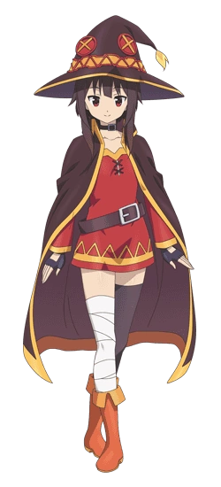
Megumin let out a sigh an hour later as she sifted through the offerings of one of Axel’s few clothing shops. Ryza needed something to wear but wasn’t able to venture out since there was nothing that fit her. So after awkwardly taking her sizes, Megumin had been sent out to purchase an outfit or two. “I still can’t believe that spell turned Kazuma into another person. It was just supposed to give him thick, funny thighs!” They had thought that having him be the object of attention might make him rethink his attitude. Well his attitude had been readjusted. Forcibly.

Fashion wasn’t really Megumin’s forte, and so she’d just tossed a few outfits that should fit Ryza in a basket. “I better be getting repaid for these…” Even though she was part of the reason Ryza was in that situation in the first place? Well, Megumin had never really been a selfless person. Case in point? While shopping for Ryza, a shirt had caught her eye to purchase for herself. She quickly dipped into the changing room to try it on.

But stopped short of putting the shirt in question on when she found her thighs rubbing against each other strangely.

“…Eh?” Megumin stared down at her legs. Something that wasn’t all that hard to do since her chest was so lackluster in size. “…?” Something was off about this view, wasn’t it? It almost seemed as if her thighs were— “EEEEEEH!?” The girl cried out the moment she put two and two together. It was a good thing the store clerk was out back doing inventory. She didn’t even hear her!

But the girl’s cries were warranted. Because she was observing the very same thing that had happened to Kazuma earlier that day… happening to her own body. Beneath the skirt of her tunic she could see her thighs bubbling up in mass, thickening while the skin around them was pulled tight. But wasn’t this sight even stranger than what had happened with Ryza? The coloration of the skin around her thighs wasn’t right. Rather than retaining their palish pink it almost seemed as if their colors were darkening?

“How is this possible? We only cast the spell on Kazuma, so…” Aqua had tried the reversal spell twice with Megumin present (to no effect), but she hadn’t felt any magic travel her way during that procedure. “This is a pain in the ass!” Well it was certainly annoying, but the explosion-wielder wasn’t typically one to express her agitation with that kind of language. She noted it, and that only added to her worries. If Kazuma had become a completely different person, then…

The thickness of her thighs continued to bloat, fraying the top of the legging on her left leg, and beginning to unravel the tops of the bandages on her right. The tan they were developing darkened more towards a light bronze, but the tan also appeared to travel. It crept down her legs towards her feet, and up past her waist so that her torso, arms, and face were all recolored in its image. Even her nipples darkened to a dark brown beneath her tunic.

Should she go seek help? This naturally felt like the right play. How far was Wiz’s place from this store? But the idea of just sprinting out was becoming problematic in its own right. Her thighs, now nearly twice as thick as her waist, were indecent in design – and so girthy that her hips inevitably stretched significantly wider, lifting the tunic so that her underwear were completely exposed. Much like Kazuma’s own transformation this likewise effected her ass, and Megumin’s rump could be felt chewing up her underwear from behind.

“M-Maybe I can just wrap my cloak around my lower body? That wouldn’t be very trendy though!” Trendy? Since when did she care if things appeared trendy or not? Not to mention it was a matter of practicality in this case, and— “Shit! Am I getting taller?” Panicked confusion was ultimately interrupted by a wobbly feeling and the realization that her eye level was sliding upwards. She certainly was, springing up from under five feet to almost 5’3” in the matter of seconds.

This made her fashion woes worse, for the base of the tunic had been lifted high enough to reveal her thick ass and torn undergarments entirely, along with the base of a tummy that seemed a little more toned than it had been prior. She felt more confident now that she was taller, and on top of that her very thick lower half didn’t seem quite as ridiculous now that her height had better evened things out.

Megumin bit her lower lip for a moment in a gesture that looked rather suggestive, not that she had meant it that way. This was just a side effect of her lips having taken fuller, thicker shapes midst a tanned face that began to appear a touch more mature. Growing taller was one thing, but she had also grown a few years older up to eighteen. And not only did her face reflect this, but structurally its design changed to that she looked like a different woman altogether. “Hmm…”

She looked down at herself again with eyes that were now a steely blue color. “This outfit sucks.” Her voice was still feminine, but it also carried a coarse purr that almost came across as sensual in how she spoke it. Megumin also knew that her outfit shouldn’t have been much of a concern in the moment, and yet it was so distractingly hideous. She just wanted to rip it off!

More reasons were soon given for her to just that. “Oh!” Because she purred at the feeling of the skin around her small breasts being pulled tighter. Observing her tunic it was simple enough to see what was happening. Her bosom was swelling, non-existent mounds flourishing as larger orbs took shape. Orbs that she mischievously gave a few honks with tanned, manicured fingers before they peaked at C-cups. “Wonder how many dudes I could fluster with these girlies?” Megumin really couldn’t stay on topic.

But she also didn’t really mind much anymore? If anything she was more concerned about the aftermath.

Clicking her tongue, the teen didn’t bat an eyelash even after noticing her bangs hanging loosely… while also presenting a dark silvery color that departed from their original brown. Her whole head of hair had been painted in this silver along with her brows and a now very messy bush of pubes. When it came to the hair on her head, bangs were parted in the center and a messy, shoulder-length bob was made with the rest of it. It had clearly been styled that way, and deep down even without seeing it Megumin could tell that it all looked super hot.

She wanted to look that way.
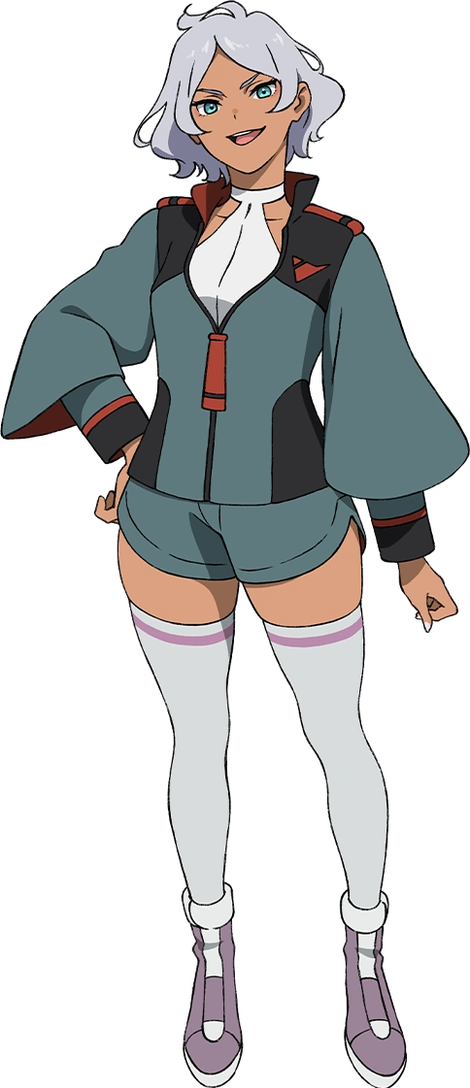
“Ugh, did it really happen to me too? Did the spell linger? Secelia… Secelia… Nope, can’t say my old name.” Shrugging, Secelia Dote was acting surprisingly flippant about the fact that she had just been transformed into another person. Much like Kazuma was to Ryza, Megumin’s ego was still present within this new body and personality. But she couldn’t speak her old name aloud. She was also bursting out of her usual tunic. “Whatever, it’s not that fashionable anyways.”

The young woman almost felt relieved to strip it off, instead reaching out of the changing room and grabbing one of the dresses she had picked up for Ryza to put on before anyone noticed. Secelia would just claim that it was what she was wearing when she had come into the store! Even though no one had seen a tanned, thick-thighed girlboss come into the shop in the first place.

“Wonder if this means that Aqua…? Hahaha! Let’s see, I guess!”

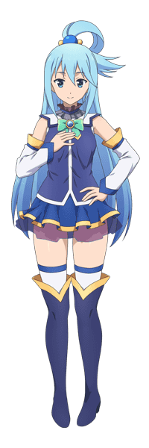
Aqua was much more bothered about what she had done to Kazuma than Megumin was. The spell had been her idea, and altering the boy’s very nature hadn’t been something she would have wanted to do to anyone. Yet after helping Ryza acclimate to her situation a little and sending Megumin to fetch clothes, the goddess had decided to take a bath to relax her nerves. Ryza had been oddly understanding about it. Probably because she was a much kinder person than Kazuma had ever been.

“Haaaah…” The hot water and steam of the open air bath that was in their mansion brought the goddess instant relief once she lowered her body in. She could just feel the stress melting away! “How are we supposed to fix this? I wrote down that spell and the reversal, but the reversal didn’t work. Do we need to go all of the way back out to that library to look for a solution?” Even if Kazuma was better like this, she wasn’t so morally reprehensible as to leave him that way.

She rubbed her legs together under the water, thighs touching a little too soon. With everything that had happened to Kazuma it was certainly enough to catch her attention. “Huh? Don’t tell me…” Aqua’s thighs were already plenty thick, but they hadn’t been as bombastic as Ryza’s. Yet upon standing up in the bath she was greeted by the sight of her thighs… already having doubled their original girth. “EEP!?”

It had been so shocking that she had sat right back down in the water, the feeling of this plush flesh lipping over the edge of the underwater seat she was resting on difficult to ignore. Just as it was difficult to ignore the hunch that she was gradually pushing a little higher out of the water? Like the seat she was on was being raised, but that wasn’t technically the case. Her ass had been inflating with the same girth that her thighs, which now rivaled Ryza’s in thickness, had accumulated.

“How could this happen? Did the spell affect me too? Did it backfire? …Why am I so calm?” It was almost funny that the strangest thing from the goddess’ perspective was her present demeanor. It was true that she would normally freak out in a ridiculous fashion if something like this had happened to her, but aside from sitting back down in the water to act like nothing was wrong her response had been an extremely measured one.

In the meantime, the beautiful blue hair that she was known for showed signs of darkening. Beginning at the tips of each strand a raven black had emerged, and that darkness gradually crept up towards her roots at which point it would become her natural hair color. But it was a task made easier by its length, for hair that generally reached past Aqua’s ass had now shortened to hang just past her shoulders. Even the cut of her bangs was straighter now, making it easier to show how her eyes now had both a color that leaned more into silver, as well as a shaping that was more almond-like.

More similar to the eyes Kazuma had possessed. The eyes of a Japanese individual.

“Okay, so what can I do here…?” She kept herself calm, noting that her voice had changed to seemingly mirror that calmness with how borderline monotonous it now was. “I’m getting smaller.” The slight height boost while sitting she’d gotten from her swollen ass cheeks had been temporary, and a few inches that peeled off her overall height saw her sink a little more into the bath than she had before. This somehow made her thighs look even thicker, and at the same time? Her breasts grew a little bit as well. They were fuller horizontally, giving her an appealing fullness for a girl of her age.

And therein existed another inconsistency. Aqua appeared a few years younger as well, making her mid-teens as opposed to late teens. Her face exemplified this perfectly, for as it had inevitably leaned into a more Japanese shape with full, round cheeks and plump yet flat lips beneath those reshaped eyes, those features were all notably more baby-faced. “Could I reverse it with magic? But…” For some reason she couldn’t think of any spells. Did she even know how to cast a spell now? The methods through which she had changed Kazuma (and apparently now herself) completely passed her by. She couldn’t fathom being able to do such a thing.

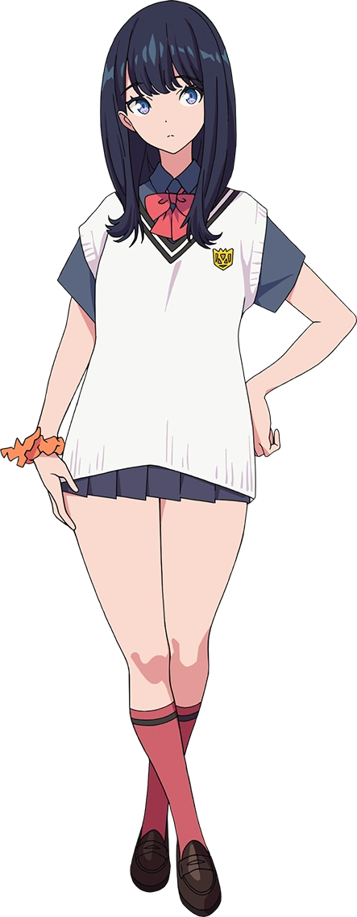
“Rikka… My name is Rikka…” Rikka Takarada if she were to speak the full name, but she wasn’t trying to. Aqua had never possessed a surname, she had just simply been the goddess Aqua. But now she wasn’t Aqua, nor was she a goddess. She had become a normal, teenaged human girl. “Huh… Does this mean I can’t use magic anymore?” She was strangely calm about this realization, but then again that was Rikka’s personality bleeding through. No longer was she the nonsensical woman she had been before.
Rikka was much more serious and measured with her words. A teenager who had been blessed with thighs as thick as Secelia’s and nearly as thick as Ryza’s. “This is going to complicate the whole thing even more, isn’t it?” To reverse the situation they’d somehow have to convince others of their old identities. Which they couldn’t. “Ryza… Secelia… Wait, is Secelia Secelia?” These words didn’t make sense to just anyone, but she had tried to speak Kazuma and Megumin’s real names.

Her brain had autocorrected them, implying that even Megumin had fallen victim to the spell. That was even worse. No one else knew about them casting that spell, and if they couldn’t speak each other’s true names then… Who the hell was going to believe them? That sounded like a problem for whenever she got out of the bath.

“That’s… probably going to be problematic.”

