Daily practice routine – example (Beginner - Intermediate) :

Practice structure
15 - 30 minutes routine:

Warm up (5-10 minutes): Muscle memory exercise , new chord shapes (see video for instructions)

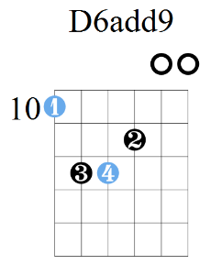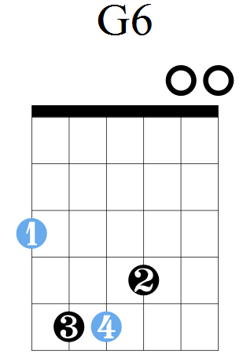

Practice (10 minutes) : Fingerpicking pattern (“All related”) practice with metronome (Start at 80, aim for 120)

Reinforcement (5- 10 minutes): Play one of the songs we have worked on: Om Shanti / Cuatro vientos / Vallerie. Point of focus: transitions between fingerpicking & strumming

Assignment:
- Cuatro vientos: Make a video demonstrating the transition between fingerpicking & strumming with a metronome (110-120 BPM)
- Vuela con el viento: Make a video demonstrating coordinating singing & playing simultaneously: fingerpicking on the verse, strumming on the chorus. Add crescendo before the chorus (see video)

Daily practice routine – example (Intermediate - advanced) :

Practice structure
30 - 45 minutes routine:

Warm up (5-10 minutes): Dorian scale & 3rds sequence, with a metronome (80-110 BPM) 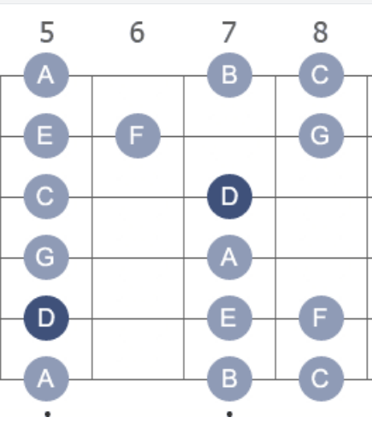

Practice (20 minutes) : Improvise over the chord progression: Dm | C | G | G (use the recordings). Solidify a 4 bar long melody and repeat it, make a recordings.

Reinforcement (15-20 minutes): Repeat the arpeggios on the 5th position over the metronome/playback (120 BPM) – see video

Assignment:
- Make a video of the melody you composed over the chord changes.

