SCREAM AND SPROUT
COMMISSION STORY
BY CHALDEACHANGE
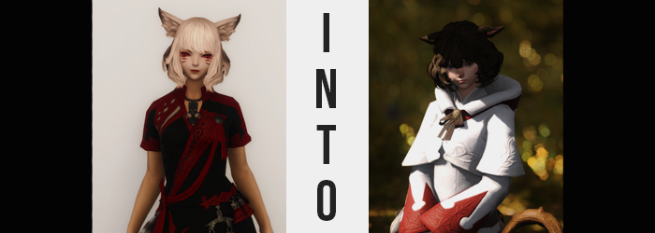

Ranka was not enjoying this temporary party experience whatsoever.

Experienced as she was, she wasn’t typically one to party up with random strangers who needed the help with dungeons and battles that they were not familiar with. In the world of Hydaelyn experience was key, and things were made easier because that experience was exemplified by their levels as adventurers. Ranka? She wasn’t even a mortal, rather being a Fox Auspice rather akin to a kitsune.

Levels? She transcended the need for such things, and to mortals she was merely perceived at whatever they believed to be the maximum level attainable. It went without saying that being so powerful made her out to be rather smug, and her arrogance wasn’t the type that typically played well with mortals at all.

This man though? This generic looking troglodyte in his generic looking armor, at a mere level 60? He had evidently been attempting to strike at Ranka’s every last nerve. Throughout their entire venture into the The Fractal Continuum in Azys Lla he had been barking orders at her that were nonsensical. Stand here! Do this! Do that! They were all things that went against her better judgment and at times put her in harms way.

So it went without saying that in the wake of it all, she was unamused. If she had a poor opinion of mortals before, now her opinion of them had soured even more so. “And what were you doing, my fair brute? Have you a single bit of sense in that thick head of yours, or do you perhaps see me as expendable? Did you not need my strength?” It certainly wasn’t unlike the fox to speak in such a condescending tone, and in a manner that wasn’t particularly modern.
In fact, she’d lashed out at him the moment they had returned to their temporary base at the inn in Gridania, having ignored him the entire trip back. Out of the entire party, only the tank and the fox had returned to their lodgings for now.

“And what of you, wench? Hidin’ in the shadows, stealin’ aggro whenever you wanted? You ain’t exactly in a position to judge my team play when the only reason I acted like that in the first place was because you weren’t cooperative!” Did he have a point? It was very likely that he wasn’t wrong, but when it came to mortals Ranka would fault them over herself ten times out of ten.

Rather, his pointed tone only served to agitate her more. “Tch! As I expected, mortals just don’t respect the opinions of those that vastly out-level them! Even at cap, you would be in no position to question me, brat!” The fox turned up her nose at him and turned her back, but doing so was a mistake. He’d begun to rummage around for something in a solid, oak drawer nearby. And the moment he had found it?

“Well, if your experience is what makes you all haughty, then let’s see what you’re like without it!” Ranka hardly had an opportunity to turn around and see what he was doing for her did it, and a beam of white light had shot from a tiny wand in his right hand, immediately striking the fox who yelped in surprise. “This wand cost me a pretty amount of Gil! Said you could steal away the talents of another! So let’s see if it ‘twas worth it!”

Having turned around to face him once more, the woman raised an eyebrow and crossed her arms beneath her chest. “You really think a trinket such as that could influence an auspice? You certainly have some… some… nerve.” Wait, where had her nerves gone? Why had she had so much trouble getting out that sentence when she was typically so fluent?

A pit developed at the base of the woman’s stomach. Ranka naturally believed herself to be an all-powerful existence, the type of existence that no one could freely mess with. That was supposed to be the deal, right? Survival of the fittest? Gain enough strength and you can live comfortably for the rest of your life? All that walked this world knew that this was how things worked, and yet for the first time in her life the Fox Auspice felt rather threatened.

“Some nerve, is it? Well, I dunno know about that, but you sound better already.” The tank’s snarky remarks appeared to grow more confident now that he could see that what he was doing was working, but he also turned his back to her. Part of the instructions for the artifact he’d used suggested turning away due to potential clothing issues.

Not that Ranka was literally ever shy about showing more of her body than the others were comfortable with. Even now, most of her pale legs were entirely bare, for she was merely wearing a black turtleneck that was just barely long enough to cover her black panties below. For someone that liked to jump into dungeons to pass the time, she seldom dressed the part.

“WH-WHAT DID YOU DO TO ME!? DON’T TURN YOUR BACK TO ME, D-DARN YOU!” One of the fox’s heels crashed against the wooden floor in an attempt to sound intimidating as she lurched forward slightly. Yet her own words betrayed her, the woman not only stuttering but swapping out a curse word for something tamer. Already, the haughty and archaic dialect that Ranka typically defaulted to had begun to unwind.

And yet because she was distracted with getting to the bottom of her current courage deficiency, the way that her body had begun to unravel was something that the woman hardly took notice of initially. Mind you, they weren’t exactly incredibly obvious changes to the first place – she could feel her power beginning to dwindle, sure, but she hadn’t the foggiest idea that it was also affecting her physical state.

Her fingers were an exemplary sign, really. While typically flawless, a number of scars and callouses spread against them, while her crimson nails had their paint erased and shortened to show signs that Ranka had been, perhaps, nibbling them. Embedded in the skin of these various places? Small pieces of wood. Splinters – implying she was swinging around a wooden weapon of some sort. Like a crook, perhaps?

The pristine yet vaguely supernatural pale blonde of her hair and fur, for example? It was in the process of rapidly losing its luster. When it came to her vulpine ears and tail, it was clear enough that the pale blonde was being overcome by a very plain brunette that, at the very least, made her features appear much more standard for a fox by the time the colors had bled in entirely.

On the other hand, while her fox traits merely suffered this change in color for now, the affliction that affected her hair as it did was a little less kind. Ranka was keen on taking great care of her hair. It always had to look its silky-smooth best, pulled almost impossibly straight and styled to her liking, ultimately. There was never a single strand out of place – that she made absolutely sure.

While the brown crept into her mane from the now browned fur of her ears, however? A chaos that would break her heart began to unravel the woman’s favorite hairdo, each and every strand that was dyed in this new color unravelling or otherwise becoming whole uncooperative with the style she had put it into that morning.

It all curled naturally around the sides and back, ultimately looking to try and conceal the sides of the woman’s ‘beautiful’ face as well as the peak of her neck in the back, and her bangs hung with a newfound fluffiness that was thick in the center with the bangs themselves just barely parted above either eye.

“You… STUPID! You big… Uh… Uhhh?” The mental side effects of the wand’s usage disturbed Ranka the most, because while she had begun to come across as sheepish and unconfrontational, deep down? Ranka was still her same old self. She wanted to call this guy an ‘asshole’ and assert her dominance over him like she did everyone, and yet the best she could muster was a stuttered whimper with which she could hardly convey any negativity in a way that might come off as harsh.

In fact, it was something that was being reflected in her body language. Even though his back was still turned to her, she couldn’t look directly at him with her eyes flickering back and forth between him and the floor. As if to thematically represent the fact that even her gaze was growing more subdued, the bright crimsons within dulled into a terribly plain blue, her pupils rounding so that her supernaturality became something that could be questioned.

Ranka was aware of it though. Humans could only perceive her as the maximum level, but she could sense it. Her power level was dwindling, and with it the level she possessed. At best? She might have been level 70 by now, level 65 at worst. “H-Huh? What…? What… My clothes are…?” The fox’s voice had grown wholly soft by this point, which served poorly to communicate the shock she felt in response to the fit of her outfit feeling looser than it had before.

That feeling had risen for good reason, though. Her figure had never been bombastic, but Ranka had a great deal of pride in her above average, perky tits, her thick thighs (which she often put on display), and her swollen rear (which ended up on display more often than you might expect). All three of those areas succumbed to some degree of loss in one way or another, once again enforcing what was clearly becoming a common trend.

Instilling an overwhelming plainness into her features.

When it came to the woman’s breasts, their perky fullness was robbed so that they rested as a meager pair of B-cups that left the front of her tight turtleneck looking emptier than they had before. The thin trim of her waist went next, broadening just slightly as the toned muscles of her body diminished to leave her softer looking in every capacity – as if she were an adventurer that didn’t often engage in any overly physical work.

Moving down, Ranka’s hips compressed in towards one another to reduce their overall gait by several inches, which left her underwear no choice but to sit a little more loosely than before. That looseness was only increased as the cheeks of her butt collapsed with several jiggles, and her thighs in turn followed suit so that they were leaner and left a slight gap between them.

“A-Ah!? Why am I so… so… I look very boring…” is what the fox had said. What she was thinking, however? MY BEAUTIFUL CURVES! MY HAIR!? JUST WHAT DID THAT OAF DO TO ME!? MY FIGURE IS SO BLAND AND BORING! THAT ASSHOLE! Well, it was certainly a far cry from what she was able to muster word wise. “How could… such a thing…? Nn…” A hand reached down to grab her panties, fearful that they would fall off and expose her pussy to the man. But since when did she even care that much about showing off? It was so unlike her!

Her condition was worsening though, and now it was targeting the features that made her a Fox Auspice in the first place. A single glance at Ranka’s complexion showed that her skin was darkening, the one pure white of her exposed thin dotted with patches of tan that spread and multiplied, all ultimately merging together into a color that was as consistent on her thighs as it was her face.

Speaking of her face, though? There were darker spots that surfaces across the tops of her cheeks and nose. Dark freckles that merely contributed to her plain, shy, childhood friend-like aesthetic. Ranka’s face actually thickened in the cheek area though, and her bloated, glossy lips lost a great deal of their luster while her eyes softened in general prominence. What ultimately stood out the most upon her facial features were her nose, which had flattened and darkened in color to seem almost feline, as well as the removal of the crimson, whisker-like markings in favor of white lines that wrapped under her eyes from the sides of her face.

HEY! WAIT A SECOND! MY TAIL! WH-WHAT’S HAPPENING TO MY TAIL!? Lost in the chaos of it all, she had spared a single glance over her shoulder – and her vulpine tail’s shape shocked her. The fur that danced upon it in such thick tufts was thinning and shortening, brown now growing closer to the bone of the tail itself. The tip became rounded, and the overall density of the appendage grew consistent… until her tail better resembled that of a Miqo’te, the traditional feline race of this realm. “N-No…” H-How could this b-be…? E-Eh!? Oh no! Even my… even my thoughts are… Growing meeker, yes.

Now beyond anxious, the woman’s fox ears flattened against the top of her head. But they were changing as well, the soft fur tufts within them dwindling as the overall shapes of these ears grew just the slightest bit rounder and flatter, until they were undeniably a pair born to match the background of her tail.

“I… I… Uhm…?” The maiden wished to ask the man to change her back, but she just couldn’t find the words. What if he gets mad? What if he says something hurtful? Ranka’s hatred had been extinguished in its entirety, for even her psyche had been altered to reflect the fear and anxiety her body and words had been showing all of this time. And yet? These was still one final change to be had.

For a moment it felt as if her clothing was melting, and not long after its wearing couldn’t help but giggle wildly. Why? She was being tickled! Not intentionally, but the black material of her outfit had begun to crawl about her body, firming up and changing colors so that her outfit would become something more befitting of her current job… and level.

Yes, her level had diminished all of the way down to 50, which was the bare minimum to engage in some of the slightly hard dungeons Eorzea had to offer. All of the talents she’d possessed before, all of the knowledge she had about combat and how the world worked? It was gone, and her knowhow was comparative to her level. So it was only fitting that she would be dressed in a way to compliment this.

The resulting ensemble is what most would consider to be the standard for those that pursued the White Mage proficiency. A flowing, white leather tunic with crimson highlights, decorated with a puffy hood and plain, tanned boots. Other than her hands and her face, it showed absolutely none of her skin. And from Ranka’s perspective, with her personality as it was now? That was for the best. She was such a plain looking girl with nothing good to offer anyone, so of course she didn’t have the confidence to even show her body a little bit.

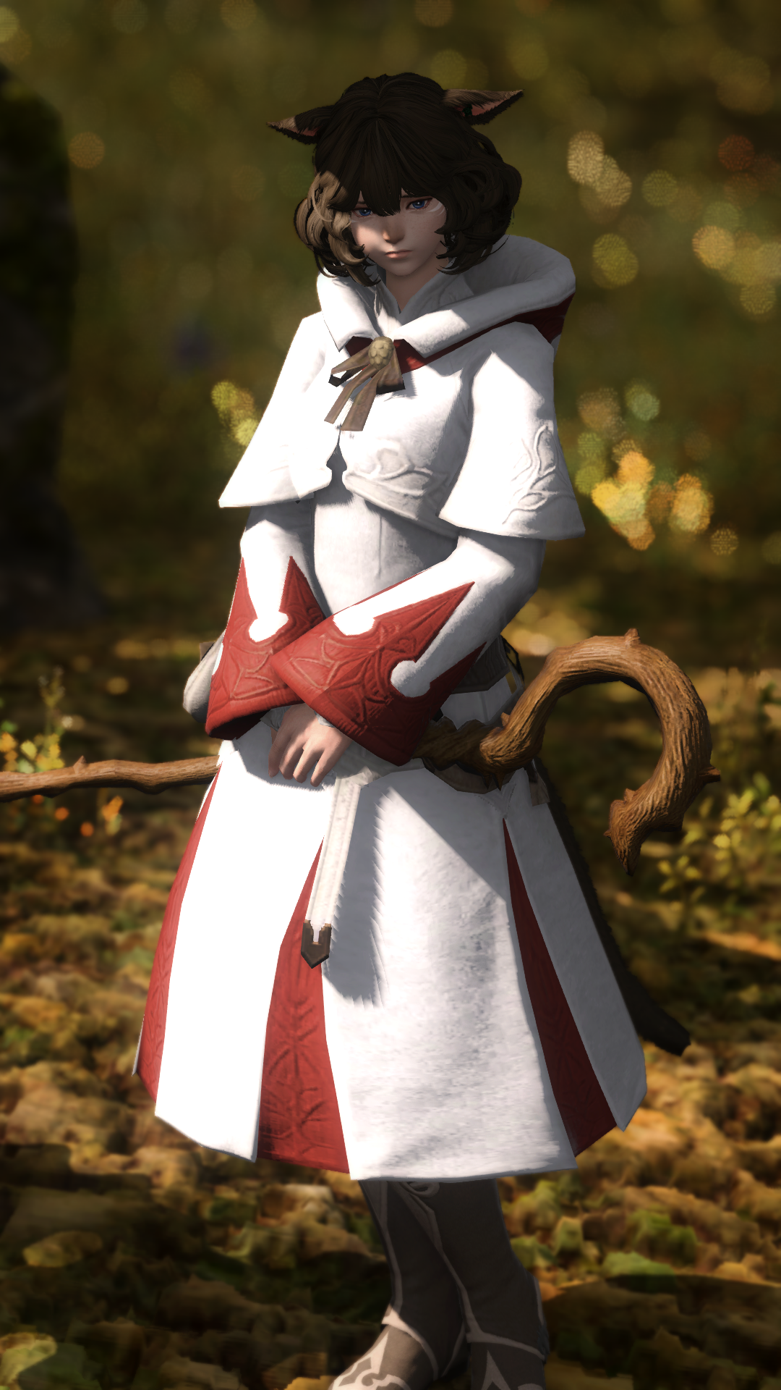
“Well?” A single word from the tank was enough to force the girl to jump, her withdrawn body language suggestive of how much her true nature had changed. She had once been overconfident and rude, and now she could hardly listen to the man she’d once called weak speak without cowering slightly. “Not talkin’ so cocky now, are ya?”

Forget her change in personality for a moment though, because she wasn’t even a fox anymore! She’d been reduced to the paltry form of a mortal, and a Miqo’te at that. Rather than being vulpine, she had become a feline. “N-No sir… I apologize… for… for what I said before…” The old Ranka would never have apologized, but now faced with a man that she found to be downright intimidating, she felt as if that she had to apologize so that she remained in his good graces.

Being mortal now, her need for Gil had become a necessity. Food, water, board – it all costed money, and being a meager level 50 healer meant that it would be difficult for her to find another party at such short notice if he tossed her aside. What she had once seen as a trivial waste of time before had now become a struggle of life or death for the shy Miqo’te. Even her name had undergone an alteration, and she couldn’t think of herself, nor introduce herself, as anything other than Rani Motya.

“That’s what I’m talkin’ about, little missy. Shame your level’s so low though, but ya gotta do what ya gotta do.” The tank was clearly admiring his handiwork, each glance of his at her appearance provoking her to look away meekly. This conversation was anxiety-inducing enough on its own, the extra attention his gaze was giving her only worked to worsen those fears of hers.

What was she to do now? Could she even share a room with these people and fall asleep without having a panic attack. “B-But um… Can I still work… with you guys? The Gil… I kind of… need it…” Honestly? She was so sheepish now that it was extremely adorable in a sense, to the point that the tank realized her couldn’t say no to her.

“Fine, fine. But if you’re terrible, I ain’t bringing you again.”

But she was terrible, and he did bring her again.

Because she was just too damn cute.

