PRINCESS BROOKE
THE ORGANIC VEGETARIAN FEEDER

Have you ever met a 15/10? Well, I have, and her name is Brooke! On a scale from 1 to 10 of beauty, I like to follow Jim Jefferies, The Comedian’s, View of it. A 10, you rarely ever see! 10’s only hang out with other 10’s, They are models, Singers, Superstars, The rich and elite. Brooke is a 10! She is 20 years old and a true dominant goddess to the core! We met over a dating app, I sent her a message immediately!

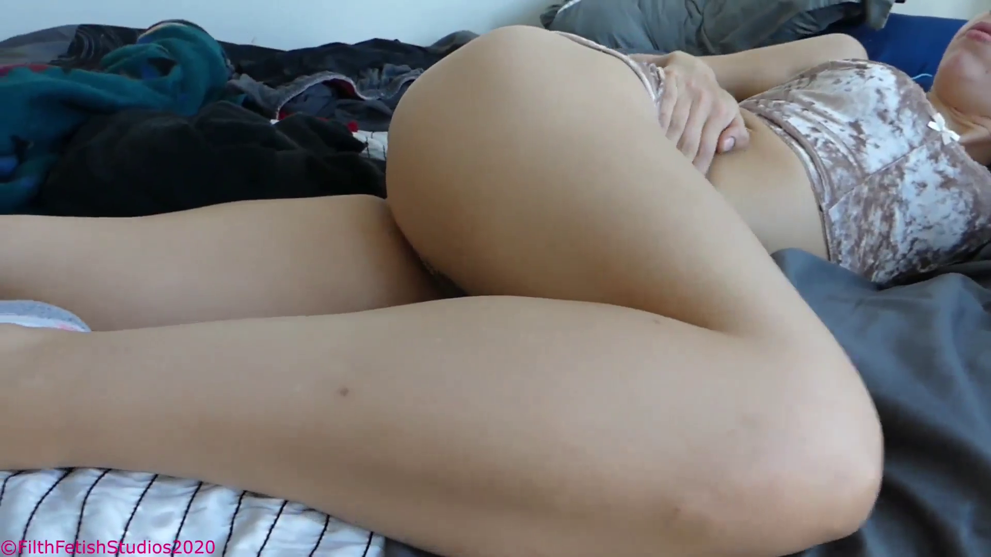

Jimmy: Wow, your pictures are beautiful Princess

Brooke: Haha, I matched with you to tell you your trash! I would never date you!

Jimmy: I would eat your shit, Princess!!

Brooke: LOL!!!

Brooke: Alright I’m down! You better not fucking waste anything!

Jimmy: My address is ***************

Brooke: Wait! You’re serious?

Jimmy: Smiley emoji and poop emoji ABSOLUTELY. How about this… if I’m not able to finish everything, I will pay you $1000

Brooke: I’m going to ruin your mouth!

This is our EXACT conversation. It was quick, to the point, she was more excited than anyone has ever been to use my mouth! She sent me her address and I ordered an uber for her, it was $200 and I was a tiny bit hesitant. She is from far up in the countryside and it was a lot of money both ways, plus the $1000 if I didn’t finish her offering. I had no idea at the time though, I would have gladly paid $10,000

I sat there with my phone in hand, watching the car get closer and closer to my home. The entire way she was sending me messages like:

“I’m so gassy! I had a bean and lentil soup for lunch! I’m not gonna waste my precious gas on this dirty uber driver though, I want it all to go right in your fucking nose!”
“I have to pee so badly! I came three times in the backseat of this ride from clenching my pussy so much! Are you excited for me to waterboard you with my golden nectar?”
“You better be good with your tongue toilet! It’s gonna be in my asshole all night!”

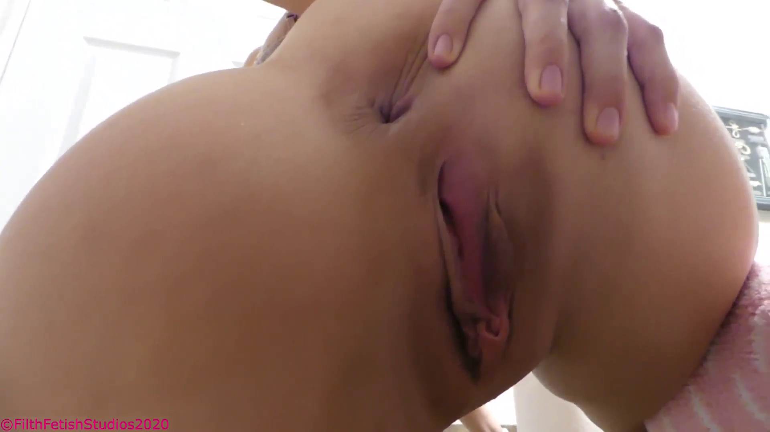

When the uber arrived and she stepped out, I was FLOORED! She was even more attractive than her pictures! Big blue eyes! Long blonde locks! A smile full of white teeth that stretched across her face! She had on black stockings and boots with little metal spikes on them. I ran to her and introduced myself but she reached out and pointed to the pavement on the street!

“DOWN, kiss my boots” she ordered, the Uber driver was still there watching with a look of shock, he was elderly and foreign. I got to my knees and kissed the tops of each of her boots before slowly getting back to my feet. She shoved her overnight bag into my hands and then began walking into my home like she owned the place. I wish I had a picture of the Uber drivers face, it was priceless!

When we got inside, she gave me her coat which I hung up. Her body, my god, 10/10! She is thin but with curves in just the right places. Powerful muscular toned thighs with just the right amount of fat! Her ass is so round and thick, so bubbly, her smile and blonde hair, everything, it was like she was sculpted by the gods!

“So, where is my toilet box, show me! It’s the least you could do, I’ve been holding it in all morning!” she said with a big smile, I could see, she wanted this. Usually, it’s about me, the few times I have paid for something like this, the women are NEVER into it, But Brooke, her eyes, they were longing for it. I could see she was anxiously waiting to destroy my mouth.

“It’s upstairs Princess” I smiled and began walking, she quickly cut in front of me.

“NEVER walk before me, always behind me, and keep your head down” she ordered.

“Yes, princess!” I replied and followed her.

As we walked up the stairs, her ass was right in front of my face. She took slow deliberate steps, wiggling her big bum back and forth. At the 10th stair, she stopped and arched her back, sticking out her ass and pulling up her black dress. Her stocking covered ass was so big and round. I could see she had nothing on underneath.

“I rarely wear panties,” she said with a giggle while wiggling her ass!

“Quick, nose to my asshole now!” she demanded.

I grabbed the railing and leaned in, pressing my face to her crack and letting my nose sink into the area between! The first thing I could smell was sweat, it was very clearly sweat, the strong salty vinegar odor of unwashed skin. She had mentioned to me earlier how she was going to the gym and to do yoga before coming, so the odor did not surprise me. The second thing my nose picked up was a soft and subtle smell of earthy shit! Her soft cheeks were covering my face and I was in heaven! I sniffed in and out, inhaling the thick odor when suddenly.

BBBBBFRRTTTTTT

My eyes began to water almost instantly! The smell, my god! I have taken a lot of farts to the face in my time on this planet, but this stunk, really stunk! I could feel my lungs reacting as I started to choke, but like magic, she grabbed the back of my head forcing me deeper! I could feel my nose pressing to her puckered anus through the tights as she laughed a bit.

“Breathe in and out, nice and slow, I don’t want to smell a thing”

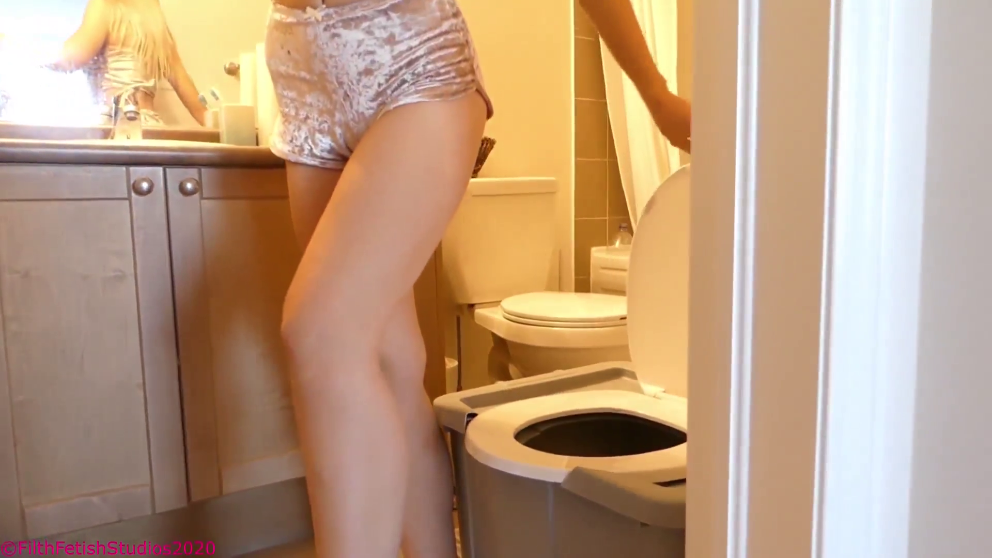

I stood there on the stairs, my dick rock hard with her gas around my face like a mist. She walked up the stairs slowly, looking over her shoulder down at me with the most alluring smile. I ran after her, tripping at the top of the stairs as she laughed.

“God, you can’t even walk properly! It’s a good thing I’m here” she laughed and entered my room.

I followed as she walked to the bathroom and began inspecting my toilet box. I dropped to my hands and knees, her ass inches from my face. She turned around and sat down without taking off her stockings. I watched as her thick ass and plump thighs hit the seat, I had never wanted to eat someone’s shit so badly! She bounced a few times on the box, feeling it out.

“This will do, for now though, I expect something nicer in the future, as in next time I am here. A Princess can’t be using such a trashy toilet, you agree don’t you?” she asked with a smile.

“Yes, Princess! I will build anything you like with any modifications you request” I answered.

“Good, now come here,” she said while standing up and walking to my bed. She took a seat on the side with her feet hanging over the edge. She still had her boots on. I crawled to her feet and kissed her boots again, she smiled down at me.

“You are obedient, I like that, now remove my boots and press my soles to your face while I speak, and I want you to listen carefully” she instructed.

I undid the laces on her boots and then slowly pulled each foot out one at a time. She had long slender feet, the kind dancers or ballerinas have. The stocking’s feet were so sweaty and damp on the bottoms and I could smell the sour odor already. I lifted one of her feet to my face and pressed my nose to the damp area under her toes taking a deep sniff, inhaling the odor deep into my lungs. She had a huge smile on her face as she spread her toes and curled them around my nose.

“Does it smell good? I didn’t shower just for you!” she laughed and moved my face up and down making me nod with her sweaty foot.

“Now, I’m sure you have eaten shit before, but I’m different from the other trash women you have met! I only eat organic fresh foods, I don’t drink any tap water ever, and I only eat vegetarian, so you are going to be getting the healthiest meal possible! I’ve been cooking it for you all day!” she said with a smile while rubbing her stomach. I had her soles both pressed to my face still as I sniffed in and out. Her feet were so vinegary and wet like she had been walking in those boots for days!

“So when I feed you, I want you to eat EVERYTHING, if you miss even a bit, you will finish off the floor of the toilet box. There are starving people out there, so many toilets that would DIE for my shit! So don’t make me regret choosing you as my commode!” she smiled and stood up taking her feet off my face.

“What are you waiting for? Get in the box!” she smiled as I rushed to the bathroom!

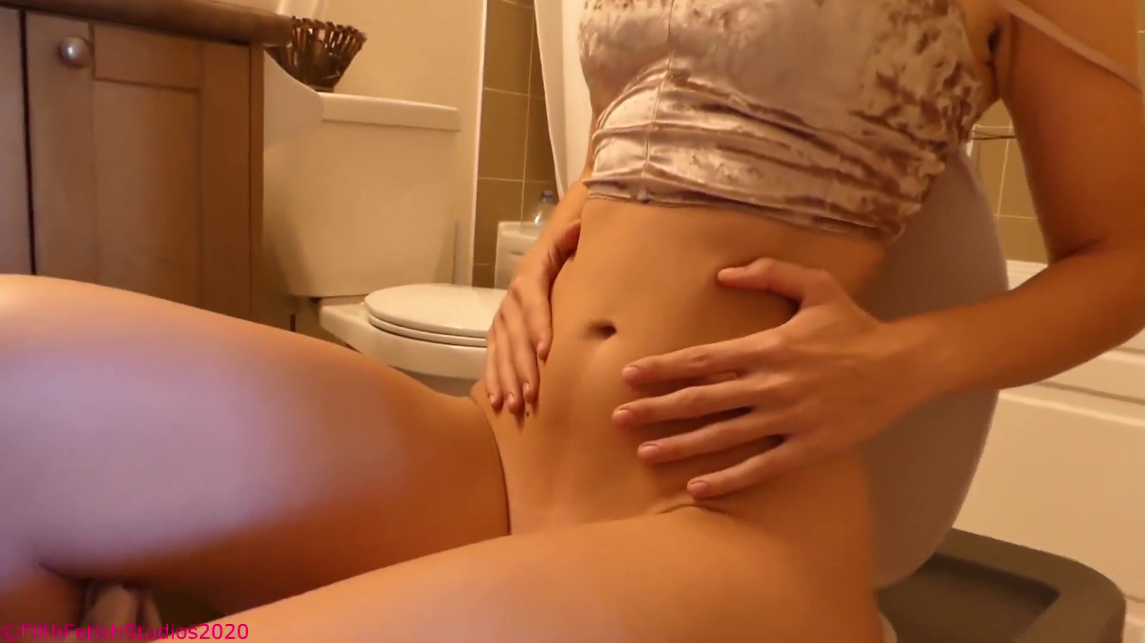
I have never in my life gotten undressed or gotten into the toilet box so quickly! I was literally moving a mile a minute, not only from my own anticipation and excitement but also because I did not want to keep this Princess waiting. As soon as I was in the box, she appeared above me, opening the lid and looking down on me. I was drooling, my mouth salivating, I wanted her shit so badly.
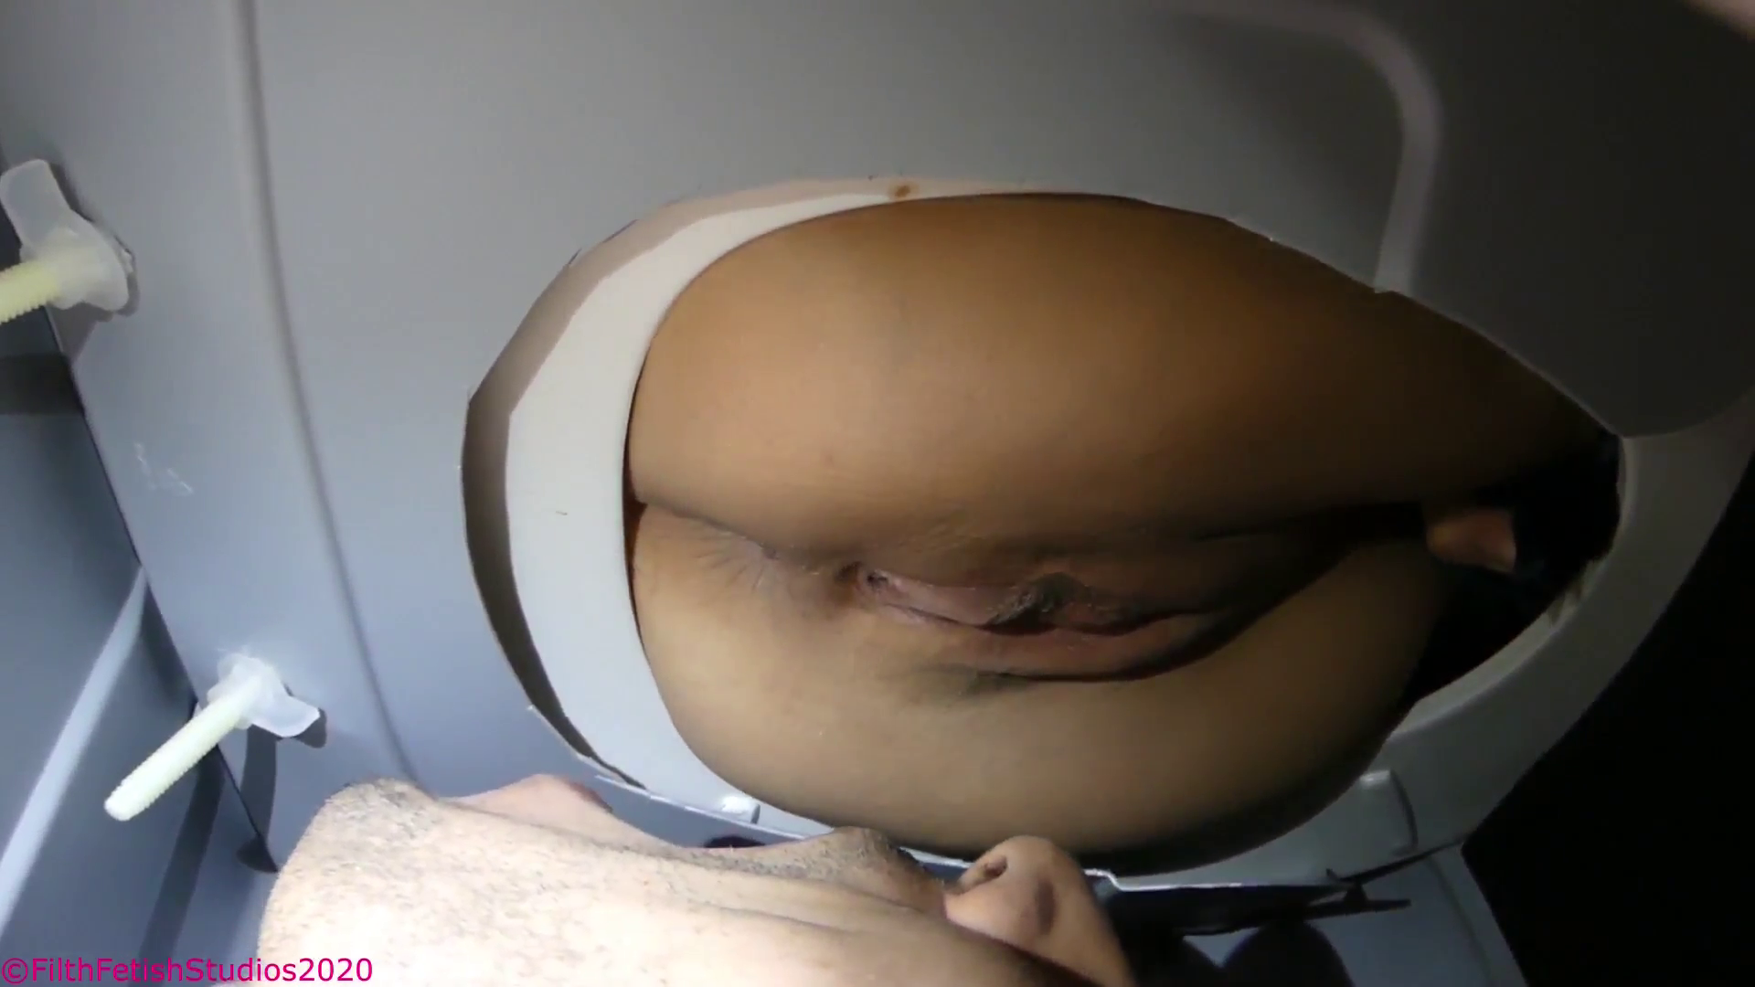
She stood above me, teasing her ass and doing a striptease before plopping down above me. Her ass and pussy just inches from my waiting face. Right away I could smell her body odor, the incredibly strong odor of sweat! It was on her pussy, her ass, all of it smelled so sour. I took a big deep breath and she laughed before cutting a rancid fart! It smelled of lentils and vegetables. I could not hold back and lifted my head up, pressing my nose to her asshole and sniffing it in, the odor was so thick.

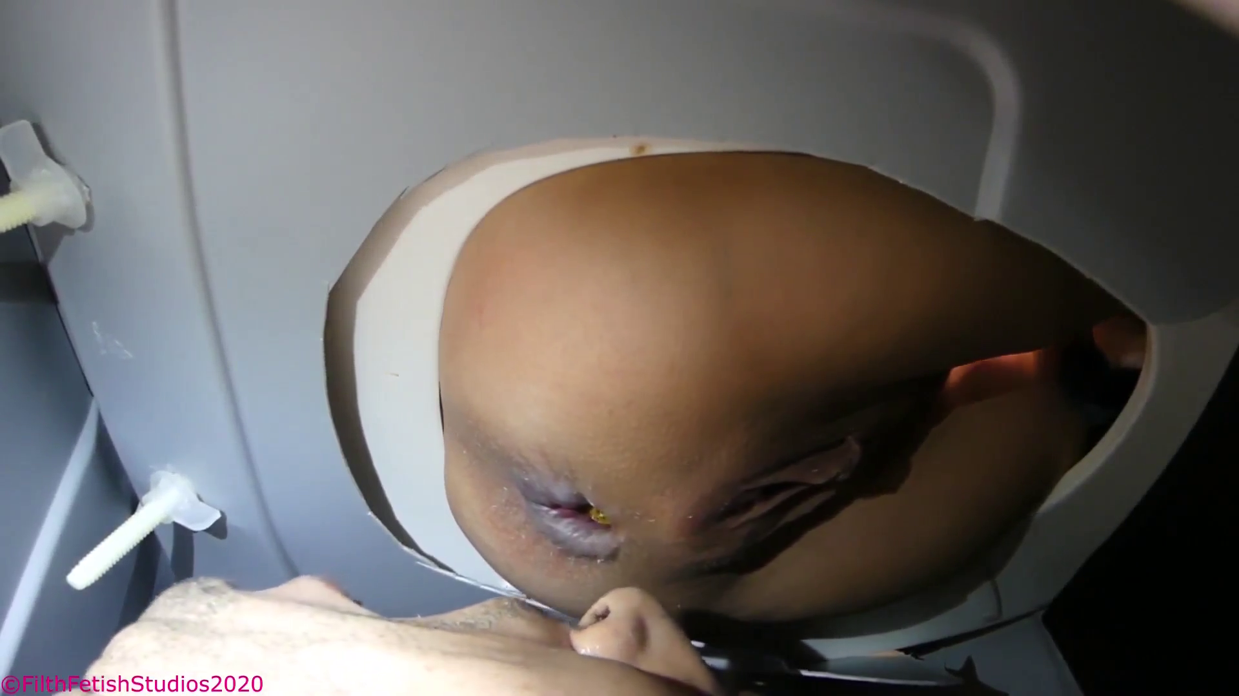
Her asshole began to spread and the box filled with the sweet heavy aroma of her shit. It was rancid and filled with the odor of vegetables but I was entranced. It was like I was under a spell, my mouth wide open as she laughed above me. I wanted to impress her, I wanted to eat it all! The first bit of shit popped out, a tiny nugget that rolled down my cheek, followed by another that rolled down the center of my head. I was humiliated, I wanted to catch them! In a desperate attempt to make her happy, I lifted my head and wrapped my lips around her asshole, just as she began to loosen up.

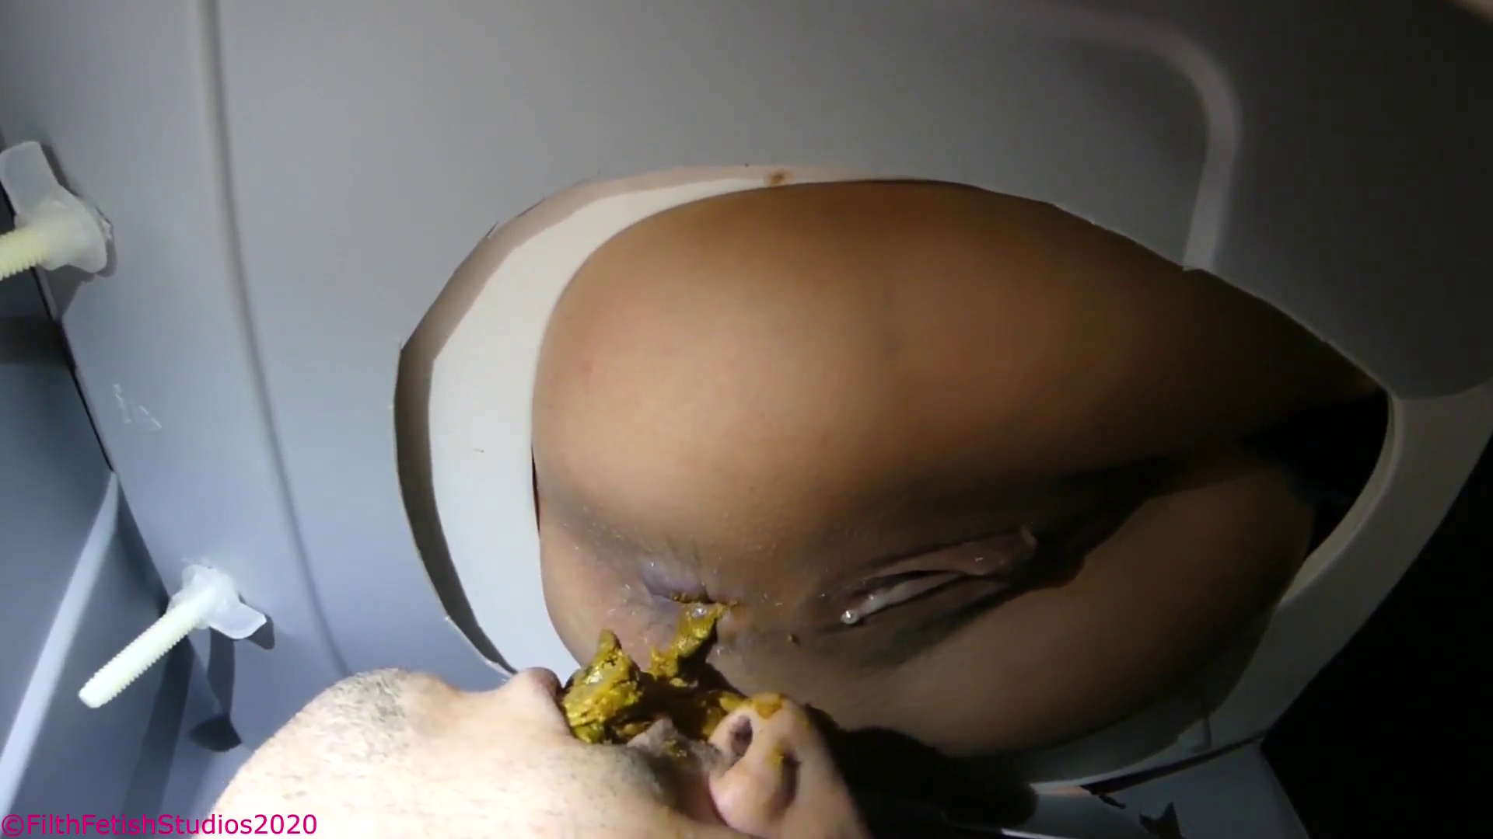

I felt her anus spread inside of my mouth as it began to crackle and let loose a long soft log of vegetable flavored shit! I was crying from how strong the fumes were, it was like sticking your head into a pile of cow manure! I could hear her laughing above me, grunting as she pushed out more, and more! My mouth was filled to the limit, my cheeks puffed out as her feces ran down my face! It was so thick and gritty, the vegetables were all digested but the flavor remained!

My mouth was completely full as her dirty asshole winked at me over and over, I knew she was waiting for me to clean her, but my mouth was so full! I pressed it all to the back of my throat and leaned up, my tongue and lips on her rectum as I began licking.

“Mmmmmmm clean it all off” she purred as her anus spread in my mouth. I could feel it widening and tightening on my tongue as I licked up and down tasting her sweet shit. Suddenly she pushed hard and more shit exploded out, my lips so full, it piled over my mouth as I dropped my head back! She laughed above me as she cleaned her ass, dropping the paper onto my face, without a care in the world!
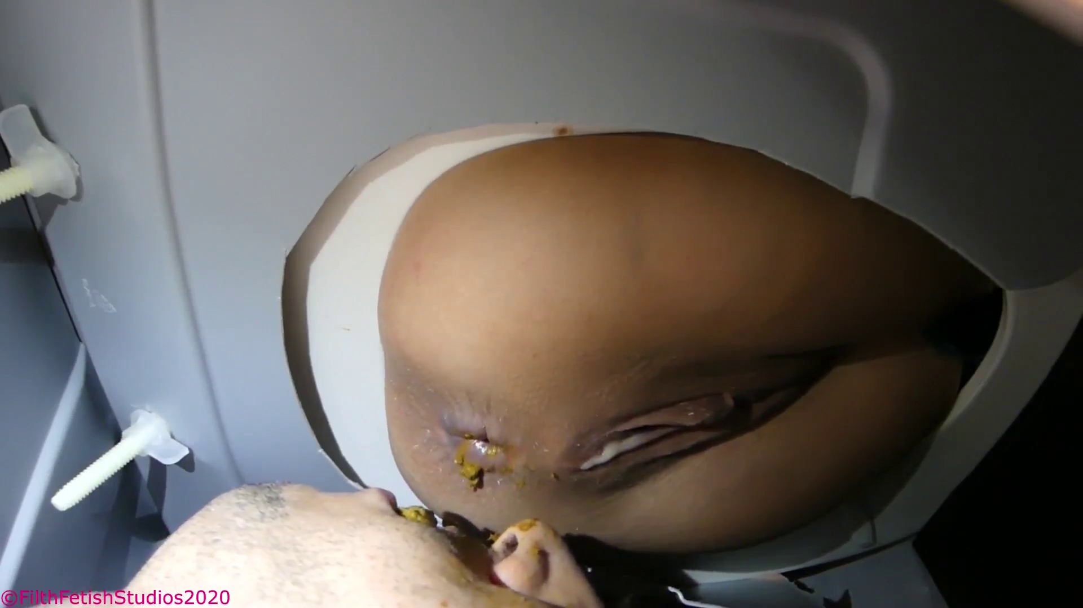

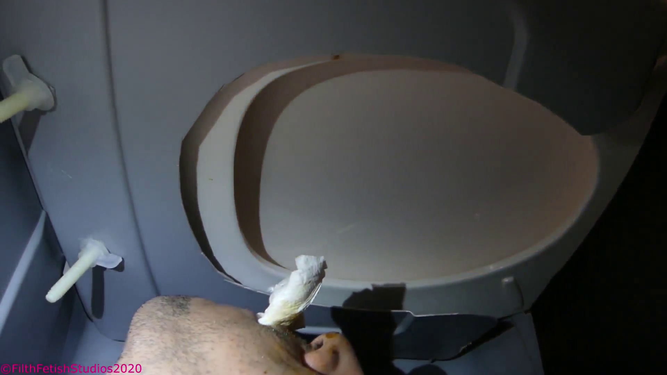

I laid there, her toilet paper in my mouth, my cheeks full of her shit. I had swallowed a good deal and it was in my throat, slowly moving into my stomach. I could hear her washing her hands as I started stroking my dick, I couldn’t wait for her to leave! I let out a deep gag as I chewed on a sour piece of feces and she opened the lid to peek down at me. Her smile was contagious.

“My god, this is so fucking hawt!” she laughed and dropped the lid.

“When you’re done eating ALL of my shit, clean up in here and join me in the bedroom. I think my asshole could use a thorough cleaning” I heard the bathroom door close and my dick erupted with cum like a fucking volcano!

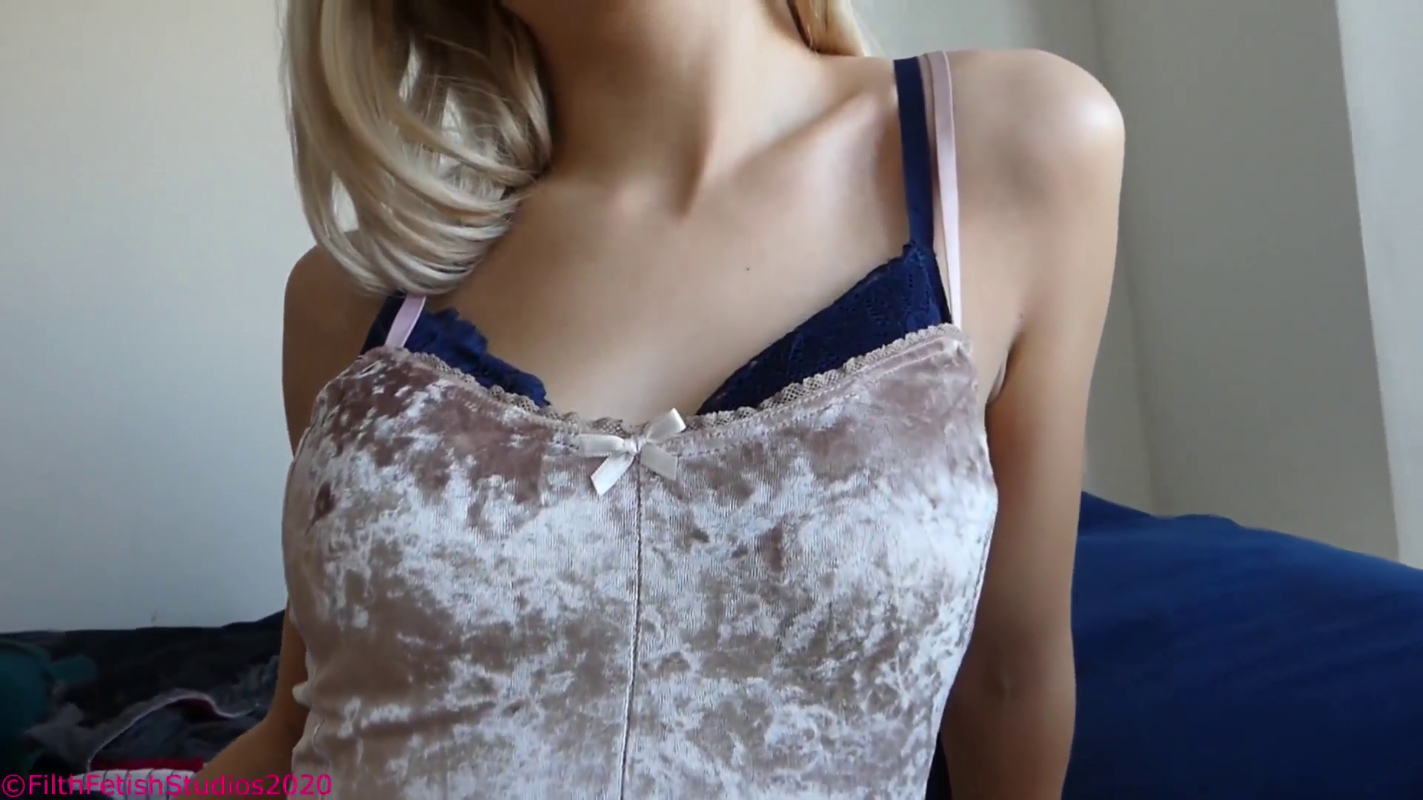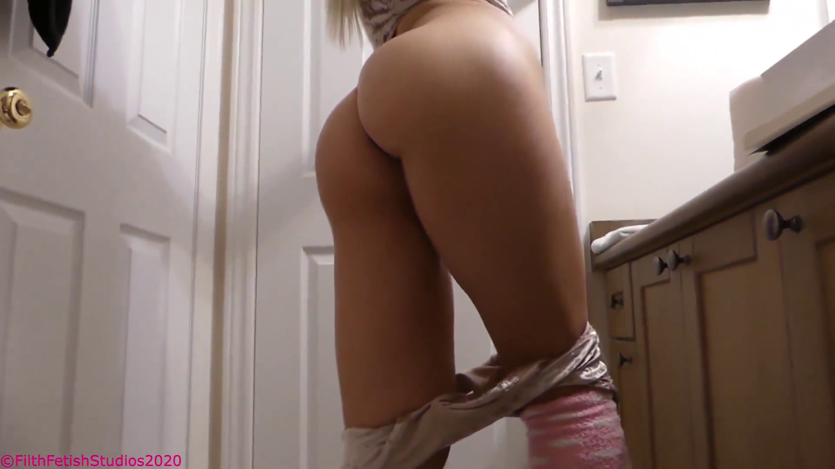
PART 2 AND THE VIDEO COMING TOMORROW NIGHT FOR THE $30 TIER

