GERMAN INGENUITY
COMMISSION STORY
BY CHALDEACHANGE
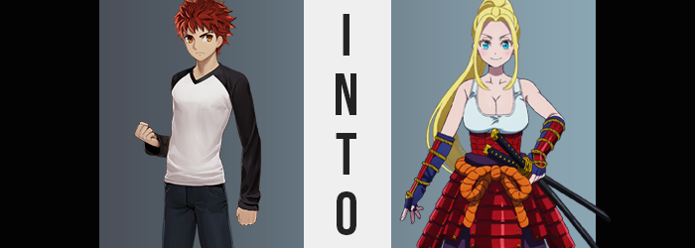

It was nice to hear his home being so noisy.

For a long time it had been a little lonely for Shirou Emiya. Sure, he had guests most nights. Sakura and Taiga had always made an effort to come visit him whenever they could and at least one of the two of them loved to run her mouth. He’d always been appreciative of that, because after Kiritsugu had passed away he really had been all alone. But the way things were now? They were a little different.

Before it was just Taiga trying to make conversation with her antics while the more reserved Sakura would only speak up now and again, leaving Shirou to fill in the rest. But now? As he cooked in the kitchen he could overhear the spirited conversation between three girls: Sakura, Rin, and Saber.

He wasn’t sure exactly what they were talking about. There were off chatting in one of the spare rooms while he was cooking dinner, after all. But it didn’t really matter what so long as they were comfortable and having fun, which it definitely sounded like they were. It warmed his heart to hear Sakura participating so substantially, laughing when something was funny, and expressing her embarrassment when she felt bashful. Rin and Saber had really gotten her to come out of her shell.

And he didn’t believe that would have been possible with him alone.

“Alright, looks like things are almost ready here…” The Fifth Holy Grail War of Fuyuki was still ongoing, but it didn’t seem as if the end was anywhere in sight just yet. Despite everything Saber seemed to be an unusual case and was keen on remaining in a physical shape in the human world and now joined them at his table every night. Which Shirou did like, but at the same time he was getting to the point financially where he had to wonder if he needed to start asking for money to help pay for the bigger meals. Sakura and Rin were doable, but Saber? “I hope this is enough…” She had a tendency to eat a lot. Far more than any regular human naturally would.

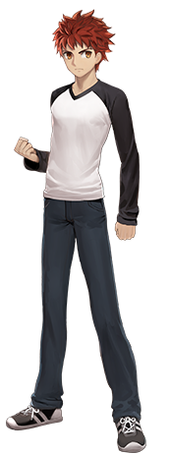
Maybe it was because she was technically a Servant being sustained with unusual means? Rin might have informed him of something like that after observing Artoria for a while (and she was certainly much more knowledgeable on the matter of Servants than he was), but evidently he had already forgotten the details. But that didn’t really matter for the time being. It did matter to his poor bank account but… he could table that conversation for later. Maybe Rin would help him?

With those financial woes tucked away for later he turned his attention back to the meal he’d been preparing. It wasn’t often they got to have seafood even though Fuyuki was so close to the ocean. But he had managed to procure some above average ingredients for a reasonable price and put together a fairly delicious looking sushi set. No doubt it would be voraciously consumed in a matter of minutes, but the important thing was that everyone enjoyed it. As someone who loved to cook there was nothing better to Shirou than the people eating his food being happy.

“Alright, I guess I should call them.” Or so he murmured to himself, but he ended up spending time setting the table first. Everyone more or less had their own spots at this point so it was fairly simple. Shirou knew what dishes and cutlery went where, and he even delivered the sushi to the table. Completing such mundane labor led to his mind wandering a little again. Not about anything serious, but he was thinking a little bit about the women still chatting it up in the nearby spare bedroom.

It didn’t really bother Shirou but sometimes he couldn’t help but think about how it seemed like the girls were excluding him a little bit. He was happy that they were getting along and happier, but they’d been talking more in private lately. He was probably being silly. It was probably because it was girl talk. The truth of the matter was that his birthday was coming up and they were trying to make plans. But of course he didn’t know that.

“Well it isn’t like I can just become ‘one of the girls’.” Or so he mused humorously to himself. It was a harmless comment with no real desire behind it. He was just lightening his own mood so he could push that little bit of negativity behind. Little did he know that making such a comment in the presence of sushi would trigger something unexpected. Not something he could have ever seen coming, nor something that could even reasonably be considered sensical. And yet…

The spell that had been weaved into the sushi he had made began to work its, well, magic.

After he managed to set everything up, Shirou returned to the nearby kitchen to make sure that he wasn’t forgetting anything. Along the way he’d noticed something though. His nipples felt a little sensitive? It wasn’t enough at first for him to think much of it without any added problems to note, but when those problems finally did come to be? “What’s going on? Am I having an allergic reaction or something? I’m hoping there wasn’t anything on that fish I’m allergic to.”

For some reason, his chest felt both swollen and achy. Looking down it even looked like that chest was a little puffier than he remembered. He reached a hand up to pat one since he was by himself, and… SQUISH! “…Squish? Why is it squishy?” His body had shuddered a touch from the contact as well. It was also sensitive. Shirou was so perplexed by this that it took him a moment to even grasp what he could see with his own two eyes. This squishy chest was growing. But once it did finally click? “WHAT!?”

Unfortunately, his shock of surprise fell on deaf ears. Whether or not someone had heard him did not change the reality that he was facing though. Both hands had come up to grope his chest now, and the weight of his chest was growing to not only fill his hands but push them away. If he wasn’t going crazy then these looked like… “Brüste!?” He had cried out ‘breasts!?’ but the word had been spewed in a different language entirely. Shirou had other things on his mind though.

Namely the orbs that were growing seemingly infinitely larger beneath his shirt. The base of his top was being lifted to show off his tummy little by little, the ampler breasts giving the fabric no choice with how much space they were taking up. His nipples were erect and the sensation of them rubbing up against his top were making him aroused – in turn making him erect down below too. “Why do I have breasts!? Ngh…” He was complaining but he also couldn’t keep his hands off of them. Unsurprising since each one was almost as large as his head by the time their growth had finally settled.

Shirou didn’t want to acknowledge the one possibility that made the most sense here, even though the supple, sensitive tits themselves weren’t the only indicator that it was happening. The hands he was fondling himself with exhibited signs as well: they were smaller, fingers thinner, and nails longer. Things shared with his feet and toes. He didn’t become less muscular at all and yet the look of his skin did change from head to toe too. It was softer and relatively hairless, like he had just shaved.

“Nein! That would be being impossible!” Making matters more confusing? His Japanese both found German words steadily mixed within while also acquiring an odd accent. His fluency wasn’t what it used to be and was gradually getting worse in tandem with his body growing more undeniably feminine.

Aside from the huge tits that were weighing the boy down from the front, his face and hair were becoming increasingly persuasive arguments to this was well. Reddish hair had already become quite shaggy and would progressively creep past his neck and down his back. Yet with time the coloring would also lighten to a very golden blonde, those bangs parted to reveal his entire forehead while also reaching past his chin.

But Shirou’s face? “Huh?” He noticed something was awry there when he bit his lower lip. It felt too thick? “My wips?” To the point he’d had a temporary lisp while first adjusting, in fact. He raised a hand from his new bosom to touch them, immediately stunned by how girlish those fingers appeared before poking them into those new, plush lips. “Like a frau?” A woman? An older woman, too. She had to be in her early twenties now, right? But haven’t I always been… NO!?

A part of him seemed to believe that his sex had always been the opposite of what it already was, but you could see why. His face had thinned but was also softer in the cheeks. The structure of his nose was girlish, but simultaneously somehow wrong? At least for the nose of a Japanese youth. That didn’t make complete sense until the changes came for his eyes. The cliff notes? Shirou was not Japanese, not any longer. Those eyes brightened with a sky blue and widened into bigger, more circular shakes. Caucasian. European. German.

“Ich bin…?” Was he German? He was thinking in German and he now had memories of Germany. It was difficult for him think of himself as a Japanese woman. In fact he longed to become one for some reason. He shook his head, long blonde locks getting tussled in the process. “No, that is wrong, is it not?” The German accent in his Japanese had become stronger, and really? That wasn’t a man’s voice any longer. It was much too high.

But was Shirou a man? No, she was a woman, right? A frau.

This wasn’t just a mental shift. The German blonde’s dick had been erect with arousal ever since her breasts had grown, but around the time her face had begun to change it had grown flaccid and small. It didn’t take long at all for it to diminish into nothing, a slit opening up just beneath it that pulled what remained of her masculinity into its folds and the womb that was dug within. It was a change that Shirou didn’t notice. In her mind she was already a woman, so having a pussy with a blonde bush wouldn’t have been odd at all, right?

The extra feminine flourish that her body was still missing formed soon after. Part of it was a narrowing of her waistline which then led into an outward swing of her hips, but the main attraction was everything that occurred around these areas. Those hairless thighs of her saw their skin stretch as weight poured into them, making everything above her knees almost three times as thick as what was below. Whereas her ass? It thickened in kind, pushing inches out behind her with full cheeks. This all placed quite a burden on her pants and boxers which all dug into body. “Sehr ungemütlich!”

Shirou fortunately didn’t need to bemoan the fit of her clothes for long. It all changed according to the magic’s intentions as well. Her shirt? The sleeves were lose and the white center pulled down so that it had a deep neckline while also covering her toned tummy as a new tank top and a scrunchie pulled long, blonde hair into a ponytail. This was as normal as things would get though, even though her lack of a bra underneath was a little abnormal.

Purple hakama pants were stretched out of her jeans and her boxers tightened into a pair of lace panties. The hakama pants began a disturbing trend. A samurai-based trend. Because pieces of crimson samurai armor appeared on her legs and around her waist – not to mention the guards over blue, fingerless gloves on her arms. With two katanas holstered at her hip it become questionable as to why a young German woman might be walking around in samurai armor, much less while carrying weapons.

“Das ist komich… Was I getting ready for dinner?” The busty blonde woman opened her commentary in her native language, German, which wasn’t exactly surprising since she was much more fluent in it than the Japanese that had followed. Still, it was impressive that a foreigner had picked up the language to that level at all, especially since she couldn’t have been much older than twenty-one.

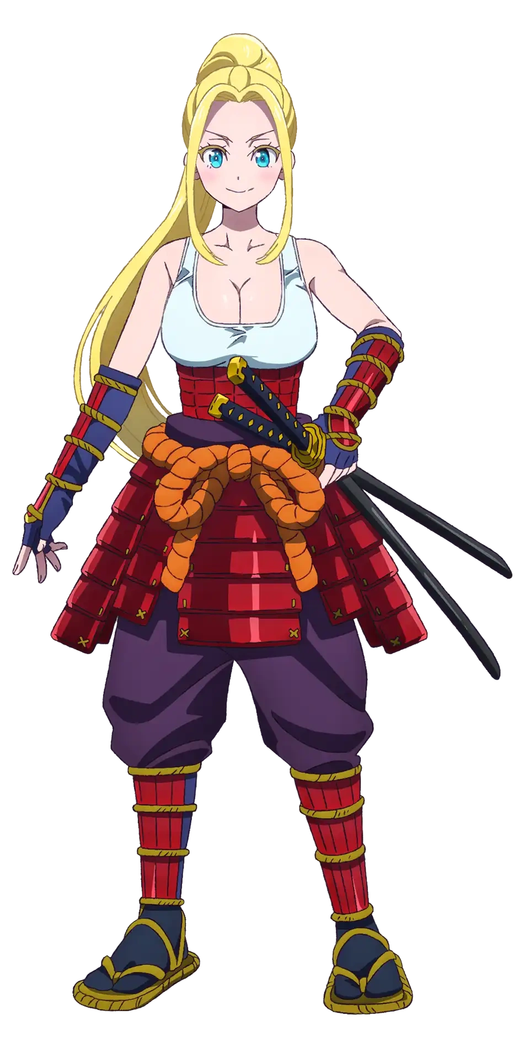
Despite the fact that she had been transformed into this form, Beatrix Amerhauser’s almost seemed like the perfect fit for the young man she had once been. She was a big Japanophile surely, but much of her obsession was focused on samurai and swords if the armor she wore over her bottom half didn’t make that completely evident.

Pretty blue eyes danced around the dining area. She did feel a little confused, but Beatrix’s mind was slowly piecing together a recollection that made more sense. Her fundamental core as a Master of the Fifth Holy Grail War had not changed and that was clear enough from the Command Seals still present on the back of her right hand.

So then what had happened to bring her to this point? “In der Tat! I finally managed to come to Nihon after all of that time, and then I was roped into this Holy Grail War?” That made sense, didn’t it? She had used her funds to rent this home during her stay, and after accidentally summoning Saber in the shed, Miss Rin had offered to help teach her about the War and how to defend herself? “I still wish I had summoned a Japanese Servant though!” Like a samurai! A ronin! Like Miyamoto Musashi!

Beatrix’s reason for coming to Japan had been a little narrower than just wanting to visit though. She was obsessed with this culture that wasn’t her own, sure, but there was one thing that she was obsessed with more than anything else. And spinning around, her blue eyes locked in on that very thing. “Sushi! Is this all being for me!?” She was on the hunt for the best sushi in all of Japan!

The blonde wasted no time and practically leaped at the table, her breasts bouncing generously as a result. She made such a ruckus that Rin eventually ran out of the room confused. “H-Hey!? Who are… Huh?” She immediately sensed it now that she was in close proximity to the woman. Magecraft? It was trying to mess with her memories, but she had enough power to resist their effects entirely. This woman was… There was no way, right? Rin dispelled the magic in the air before it could claim her entirely, preventing her own memories from being overwritten by the spell that seemed keen on changing them. Still, that didn’t change one important detail. “YOU’RE SHIROU!?”

“Wie meinst du das? I am Beatrix! You have known this, Miss Rin!”

She didn’t have to say that with sushi hanging out of her mouth…

But hey, she was definitely one of the girls now!

