TAMING HOUSE
COMMISSION STORY
BY CHALDEACHANGE
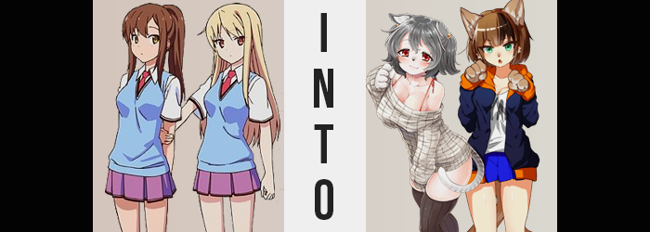

Suimei Academy’s Sakura Hall had been rowdy as of late. Perhaps even more so than normal, which was a shocking thing to state considering it was a dorm that contained the overly energetic Misaki Kamiigusa. But this story isn’t about her, even though the changes that had swept through the residents of the dorm were very obvious and very easy for her to invest herself in.

Love was in the air, so to speak, with two of the dorm’s residents crushing on a third. The arrival of Sorata Kanda had really shaken things up back when it had happened. That boy had made connections with all of the dorm’s quirky characters, but he was extremely close to the quiet and antisocial Mashiro Shiina, a girl who, despite her age, was a world famous artist.

At some point they had gotten very close, and Sorata’s childhood friend, the tomboyish Nanami Aoyama had moved in. An aspiring voice actress, much like with Mashiro it was obvious that she had some sort of romantic inclination towards her childhood friend. And as a result? Drama had begun to brew! They had very obviously begun to compete for Sorata’s attention, whether he realized what was happening or not.

Little was anyone aware, but a new stray cat had wandered into the dorm.


“Why am I so restless? This sucks…” Nanami had been curled up into a fetal position upon her bed that night, with the light of the moon filtering in from a nearby window serving as the only light available. She was sulking, more or less, over the fact that Sorata had chosen to help Mashiro rather than her after dinner. Was she intentionally getting in her way, or was that just how the pet-like girl was? “I’m sure if I was more like her, he’d pay attention to me too… Though I guess it’d help if I had a better body too.” An exhausted chuckle accompanied her words after she breathed them into her knees.

There was no one around to tell her that she was fine as she was, something that was certainly true. But just because there was no one around that could talk some sense to her, that didn’t mean there was nothing around. There was a cat. One with yellow eyes that had curled up beneath her bed. But this cat was more than just a regular cat. Sensing Nanami’s desires, its eyes had begun to glow.

Not long after, the brunette in question unfurled from the fetal position she had been sitting in for the past fifteen or so minutes. “…Eh?” Something felt off, but she couldn’t really describe what that feeling was? It almost felt like her skin was itchy, and she didn’t have goosebumps or hives or anything, and so she stood out. Maybe her muscles had just been falling asleep from being curled up, she had thought.

That wasn’t really the case, but Nanami couldn’t exactly be faulted for not realizing this immediately. After all, the initial signs that something was awry did not take place in a space that was naturally noticeable. Not without a mirror at least, for it was something reflected in her eyes. Namely her pupils, for they were gradually drawn vertically in both directions until they resembled slits. Cat-like slits. Just as bizarrely, so too did their amber colors change. They grew brighter and more vibrant until they burned red – a color that certainly wasn’t normal by any standards.

“Maybe it was nothing, nya?” Oh she had been so close to carrying on with her night as if nothing had happened, but unfortunately that unintended nya put something of a kink in that plan. “Did I just make a cat noise? Maybe I need to sleep, nya. …What!?” She’d done it again!? Why? Maybe she was sick? Did she have a favor? Nanami sure hoped that was the case. But her eyes aside, there were plenty of reasons to suggest that she hadn’t just caught a simple cold.

Her hair, for one. Chestnut brown strands found themselves lightening some, taking on a sparkly silver that was just as non-standard as the color her eyes had taken on. This hair grew a little thicker, but there was a cost to be paid for that. Because it was shortening too, rewinding in length until it settled just above her shoulders, bangs parted at the sides while some remained dangling down the center.

“NYA-CHOO!” A tingling in her nose pushed Nanami to let out a mighty sneeze – one that began with the same cat noise that was throwing her off in the first place. That was really no surprise though, because the cause of the sneeze? Well, her nose had been pulled out ever so slightly. Nostrils had collapsed and the nose itself had darkened to black. All in all, it created the illusion that she had a slight muzzle now – and with her pushed out, her resting expression even appeared undeniably cat-like.

Nanami was left blinking, her look going cross-eyed while she tried to believe her own eyes. It took a hand reaching up to feel that this black nose was wet for her to finally believe it, and the cry she made could have shattered a window. “WHAT!? WHAT’S HAPPENING TO ME, NYA!?” Was she turning into a cat? That was impossible! Even if she was making cat noises, and her nose looked like a cat nose, and her fingers were getting thicker and covered with fur – wait.

“No, nya, no, no!” Another cat noise slipped itself in midst her vocalized panic, and she threw both hands out in front of her to watch digits swell. It wasn’t just her fingers, but her palms were getting bigger as well! With fingers becoming round, soft white fur poofing out of them, they looked less and less human. And more and more feline. Tiny claws emerged from where each fingernail had been, while pink beads appeared on the undersides of each finger and palm. “NYAAAA!?”

The sound of her socks tearing indicated that the very same changes had struck her feet, but those feet had also shrunken horizontally as well. By comparison they were much smaller than the paws on her hands, but these feet paws were still enough to keep her upright while the backs of them protruded out of torn leggings past where her ankles would typically rest. “This isn’t… right…” The teen’s voice was softening, and it sounded much calmer than she had been before. This wasn’t on purpose. She felt more at peace, almost tired, even though she should have been expressing the alarm that she felt.

Was it really not right? Those big, fluffy paws of hers struck her as a little familiar. After all, wasn’t she a cat girl? N-No! I’m not…! Even then, Nanami didn’t sound all that sure about herself. And her body was still changing to support the opposite truth, what with how her ears had slowly been climbing to the top sides of her head and inherited the same silver that had painted her hair in the form of soft fur, with white on the underside of what were now clearly a cat’s ears. As well as a matching tail that peeked out from between her shirt and her skirt, stripes upon its silver.

This was all just a side effect of the power of the cat beneath her bed, mind you. It could grant the desires of a human at the cost of having feline DNA implanted upon them, which was exactly what had happened here. Nanami had wanted to be ‘more like’ Mashiro, and now she was quiet, calm, and strongly desired to be doted upon. But she’d also requested something else: a better body.

Now a desire like that was subjective. But from a cat’s point of view, wouldn’t a better body by one that could properly nurture others? It ultimately helped create conditions similar to what Nanami’d had in mind, but it wasn’t quite right either. Regardless of accuracy, it was still her Seimei uniform that paid the price.

Both her white shirt and the blue blazer overtop began to feel tight, forcing a nya-like moan to bellow from lips that grew plumper against an increasingly docile cat maiden. It was no surprise that this change was one part discomfort and one part pleasure, because her breasts were swelling larger. Having a sportier body type normally, she was a pretty lean young woman. But as breasts grew bigger and bigger, disheveling her bra and lifting the base of her tops, an overwhelming softness saw all of her body’s muscle soften to give her a much tenderer appeal.

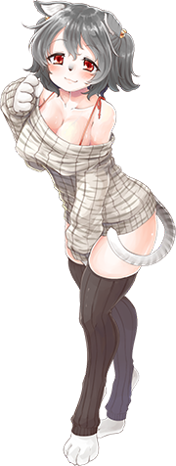
Hips were forced wider as a direct result, and her skirt soon lifted some thanks to her ass and thighs bloating. Her tail rubbed up against the sides of those exposed thighs, plump and appealing – the kind of lap most men would dream to have their ears cleaned upon. But that was the type of appeal her body exuded overall now.

“…Hm? What time is it, nya?” Her voice soft and almost spacey, the young feline woman practically purred as she pawed at her own cheek with a fluffy, silver cat’s paw. Her body soft, supple, and abundant, it was clear that the uniform she had been wearing no longer fit her properly. She wanted to get into something thin and loose, something that showed off her purrfect features. How else would she win Sorata’s attention in the end? Seeing as he was so good with cats, it went without saying that she wanted to be his number one!

But tactical clothing choices aside, she didn’t really have the outgoing personality necessary to compete with her rival. Which rival? You know… the other cat! In fact, the cost of her bountiful body had been an inversion of her personality, making her soft-spoken, shy, and in need of a little spoiling now and again. Much like Mashiro was. That rambunctious Mashiro! Her rival!

Excited as she was, ultimately? Nanami curled up to take a nap before she could even get changed. Providing the perfect opportunity for the white cat to escape out of her window.

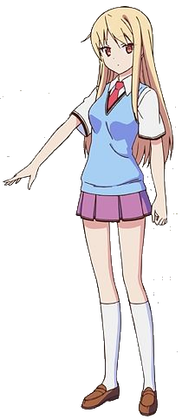
Sometime later that evening in a different room of the dorm, Mashiro had just finished putting the finishing touches on the doujin she had drawn with Sorata’s encouragement. He had left a little while prior, but wanting to impress him the quiet girl had put all of her due diligence into completing the project so that she could show him the next day. Antisocial as she was, she had fallen for him, and she didn’t really know what to do with those feelings. “If only… I was better at talking with others…”

She’d idly made this comment aloud, unaware of the white cat sitting on her nearby windowsill. To be fair, even if she had known it was there, she wouldn’t have not made the comment. It was just a cat, after all. A cat with special powers that triggered when its golden eyes came alight… just as they were now.

“…?” Not one to comment on things unnecessarily, Mashiro tilted her head slightly in response to a rather uncanny feeling. What was this best described as? A burst of energy? She almost felt wound up enough to go for a run, which would have been a first for this creative-minded individual.

But this energy came with a physical side effect, not that Mashiro herself really realized. All of her muscles had tightened in tandem with each other, swelling stronger as they eventually bulged to give this recluse the glow of a fit young woman. It could be seen in her arms, legs, and even her tummy – but it wasn’t so dramatic that her outfit had really been disheveled. Not yet anyways.

Compared to Nanami’s reaction, mind you, Mashiro’s base personality meant she hardly batted an eyelash towards the transformation she underwent. Even if her personality were to change (and it would), the moments where things would be the most noticeable were in the beginning, and by the time things tampered off her mind would have already been altered to accept this new reality that she would be presented.

“…Mm?” Case in point, her head had suddenly begun to feel a little itchy. Rather than really ponder much about, or think anything of it though, the teen only scratched at her scalp for a moment. Even though the cause was something worth fretting over, what with the full length of her hair being slurped up like a man eating spaghetti at an Italian restaurant. When all was said and done they length of it all had been pulled up to her nape.

And then it soon darkened. The color that emerged against her pastel locks was a much more mundane color, and in a way it almost seemed like she had just stolen the color from Nanami now that her roommate had already succumbed to the same cat’s spell. But it was a dark brown that emerged, seeing the short style seem even more generic than it already did. Toss in a bright green that took her reddish-amber eyes by storm, and make those eyes look even bigger than they had ever been, and it was clear that things were transpiring in a similar fashion to Nanami’s transformation.

Mashiro retained her age, but as the energy within brought her to begin fidgeting with her own two hands, it was clear that this was all she would retain of her old self. She already looked dramatically different than normal, and facial features that shifted to give her face a fuller look only contributed to that. “NYA-CHOO!” Throw in a similar sneezing phenomenon that saw her nose pulled out, darkened, and moistened, and her encroaching feline nature became hard to deny.

Lo and behold, her ears showed the very same signs that her friend’s had before they had completely been cat-ified. With their tips pulled into points, they slowly rode the sides of her skull until they were fasten on the sides of her head’s peak. By this point the points were aimed more or less upward, and the cartilage arced itself so that they resembled open cones. From that point on there was simply an emergence of soft, brown fur – lighter on the underside – to make them undeniable like those of a cat.

So too did her tail emerge. “Nya!?” It was the first thing to take Mashiro by surprise, and she practically jumped while it weaved out from beneath her blazer but above her skirt. The act of it growing it had shocked her, and she’d cried out because the growing energy had reached a boiling point. When her eyes set their sights on it, in all of its striped, brown glory, mind you? “Why did my tail scare me, nya?” Mashiro wasn’t sure. And she was also speaking unnecessarily, which was very out of character for her.

With the stage set, it did not take long for her hands and feet to take on their paw-like counterparts. Unlike Nanami though, she was actually denied some digits. Fingers and toes alike swelled, but her pinkie fingers merged into the fingers beside them so that she had only four, very thick brown fingers. While her feet? Only three big toes per paw, all complete with sharp claws. The fur that decorated them climbed up to her knees and elbows, leaving her thinking that her uniform felt a tad bit uncomfortable.

The fur wasn’t actually the cause, mind you. Mashiro actually shrunk two inches, leaving her clothes to fit just a little looser for but a brief moment despite the new muscle that covered her body. On the other hand, two areas of her person began to swell, and they undeniably took up a great deal of room.

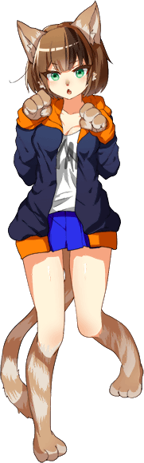
The first was her chest, which swelled a single size and lifted her shirt’s underside just a little bit. But they didn’t grow anywhere near as big as Nanami’s, and instead just looked a little too big for her athletic frame. On the other hand, her ass flourished with much more abundance than the other cat’s had. Each cheek was full and soft despite the firm muscle beneath them, and the excess bled downwards to give her thighs a thicker appeal.

While the tomboyish Nanami had become a soft-spoken, soft-bodied young woman, the soft-spoken Mashiro had become athletic, toned, and so energetic that she was very obviously struggling to stand still even though her clothes didn’t quite fit. It was honestly a miracle that she hadn’t noticed just how dramatic of a change it was, especially with tufts of fur sticking out from the sides of her face.

“Oi!? Why’s my room all stuffy, nya!?” Now that some sense had returned to her, Mashiro was practically jumping around her dorm room with confusion. It was definitely her room, but she didn’t recall ever being so organized. She was always bursting with energy! It was hard to keep everything straight in the end. Papers and paints had already been chaotically strewn about the room as she picked them up and touched them with her paws.

An energetic tomboy by nature, there was one person that made Mashiro the cat girl bashful, and that was Sorata. Even now she was more wired than usual because she was anxious. What should her next move be? How could she compete with her well-endowed, soft spoken rival, Nanami? Well, she wasn’t going to turn any heads in her stuffy uniform! And wasn’t it stuffier than normal? Especially around the chest? She’d have taken a loose hoodie and shorts any day of the week.

“Maybe Sorata-kun is in the kitchen. I should go conveniently be there too, nya!” After rooting around in her drawers, tail swishing while she picked out some comfier clothes, she bounded to the door and flew out into the hall, excited to try and get one over on Nanami! …Or so the plan had gone, but…

The only one in the kitchen was Nanami, who had just woken from her nap!

